SHEETAH · FORMULAS & FUNCTIONS · MODULE 1: HOW EXCEL CALCULATES · LESSON NOTES

1.2 Watching Excel think
Step through a formula with Evaluate Formula, check pieces with F9, show every formula at once, and know when Excel recalculates.

By the end of this lesson you can
- Step through a formula with Evaluate Formula, one piece at a time.
- Check part of a formula with F9 in the formula bar, then Esc.
- Show every formula on a sheet with Ctrl+` (Show Formulas).
- Tell Automatic from Manual calculation, and recalculate with F9.

Lecture

See inside a formula

Evaluate Formula: Excel’s working, step by step
Formulas › Evaluate Formula shows a formula being worked out one piece at a time, like a teacher writing the working on the board.
- Click Evaluate to work out the underlined part; click again for the next one.
- Step In opens a cell the formula points at, to see that cell’s own formula.
- The best tool when a result looks wrong and you can’t see why.
1. =B2*C2-D2 Excel looks up B2 first
2. =40*C2-D2 then C2
3. =40*250-D2 multiplication comes before subtraction
4. =10000-D2 now D2
5. =10000-1500
6. 8500
Each click of Evaluate works out the marked part.
In real life · A caterer in Hyderabad: billed ₹8,500 for 40 plates at ₹250 with a ₹1,500 discount. Evaluate Formula showed the client exactly how.
Evaluate Formula: Formulas › Formula Auditing
Step In: look inside a cell the formula uses

The Evaluate Formula box
The box shows the formula with the next part underlined. Each click replaces that part with its value, until only the answer is left.
- Select the cell first, then Formulas › Evaluate Formula.
- Values already worked out are shown in *italics*.
- Click Restart at the end to go through it again.
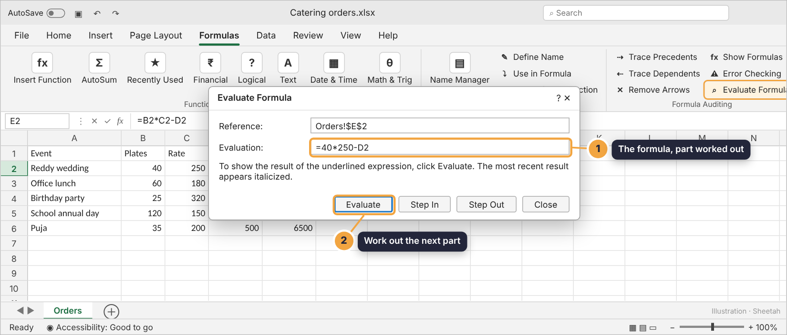
Evaluate Formula, part-way through
In real life · Meena, a junior accountant in Chennai: used Evaluate Formula on a commission sheet and spotted the step where a blank cell was treated as 0.

F9: check one piece, then Esc
In the formula bar, select part of a formula and press F9: Excel shows that part’s value. Press Esc to put the formula back.
- Always press Esc afterwards. Press Enter instead and the number replaces that part of the formula for good.
- Any piece works: a range shows as {40,60,25}, a test shows TRUE or FALSE.
- On many laptops you need Fn+F9.
Action: F9, then Esc
In real life · Rahul, a sales analyst in Gurugram: suspected the target in a long formula. He selected just that part, pressed F9, saw 0 (the target cell was empty), and pressed Esc.
F9 in the formula bar: show the selected part’s value
Esc: cancel, keeping the formula as it was
Check yourself: You select part of a formula, press F9 and see its value. What do you press next to keep the formula as it was?

Every formula, and when Excel calculates

Show Formulas: the whole sheet at once
Press Ctrl+` (the key above Tab) and every cell shows its formula instead of its answer. Press it again to switch back.
- A typed-in number hiding among formulas stands out: it’s the one without =.
- Columns widen to fit; nothing is changed. Also at Formulas › Show Formulas.
- In Sheetah’s grids, press Ctrl+` or click the {=} button in the toolbar.
Action: Ctrl+`
In real life · An auditor at a bank in Mumbai: presses Ctrl+` first on every workbook she reviews: a total typed in by hand stands out at once.

Automatic or Manual calculation
Normally Excel recalculates the moment anything changes. In Manual mode it waits until you press F9.
- Switch at Formulas › Calculation Options.
- The mode comes from the first workbook you open, so a colleague’s file can switch your Excel to Manual.
- Numbers that won’t update? Check the calculation mode first.
Avoid: Manual. You change a price and the totals don’t move. The status bar says Calculate. Press F9 to recalculate.
Do this: Automatic (the default). Every formula updates as soon as you press Enter. Keep it like this unless a huge file is very slow.
In real life · A finance team in Chennai: shared a huge budget saved in Manual mode. Next morning everyone’s totals looked wrong, until someone pressed F9.
Automatic: recalculate on every change
Manual: recalculate only when you press F9
Shift+F9: recalculate the current sheet only
Check yourself: You change a number but the total beside it doesn’t change, and the status bar says Calculate. What is going on?

Guided demo
Work out each catering bill, then look inside the formula and at every formula on the sheet.
1. Bill = plates × rate − discount.
2. Fill it down for every event.
3. Like Evaluate Formula, fx? shows each step: B2, C2, the multiplication, then the subtraction.
4. Show Formulas (Ctrl+` in Excel): every cell shows its formula. They all follow the same pattern.
5. Press it again to see the answers.

Lab: try it yourself
Finish the catering bills, then answer questions about how Excel works them out. Click fx? in the toolbar to see any formula worked out step by step.
Open the practice workbook that comes with this lesson, or do the lab in the app.
1. In E2, work out the Reddy wedding’s bill: plates × rate − discount.
Hint 1: Point at the cells: B2, C2 and D2.
Hint 2: Multiplication happens before subtraction, so no brackets are needed.
Hint 3: =B2*C2-D2
2. Fill the formula down to E6, so every event has its bill.
Hint 1: Select E2.
Hint 2: Drag the fill handle (the small square) down to E6.
Hint 3: Each row should use its own plates, rate and discount.
3. Evaluate Formula works through =B3*C3-D3 for the office lunch (60 plates, ₹180, ₹900 off). Put the steps in order.
- =60*C3-D3
- =60*180-D3
- =10800-D3
- =10800-900
- 9900
Hint 1: It looks up cells as it reaches them.
Hint 2: Multiplication before subtraction.
Hint 3: The last step is the answer.
4. You select B2*C2 in the formula bar of E2 and press F9. What does the formula bar show?
- =10000-D2
- 8500
- =B2*C2-1500
- 10000
Hint 1: F9 replaces only the selected part.
Hint 2: B2*C2 is 40 × 250.
Hint 3: The rest of the formula stays.
5. A colleague’s file opens and the totals don’t change when you type new numbers. What do you check first?
- The font
- Formulas › Calculation Options
- The sheet’s name
- Show Formulas
Hint 1: What would make Excel stop recalculating?
Hint 2: Look at the status bar.
Hint 3: It’s on the Formulas tab.
6. With Show Formulas on, one cell in the bill column shows 8000 while the others show =B4*C4-D4 and so on. What does that tell you?
- It’s the correct total
- Someone typed a number over the formula there
- Excel is in Manual mode
- The column is too narrow
Hint 1: Formulas start with =.
Hint 2: A plain number doesn’t update.
Hint 3: Someone typed over it.

Quiz
1. Where is Evaluate Formula?
- Home › Editing
- Formulas › Formula Auditing
- Data › Data Tools
- View › Show
2. What does Ctrl+` do?
- Copies the cell above
- Shows every formula instead of its answer
- Recalculates
- Opens Insert Function
3. In the formula bar you select part of a formula and press F9, then Enter. What happens?
- Nothing changes
- That part is permanently replaced by its value
- The formula is deleted
- Excel recalculates the sheet
4. Evaluate Formula shows =60*180-D3. What does the next click show?
- =10800-D3
- =60*180-900
- 9900
- =60*(180-D3)
5. Which calculation mode is best for everyday work?
- Manual
- Automatic
- Automatic except tables
- It doesn’t matter
6. What does Step In do in Evaluate Formula?
- Closes the box
- Shows the formula inside a cell that the formula uses
- Deletes the formula
- Moves to the next sheet

Recap
- Evaluate Formula steps through a formula one piece at a time.
- F9 in the formula bar shows a selected part’s value; always press Esc afterwards.
- Ctrl+` shows every formula; numbers that won’t update usually mean Manual calculation.
Keep this line: Evaluate, F9 then Esc, Ctrl+`, and keep calculation Automatic.

Answers

Lab
1. =B2*C2-D2
2.
3. =60*C3-D3 → =60*180-D3 → =10800-D3 → =10800-900 → 9900 Cells are replaced as Excel reaches them; × happens before −.
4. =10000-D2 Only the selected part becomes its value: =10000-D2. Press Esc to undo it.
5. Formulas › Calculation Options If it’s on Manual, switch back to Automatic, or press F9 to recalculate now.
6. Someone typed a number over the formula there A typed number won’t update when plates or rates change. Put the formula back.

Quiz
1. Formulas › Formula Auditing. Formulas tab, Formula Auditing group.
2. Shows every formula instead of its answer. Show Formulas. Press it again to switch back.
3. That part is permanently replaced by its value. Enter saves the edit. Use Esc after F9 to keep the formula.
4. =10800-D3. Multiplication is worked out before D3 is looked up for the subtraction.
5. Automatic. Automatic keeps every answer up to date. Manual is only for very slow, huge files.
6. Shows the formula inside a cell that the formula uses. Step In opens the referenced cell, so you can follow a chain of formulas.

