SHEETAH · EXCEL FOUNDATIONS · MODULE 1: WELCOME TO EXCEL · LESSON NOTES

1.1 What Excel is for
Workbooks, sheets and cells, and the real jobs that run on Excel.

By the end of this lesson you can
- Name the parts of a workbook: sheets, columns, rows, cells and ranges.
- Read and write a cell address like D4 and a range like A1:E6.
- Say which everyday jobs Excel does well, and when another tool fits better.

Lecture

A grid that does maths

Excel is a grid of cells that can calculate
An Excel file is called a workbook. Inside it are worksheets, the grids you see, each with its own tab at the bottom.
Every box in the grid is a cell. You can type text, numbers or dates into a cell, or a formula that works something out from other cells.
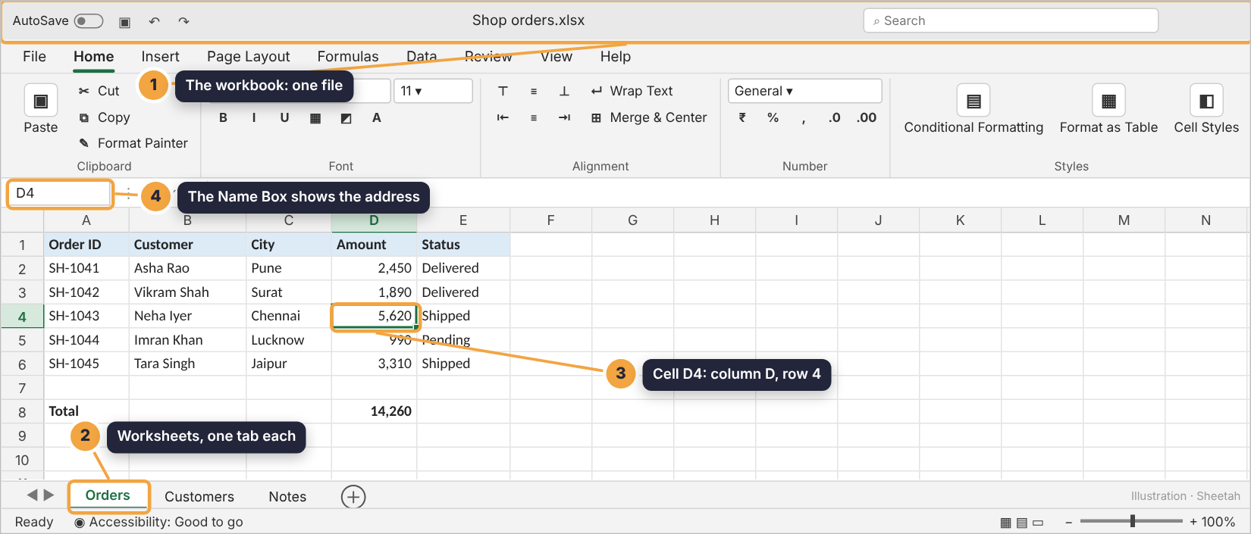
A workbook with three sheets. The active cell is D4.

Columns are letters, rows are numbers
Columns run down and are named A, B, C … After Z comes AA, AB and so on, up to XFD: 16,384 columns. Rows run across and are numbered 1 to 1,048,576.
A cell’s address is its column letter, then its row number: D4 is column D, row 4. That address is how formulas point at cells.
You see | It means
D4 | Column D, row 4
A1:E6 | Every cell from A1 to E6: a block of 5 columns × 6 rows
B:B | All of column B
Orders!D8 | Cell D8 on the sheet called Orders

A range is a block of cells
A range is a rectangle of cells, written as its first and last cell with a colon between: A1:E6.
Most of Excel’s work happens on ranges: you format them, sort them and add them up. When you drag across cells, you are selecting a range.
(Live example sheet in the app.)
Check yourself: Which address means column C, row 12?

What people actually use it for

The jobs that run on Excel
Budgets, sales trackers, attendance, stock lists, invoices, fee registers, project plans, survey results, salary sheets and dashboards all run on Excel in offices across India.
Any time you have rows of things with the same details for each (a list of orders, each with a date, customer and amount), Excel is a natural fit.
Job | What Excel does
Monthly budget | Totals, differences, a chart of where money goes
Sales tracker | Sort by amount, filter by city, sum by month
Class marks | Averages, grades, ranks, toppers
Stock register | Running balances, reorder alerts

When another tool is better
Excel is not a word processor: long letters belong in Word. It is not a database for millions of records shared by hundreds of people at once. And it is not a design tool.
A good test: if your information is a table of facts you want to sort, count or calculate, use Excel.
Avoid: Wrong tool. A 4-page letter typed into cells, one sentence per row.
Do this: Right tool. A list of 200 orders with date, customer, city and amount, totalled by city.
Check yourself: Which of these suits Excel best?

Guided demo
Watch Sheetah move around a real workbook: single cells, a range, and another sheet.
1. Click a cell to make it active. This is A1, the top-left corner.
2. Column D, row 4: cell D4 holds Neha’s order amount. The Name Box at the top left always shows the active cell’s address.
3. Drag from A1 to E6 to select a range. Every order, every column.
4. Cell D8 holds a formula. The grid shows its result; the formula bar shows =SUM(D2:D6).
5. Sheet tabs at the bottom switch between worksheets. This is the Customers sheet.

Lab: try it yourself
Explore the shop’s workbook. Click cells, select a range, switch sheets and rename one.
Open the practice workbook that comes with this lesson, or do the lab in the app.
1. Click cell C5 to make it active.
Hint 1: The column letter comes first: find column C.
Hint 2: Go down to row 5.
Hint 3: Click the cell where column C meets row 5. The Name Box should say C5.
2. What is in cell B3 on the Orders sheet?
- Surat
- Vikram Shah
- 1890
- SH-1042
Hint 1: Find column B.
Hint 2: Go to row 3.
Hint 3: It’s the customer of order SH-1042.
3. Select the range A1:E6: all the orders with their headers.
Hint 1: Click A1 first.
Hint 2: Then hold Shift and click E6.
Hint 3: Or drag from A1 down to E6. The status bar shows Count: 30.
4. Cell D8 shows 14,260. What is really inside it?
- The number 14260, typed in
- The formula =SUM(D2:D6)
- Text that looks like a number
- A picture
Hint 1: Click D8.
Hint 2: Look at the formula bar, not the cell.
Hint 3: The bar shows what was typed: a formula.
5. Rename the sheet Notes to Ideas. Double-click its tab, type the new name and press Enter.
Hint 1: The tabs are at the bottom of the grid.
Hint 2: Double-click the Notes tab.
Hint 3: Type Ideas in the box that appears and press Enter.
6. On the Orders sheet, type your own city in cell G2.
Hint 1: Click G2: column G, row 2.
Hint 2: Type the city name.
Hint 3: Press Enter to finish the entry.

Quiz
1. An Excel file is called a…
- Worksheet
- Workbook
- Spreadsheet tab
- Cell book
2. How many cells are in the range B2:C5?
- 4
- 6
- 8
- 10
3. What does Orders!D8 mean?
- Cell D8 on the sheet named Orders
- An error in D8
- The 8th order
- Column D of every sheet
4. Where do you see the formula inside a cell?
- In the cell itself
- In the formula bar
- In the sheet tab
- In the title bar
5. Which job is Excel the wrong tool for?
- A fee register
- A 30-page project report
- A stock list
- A sales tracker

Recap
- A workbook holds worksheets; each sheet is a grid of cells.
- A cell address is column then row: D4. A range is first:last: A1:E6.
- Excel fits any table of facts you want to sort, count or calculate.
Keep this line: Column letter, then row number: D4. Two cells and a colon make a range: A1:E6.

Answers

Lab
1. C5 is Lucknow, Imran Khan’s city.
2. Vikram Shah B3 is the Customer column, row 3.
3.
4. The formula =SUM(D2:D6) The cell shows the result; the formula bar shows the formula that makes it.
5. Clear sheet names make big workbooks easy to find your way around.
6. Typing and pressing Enter is how every entry in Excel ends.

Quiz
1. Workbook. The file is the workbook; the grids inside are worksheets.
2. 8. 2 columns (B, C) × 4 rows (2 to 5) = 8 cells.
3. Cell D8 on the sheet named Orders. Sheet name, exclamation mark, cell: D8 on Orders.
4. In the formula bar. The cell shows the result; the formula bar shows the formula.
5. A 30-page project report. Long documents belong in Word; Excel is for tables of facts you calculate with.

