SHEETAH · EXCEL FOUNDATIONS · MODULE 2: ENTERING AND EDITING DATA · LESSON NOTES

2.2 Editing fast
F2, undo and redo, cut, copy, paste and Paste Special (values, formats, transpose).

By the end of this lesson you can
- Edit inside a cell with F2 instead of retyping it.
- Undo and redo with the keyboard.
- Cut, copy and paste cells.
- Use Paste Special for values, formats and transpose.

Lecture

Changing what’s there

Type over, or edit with F2
Click a cell and start typing: whatever was there is replaced. To fix one letter instead, press F2 (or double-click): the cursor goes inside the cell and you can move with the arrow keys.
Enter finishes the edit, Esc cancels it, and Delete clears the cell’s contents but keeps its formatting.
F2 | Edit the active cell
Esc | Cancel the edit
Delete | Clear contents
Ctrl+Z | Undo (up to 100 steps)
Ctrl+Y | Redo

Cut, copy and paste
Ctrl+C copies the selection; a moving dashed border shows what’s copied. Click where it should go and press Ctrl+V. Paste as many times as you like; press Esc to clear the border.
Ctrl+X cuts: the cells move to where you paste. Formulas that are copied adjust to their new place; you’ll see why in Module 6.
Tip: Pressing Enter instead of Ctrl+V pastes once and clears the copy border.
Check yourself: Cell B3 says “Mumabi Central”. Quickest way to fix the typo?

Paste Special

Paste only what you need
Paste Special (Ctrl+Alt+V, or right-click › Paste Special) lets you choose what to paste:
Values pastes results without formulas. Formats copies the look without the content. Transpose turns a row into a column, or a column into a row.
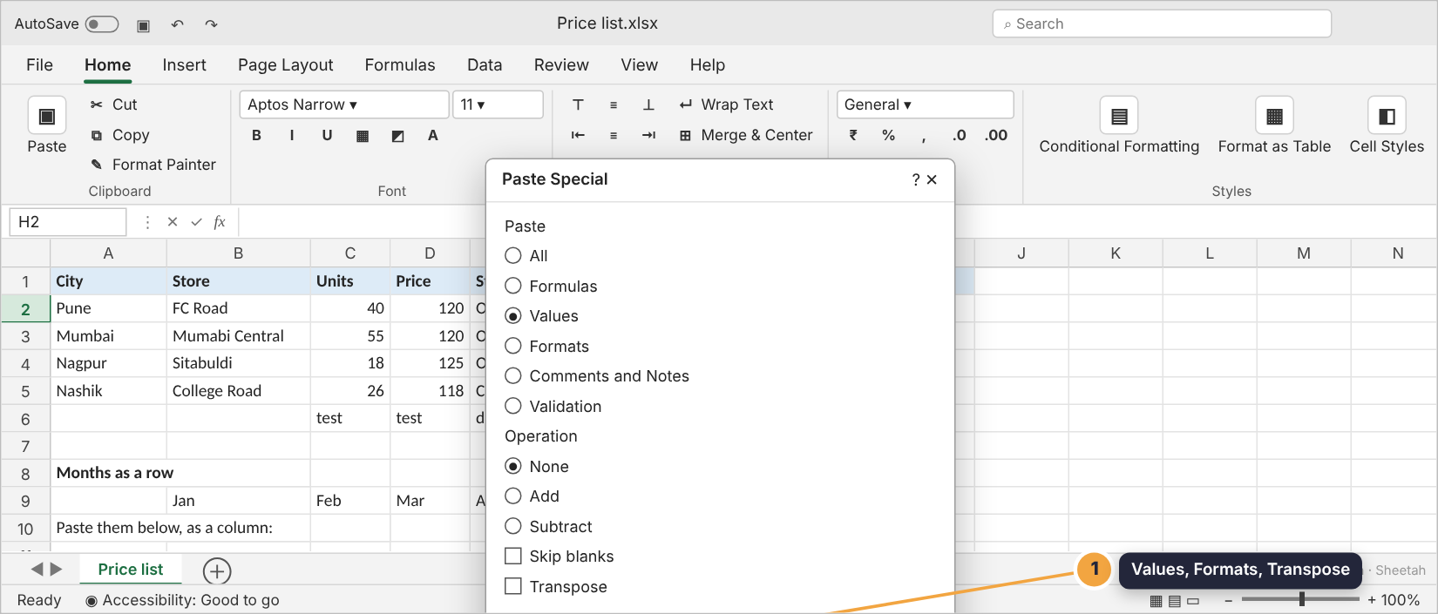
The Paste Special dialog

When to paste values
Paste values when you want to freeze results: sending a price list without your formulas, keeping a copy of this month’s totals before the data changes, or cleaning data imported from another system.
After pasting values, the cells hold plain numbers. Changing the inputs no longer changes them, which is the point.
Avoid: Plain paste of F2:F5. The formulas come along and recalculate, pointing at new cells.
Do this: Paste values. Only the numbers arrive. Nothing recalculates.
Check yourself: You need a copy of the totals that won’t change when the data changes. Which paste?

Guided demo
Fix a typo, copy a column, then paste values and transpose.
1. B3 says “Mumabi Central”. Press F2 to edit in place.
2. Fix the spelling and press Enter.
3. Copy the cities in A2:A5 and paste them into G2.
4. Copy the amounts in F2:F5, then Paste Special › Values into H2. Only the numbers arrive.
5. Copy the months row B9:G9 and paste transposed into A11: the row becomes a column.

Lab: try it yourself
Tidy the price list: fix a typo, clear junk, copy, paste values and transpose. Right-click the grid for Paste values and Paste transposed.
Open the practice workbook that comes with this lesson, or do the lab in the app.
1. Fix the typo in B3 so it reads Mumbai Central.
Hint 1: Click B3.
Hint 2: Press F2 to edit inside the cell.
Hint 3: Fix the letters and press Enter.
2. Clear the junk entries in C6:E6.
Hint 1: Select C6:E6.
Hint 2: Press Delete.
Hint 3: The cells should be empty.
3. Copy the cities in A2:A5 into G2:G5.
Hint 1: Select A2:A5 and press Ctrl+C.
Hint 2: Click G2.
Hint 3: Press Ctrl+V.
4. Put the amounts from F2:F5 into H2:H5 as plain numbers, not formulas.
Hint 1: Copy F2:F5.
Hint 2: Click H2, right-click.
Hint 3: Choose Paste values.
5. The months in B9:G9 are a row. Paste them as a column into A11:A16.
Hint 1: Copy B9:G9.
Hint 2: Click A11 and right-click.
Hint 3: Choose Paste transposed.

Quiz
1. What does F2 do?
- Saves the file
- Edits the active cell in place
- Opens Help
- Fills down
2. You press Delete on a bold, yellow cell. What’s left?
- Nothing at all
- An empty cell that is still bold and yellow
- #REF!
- The previous value
3. Which Paste Special option turns a row into a column?
- Values
- Formats
- Transpose
- Skip blanks
4. What is the shortcut for Paste Special?
- Ctrl+Shift+V
- Ctrl+Alt+V
- Alt+P
- F12
5. You pasted the wrong thing. What do you press?
- Esc
- Ctrl+Z
- Ctrl+Y
- Delete

Recap
- F2 edits in place; typing replaces; Delete clears contents but keeps formats.
- Ctrl+Z undoes, Ctrl+Y redoes.
- Paste Special (Ctrl+Alt+V): Values, Formats, Transpose.
Keep this line: F2 to fix, Ctrl+Z to undo, Paste Special › Values to freeze results.

Answers

Lab
1.
2.
3.
4.
5.

Quiz
1. Edits the active cell in place. F2 puts the cursor inside the cell.
2. An empty cell that is still bold and yellow. Delete clears contents, not formatting.
3. Transpose. Transpose swaps rows and columns.
4. Ctrl+Alt+V. Ctrl+Alt+V opens the Paste Special dialog on Windows.
5. Ctrl+Z. Ctrl+Z undoes the last action.

