**Name:** Dhruvraj Singh Rawat  
**Roll No:** 15UEC022

**Q: Which error is greater error_1 or error_2? Why?**

The is **greater** in error_1 as compared to error_2 as in prior the bits are sent only once and the probability of them in corrupting in between is very large whereas in the second case a single bit is repeated 3 times and probability of corrupting all of them is very small as compared to the prior.

**Q: What is coding gain.**

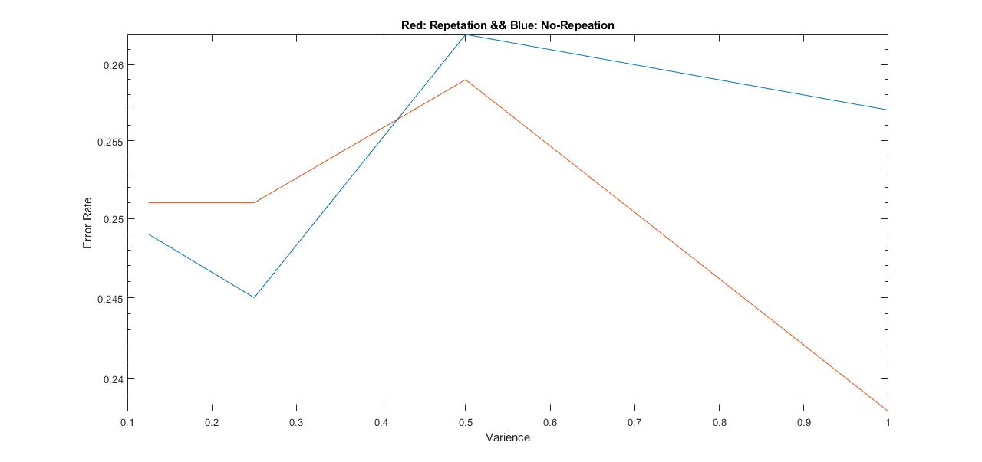

Figure : Coding Gain founded from Part 4

In our problem the coding gain can be defined as the difference between the Error rate between coded and non-coded signal when both are sending same number of Bits. In our case the Error rate is less for repeated bits (RED) as compared to BLUE. Thus, by using the Red we are having coding gain over blue in variance range 0.4 -🡪 1 (as seen from the above graph).