
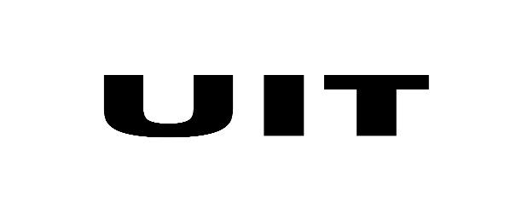
Internship Report
On
(Project Intern)

Internship Duration
(1/11/2025) to (31/5/2026)
Fx31 Labs

in partial fulfillment for the award of the degree of
BACHELOR OF TECHNOLOGY
in
COMPUTER SCIENCE AND ENGINEERING

Submitted By
SHAUMIL MISTRY
(Enroll. No. 20220702126)

under the guidance of
Mr. JATIN AMBASANA
Assistant Professor UIT, KU

UNITEDWORLD INSTITUTUE OF TECHNOLOGY
KARNAVATI UNIVERSITY
Uvarsad, Gandhinagar, Gujarat-382422
MAY 2026

INTERNSHIP COMPLETION CERTIFICATE

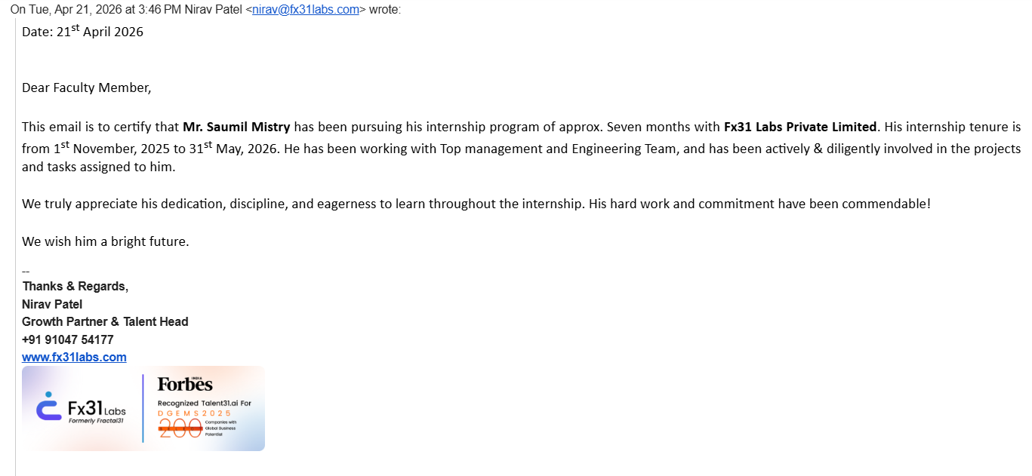

INTERNSHIP OFFER LETTER

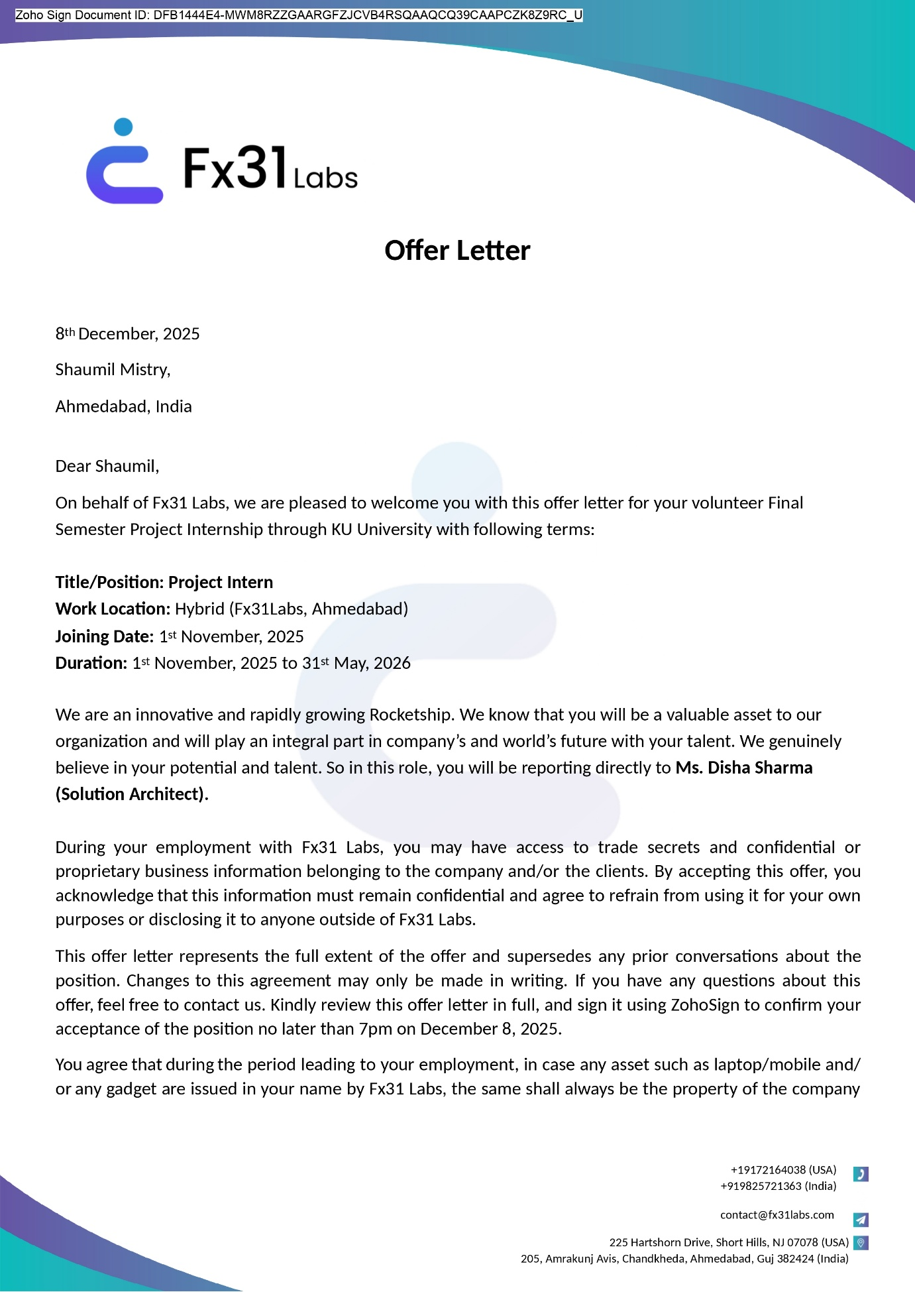
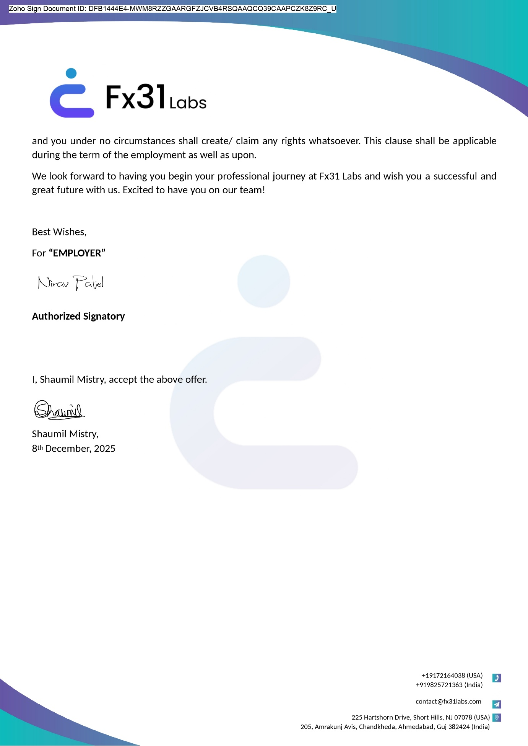

NOC from CSD KU

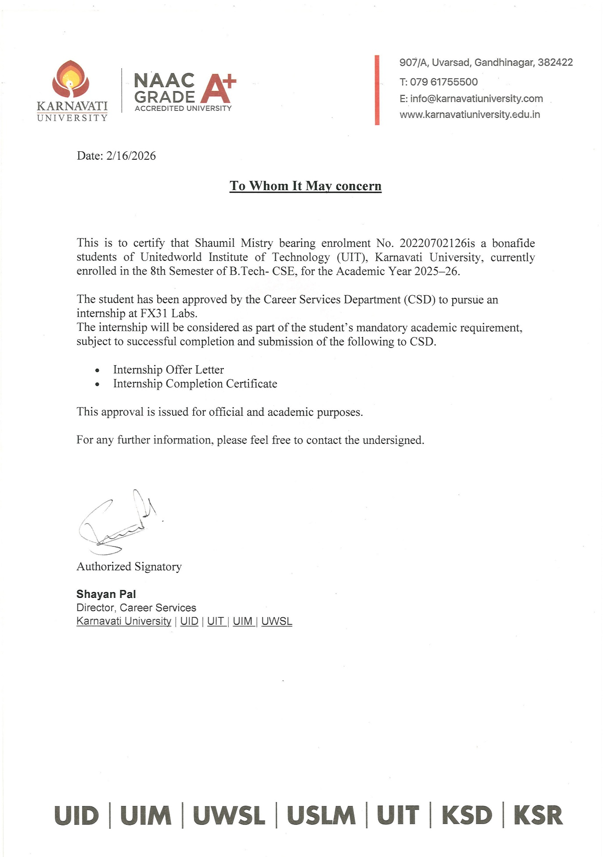


DECLARATION BY THE STUDENT

I, Shaumil Mistry, 20220702126, student of Bachelor of Technology in CSE hereby declare that the internship report titled “Project Intern” which is submitted by me to Unitedworld Institute of Technology, Karnavati University, in partial fulfilment of requirement for the award of the degree of Bachelor of Technology in Computer Science has not previously formed the basis for the award of any degree, diploma, or other qualification.
I further declare that due permission has been obtained for the use of any copyrighted material included in this internship report, except for brief excerpts that require only proper acknowledgment in scholarly writing, and all such use has been appropriately acknowledged.

Gandhinagar
Date
Shaumil Mistry
20220702126
B. Tech CSE


KARNAVATI UNIVERSITY
Uvarsad, Gandhinagar, Gujarat-382422
Unitedworld Institute of Technology

BONAFIDE CERTIFICATE

This is to certify that Shaumil Mistry, 20220702126 a student of B. Tech CSE, has successfully completed the internship report titled “Project Intern”, submitted to Unitedworld Institute of Technology, Karnavati University, in partial fulfillment of requirement for the award of the degree of Bachelor of Technology.
This report is a bona fide record of the work carried out by the student under my guidance and supervision. To the best of my knowledge, this work is an original contribution and has not been submitted, either in part or in full, for the award of any degree, diploma, or any other qualification at this University or elsewhere.
Date:
Place: Gandhinagar

Mr. Jatin Ambasana
Assistant Professor
Unitedworld Institute of Technology

(External Examiner) Dr. Rebakah Geddam
Assistant Dean
Unitedworld Institute of Technology

Dr. Puneet Sharma
Associate Dean
Unitedworld Institute of Technology

ACKNOWLEDGEMENT

I would like to convey my heartiest thanks to my organization guide Mr. Nilesh Modi, Fx31 Labs, Ahmedabad, Gujarat, for their invaluable guidance and continuous support throughout my internship. Their expertise, problem-solving approach, and encouragement have been instrumental in enhancing my learning experience.
I especially thank my guide Mr. Jatin Ambasana, Assistant Professor, Unitedworld Institute of Technology, Karnavati University for all his guidance and support. His extreme patience has guided me in situation of need for which I am extremely grateful.
I wish to express my sincere thanks and deep sense of gratitude to Dr. Puneet Sharma, Associate Dean, UIT, and Dr. Rebakah Geddam, Assistant Dean, UIT, Karnavati University, for their valuable support and encouragement.
I am also thankful to our coordinator, Ms. Rama M. Maliya and UIT Placement Team for their continuous guidance.
I would like to acknowledge the Career Service Department (CSD), Karnavati University for their support in fulfilling my internship requirements. Their timely assistance played a crucial role in the successful completion of my work.
I am thankful to my friends for their unwavering support, encouragement, and willingness to help me whenever needed.
Above all I am indebted to my beloved parents, whose blessing and best wishes have gone a long way in making this semester internship a grand success.

Shaumil Mistry
20220702126
B. Tech CSE

ABSTRACT

This document outlines the internship project performed over a seven-month period from 1st November 2025 to 31st May 2026 at Fx31 Labs, Ahmedabad by the Project Intern. The focus was on building a full-stack freelance marketplace platform called OnTask and designing/developing it from start to finish using the MERN stack (MongoDB, Express.js, React.js, Node.js).
OnTask connects job providers (Organizers) and freelancers (Taskers) through an all-inclusive hiring workflow with job postings, application management, messaging in real-time, negotiating budgets, and payment through escrow.
This project had a structured weekly task framework; tasks included designing wireframes in Figma for UI/UX, to building authentication and core features for the app, to enabling real-time communications via Socket.IO, to integrating Firebase push notifications.
In five of the six months, all the major modules of the project were completed. The final month of the internship will be dedicated to testing and handing off the app. This experience offered extensive opportunities for learning how to improve technical abilities, develop professionally, and apply those skills to real development projects.

TABLE OF CONTENTS

INTERNSHIP COMPLETION CERTIFICATE i
INTERNSHIP OFFER LETTER ii
NOC from CSD KU iv
DECLARATION BY THE STUDENT v
BONAFIDE CERTIFICATE vi
ACKNOWLEDGEMENT vii
ABSTRACT viii
TABLE OF CONTENTS ix
List of Tables x
Chapter 1: Introduction 1
1.1 Overview of the Internship 1
1.2 Objectives of the Internship 2
1.3 Scope of the Work 3
Chapter 2: Company Profile 6
2.1 Introduction to the Company 6
2.2 Vision, Mission & Core Values 7
2.3 Products/Services Offered 9
2.4 Organizational Structure 10
Chapter 3: Work Profile & Responsibilities 12
3.1 Internship Role and Designation 12
3.2 Tasks Assigned 12
3.3 Technical & Managerial Skills Acquired 15
Chapter 4: Project/Work Done 17
4.1 Description of the Work 17
4.2 Technologies/Tools Used 18
4.3 Challenges Faced and Solutions Implemented 18
4.4 Contributions to the Company 19
Chapter 5: Learning Outcomes & Observations 20
5.1 Technical Learning 20
5.2 Professional & Ethical Learning 21
Chapter 6: Conclusion & Recommendations 22
6.1 Summary of Internship Experience 22
6.2 Recommendations for Future Interns 23

List of Tables

Sr No. | TABLE NAME | Page No.
1.1.1 | Technology Stack Overview | 1
2.1.1 | Company Overview | 6
2.2.3.1 | Company Core Values | 8
2.3.1 | Company Services Offered | 9
2.4.1.1 | Company Roles | 11
3.1.1 | Internship Details | 12
3.2.1 | Tasks Details | 12
3.3.1 | Technical Skills | 15
3.3.2 | Managerial Skills | 16

Chapter 1: Introduction

Overview of the Internship
This document reflects my experience as a Project Intern at Fx31 Labs, a technology company that creates digital solutions. My internship was spent as part of the core development team for OnTask, a full-stack freelance marketplace and task management application that connects job providers (Organization or Organizers) and job seekers (Taskers/Freelancers). By providing an environment for users to post jobs, search for talent, communicate in real-time, and manage payment processes, OnTask delivers a complete life-cycle of services for its users.
Throughout my internship, I was involved in all aspects of the software development process, including designing RESTful API endpoints on the back-end and building user interfaces on the front-end. There was one technology stack that was primarily used during my time at Fx31 Labs:
Table 1.1.1: Technology Stack Overview
Layer | Technology
Frontend | React.js (Vite), React Router DOM, Context API
Backend | Node.js, Express.js
Database | MongoDB (via Mongoose ODM)
Real-Time | Socket.IO (WebSockets)
Authentication | JWT (JSON Web Tokens), Passport.js, Google OAuth 2.0
File Handling | Multer (multipart/form-data)
Notifications | Firebase Cloud Messaging
Payment/Wallet | Custom Escrow-based Wallet System
Version Control | Git
Throughout my internship, I have found that I've had enough time to work at all levels of the application. I've developed new features and learned how to debug difficult business logic flows. The Fx31 Labs team has been a great mentor, and it has provided me with a lot of industry experience around agile development, code review processes, and working as part of a team through each process of engineering.

Objectives of the Internship
The internship with Fx31 Labs serves two objectives - contribute to develop the OnTask platform and improve the technical skill set of the intern to full-stack developer for web applications. The specific objectives are as follows:
1.2.1 Primary Project Objectives
1. Design, Build & Integrate Core Platform Features - Actively participating in the development and integration of key system components (User Authentication, Job Posting, Application Management, Real-Time Messaging, Wallet/Escrow) to create an on-going, reliable and maintainable product.
2. Design & Develop Scalable RESTful API Architecture - Creating a set of well-designed and implemented RESTful API endpoints that will serve as the foundation for other development efforts to support all major app functionality (user management, job lifecycle management, payment processing, review creation and notification handling).
3. Integrate Real-Time Communication - Utilizing Socket.IO technology to enable real-time communication via WebSockets for live messaging between Organizers and Taskers, as well as in-app notifications for user actions resulting from a job application, offer, or hire.
4. Develop a Secure Financial System - Creating a well-designed, implemented, and maintained wallet system to provide secure fund transfer capabilities, locking down budget by job upon hire, and ensuring that only approved funds are drawn out of the wallet (financial disputes resolved).
5. Create an Innovative, Responsive, and Modern Front End - Implement a Responsive, User-Friendly Front End Built with React.js to Accommodate All Main User Flows Including Dashboard Views for Both Organizers and Taskers, Job Search Functionality, Talent Search Capability, Profile Management, and Earnings Tracking.
1.2.2 Goals of the Experience
1. Gaining Hands-On Experience on a Day-to-Day Basis Implementing a Live Application on the MERN (MongoDB, Express.js, React.js, Node.js) Stack Will Provide You with a Clear Understanding of how to Use the Full-Stack MERN in a Real Business Environment.
2. Understand How Software Developers Work Through the Following Software Development Produce Cycle:
Feature Planning, Task Decompositions, Git, and Collaborative Code Contributions.
3. Develop Problem-Solving Skills by Working on Debugging Complex Back End logic, Understanding How to Integrate with APIs; and Managing Front End State to Debug Any Issues.
4. Learn how to Manage Security and Authentication for Applications Using Industry-Standard Security Protocols (i.e., UsingJWT & OAuth for Authentication/ Authorization and Resetting Passwords via OTP) and How to Validate Data Before Ingesting into the Application.
5. Create Confidence and Competence with the Ability to Produce Production-Ready Code as a Result of Being mentored by Experienced Developers.

1.3 Scope of the Work
This internship project was constrained to deliver an OnTask product. All development is full stack and falls within one or more of these four categories:
1.3.1 User Management & Authentication
- Register for two roles — Tasker/Freelancer or Organizer/Job Provider
- JWT secure log-in to access the platform
- Allow users to use their Google account log-in with Passport.js OAuth 2.0
- Use OTP to retrieve lost accounts/forgotten passwords
- Allow users to manage their profiles (upload profile picture and resume)
- Allow other users to view public profiles and follow them on the platform.
1.3.2 Job & Application Management
- Complete job lifecycle managed by Organizers from posting jobs (create, view and edit) to managing jobs, including applicants applying for and tracking application status.
- Job applications can be tracked with different statuses during the application process as well as receive feedback throughout the hiring process from the Organizer.
- Organizers have an interface to review job applicants (short list, make job offers and hire).
- New jobs cannot be created as duplicates.
1.3.3 Real-Time Messaging
- Allow for private direct messaging from Organizers to Taskers.
- Delivery of messages to and from the Organizers and Taskers will occur in real-time using Socket.IO for messaging without page refresh.
- Maintain a history of messages in the MongoDB database.
- Record the number of unread messages using notification badges.
1.3.4 Notification System
- Trigger notifications within the app for users using WebSockets.
- Send Notifications using Firebase Cloud Messaging (FCM) for Users' push notifications, when Taskers apply to Organizers, Organizers hire Taskers, and when messages are sent and received.
1.3.5 Wallet & Escrow Financial System
Users can "balance" their "wallet" that they manage, such as locking money as escrow when a provider applies to hire to get a job; and use the budget negotiation flow (job seeker approves or rejects) to select the amount(s) to be released as payment to a Tasker (payment to the provider) at some point after the Task has been completed.
Users can withdraw funds.
Users can pay a Tasker (bonus) from their provider account.
1.3.6 Search & Discovery
Taskers can search for providers by skills.
Taskers can search for jobs based on category and keywords.
Taskers will have a talent discover page, with a link to their public profile.
1.3.7 Pricing & Subscription
Pricing page to design, build and publish.
The subscription level for our monetization.
1.3.8 Settings & Platform Feedback
Settings page to allow account settings (change account information, change password)
A way to provide feedback about the app or make suggestions.

Chapter 2: Company Profile

2.1 Introduction to the Company
Fx31 Labs (aka Fractal31) is an innovative tech start-up company based in Ahmedabad, Gujarat, India & an International base in Short Hills, New Jersey, USA. Established in 2022, the company is rapidly growing into a leading offshore software engineering and digital product development company with a focus on Generative A.I. (GenAI) and how it can be leveraged to improve A.I. driven deep tech talent augmentation and scalable software development.
Table 2.1.1: Company Overview
Detail | Information
Company Name | Fx31 Labs (Fractal31)
Founded | 2022
Headquarters (India) | 205, Amrakunj Avis, Chandkheda, Ahmedabad, Gujarat 382424
USA Office | 225 Hartshorn Drive, Short Hills, NJ 07078
Industry | Information Technology & Software Development
Specialization | Generative AI, Digital Product Development, IT Outsourcing
Team Size | ~38 employees (as of 2026)
Website | www.fx31labs.com
Contact (India) | +91 91047 54177
Email | contact@fx31labs.com

Fx31 Labs provides a variety of services to a range of clients such as startups, small and large enterprises both in India and globally, integrating strategy, design and engineering services for clients to solve business problems. Fx31 Labs has established an outstanding reputation through its many achievements including:
1. 100% Hiring Success Rate
2. Top 3% of Quality of Talent Delivered to Clients
3. 97% Talent Retention Rate
4. 95% On-Time Delivery
5. 100+ Combined Projects Delivered
6. 30-50% Cost Savings Over Traditional Hiring Models
7. 2 Day Average Time From Submission To 1st Interview for Clients Talent Requirements
Fx31 Labs has established itself as the premier provider of cutting-edge A.I. targeted towards enhancing the quality of talent sourced globally as well as maintaining its competitive advantage of being able to provide clients with Fortune 500 quality engineering teams at a highly competitive rate. Fx31 Labs has received significant recognition from multiple prominent B2B platforms and has an active global clientele base across fintech, commerce tech, healthcare, and startup ecosystems.

2.2 Vision, Mission & Core Values
2.2.1 Vision
“Fx31 Labs' Vision is to connect Tier 3 talent to Tier 1 Opportunities and optimize the use of human capacity by leveraging technology to change how we interact in the world.”
This vision has been shaped from the founding team's own experiences of growing up in Tier 3 cities, then as professionals working in multinational corporations. They seek to build an ecosystem that connects qualified professionals in Tier 3 cities with world-class employment opportunities irrespective of where they are located. The vision is the driving force behind everything the company does including sourcing, recruiting, and preparing talent for success; building partnerships with clients; and ensuring client success.
2.2.2 Mission
“Our Mission is to use the power of next-generation tools (also known as “generative AI”) to provide customized and scalable solutions that help our customers achieve measurable business results and position their organizations to succeed in today’s fast-paced, digital environment.”
The mission statement indicates that Fx31 Labs is committed to delivering software and changing how our customers operate by being good technology partners to their organizations; they utilize technologies such as generative AI (large language models) and intelligent automation, positioning themselves as true partners in the innovation process not merely IT vendors.
2.2.3 Core Values
Values are what define the company culture of Fx31 Labs through the core values established by the organization to create a daily guide for employees to follow in their relationships with one another, as well as with clients:
Table 2.2.3.1: Company Core Values
Core Value | Description
Innovation First | Ongoing application & amalgamation of Future Tech for the full service offer array & all operational processes of the company via GenAI.
Talent Excellence | Seek out & grow only the top 3% of engineers; every team member will operate at World-Class quality standards.
Client-Centricity | Consideration of clients' success will come from our understanding of their business problem and delivering quantified results, rather than coding alone.
Inclusivity & Opportunity | Creation of pathways to access Tier 1 project's opportunities to Tier 3 talent without geographic or socioeconomic limitations.
Agility & Adaptability | Implementation of an operating speed & agility model that will allow support for Startups, MVP's, & Enterprise Transformations simultaneously.
Integrity & Transparency | Establishing & nurturing open and honest communication with Clients in order to build long-lasting customer relationships, provide consistent deliverables to Clients, and to be held accountable for our partnership with each other.
Continuous Learning | Fostering a culture of knowledge sharing, professional advancement, and anticipation to where the technology industry is going.

2.3 Products/Services Offered
Fx31 Labs has many types of tech services for startups, small to medium businesses, and large corporations. They combine AI thinking with years of engineering experience to provide good digital solutions in several verticals.
Table 2.3.1: Company Services Offered
Services | Description
AI Talent Augmentation | Offering AI-enabled vetting of top-tier deep tech talent, and facilitating the hiring process, we provide access to engineering, design, and project management teams with an average time from request to first interview of only 2 days.
GenAI-Powered MVP Development | Accelerated minimum viable product (MVP) development for start-ups built with Generative Artificial Intelligence (GAI), allowing for shorter timeframes (ideation to deployment).
Generative AI / ML Consultancy | LLM integration (GPT/Google/Bard), AI agent development, ML/DL model development, NLP pipelines, smart automation, etc.
Mobile App & Web Development | Full-cycle (front-end, back-end, and database layers) mobile and web application development in React.js/NODE.js/Python/Flutter, and other technologies.
Dedicated Development Teams | Embedded teams of engineers, designers, and project managers working closely with clients in an agile manner for an extended period based on client preferences.
Software Outsourcing | ISO-quality offshore software development with 30-50% savings compared to the US, along with complete transparency and sprint-based progress reporting.
Remote CTO Services | Part-time or consultative services of technical leadership for start-ups and small to medium size companies without senior technical talent.
Coderbotics AI | AI-based coding/automation assistant by FX31 Labs - our #1 product, embedded in all our products, services and solutions.
Emerging Technologies | Expert services in the areas of Blockchain, Internet of Things, Robotics, Robotic Process Automation and Augmented/Virtual Reality.
Cloud, DevOps & QA | End to end services in AWS, Azzure, GOOGLE, Docker, Kubernetes, Jenkins and selenium in cloud infrastructure and quality assurance.

2.4 Organizational Structure
Fx31 Labs has a small, lean team with an agile structure that enables a rapid response for all sorts of work. In 2026, the company has around 38 employees in its India and US operations who are divided into functional teams.
2.4.1 Leadership Team
The company is headed by a highly experienced team of former veterans from leading global companies and acclaimed universities:

Table 2.4.1.1: Company Roles
Name | Role
Dr. Nilesh Modi | CEO & Founder Technologist (25+ years of experience); MS & PhD from University of California; ex-Intel IBM Cadence Cygnet Infotech
Kushagra Saxena | Investor & Strategic Advisor Fortune-50 executive; ex-CTO, MasterCard; Stanford alumnus; Chairman, Function Ventures
Filipe Garcia | Head of Business Development & Sales
Janak Porwal | Associate Partner (Technology)
Disha Sharma | Chief Architect / Director, Technical Success
Aastha Bhatnagar | Head of Finance and Partnerships
Nirav Patel | Head of Talent (Senior Manager, Human Resources)

Chapter 3: Work Profile & Responsibilities

3.1 Internship Role and Designation
Table 3.1.1: Internship Details
Detail | Information
Designation | Project Intern
Organization | Fx31 Labs, Ahmedabad
Project Assigned | OnTask — Freelance Marketplace Platform
Internship Duration | 6 Months (1 month remaining as of report date)
Work Mode | Hybrid (On-site + Remote)
Reporting To | Project Mentor / Technical Lead

As part of my internship, I was placed as a part of the development core team of OnTask. This is a full stack MERN application designed to help Organizers find and get help from experts Taskers. I had to carry out all the roles which ranged from design for the UI/UX using Figma to front-end and back-end development. I did this work on a weekly basis so that what I completed for that week is to be submitted by the end of the week, and reviewed by my mentor.

3.2 Tasks Assigned
The internship is a six-month sprint; I will be at the end of my fifth month of work when my internship is over and I will be working on my final sprint. These are what I have completed in the first five months of my internship:
Table 3.2.1: Tasks Details
Week Details | From - To Date | Task Details
Week 1 | 01 Dec - 05 Dec 2025 | Getting started, gathering project requirements and discussing with product owner, meeting the team and getting introduced to the OnTask vision and user personas.
Week 2 | 08 Dec - 12 Dec 2025 | Technology stack, Git & GitHub setup, MERN stack project structure, development environment setup.
Week 3 | 15 Dec - 19 Dec 2025 | Figma wireframing - Part 1: Login, Signup, Forgot Password, OTP (One time password) Verification, Landing Page screens; initial design feedback from mentor.
Week 4 | 22 Dec - 26 Dec 2025 | Figma wireframing - Part 2: Organizer Dashboard, Tasker Dashboard, Job Post, Job Listing, and Messaging, Profile screens.
Week 5 | 29 Dec - 02 Jan 2026 | React.js project setup, React Router setup, global CSS variables, Navbar, Footer and Sidebar components.
Week 6 | 05 Jan - 09 Jan 2026 | Landing Page with hero, features, how it works, testimonials and CTA sections with mobile responsiveness.
Week 7 | 12 Jan - 16 Jan 2026 | Auth Frontend Pages: Login, Sign-up, Forgot Password and OTP Verification form w/validation and styling.
Week 8 | 19 Jan - 23 Jan 2026 | Auth APIs: Node.js + Express.js REST API for user signup, login, JWT token, and bcrypt hash for storing passwords.
Week 9 | 26 Jan - 30 Jan 2026 | Passport.js for Google OAuth 2.0, OTP clock and email (using Nodemailer), and password reset flow.
Week 10 | 02 Feb - 06 Feb 2026 | Step-by-step Job Posting page (job title, job description, required skills, salary budget), backend API to add a job and form validation middleware.
Week 11 | 09 Feb - 13 Feb 2026 | Job Listing page (search & filter), Job Detail page, dynamic routing, and APIs to fetch jobs.
Week 12 | 16 Feb - 20 Feb 2026 | Apply-to-job for Tasker, apply schema in MongoDB, apply API, and Organizer application listing panel UI.
Week 13 | 23 Feb - 27 Feb 2026 | Organizer review panel: show applicants, accept or reject applications, shortlist logic & manage status of applications.
Week 14 | 02 Mar - 06 Mar 2026 | Hire flow: approve system with budget negotiation, Taskers accept/reject flow, and hire confirmation with budget being locked.
Week 15 | 09 Mar - 13 Mar 2026 | Socket.IO server with real-time Organizer and Tasker chat, persisting chat messages in MongoDB, and chat UI.
Week 16 | 16 Mar - 20 Mar 2026 | Chat: unseen message badge, availability online/offline, in-app real-time chat notification.
Week 17 | 23 Mar - 27 Mar 2026 | Wallet & Escrow: wallet schema creation, escrow deposit on job hire, wallet balance, Open Escrow list, wallet transactions, and wallet dashboard.
Week 18 | 30 Mar - 03 Apr 2026 | Payment release on job completion, withdrawal flow for Organizer, payment status tracking, and backend API integration.
Week 19 | 06 Apr - 10 Apr 2026 | Integration with Firebase Cloud Messaging (FCM), configuration for job updates push notification, and device token handling.
Week 20 | 13 Apr - 17 Apr 2026 | Advanced Tasker & Job search with filtering by skill/location/budget, search results display, and query optimisation.
Week 21 | 20 Apr - 24 Apr 2026 | Public profile page, portfolio, skill badging, multer-based file upload (portfolio images), and profile view count.
Week 22 | 27 Apr - 01 May 2026 | Settings: edit profile, password change, notifications and account settings.
Week 23 | 04 May - 08 May 2026 | Fixes to page UI bugs, responsiveness on mobile and for different browsers, loading indicators, error boundaries, and other UI enhancements.
Week 24 | 11 May - 15 May 2026 | Testing new features, trouble shooting bugs and ensuring features are not broken in different modules.
Week 25 | 18 May - 22 May 2026 | Code refactoring, inline comments, documenting the project in a structured way and handover notes.
Week 26 | 25 May - 31 May 2026 | Final report writing, presentation of the project to the mentor and internship handover.

3.3 Technical & Managerial Skills Acquired
The internship provided some practical experience with the technical tools and professional practices:
Table 3.3.1: Technical Skills
Skill | Description
React.js | Creating component-driven UIs, data management (Context API), routing.
Node.js & Express.js | Building REST APIs, middlewares, authentication, routes.
MongoDB & Mongoose | Modelling, object references (populate), queries.
Socket.IO | Websockets for real-time communication for chat and notifications.
Figma | Design mock-ups, prototypes of web application screens.
JWT & OAuth | User registration, login, and social login.
Git & GitHub | Code management, branch, pull request system.
Firebase | Firebase Cloud Messaging (FCM) integration with push notifications.

Table 3.3.2: Managerial Skills
Skill | Description
Task Management | Following a sprint cycle each week, setting priorities, and deadlines.
Team Collaboration | Syncing up with mentors and colleagues during code reviews and live code walkthroughs.
Problem Solving | Observing, researching and fixing complicated backend logic and app state.
Documentation | Coding and maintaining projects with clean code, comments and project notes.
Communication | Weekly reporting and discussion of blockers with a lead mentor.

Chapter 4: Project/Work Done

4.1 Description of the Work
The objective of the internship was to create the full stack OnTask freelance marketplace using MERN stack technology. Users of this market will fall into two categories - 'Organizers' who provide jobs and 'Taskers' who are freelancers or job seekers. The goal of the OnTask marketplace is to provide a complete solution for hiring an employee; it will provide a simple way to post a job as well as look for job candidates, communicate in real time, manage contracts, and securely pay.
This entire OnTask marketplace platform is built from scratch during this internship. The following describes some of the most important modules of the OnTask marketplace:
- Authentication Systems - Dual role registration, JWT-based login, Google OAuth login, and OTP based password reset
- Job Management - Multi-step job posting based on budget options (fixed, ranges), job listing as well as filter options, and application management
- Hiring Workflows - Review application, negotiate budget, hiring confirmation through an escrow method, and progress tracking
- Real-time messaging - One-on-one real time chat functionality through Socket.IO with notification badges and message history
- Wallet and Escrow - Securely lock up funds until the job is hired, release funds upon project completion, give gratuities, and withdraw funds
- Notifications - On-time app notifications and push notifications via Firebase for all major events.
- Search & Discovery - Skill discovery for Taskers and Job Search based on Categories/Keywords.
- Profile/Portfolio - Avatar, bio, skills, hourly rate and portfolio items within profile.

Used Figma for Wireframes and UX/UI for the initial batch of tasks. Translated into a React.js App (Jan - Current).

4.2 Technologies/Tools Used
Frontend: React.js, React Router, Context API, Socket.io, Lucide React, Tailwind CCS
Backend: Node.js, Express.js, Socket.io, Passport.js, Multer, JWT (JSON Web Tokens), Nodemailer
Database: MongoDB/Mongoose ODM
Services and APIs: Google Cloud Messaging, Google OAuth 2.0
Design Tools: Figma
Developer Tools: Repo on Github, test project with Postman, write code in VSCode

4.3 Challenges Faced and Solutions Implemented
1. Notifying Real-Time Recipients of Notification Delivery - Due to multiple active sockets, real-time notification delivery was challenging to navigate to the appropriate recipient. By creating a userSockets Map on the server, the developer established a connection between the userId and the appropriate socketId so that relevant events could be delivered.
2. Locking The Escrow Budget at the Time of Hiring - Due to business logic, one of the main challenges was to establish an escrow budget that could be locked at the point of hire and not changed after that point. The agreed Budget was saved in the hire record in the Job document to establish an escrow amount and to confirm the Budget prior to any payment transaction.
3. Preventing Duplicate Job Postings - The organizers sent notifications that could lead to duplicates of the job posting. A backend check could be added to compare some of the main components of job postings to prevent duplicate job postings; job title, employer id and start date were established during the creation of any new jobs. If duplicates were found a conflict error would be returned.
4. Ensuring Job Progress Bar Accurate - The time-based calculation method to determine progress was unreliable for jobs that had already started. A Mongoose virtual property (timebasedProgress) was created to dynamically determine elapsed time as a percentage of the total duration of the job. The startDate or createdAt were used as the reference point for the calculation.
5. Multi-Device Token Management for Firebase Push Notifications - Involved updating FCM tokens whenever the user logged in and refreshing the client-side fcmToken field using the Firebase SDK when a new token was created.

4.4 Contributions to the Company
In relation to the OnTask Project, the following contributions were made directly to Fx31 Labs:
- Built and delivered a fully functional, production-ready MERN app that went from wireframe to product. This was also an internal capability demonstration and portfolio piece for Fx31 Labs.
- Demonstrated that Fx31 Labs can provide end-to-end full-stack projects with real-time features, financial systems, and OAuth integrations.
- The design team used the Figma wireframes developed in Month 1 as reference assets for developing client presentation decks.
- Documented the Socket.IO notification architecture and the escrow-based payment process to elevate the company's internal knowledge base for future project teams.
- Validated Fx31 Labs' internship program showing that the model is successful because intern-level developers can build complex feature-rich applications independently within a structured mentorship workflow.

Chapter 5: Learning Outcomes & Observations

5.1 Technical Learning
Working at Fx31 Labs allowed me to have an intense and hands-on learning experience on the entire MERN stack. Building the OnTask platform from scratch provided me with practical experience of concepts that are hard to learn in an academic setting.
One of the things I learned about from a technical perspective was creating and structuring a scalable REST API by separating concerns to help achieve clean code architecture using a modular, maintainable approach to develop over 12 different API routes.
Working with Socket.IO also introduced me to real-time communication and learning how WebSocket connections are established and maintained so that live data can be sent to the appropriate client (i.e. without refreshing the website). Additionally, how to manage the userSockets Map in order to route events to individual users on the backend helps me better understand how to track server-side sessions.
Creating the escrow and wallet system provided me a deeper look into financial logic in software including how funds are locked/held/released/transferred safely without using a direct third-party payment gateway. In addition, using complex Mongoose document updates through atomic-like operations helped me limit the possibility of data inconsistency.
Being able to authenticate was another important experience for me during this course. I learned a lot about how to generate and verify JWT tokens, how to set up Google OAuth strategies using Passport.js, how to use middleware-based authentication to protect routes, and how to use Nodemailer to send OTPs for password resets. At times, each of these posed unique challenges and required a full review of the documentation and an adequate amount of testing.
From my experience with Figma prior to implementation, one take away is that creating wireframes ahead of time, before software development starts, will save you time during the development process. Having a clear UI/UX design will allow you to minimize the amount of rework required to complete software development in a timely manner after the implementation phase begins.

5.2 Professional & Ethical Learning
Through the internship experience, I have not only improved my technical skills, but I have also gained an understanding of how software development is done in the real world by a company.
Accountability & Deadlines - By working on deliverables throughout my internship, it helped me understand that features are broken down into smaller parts and are delivered on time based on a specific timeframe. If I do not complete what I set out to accomplish in my sprint, it would have serious implications.
Code Quality & Responsibility - The fact that my code is going to be read, reviewed and modified by other people, is a source of great responsibility for me to ensure I do as close to a perfect job with the code I write.
Collaboration Mindset - I learned how to give and receive constructive criticism and how to ask for help sooner rather than later by doing code reviews and having discussions about my code with my mentor.
Ethics & Technology Use - By working with real people's data such as their financial transaction data and private messages has made me acutely aware of privacy, secure storage of sensitive information (passwords and OTP's), and my ethical responsibility for creating systems that users can trust.
Learnings from the Industry - Through my experience at Fx31 Labs and learning how they create value for their clients during their engagements has shown me how technology companies function on a bigger scale than just providing software.

Chapter 6: Conclusion & Recommendations

6.1 Summary of Internship Experience

The six-month internship that I did at Fx31 Labs in Ahmedabad was an incredibly rewarding and growth-driven experience. The opportunity to work as a project intern on the OnTask platform gave me a chance to be a part of the real world software development lifecycle, from wireframing the initial designs in Figma all the way to building a fully functional full-stack web application using the MERN stack.
Through five months of development on the OnTask platform, I made substantial contributions to all of the major modules user authentication, job management, real-time messaging, escrow wallet system, notification delivery, search functionality I contributed significantly to all five major modules. The final month will be spent performing testing, polishing, and handing over the project to wrap up this complete development internship.
By bridging the gap between book knowledge and industry practice through this internship experience, I was able to apply the theoretical knowledge I had learned in school (RESTful API design, database schema modeling, real-time communication) along with real-life experience creating these things on a real-world project that had a lot of complexity and constraints and provided structure in terms of weekly deliverables and mentor guidance, to make me more technically disciplined and accountable as a professional.
Fx31 Labs has created a helpful and cooperative workspace that allows for learning at all levels. Working with a global client base through an AI-based technology organization has provided understanding in how today's software companies evolve, create, and position value through their products.
This internship has created a strong base for future full-stack web development careers and has significantly enhanced self-assurance when creating, troubleshooting, and sending software developed for use by production.

6.2 Recommendations for Future Interns

From personal experiences during my internship with Fx31 Labs, I am making the following recommendations for students who will have similar project-based internships in the future.
Take wireframing seriously right from the start. Don’t be tempted to rush past the design phase. A well laid out Figma wireframe during the design phase will save countless hours of rework during the implementation phase. As you develop out the wireframes in Figma, invest time in fully understanding the overall user flow of the application before writing a line of code.
Become comfortable using git on day one. Use of version control is a given in the team environment and learning to use branching, commits and pull requests early will reduce the chances of losing code and having conflicts later.
Rather than just copying code from Stack Overflow or AI tools to address an immediate problem, invest the time to read the official documentation for libraries like socket.io, mongoose and passport.js; it will give you a better understanding of how the library works, which will help you debug the more complex problems that you will encounter later.
When you get stuck on a problem for longer than one hour, reach out to your mentor/lead. Professional workplaces tend to respect team members who recognize that they are stuck on something and communicate that fact quickly and clearly.
Treat each task you work on as if it is going to production. By writing clean, understandable, commented, and maintainable code even for the smallest of tasks will create good habits that will set you apart from other developers.

Appendices
