Report
Of
Data Analytics Job Simulation at Deloitte
Submitted
To
School of Computer Science and Engineering
IILM University, Greater Noida, U.P.
In partial fulfilment of the requirement of degree of
B.Tech CSE

By
Roll Number of Student: CS23411210
Name of Student: DHRUV RASTOGI
Program & Semester: B.Tech CSE, 7th Semester, Section 4CSE12
Batch: 2023-27

CANDIDATE'S DECLARATION
I, DHRUV RASTOGI, do hereby declare that the internship report titled "Data Analytics Job Simulation at Deloitte" has been completed by me to fulfil the requirement for the award of the degree of Bachelor of Technology in CSE. All the references have been quoted and I have not taken as such any material from any other source. I affirm to you that this report is my own and has not been submitted to any other institute for any degree/diploma requirement and further I shall be solely responsible for any kind of copyright violation in this regard.
Signature
Student Name: DHRUV RASTOGI
Roll No.: CS23411210

ACKNOWLEDGEMENT
I am using this opportunity to express my gratitude to everyone who supported me throughout the Internship Program. I am thankful for their aspiring guidance, invaluably constructive criticism and friendly advice during this work. I am sincerely grateful to them for sharing their truthful and illuminating views on a number of issues related to this work.
I express my gratitude to my parents for their blessings.
Signature
Student Name: DHRUV RASTOGI
Roll No.: CS23411210

INTERNSHIP COMPLETION CERTIFICATE
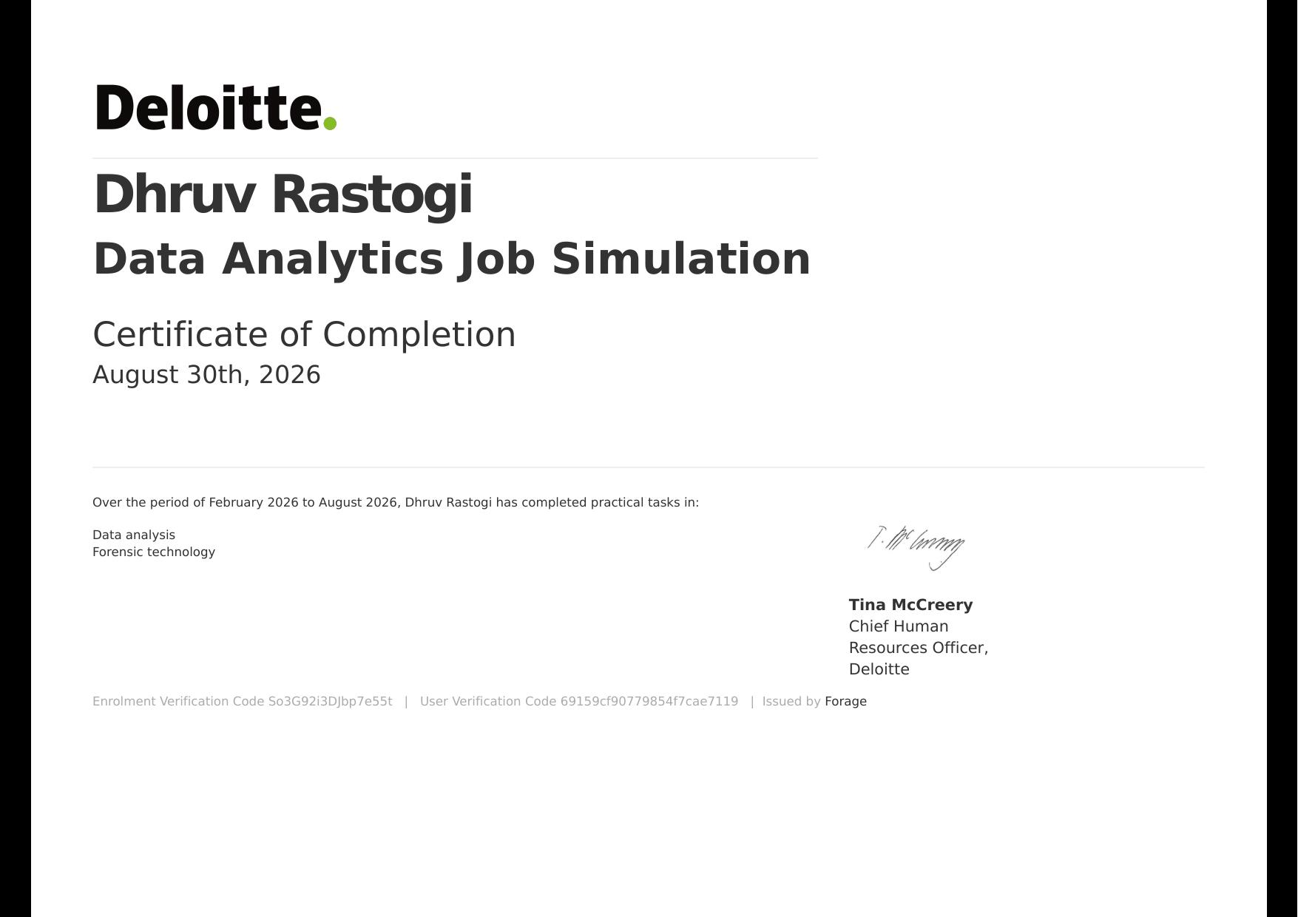

4. Project Description
4.1 Introduction
As part of the Data Analytics Job Simulation offered by Deloitte through the Forage virtual experience platform, I undertook a project designed to replicate the real-world responsibilities of a junior data analyst working with the Forensic Technology team at Deloitte. This self-paced, industry-designed simulation provided hands-on exposure to the tools, techniques, and thought processes used by data analytics professionals in a consulting environment. The internship required working with a fictional client, Daikibo Industrials, a manufacturing company facing operational and workforce-related challenges, and applying analytical methods to derive actionable business insights from raw data.
4.2 Organization Profile
Deloitte is one of the world's largest professional services networks, providing audit, consulting, financial advisory, risk advisory, tax, and forensic technology services to clients across the globe. As part of its efforts to widen access to career-building opportunities, Deloitte partners with Forage to offer free, self-paced virtual job simulations that mirror the real tasks performed by its professionals. Through this simulation, participants are given the opportunity to engage with a scenario modeled on Deloitte's Forensic Technology practice, gaining insight into how the firm approaches data-driven problem solving for its clients.
4.3 Problem Statement
The fictional client, Daikibo Industrials, operates four manufacturing factories and was facing two key challenges. First, machine telemetry data collected from sensors across the factories indicated recurring downtime, but the company lacked a clear, consolidated view of which factories and device types were most affected, making it difficult to prioritize maintenance and reduce operational losses. Second, the company needed an internal audit of its payroll data to assess whether pay was being distributed equitably across gender lines, in order to identify potential compliance risks and support fair workplace practices. Both problems required structured data cleaning, analysis, and clear visual communication of findings to non-technical stakeholders.
4.4 Project Objectives
- Analyze machine telemetry data from four global factories to identify patterns of downtime by factory and device type.
- Design and build an interactive Tableau dashboard to visualize downtime trends for business stakeholders.
- Clean and process raw payroll data using Microsoft Excel to prepare it for equity analysis.
- Apply logical functions to classify employee pay data and evaluate gender pay equity across the organization.
- Translate technical findings into clear, actionable recommendations for a non-technical audience.
4.5 Scope of the Project
The scope of this project was limited to the two structured tasks defined within the Deloitte Data Analytics Job Simulation on Forage. It covered the analysis of a provided telemetry dataset (in JSON format) using Tableau to build a downtime dashboard, and the analysis of a provided payroll dataset using Excel to assess pay equity. The project did not involve live client interaction, real company data, or deployment of the analysis into a production system; it was a guided, simulation-based exercise intended for skill-building rather than an operational business engagement.
4.6 Technologies and Tools Used
- Tableau Public/Desktop — for building interactive dashboards and visualizing telemetry and downtime data.
- Microsoft Excel — for data cleaning, logical/conditional functions, and pay equity classification.
- JSON data format — for the raw machine telemetry dataset provided by the simulation.
- Forage virtual experience platform — for task guidance, resources, and feedback.
4.7 System Architecture
The project followed a simple, linear data-analytics workflow rather than a software system architecture, since the deliverables were dashboards and spreadsheets rather than a deployed application. The workflow proceeded as follows:
- Raw Data Sources: Machine telemetry data (JSON) from four factories and employee payroll data (Excel).
- Data Import & Cleaning: Telemetry data imported into Tableau; payroll data cleaned and structured in Excel.
- Processing Layer: Calculated fields in Tableau to flag "unhealthy" machine status; logical/IF-based formulas in Excel to classify pay bands.
- Visualization & Output: Interactive Tableau dashboard (factory/device-type downtime views) and an Excel-based pay equity summary.
- Insight Delivery: Findings summarized into business-friendly recommendations for the fictional Deloitte client.
4.8 Methodology
The project was carried out in two structured phases, following pre-recorded guidance and example deliverables provided by Deloitte's team through Forage.
Phase 1 – Telemetry & Dashboard Design: The raw machine telemetry JSON file was imported into Tableau. A calculated field was created to quantify downtime by converting each "Unhealthy" status reading into a fixed time value. Factory and Device Type were used as dimensions, with downtime aggregated as SUM, and the resulting bar charts were sorted in descending order to highlight the worst-performing factories and devices. These views were combined into a single interactive dashboard with filters for factory-level comparison.
Phase 2 – Payroll Data Cleaning & Equity Analysis: The payroll dataset was cleaned in Excel to remove inconsistencies and standardize formatting. Logical functions (such as IF-based classification) were applied to categorize employees into pay bands and compare compensation distribution across genders, in order to flag any patterns suggestive of inequitable pay practices.
Throughout both phases, outputs were checked against Deloitte's example solutions provided in the simulation to validate the approach before finalizing the deliverables.
4.9 Expected Outcomes
- A functional, interactive Tableau dashboard clearly identifying which factories and device types experience the most downtime.
- Actionable maintenance-prioritization insight for Daikibo Industrials based on the downtime analysis.
- A cleaned, well-structured payroll dataset with a clear pay-band classification model in Excel.
- An evidence-based assessment of gender pay equity, along with recommendations to address any disparities found.
- Strengthened practical skills in data cleaning, Tableau dashboard design, Excel logical functions, and business communication of analytical findings.
4.10 Certificates of Completion and Communication Proof
A copy of the Forage completion certificate for the Deloitte Data Analytics Job Simulation is attached in Chapter 3 of this report.

5. Bibliography/References
1. Deloitte Data Analytics Job Simulation — Forage, https://www.theforage.com/
2. Tableau Public/Desktop Documentation — https://help.tableau.com/
3. Microsoft Excel Support Documentation — https://support.microsoft.com/excel
4. Deloitte Official Website — https://www2.deloitte.com/

