**LAB 3 Report**

**Name: Dhruv Sandesara**

**UT EID:djs3967**

**Section: 15295 (Lab Wednesday 12-1)**

**Checklist:**

**Part 2 -**

1. Constraint File (Just the uncommented portion)

set_property PACKAGE_PIN U16 [get_ports {d0}]

set_property IOSTANDARD LVCMOS33 [get_ports {d0}]

set_property PACKAGE_PIN E19 [get_ports {d1}]

set_property IOSTANDARD LVCMOS33 [get_ports {d1}]

set_property PACKAGE_PIN U19 [get_ports {d2}]

set_property IOSTANDARD LVCMOS33 [get_ports {d2}]

set_property PACKAGE_PIN V19 [get_ports {d3}]

set_property IOSTANDARD LVCMOS33 [get_ports {d3}]

set_property PACKAGE_PIN W18 [get_ports {d4}]

set_property IOSTANDARD LVCMOS33 [get_ports {d4}]

set_property PACKAGE_PIN U15 [get_ports {d5}]

set_property IOSTANDARD LVCMOS33 [get_ports {d5}]

set_property PACKAGE_PIN U14 [get_ports {d6}]

set_property IOSTANDARD LVCMOS33 [get_ports {d6}]

set_property PACKAGE_PIN V14 [get_ports {d7}]

set_property IOSTANDARD LVCMOS33 [get_ports {d7}]

set_property PACKAGE_PIN V17 [get_ports {c}]

set_property IOSTANDARD LVCMOS33 [get_ports {c}]

set_property PACKAGE_PIN V16 [get_ports {b}]

set_property IOSTANDARD LVCMOS33 [get_ports {b}]

set_property PACKAGE_PIN W16 [get_ports {a}]

set_property IOSTANDARD LVCMOS33 [get_ports {a}]

set_property PACKAGE_PIN W13 [get_ports {e}]

set_property IOSTANDARD LVCMOS33 [get_ports {e}]

**Part 3 -**

1. Truth Table of the function
2. K-maps showing minimization of the logic functions (outputs)
3. Algebraic expression of the minimized logic functions (outputs)

ALL 3 PARTS COMBINED

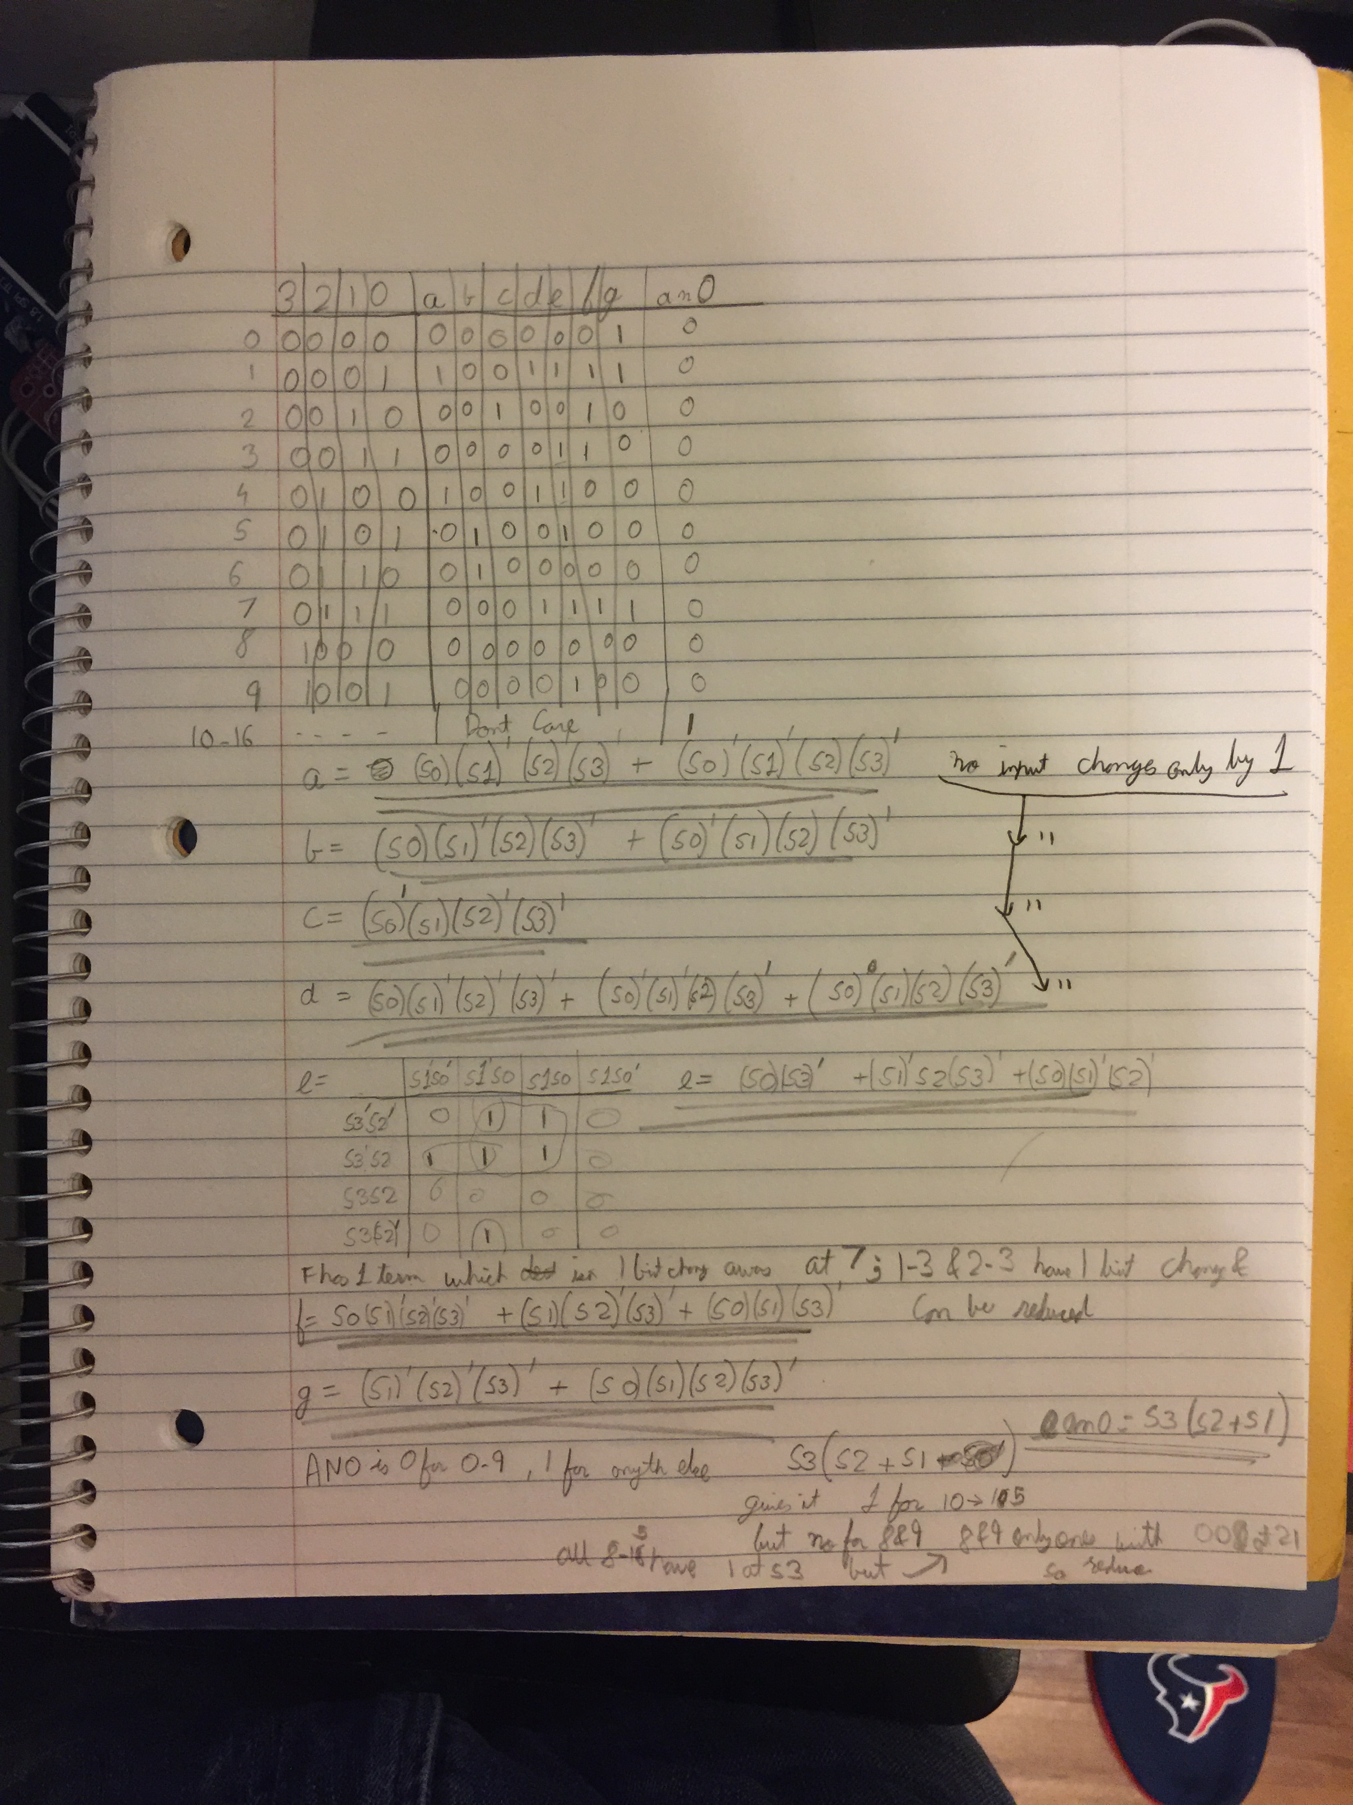

1. Verilog codes of module and testbench for structural modelling

`timescale 1ns / 1ps

//////////////////////////////////////////////////////////////////////////////////

// Company:

// Engineer:

//

// Create Date: 02/23/2018 02:03:48 PM

// Design Name:

// Module Name: BCD

// Project Name:

// Target Devices:

// Tool Versions:

// Description:

//

// Dependencies:

//

// Revision:

// Revision 0.01 - File Created

// Additional Comments:

//

//////////////////////////////////////////////////////////////////////////////////

module BCD(

input s0,

input s1,

input s2,

input s3,

output a,

output b,

output c,

output d,

output e,

output f,

output g,

output an0,

output an1,

output an2,

output an3 );

wire s0_not, s1_not,s2_not,s3_not,a0,a1,b0,b1,d0,d1,d2,e0,e1,e2,f0,f1,f2,g00,g01,an00;

not n0(s0_not,s0);

not n1(s1_not,s1);

not n2(s2_not,s2);

not n3(s3_not,s3);

and g1(a0,s0,s1_not,s2_not,s3_not);

and g2(a1,s0_not,s1_not,s2,s3_not);

or o1(a,a0,a1);

and g3(b0,s0,s1_not,s2,s3_not);

and g4(b1,s0_not,s1,s2,s3_not);

or o2(b,b0,b1);

and(c,s0_not,s1,s2_not,s3_not);

and g5(d0,s0,s1_not,s2_not,s3_not);

and g6(d1,s0_not,s1_not,s2,s3_not);

and g7(d2,s0,s1,s2,s3_not);

or o3(d,d0,d1,d2);

and g8(e0,s0,s3_not);

and g9(e1,s1_not,s2,s3_not);

and g10(e2,s0,s1_not,s2_not);

or o4(e,e0,e1,e2);

and g11(f0,s0,s1_not,s2_not,s3_not);

and g12(f1,s1,s2_not,s3_not);

and g13(f2,s0,s1,s3_not);

or o5(f,f0,f1,f2);

and g14(g00,s1_not,s2_not,s3_not);

and g15(g01,s0,s1,s2,s3_not);

or o6(g,g00,g01);

or o7(an00,s2,s1);

and g16(an0,s3,an00);

or g17(an1, 1, 1);

or g18(an2, 1, 1);

or g19(an3, 1, 1);

Endmodule

`timescale 1ns / 1ps

//////////////////////////////////////////////////////////////////////////////////

// Company:

// Engineer:

//

// Create Date: 02/23/2018 02:36:04 PM

// Design Name:

// Module Name: tb_BCD

// Project Name:

// Target Devices:

// Tool Versions:

// Description:

//

// Dependencies:

//

// Revision:

// Revision 0.01 - File Created

// Additional Comments:

//

//////////////////////////////////////////////////////////////////////////////////

module tb_BCD;

reg s0;

reg s1;

reg s2;

reg s3;

wire a;

wire b;

wire c;

wire d;

wire e;

wire f;

wire g;

wire an0;

BCD uut(

.s0(s0),

.s1(s1),

.s2(s2),

.s3(s3),

.a(a),

.b(b),

.c(c),

.d(d),

.e(e),

.f(f),

.g(g),

.an0(an0),

.an1(an1),

.an2(an2),

.an3(an3),

);

initial begin

s0=0;

s1=0;

s2=0;

s3=0;

#50;

$display("TC00");

if((a!=0)||(b!=0)||(c!=0)||(d!=0)||(e!=0)||(f!=0)||(g!=1)||(an0!=0))$display("Test failed");

s0=1;

s1=0;

s2=0;

s3=0;

#50;

$display("TC01");

if((a!=1)||(b!=0)||(c!=0)||(d!=1)||(e!=1)||(f!=1)||(g!=1)||(an0!=0))$display("Test failed");

s0=0;

s1=1;

s2=0;

s3=0;

#50;

$display("TC02");

if((a!=0)||(b!=0)||(c!=1)||(d!=0)||(e!=0)||(f!=1)||(g!=0)||(an0!=0))$display("Test failed");

s0=1;

s1=1;

s2=0;

s3=0;

#50;

$display("TC03");

if((a!=0)||(b!=0)||(c!=0)||(d!=0)||(e!=1)||(f!=1)||(g!=0)||(an0!=0))$display("Test failed");

s0=0;

s1=0;

s2=1;

s3=0;

#50;

$display("TC04");

if((a!=1)||(b!=0)||(c!=0)||(d!=1)||(e!=1)||(f!=0)||(g!=0)||(an0!=0))$display("Test failed");

s0=1;

s1=0;

s2=1;

s3=0;

#50;

$display("TC05");

if((a!=0)||(b!=1)||(c!=0)||(d!=0)||(e!=1)||(f!=0)||(g!=0)||(an0!=0))$display("Test failed");

s0=0;

s1=1;

s2=1;

s3=0;

#50;

$display("TC05");

if((a!=0)||(b!=1)||(c!=0)||(d!=0)||(e!=0)||(f!=0)||(g!=0)||(an0!=0))$display("Test failed");

s0=1;

s1=1;

s2=1;

s3=0;

#50;

$display("TC07");

if((a!=0)||(b!=0)||(c!=0)||(d!=1)||(e!=1)||(f!=1)||(g!=1)||(an0!=0))$display("Test failed");

s0=0;

s1=0;

s2=0;

s3=1;

#50;

$display("TC08");

if((a!=0)||(b!=0)||(c!=0)||(d!=0)||(e!=0)||(f!=0)||(g!=0)||(an0!=0))$display("Test failed");

s0=1;

s1=0;

s2=0;

s3=1;

#50;

$display("TC09");

if((a!=0)||(b!=0)||(c!=0)||(d!=0)||(e!=1)||(f!=0)||(g!=0)||(an0!=0))$display("Test failed");

s0=0;

s1=1;

s2=0;

s3=1;

#50;

$display("TC10");

if((an0!=1))$display("Test failed");

s0=1;

s1=1;

s2=0;

s3=1;

#50;

$display("TC11");

if((an0!=1))$display("Test failed");

s0=0;

s1=0;

s2=1;

s3=1;

#50;

$display("TC12");

if((an0!=1))$display("Test failed");

s0=1;

s1=0;

s2=1;

s3=1;

#50;

$display("TC13");

if((an0!=1))$display("Test failed");

s0=0;

s1=1;

s2=1;

s3=1;

#50;

$display("TC14");

if((an0!=1))$display("Test failed");

s0=1;

s1=1;

s2=1;

s3=1;

#50;

$display("TC15");

if((an0!=1))$display("Test failed");

end

endmodule

1. 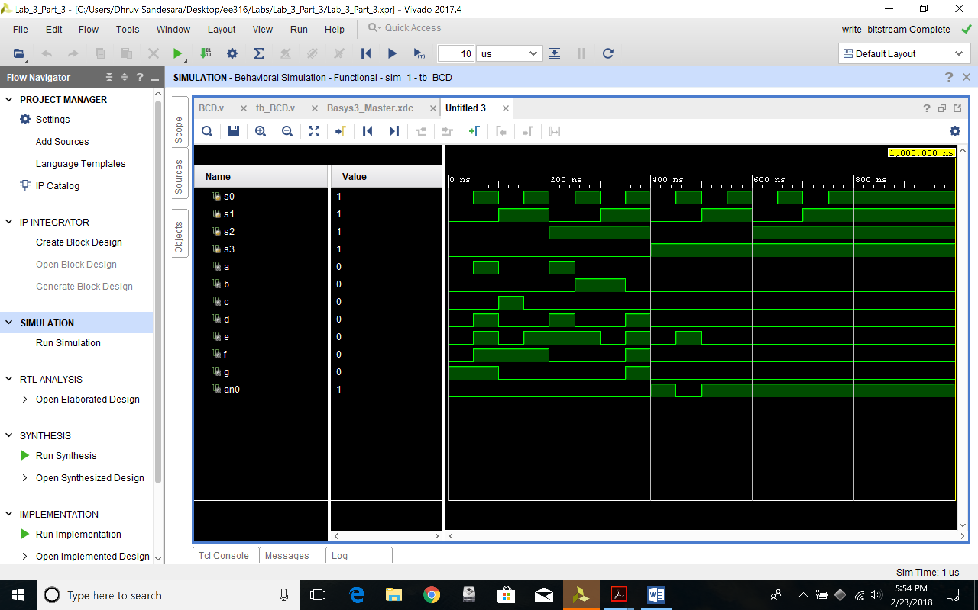Simulation waveform for structural modelling
2. Constraint File (Just the uncommented portion)

set_property PACKAGE_PIN V17 [get_ports {s0}]

set_property IOSTANDARD LVCMOS33 [get_ports {s0}]

set_property PACKAGE_PIN V16 [get_ports {s1}]

set_property IOSTANDARD LVCMOS33 [get_ports {s1}]

set_property PACKAGE_PIN W16 [get_ports {s2}]

set_property IOSTANDARD LVCMOS33 [get_ports {s2}]

set_property PACKAGE_PIN W17 [get_ports {s3}]

set_property IOSTANDARD LVCMOS33 [get_ports {s3}]

set_property PACKAGE_PIN W7 [get_ports {a}]

set_property IOSTANDARD LVCMOS33 [get_ports {a}]

set_property PACKAGE_PIN W6 [get_ports {b}]

set_property IOSTANDARD LVCMOS33 [get_ports {b}]

set_property PACKAGE_PIN U8 [get_ports {c}]

set_property IOSTANDARD LVCMOS33 [get_ports {c}]

set_property PACKAGE_PIN V8 [get_ports {d}]

set_property IOSTANDARD LVCMOS33 [get_ports {d}]

set_property PACKAGE_PIN U5 [get_ports {e}]

set_property IOSTANDARD LVCMOS33 [get_ports {e}]

set_property PACKAGE_PIN V5 [get_ports {f}]

set_property IOSTANDARD LVCMOS33 [get_ports {f}]

set_property PACKAGE_PIN U7 [get_ports {g}]

set_property IOSTANDARD LVCMOS33 [get_ports {g}]

set_property PACKAGE_PIN U2 [get_ports {an0}]

set_property IOSTANDARD LVCMOS33 [get_ports {an0}]

set_property PACKAGE_PIN U4 [get_ports {an1}]

set_property IOSTANDARD LVCMOS33 [get_ports {an1}]

set_property PACKAGE_PIN V4 [get_ports {an2}]

set_property IOSTANDARD LVCMOS33 [get_ports {an2}]

set_property PACKAGE_PIN W4 [get_ports {an3}]

set_property IOSTANDARD LVCMOS33 [get_ports {an3}]