# Lab 11 Final Embedded System Deliverables

Dhruv Sandesara

Sean Tremblay

**Deliverables (exact components of the lab report)**

**A) Objectives**

**2-page requirements document:**

1. Overview

1.1. Objectives: Why are we doing this project? What is the purpose?

The objectives of this project are to design, build and test an EKG Circuit . The EKG should give a steady heart rate. Educationally, we are learning how to develop our own project and all that is entailed. As a bonus to our own project we will include an accelerometer as a sort of pacemaker addition to our EKG.

1.2. Process: How will the project be developed?

The project will be developed using the LaunchPad. There will be switches that dictate what information the display is giving you. The system will be built on a solderless breadboard and run on the usual USB power. The system may use the on board switches or off-board switches. There will be at least five hardware/software modules: switches, Filters, LCD, EKG, Accelerometer. The process will be to design and test each module independently from the other modules. After each module is tested, the system will be built and tested.

1.3. Roles and Responsibilities: Who will do what? Who are the clients?

EE445L students are the engineers and the TA is the client.. Both students will work on the controller.

1.4. Interactions with Existing Systems: How will it fit in?

The system will use the microcontroller board, a soldered PCB, and the DC motor shown in Figure 10.1.

**2.1.** Functionality**:** The electrocardiogram (ECG or EKG) is a diagnostic tool that is routinely used to assess the electrical and muscular functions of the heart. The heart's electrical activity can be measured by electrodes placed on the skin. The electrocardiogram can measure the rate and rhythm of the heartbeat. An electrode lead, or patch, is placed on each arm and leg and six are placed across the chest wall. The signals received from each electrode are recorded. The printed view of these recordings is the electrocardiogram. An electrode lead, or patch, is placed on each arm and leg and six are placed across the chest wall. The signals received from each electrode are then recorded and displayed.

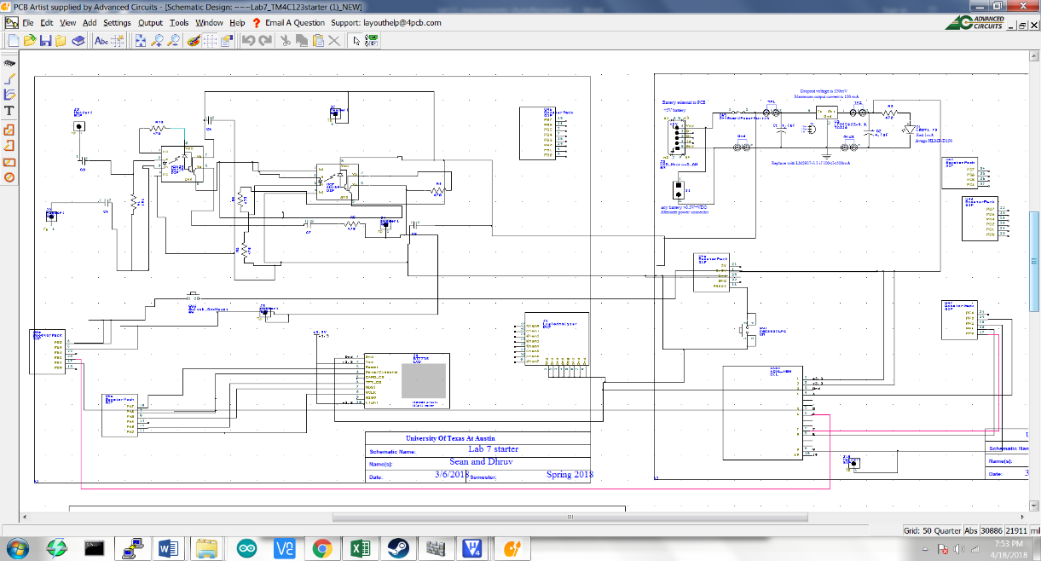

Figure 1

**2.4.** Performance**:** In general, components of the signal of interest will reside in the 0.67 to 40-Hz bandwidth for standard ECGs and up to 300 Hz to 1 kHz for pacemaker detection. We choose a AD623 instrumentation amplifier to amplify the ECG voltage from electrodes, which is in the range of several mV. This amplifier will amplify the signal voltage up to a 1000x multiplier. This ECG will be measured on our software where we will output a graph of the outputs, similar to an oscilloscope. As a noise reduction tool, we will have two capacitors corrected directly to the input of our EKG.

**2.5.** Usability**:** We will interface an electrode lead to our TM4C123 through an op amp. The input will be determined after having applied a voltage gain to the signal with an MCP6002 operational amplifier. This will act as a highpass filter should our

77r gain from the AD623 have caused unstable behavior. From here, our output, Vin, should be sampled by our ADC. The other circuit elements and their values can be seen in Figure 1.

3. Deliverables

3.1. Reports: How will the system be described?

A lab report described below is due by the due date listed in the syllabus. This report includes the final requirements document.

3.2. Audits: How will the clients evaluate progress?

The preparation is due at the beginning of the lab period on the date listed in the syllabus.

3.3. Outcomes: What are the deliverables? How do we know when it is done?

There are three deliverables: preparation, demonstration, and report. Also, there will be a lab showcase to three judges.

**B) Hardware Design**

**Detailed circuit diagram of the system (from Lab 7):**

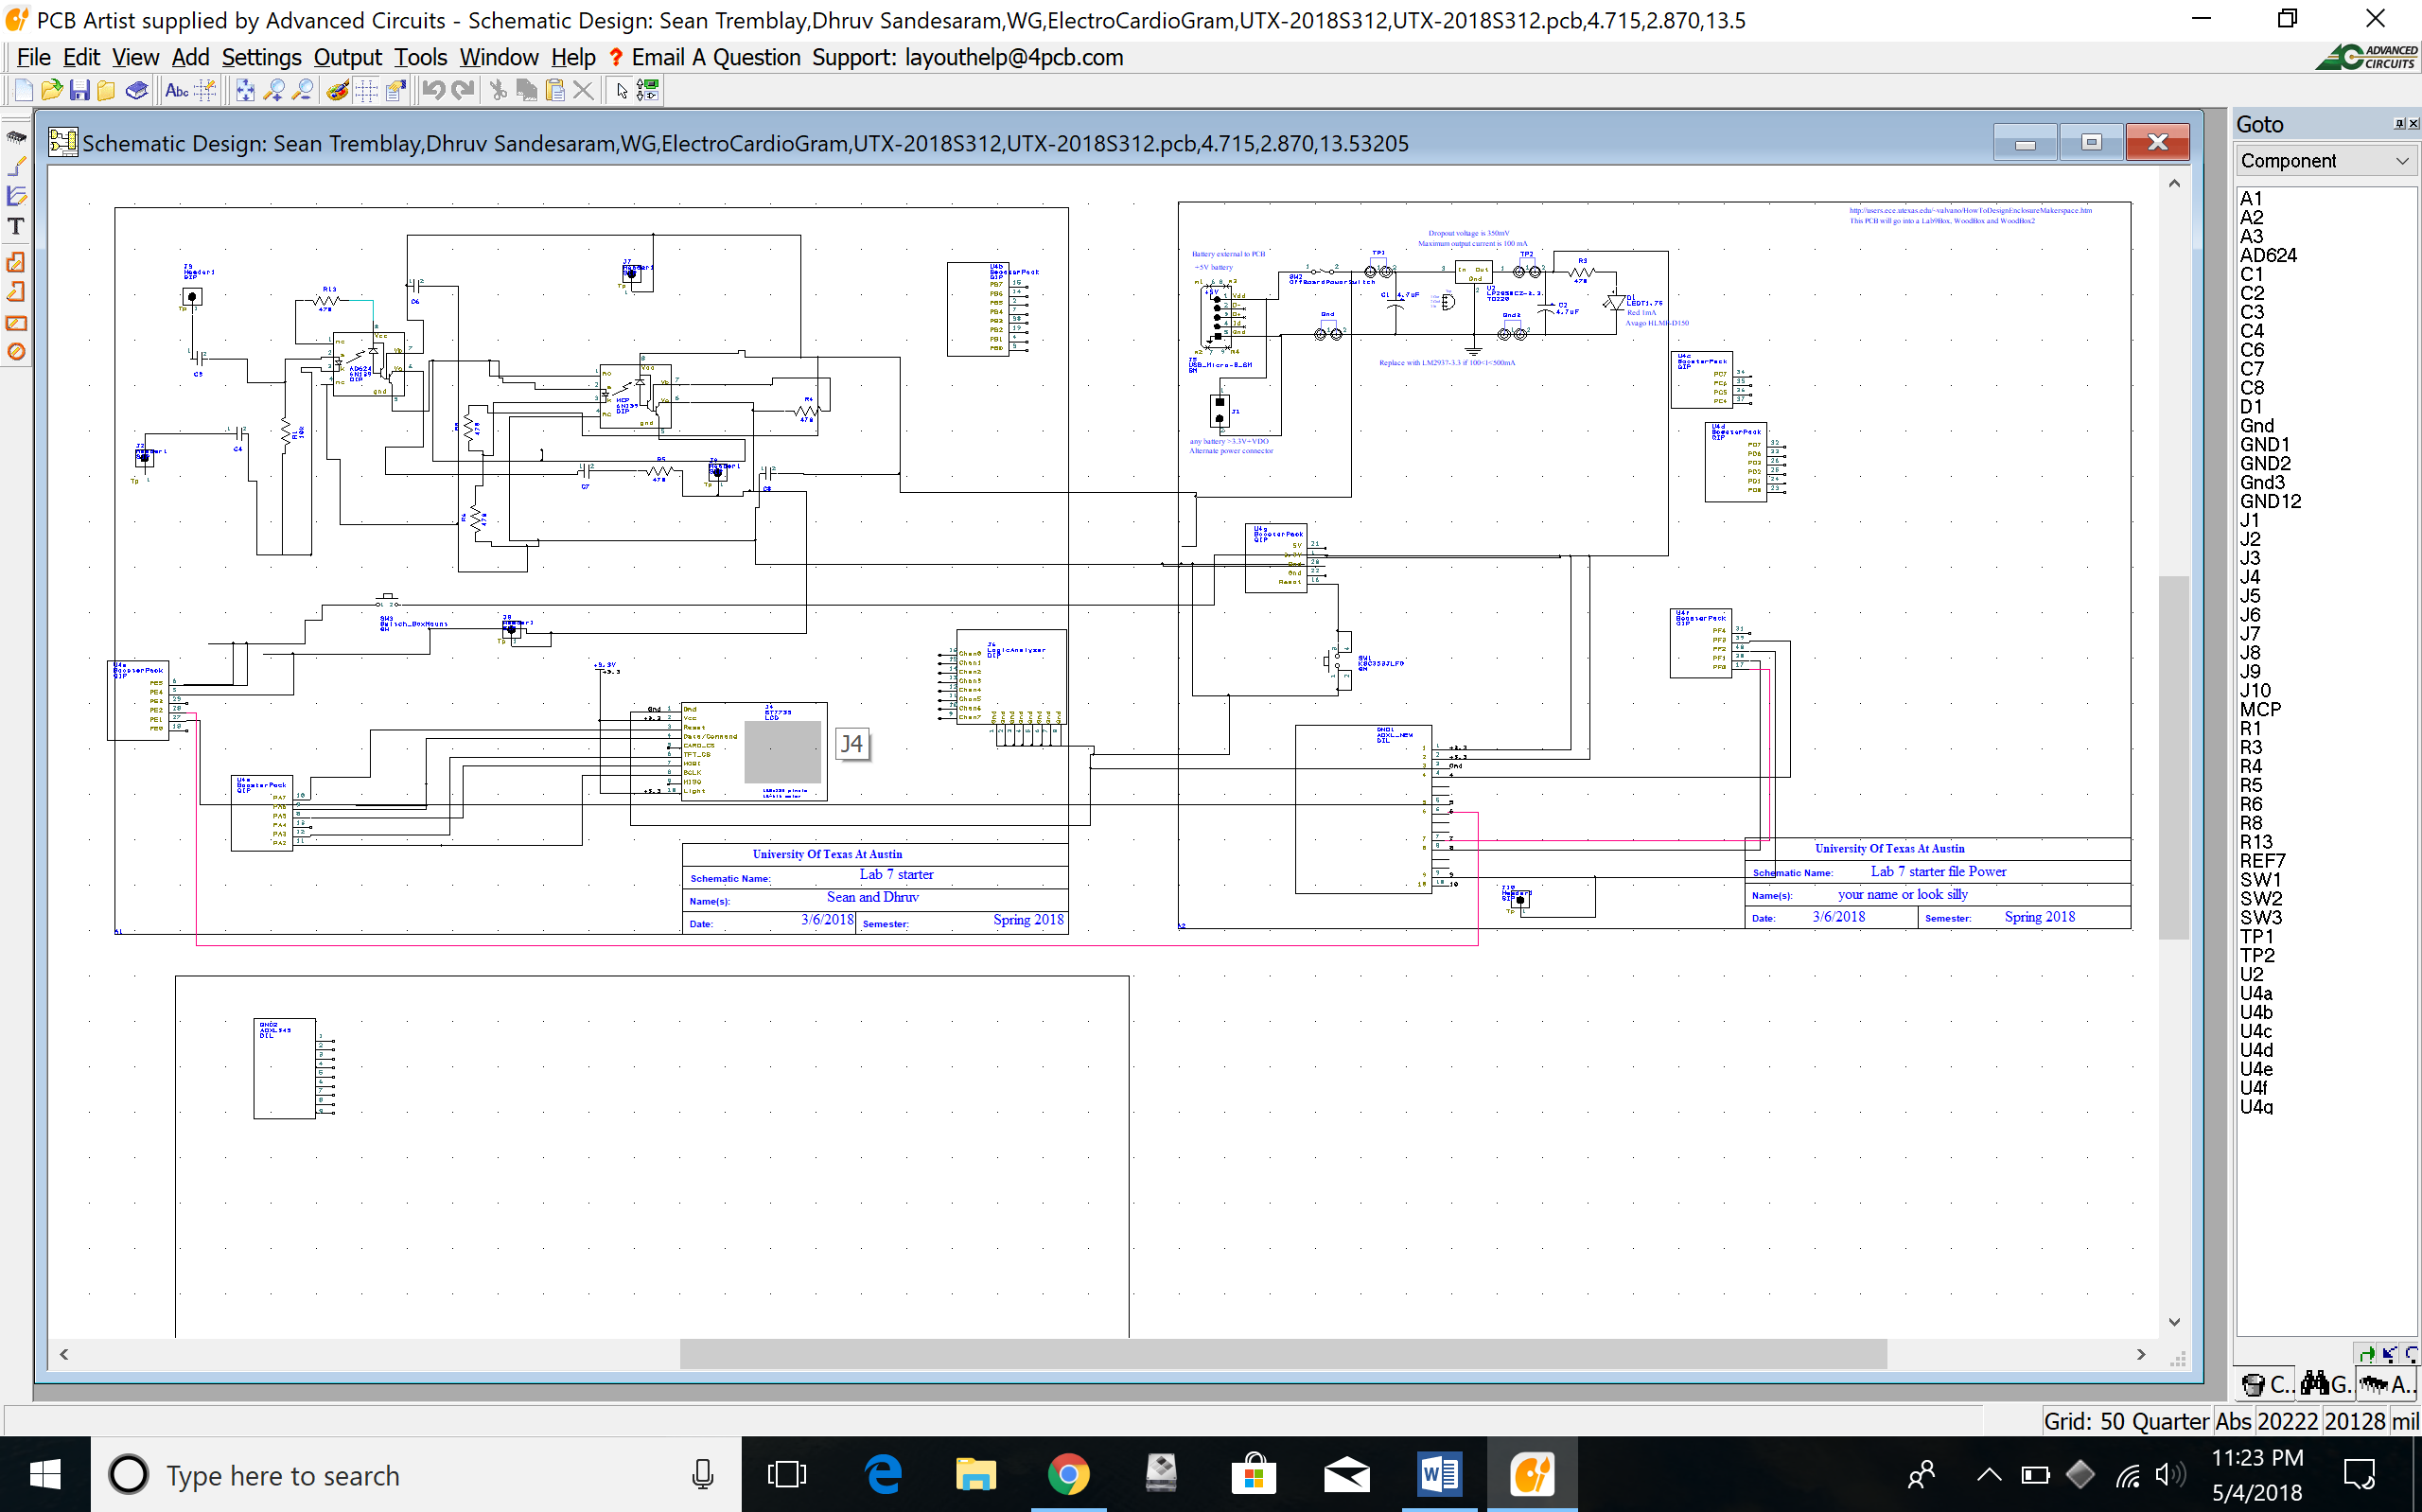Screenshot attatched above and uploaded on github as sch and pdf under the folder named lab7 report in lab 11 github

**C) Software Design (no software printout in the report)**

**Briefly explain how your software works (1/2 page maximum)**

Our software has a main function that is there for mainly initialization purposes. It initialized the LCD that we use and the Port F buttons and LEDS’s that we use. Next it reuses the code that we use for the thermistor lab for the edge triggered sampling and does x16 averaging on the adc value. The input for the adc port is the output from the circuit that we created to detect heartrate from the electrodes on the body. Then finally, it goes on to the adc value display function. Over here we store all the adc values that we have gotten in a FIFO and keep checking if the fifo is empty or not. If it is not empty then we draw a line from the previous ADC value to the next ADC value scaled to our display to give us a graph of the hear activity. After this we do post processing on the array of the fifo which contained all the previous adc values. We then run our algorithm to detect large changing in the heart activity detector and if it meets the general heart beat values then we increment the hear beats count. Next every time a hear beat is detected we check how much time had passed from the previous detected hear beat and then we extrapolate the period to figure out how much BPM we have detected. And then we display all these values on the top left of the display. Finally we have a pause and play button that we have hook up to the PORT F switches that lets us pause the EKG’s running and allows us to zoom in on the last heart beat that we had detected so medical professionals can take a closer look at it. On pressing the button again, normal ekg runs again.

**D) Measurement Data**

**Include data as appropriate for your system. Explain how the data was collected.**

Record the current required to run just the processor: 0.314 mA(with the display attached on top)

Record the current required to run the entire PCB: 0.691 mA(with electrodes connected)

ADC values on the MCP when electrodes not connected. Flat 3139= 2.52V

Values on the display whith electrodes connected: Analog waveform showing EKG values that is on average on the Voltmeter as 2.51V.

Volts out from instrumentation Amp is: 2.25V

V ref made with voltage divider circuit: 1.6V

Pin 8 on the Insttumentation amp(ADC623): 4.12

Pin 1 is 2.52

Pin 2 is analog average voltage is 329 mV to – 1.1V

Pin 3 172 mv

Pin 6 is 1.68V

Pin 7 is 5.02 V

All other pins are power related.

**E) Analysis and Discussion (none). The YouTube video is required**

Attatched below:

**Report (20):**

**F)Testing procedure and testing data (10)**

Our design requires that a voltage signal be acquired from the changing electric potential of the human skin. This means that many of our tests had to be conducted using live tests, where connecting to various parts of the body and grounding in different spots: like the ankle or the chest, gave different results. Ultimately, we concluded through monitoring the response on our LCD, that our best input locations were on the thumbs.

Similarly, to test the preliminary success of our project, we needed to verify that our voltages were in an appropriate range. Therefore, we used the test pins on our PCB and Voltmeter tests to verify that our Op-Amps were outputting a proper and stable voltage. This meant attaching the voltmeter probes either to empty pin holes on our breadboard or to wires on our breadboard. This allowed us to gauge how effectively our circuitry was built, and if we had incorrectly placed any parts or wires.

Finally, we used our Keil Debugger as a means to check whether our GPIO pins were effectively being written to and/or receiving data correctly. We often ran into cases where simple initializations would freeze our entire system. Therefore, having this tool at our disposal helped to reduce the time spent debugging these issues.

Also for our testing data, we calibrated the heartrate retection and the actual heartrate that we detected with a firbit and we had our results within +/- 4.3%.

**G)YouTube video (10):**

<https://youtu.be/kfuPX8SgTAk>