EE445L Lab 3 Report

Dhruv Sandesara

Sean Tremblay

A) Objectives

The objectives of this project are to design, build and test an alarm clock. Educationally, students are learning how to design and test modular software and how to perform switch/keypad input in the background.

B) Hardware Design 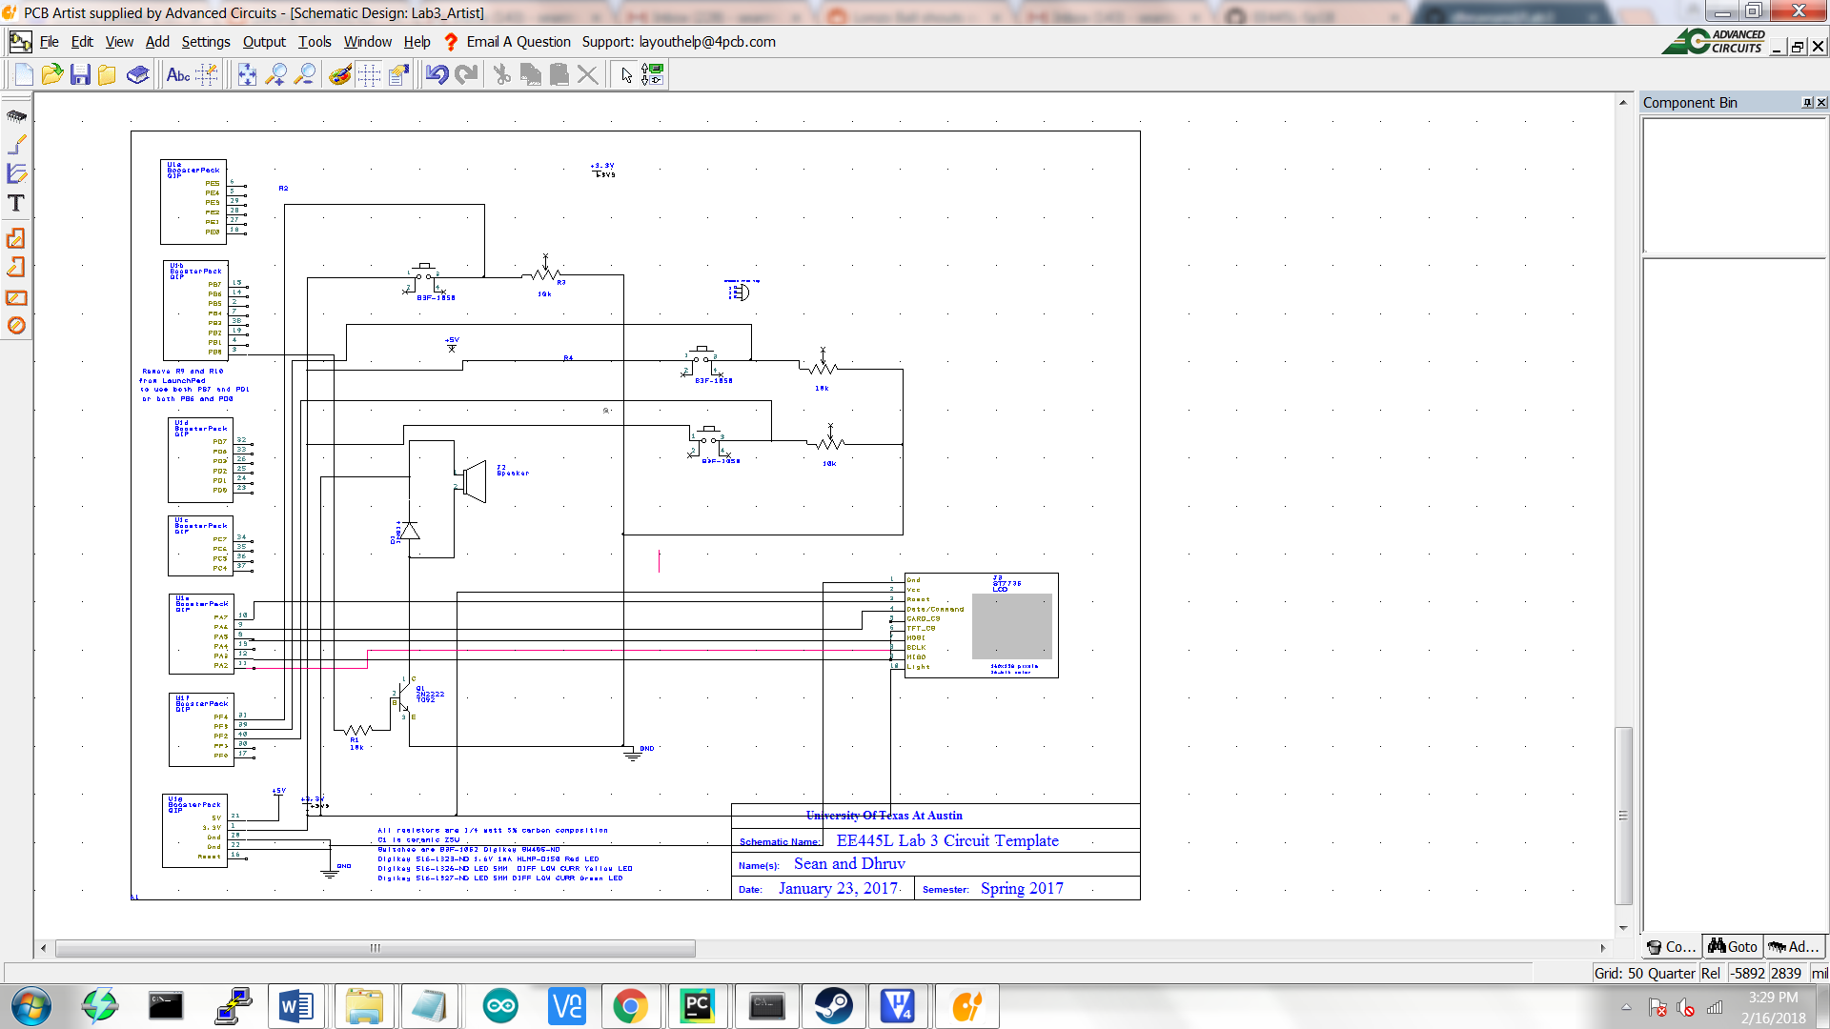

C) Software Design (upload your files as instructed by your TA)

Files uploaded onto Github: Classroom. We have organized our software the same as the example and has the same call graph

D) Measurement Data

1. Plot the +5 and +3.3 supply voltages versus time and record the rms magnitudes

a) 5 Volt power supply

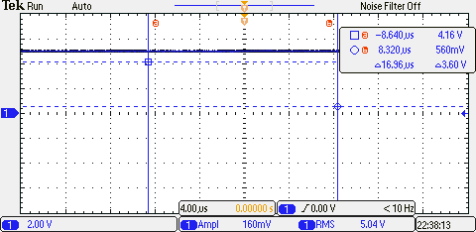

b) 3.3 Volt power supply

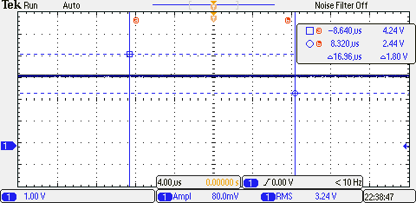

2. Plot the speaker voltage (or output voltage) versus time during an alarm sound

a)PWM output on PB3(Speaker on)

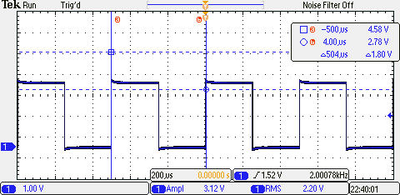

b) Speaker Voltage values

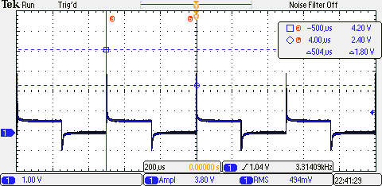

3. Measurements of current required to run the alarm clock, with and without the alarm

a)Without alarm: 5v **71mA**

**b)**With Alarm : 5v **83mA**

E) Analysis and Discussion (give short 1 or two sentence answers to these questions)

1) Give two ways to remove a critical section.

Answer:

Two general ways to remove a critical section are:

1. To disable interrupts and reenable after the critical code is finished.
2. Use two variables called lock and key. The intuition if lock is false, then a process can enter the critical section, and otherwise it can't

initially, lock is false.

2) How long does it take to update the LCD with a new time?

Answer: We took multiple trials of how long it takes for the screen to update and we found on average it takes **62.97352 ms** to update the screen.

3) What would be the disadvantage of updating the LCD in the background ISR?

It would take too much time, and ISR’s are supposed to be relatively fast so that we can get back to lower priority tasks

4) Did you redraw the entire clock for each output? If so, how could you have redesigned the LCD update to run much faster, and create a lot less flicker?

We did, but the means of removing this concern would be to draw a white line (Our background was white, and our line black) where the previous line was, as well as a new black line at the new location.

5) Assuming the system were battery powered, list three ways you could have saved power.

i) We could lower the bus frequency that we are running slower, but we would need to update our timers accordingly with this change.

ii) We can activate the sleep mode on the Stellaris for when the system is not running intricate activities. Like rewriting the screen or sounding the alarm.

1. Another method we could use is to shut off pins that are not immediately being used. This could include pins that change the screen and sound.