Flaky Test Detection and Automatic Quarantine in a Containerized CI Pipeline Using Repeated Runs, Pytest and GitHub Actions

Title page
Course | DevOps (216U01E744), Semester VII
Activity | LAB CA Activity 2: Mini project
Institution | KJSCE
Team members and roll numbers | Dhruv Saraf (16010123111), Smit Zawar (16010123063), Shashwat Shukla (16010123829)
Repository | https://github.com/dhruvsaraf05/DevOps-LABCA
Live application | https://quarantine-flaky-ci.vercel.app

1. Abstract
Flaky tests pass and fail on the same code. They make continuous integration (CI) untrustworthy, because teams learn to re-run failed builds until they turn green and real failures get ignored. This project builds a CI/CD pipeline for a containerized FastAPI service that makes flakiness visible and keeps it from blocking releases. The pipeline runs the pytest suite ten times in parallel Docker containers on GitHub Actions, classifies each test as stable, flaky or broken from the JUnit results, records flaky tests in a quarantine.json file through an automatically opened pull request, and blocks the build only when a non-quarantined test fails in every run. Code that passes the gate is released: the runtime image is pushed to GitHub Container Registry (GHCR), the same commit is deployed to Vercel with the Vercel CLI, and a smoke test checks that the live /version endpoint returns the exact commit SHA. The whole system uses free tiers only.

2. Introduction and problem statement
A test is flaky when it gives different results for the same code. Common causes are non-determinism (random values, unreliable network calls), timing and race conditions, and shared state that depends on test order. A single flaky test is enough to turn a trusted CI signal into noise.
The usual reaction is an automatic retry. Retrying has two costs: it hides the flakiness, so nobody fixes it, and it makes every build slower for as long as the test exists. The alternative studied here is to detect flakiness by repetition, quarantine the flaky test so it stops blocking the build, keep it visible in every report, and still block on tests that are genuinely broken.
Problem statement. Design and implement a containerized CI/CD pipeline that detects flaky tests automatically, quarantines them through a reviewable change, blocks only on real failures, and releases only code that passed that gate.

3. Objectives
- Build a small containerized web service with an automated test suite.
- Seed the suite with flaky tests that represent real flakiness categories.
- Write a detector that classifies tests from repeated runs, using only the Python standard library.
- Run the suite ten times in parallel containers in CI and apply a gate: block on broken tests, never on flaky ones.
- Persist the quarantine through an automatically opened pull request.
- Release only gated code: image to GHCR, deployment to Vercel, smoke test of the live version.
- Demonstrate the behaviour with four scenarios (before, detection, real bug, delivery).
- Stay within free tiers.

4. Background
Flaky tests. Luo et al. studied flaky-test fixes in open-source projects and grouped root causes into categories such as asynchronous waiting, concurrency and test-order dependency [1]. Google reported that a non-trivial share of its test failures came from flaky tests and described mitigation through reruns and tracking [2]. Fowler describes non-determinism in tests as a problem that erodes trust in a suite and recommends quarantining non-deterministic tests [3].
Quarantine versus retry.
 | Automatic retry | Quarantine (this project)
Flakiness visible? | No, the build just goes green | Yes, listed in every report
Build time | Slower on every flaky failure | Unaffected
Does it block on real bugs? | Only if the bug fails every retry | Yes, a test failing every run blocks
Follow-up | Easy to forget | A pull request records it for review
Risk | Hides regressions that fail intermittently | A quarantined test can hide a real bug, so it stays listed and runs every time
Test-order shuffling. pytest-randomly shuffles the order of tests on every run. A test that secretly depends on state left by another test then passes or fails depending on the order, which exposes the dependency.

5. System architecture
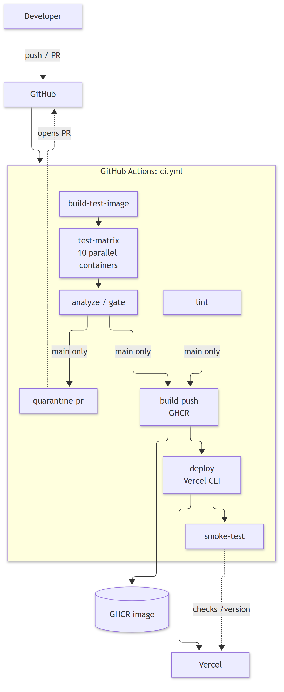
The pull-request path runs lint, build-test-image, test-matrix and analyze. The release path (quarantine-pr, build-push, deploy, smoke-test) runs only on push to main, after the gate. A manual workflow, naive-ci.yml, runs pytest once with no detector and is used only to show the "before" state. More diagrams are in architecture.md.
Where Docker and Vercel fit. Docker is the test environment (all ten matrix runs use the same image) and the release artifact in GHCR. Vercel does not run Docker images: it builds the same commit from source and runs it as a serverless function. Both carry the same commit SHA, written into app/_version.py before each build.

6. Tools and technologies
Layer | Choice | Why
Language and framework | Python 3.12, FastAPI, Uvicorn | Small, typed, easy to test
Tests | pytest, pytest-randomly, httpx (TestClient) | Random order exposes order dependence
Lint | ruff | Fast, one tool
Detector | Python standard library only (xml.etree, json, argparse) | No dependencies, simple to explain
Container | Multi-stage Dockerfile: base, test, runtime (non-root) | Dev tools never reach the release image
CI/CD | GitHub Actions | Free for public repositories, matrix builds
Registry | GHCR (public package) | Free, tied to the repository
Deployment | Vercel Hobby plan, deployed by the Vercel CLI from CI | Free; CI is the only deployer
Local | Docker Compose, Makefile | Same commands as CI

7. Implementation

7.1 The application
A Notes API with /health, /version and CRUD on /notes, backed by an in-memory store (app/store.py). POST /notes returns 201 and the created note. /version returns the GIT_SHA environment variable if set, otherwise GIT_SHA from app/_version.py, which CI overwrites with the commit SHA. The app is intentionally tiny; the pipeline is the project.

7.2 Tests
File | Content
tests/test_notes_api.py | 15 test functions (17 test cases with parametrization), all stable, order-independent (an autouse fixture resets the store)
tests/test_flaky.py | The seeded flaky tests (below)
tests/test_quarantine_hook.py | 4 tests of the quarantine hook, run in a temporary project with pytest's pytester
tools/test_flaky_detector.py | 25 unit tests of the detector on small synthetic JUnit XML files
Seeded flaky tests.
Test | Category | Mechanism
test_flaky_random_dependency | Non-determinism | A simulated upstream call fails with probability FLAKE_RATE (default 0.3)
test_flaky_timing | Timing | A lookup is slow (0.2 s) with probability FLAKE_RATE; the test asserts a 0.1 s deadline
test_flaky_order_dependent | Shared state | Passes only if one of the two tests above already ran (they record store.last_operation, which the store reset does not clear). With random order it runs first about 1 time in 3. This rate is a property of the test order, not of FLAKE_RATE.
The simulated operations use random.SystemRandom, because pytest-randomly re-seeds the global random module before every test, which would otherwise make the draws repeatable.

7.3 Docker
The Dockerfile has three stages. base installs only the runtime dependencies (read from pyproject.toml) and copies app/. test builds on base, adds the dev dependencies, tests/ and quarantine.json, and runs pytest. runtime also builds on base, creates a non-root user, exposes port 8000 and runs Uvicorn. Because runtime does not build on test, pytest, ruff and httpx are absent from the release image. This was checked by running import pytest inside the running container, which fails.

7.4 The detector (tools/flaky_detector.py)
Input: a directory of JUnit XML files, one per run. Output: report.json, report.md and an updated quarantine file.
- Parse. Each <testcase> becomes a pytest node id (tests/test_flaky.py::test_flaky_timing) from its classname and name. A <failure> or <error> child means failed, <skipped> means not run, anything else means passed.
- Classify. Counted over the runs in which the test executed: no failures means stable, no passes means broken, otherwise flaky with flake_rate = failed / runs.
- Gate.
  - Broken and not quarantined: exit 1, the build is blocked.
  - Flaky and not quarantined: marked newly quarantined, does not block.
  - Already quarantined: never blocks, always listed in the report.
- Input errors (no XML files, unreadable XML, a test missing from some runs, malformed quarantine file) produce an error report and exit 2, and the quarantine file is not rewritten. This is an addition: a broken input must not look like a passing gate.
- Write outputs. A Markdown report (summary counts, then sections for broken, newly quarantined and already quarantined tests, then a collapsible table of all tests), a JSON report, and a new quarantine file with existing entries kept and new ones appended.
quarantine.json entry:
{
"id": "tests/test_flaky.py::test_flaky_timing",
"flake_rate": 0.2,
"runs": 10,
"detected_at": "2026-10-19T23:12:58Z",
"commit": "ebcf46cbf8305d7103b38d1931eb3b7be0e5a316",
"reason": "mixed results across repeated runs"
}

7.5 Raw detection runs and quarantine at the gate
Detection runs set IGNORE_QUARANTINE=1, so pytest reports true results. Quarantine is applied at the gate, never by hiding failures. For normal runs (make test), a hook in tests/conftest.py marks quarantined tests with xfail(strict=False), so they appear as xfail or xpass.

7.6 CI/CD jobs (.github/workflows/ci.yml)
Job | Details
lint | ruff check . and pytest tools/
build-test-image | docker/build-push-action with the GitHub Actions cache, target: test, then docker save | gzip uploaded as an artifact
test-matrix | Matrix run: 1..10, fail-fast: false. Loads the image and runs pytest in a container with IGNORE_QUARANTINE=1 and FLAKE_RATE=0.3, writing junit-N.xml to a mounted folder. The pytest step has continue-on-error: true, so the job reports results, not failure. Each job uploads its XML.
analyze | Downloads all junit-* artifacts into one folder, runs the detector, appends report.md to the job summary, uploads flaky-report, and fails with the detector's exit code. Exposes newly_quarantined as a job output.
quarantine-pr | Push to main only, only if newly_quarantined is not 0. Replaces quarantine.json with the detector's output and opens or updates the PR bot/quarantine with peter-evans/create-pull-request. The PR body is the report.
build-push | Push to main, needs analyze and lint. Writes the SHA to app/_version.py, logs in to GHCR with GITHUB_TOKEN (packages: write for this job only), builds --target runtime and pushes :<sha> and :latest.
deploy | Needs build-push. Environment production with the live URL. Writes the SHA to app/_version.py and runs vercel deploy --prod --yes. Credentials (VERCEL_TOKEN, VERCEL_ORG_ID, VERCEL_PROJECT_ID) come from repository secrets and are never printed.
smoke-test | Polls /version every 10 s for up to 3 minutes until it equals the commit SHA, then checks /health returns 200 and POST /notes returns 201 with the note in the body. Single-request checks only.
Other decisions: minimal permissions: (contents: read at workflow level), concurrency groups that cancel superseded runs on pull requests but queue runs on main so a release is not cancelled midway, and a Vercel project that is not connected to the Git repository so that only the gated deploy job can release.

7.7 Branch protection
main requires a pull request and the lint and analyze checks to pass. Admin enforcement is off, which lets the repository owner merge the bot's quarantine PR (see Limitations).

7.8 Problems met during implementation
Problem | Cause | Resolution
First deploy job failed: uv is required but was not found | vercel build uses uv for Python projects and the runner had none | Installed uv in the job
Second failure: ENOENT ... tests/conftest.py | The prebuilt bundle included tests/ and tools/, which .vercelignore excludes from the upload | Excluded them in vercel.json
Production returned HTTP 500 after the prebuilt deploy | The runner-built bundle lacked pydantic_core's native module, so the function failed on import | Used the fallback in PLAN.md: vercel deploy --prod, letting Vercel build remotely. The next deploy restored service and the smoke test passed.
The naive-ci "before" demo would turn green once quarantine existed | make test applies quarantine | naive-ci sets IGNORE_QUARANTINE=1

8. Results
All results below come from real runs in this repository.

8.1 Local repeated runs
Across 40 local runs, before quarantine: test_flaky_random_dependency failed 14 times (35%), test_flaky_timing 9 times (22%) and test_flaky_order_dependent 9 times (22%). All 17 stable API tests passed every run.

8.2 Detection in CI (scenario B, pull request run)
A pull request added a fourth flaky test. The matrix ran ten times and the detector reported:
Gate: PASSED, 25 tests, 10 runs.
Test | Class | Pass / Fail | Flake rate | Quarantined?
test_flaky_demo_new_test | flaky | 7 / 3 | 30% | newly quarantined
test_flaky_order_dependent | flaky | 5 / 5 | 50% | yes
test_flaky_random_dependency | flaky | 6 / 4 | 40% | yes
test_flaky_timing | flaky | 8 / 2 | 20% | yes
21 other tests | stable | 10 / 0 | 0% | no
After the merge, the pipeline opened the PR "chore: quarantine 1 flaky test(s)", which added the new test to quarantine.json. Once it was merged, the next run listed all four tests as already quarantined and opened no new PR.
The second image is the same report table as the job summary, taken from the body of the bot PR. The bot PR reports the later run on main, so the counts of the older flaky tests differ slightly from the PR 2 run above. That is the expected spread of random failures.
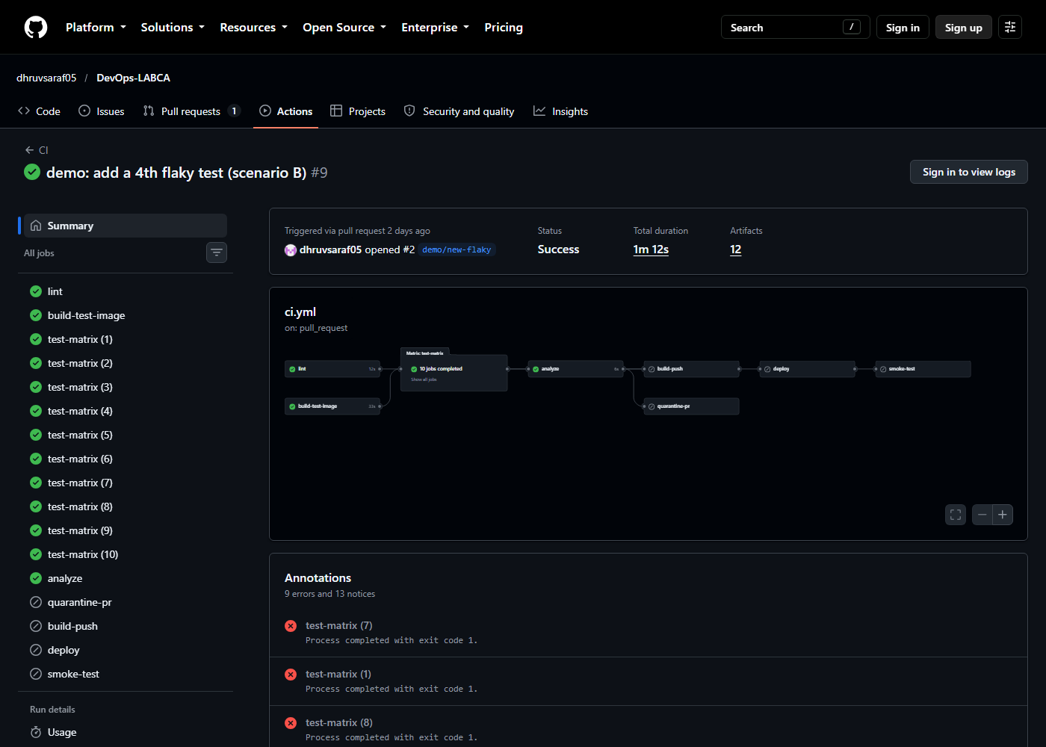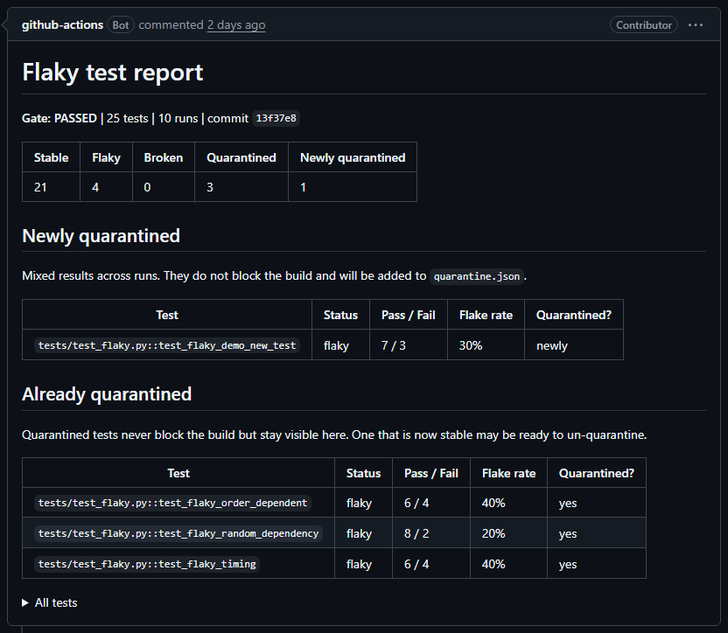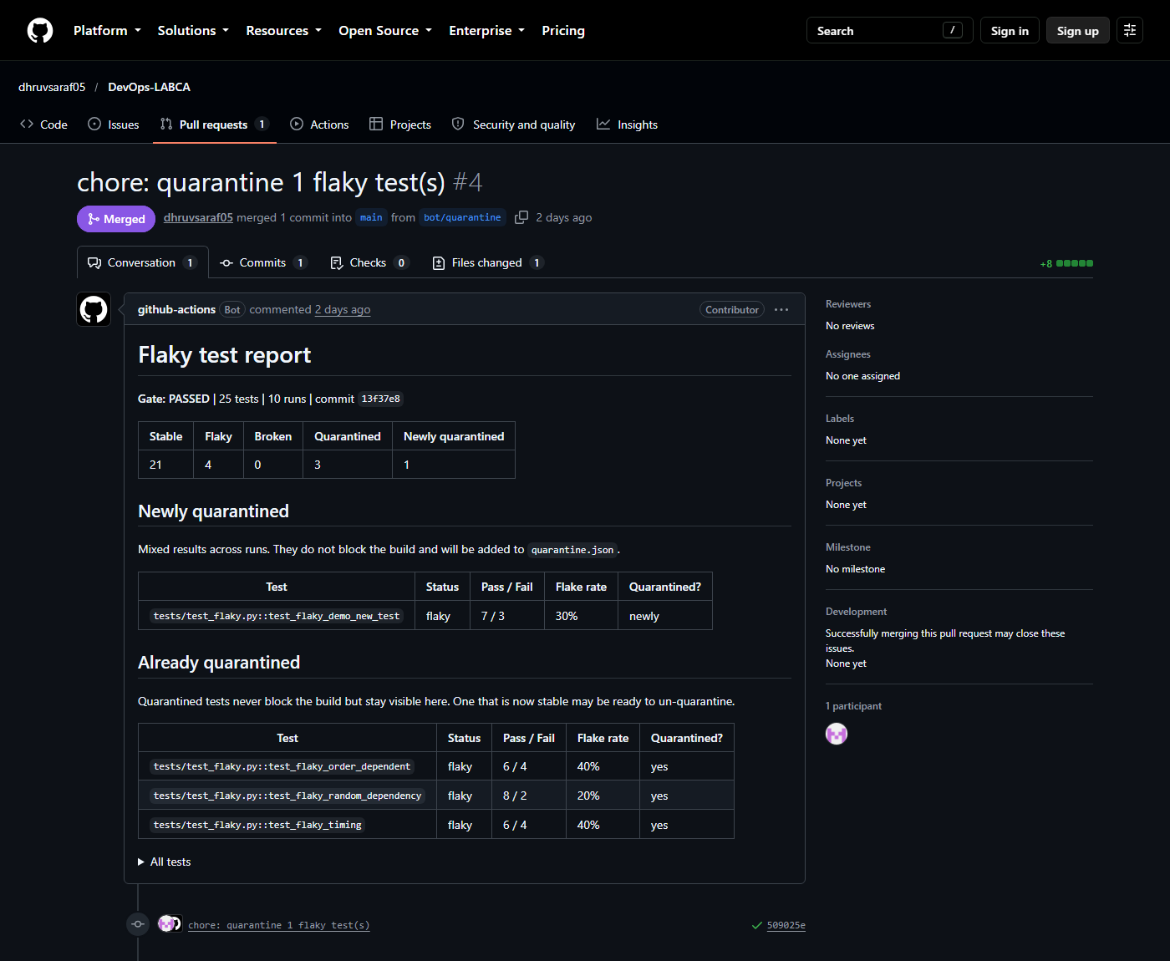

8.3 Before: no detector (scenario A)
The manual naive-ci workflow runs pytest once. Eight runs on the same code: 5 failed and 3 passed.
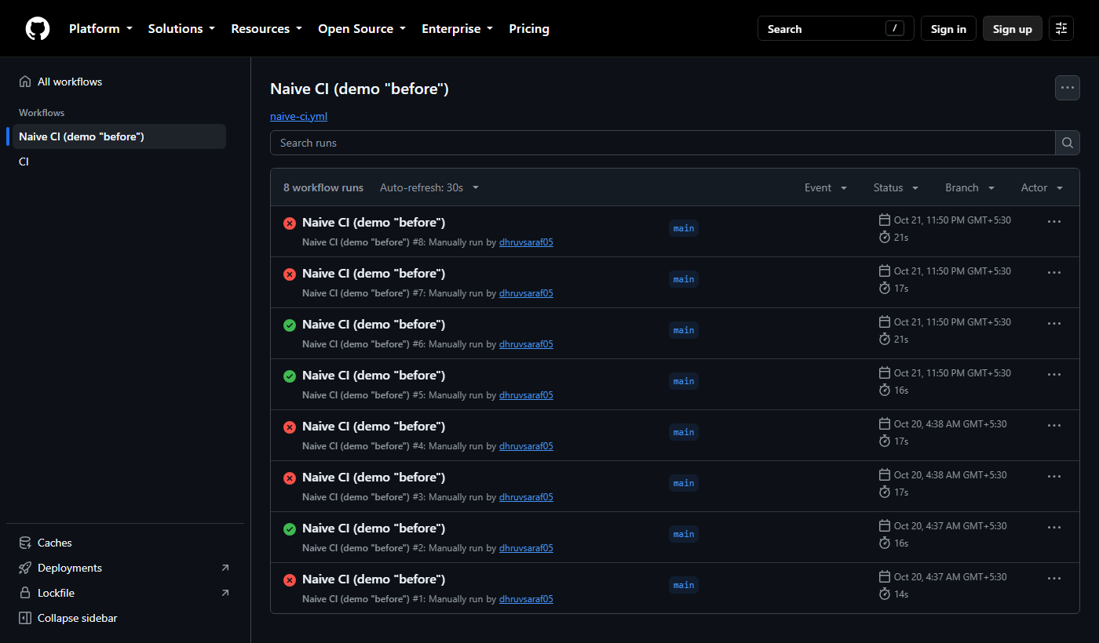

8.4 A real bug is blocked (scenario C)
A pull request changed POST /notes to return 200 instead of 201. The detector reported:
Gate: BLOCKED, 24 tests, 10 runs.
Test | Class | Pass / Fail | Quarantined?
test_create_note_content_is_optional | broken | 0 / 10 | no
test_create_note_returns_created_note | broken | 0 / 10 | no
The analyze job failed and branch protection blocked the merge, so the bug never reached main. The release jobs (build-push, deploy, smoke-test) run only on main, so nothing was published and the Vercel dashboard shows no deployment for this change. The quarantined flaky tests were still listed and did not affect the result.
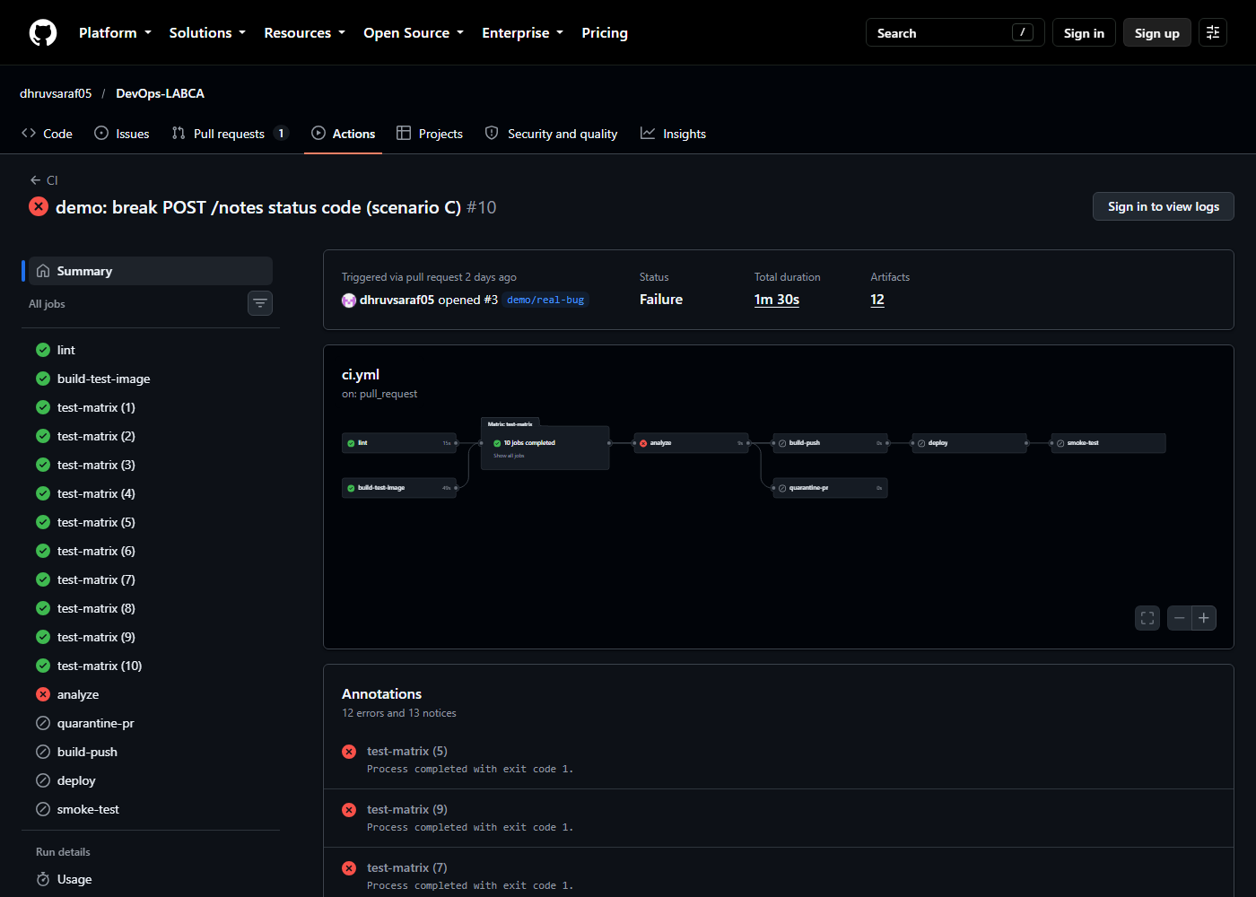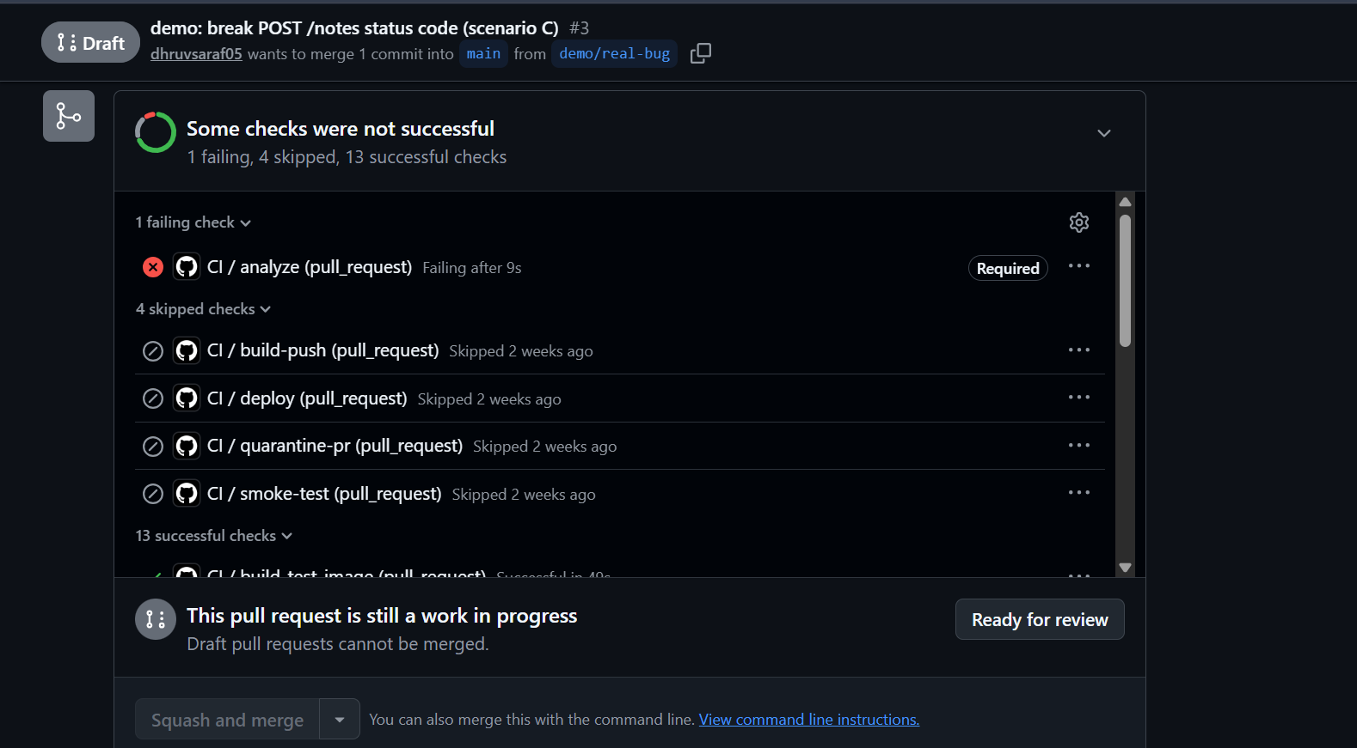

8.5 Delivery (scenario D)
A harmless change (API description text) was merged through a pull request. All jobs passed: lint, build-test-image, ten test-matrix jobs, analyze, build-push, deploy and smoke-test. The live /version returned the commit SHA of that merge, and GHCR had the image tagged with the same SHA and latest.
The Vercel deployments page lists one Production deployment per commit on main. The project is not connected to the Git repository: the branch and commit shown come from the checkout that the Vercel CLI ran in during the deploy job. Failed attempts from the setup (section 7.8) also appear in the full list, such as the Error row at the bottom.
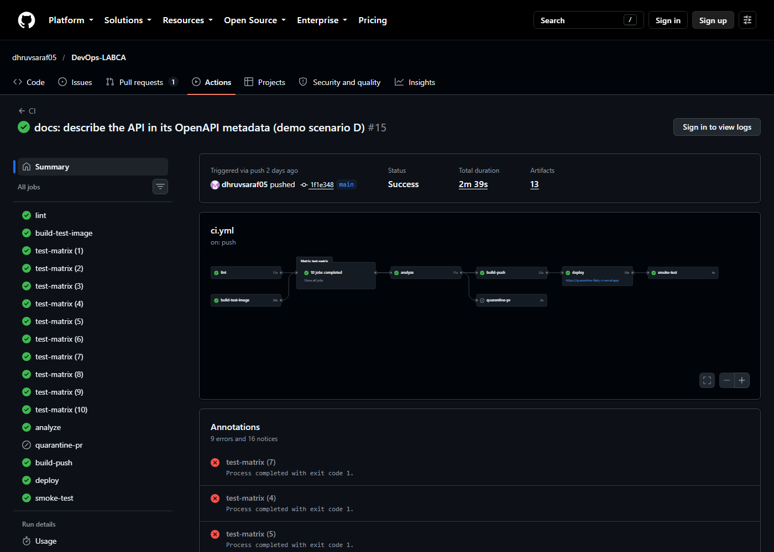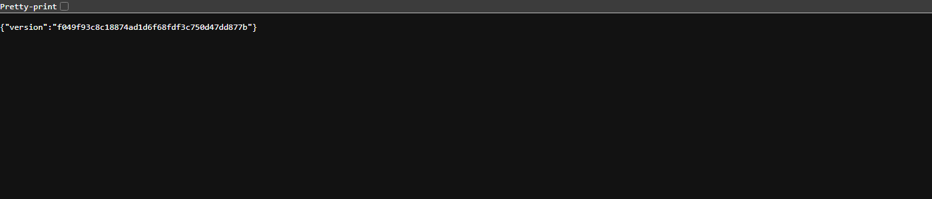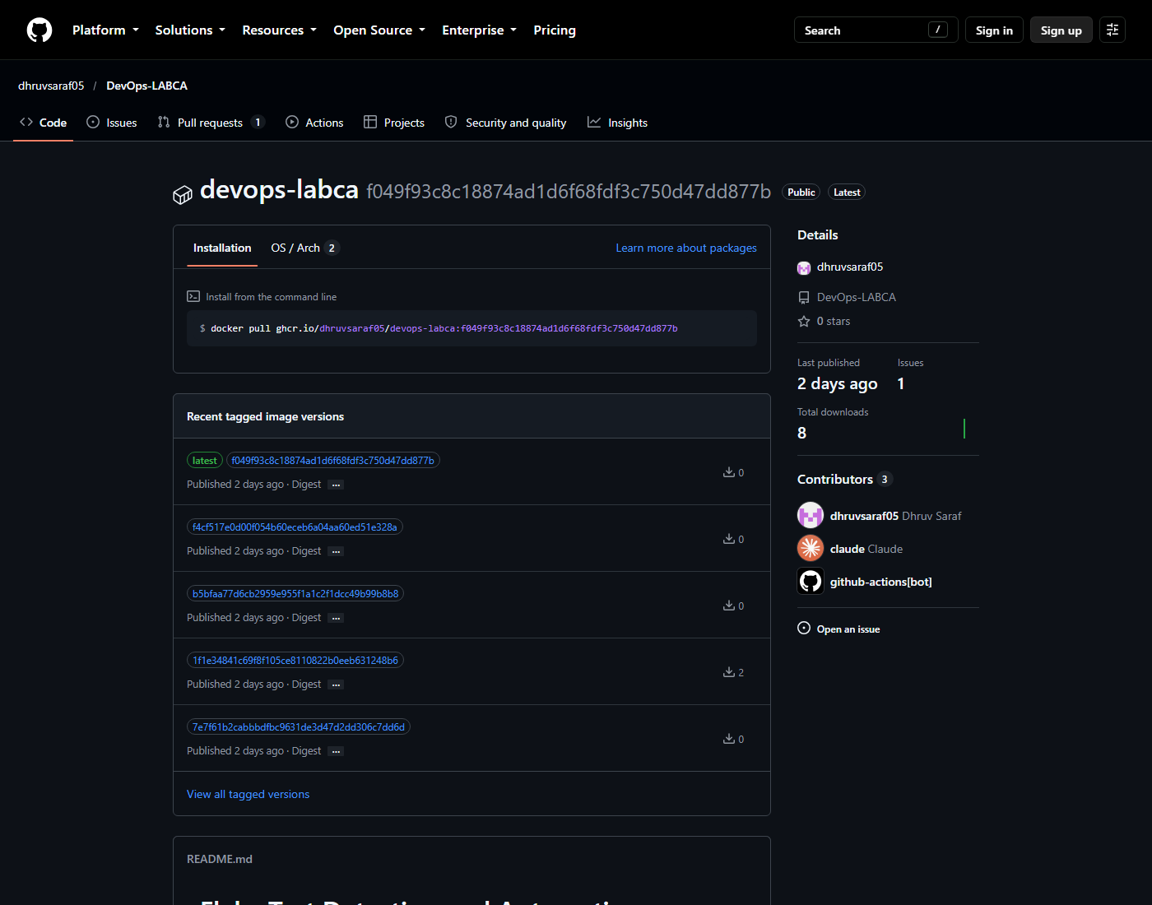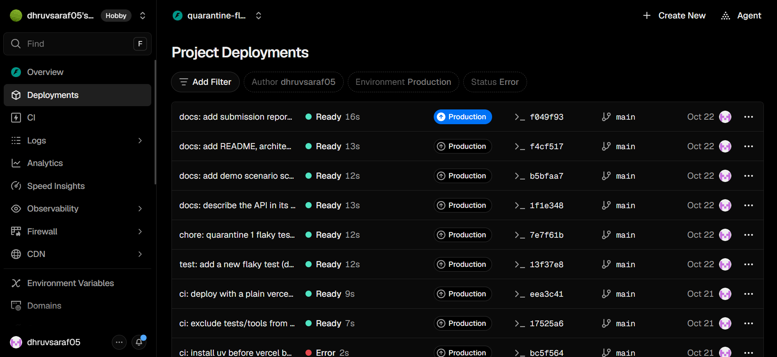

8.6 Pipeline timing
Run | Duration
Pull request, gate passes (scenario B) | 72 s
Pull request, gate blocks (scenario C) | 90 s
Push to main, full release chain (scenario D) | 159 s

9. Probability analysis: why 10 runs
Let p be a flaky test's per-run failure probability. With N independent runs:
- It escapes detection (passes all N runs): (1 - p)^N.
- It is mistaken for broken (fails all N runs): p^N.
p | N = 5 | N = 10 | N = 20
0.3: escapes detection | 16.8% | 2.8% | 0.08%
0.3: mistaken for broken | 0.24% | 0.0006% | about 0
0.1: escapes detection | 59.0% | 34.9% | 12.2%
At p = 0.3, ten runs detect the test about 97% of the time, and a misclassification as broken is practically impossible. More runs improve detection of rare flakes but cost CI minutes, since each run is a separate parallel job. Tests that fail rarely (p = 0.1) can still escape a 10-run check, which is a stated limitation. The independence assumption is also approximate: runs share the same code and image, and only the seeded randomness differs.

10. Limitations and future scope
Limitations
- Detection is probabilistic. Tests with low flake rates can pass all 10 runs.
- Quarantine can hide a real bug. The mitigation is that quarantined tests keep running, stay listed in every report and change only through a reviewable pull request. A quarantined test that starts failing 10/10 does not block.
- Quarantine needs human follow-up. The system stops flaky tests blocking the build; it does not fix them.
- CI minutes. Ten matrix jobs per run use more minutes than a single run.
- The bot's pull request gets no CI checks. Pull requests created with the default GITHUB_TOKEN do not trigger workflows, so the required lint and analyze checks never report on the quarantine PR. The repository owner merged it with admin bypass.
- No persistent storage in production. Vercel runs the app as a serverless function, so the in-memory store does not persist across requests. This is why the smoke test uses single-request checks only.
- Vercel does not run the Docker image. The GHCR image is a release artifact that runs locally or on any container host.
- The order-dependent flaky test is controlled by test order, not by FLAKE_RATE.
- Remote-build deploy. The deployed bundle is built by Vercel, not the exact bytes built in CI. The commit and SHA are identical, which the smoke test verifies.
Future scope
- Use a database (for example Postgres) so the deployed API is stateful and the smoke test can create and read back a note.
- Open the quarantine PR with a token or GitHub App so required checks run on it.
- Suggest un-quarantining a test that passes 10/10 on main for several consecutive runs.
- Keep a flakiness history file and show the trend in the report.
- Add a pull request comment with the flaky report.
- Add a job using pytest-rerunfailures to compare retries (green but hidden) with this approach (visible and tracked).

11. Conclusion
The pipeline detects flaky tests by repetition in identical containers, quarantines them through a reviewable pull request, keeps them visible in every report, and blocks only on tests that are broken. The four scenarios show the whole behaviour on real runs: random red and green without the system, a new flaky test detected without blocking, a real bug blocked from merging and deploying, and a clean change released to GHCR and Vercel with the live version checked against the commit SHA.

12. References
[1] Q. Luo, F. Hariri, L. Eloussi and D. Marinov, "An Empirical Analysis of Flaky Tests," Proc. 22nd ACM SIGSOFT International Symposium on Foundations of Software Engineering (FSE), 2014. https://doi.org/10.1145/2635868.2635920
[2] J. Micco, "Flaky Tests at Google and How We Mitigate Them," Google Testing Blog, 2016. https://testing.googleblog.com/2016/05/flaky-tests-at-google-and-how-we.html
[3] M. Fowler, "Eradicating Non-Determinism in Tests," 2011. https://martinfowler.com/articles/nonDeterminism.html
[4] pytest documentation. https://docs.pytest.org
[5] pytest-randomly. https://github.com/pytest-dev/pytest-randomly
[6] FastAPI documentation. https://fastapi.tiangolo.com
[7] GitHub Actions documentation. https://docs.github.com/actions
[8] GitHub Container registry documentation. https://docs.github.com/packages
[9] Vercel documentation: deploying FastAPI and the Vercel CLI. https://vercel.com/docs

