ST-GCN + Federated Learning + KOA + ALA
Package Installation and Import
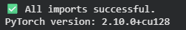
Dataset Load
Herlev has 7 classes stored in subfolders:
- normal_columnar, normal_intermediate, normal_superficiel (NORMAL)
- light_dysplastic, moderate_dysplastic,
severe_dysplastic, carcinoma_in_situ (ABNORMAL)
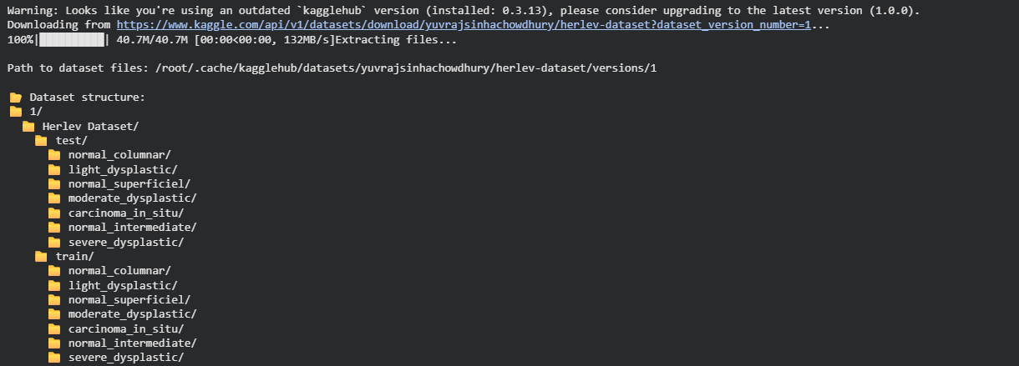
Dataset Class Distribution
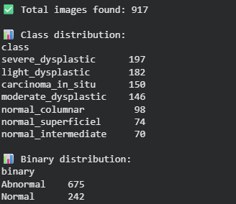
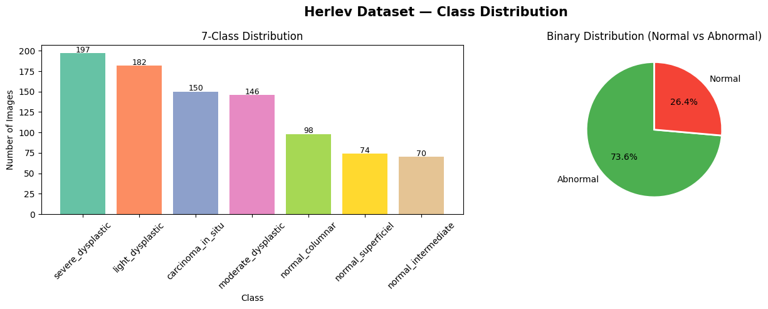

Data Sample of Each Class
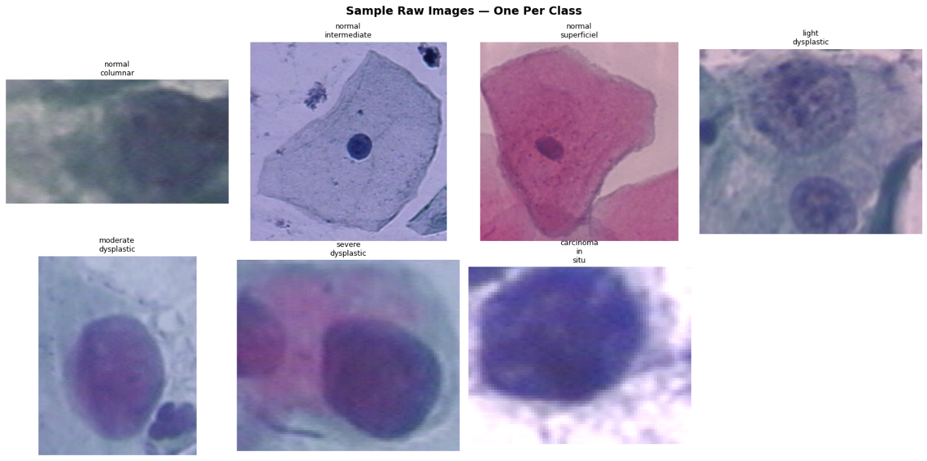
Applied Preprocessing: Nucleus/Cytoplasm Segmentation
We use RPN with Selective Search thresholding to segment:
- Nucleus: The darker, central blob
- Cytoplasm: The surrounding lighter region
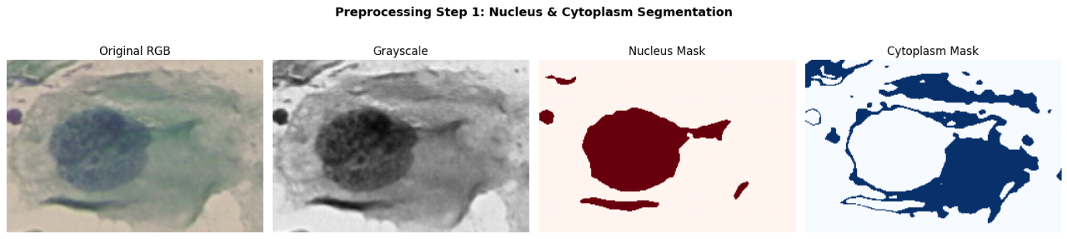

Preprocessing — Segmentation Results on Multiple Classes
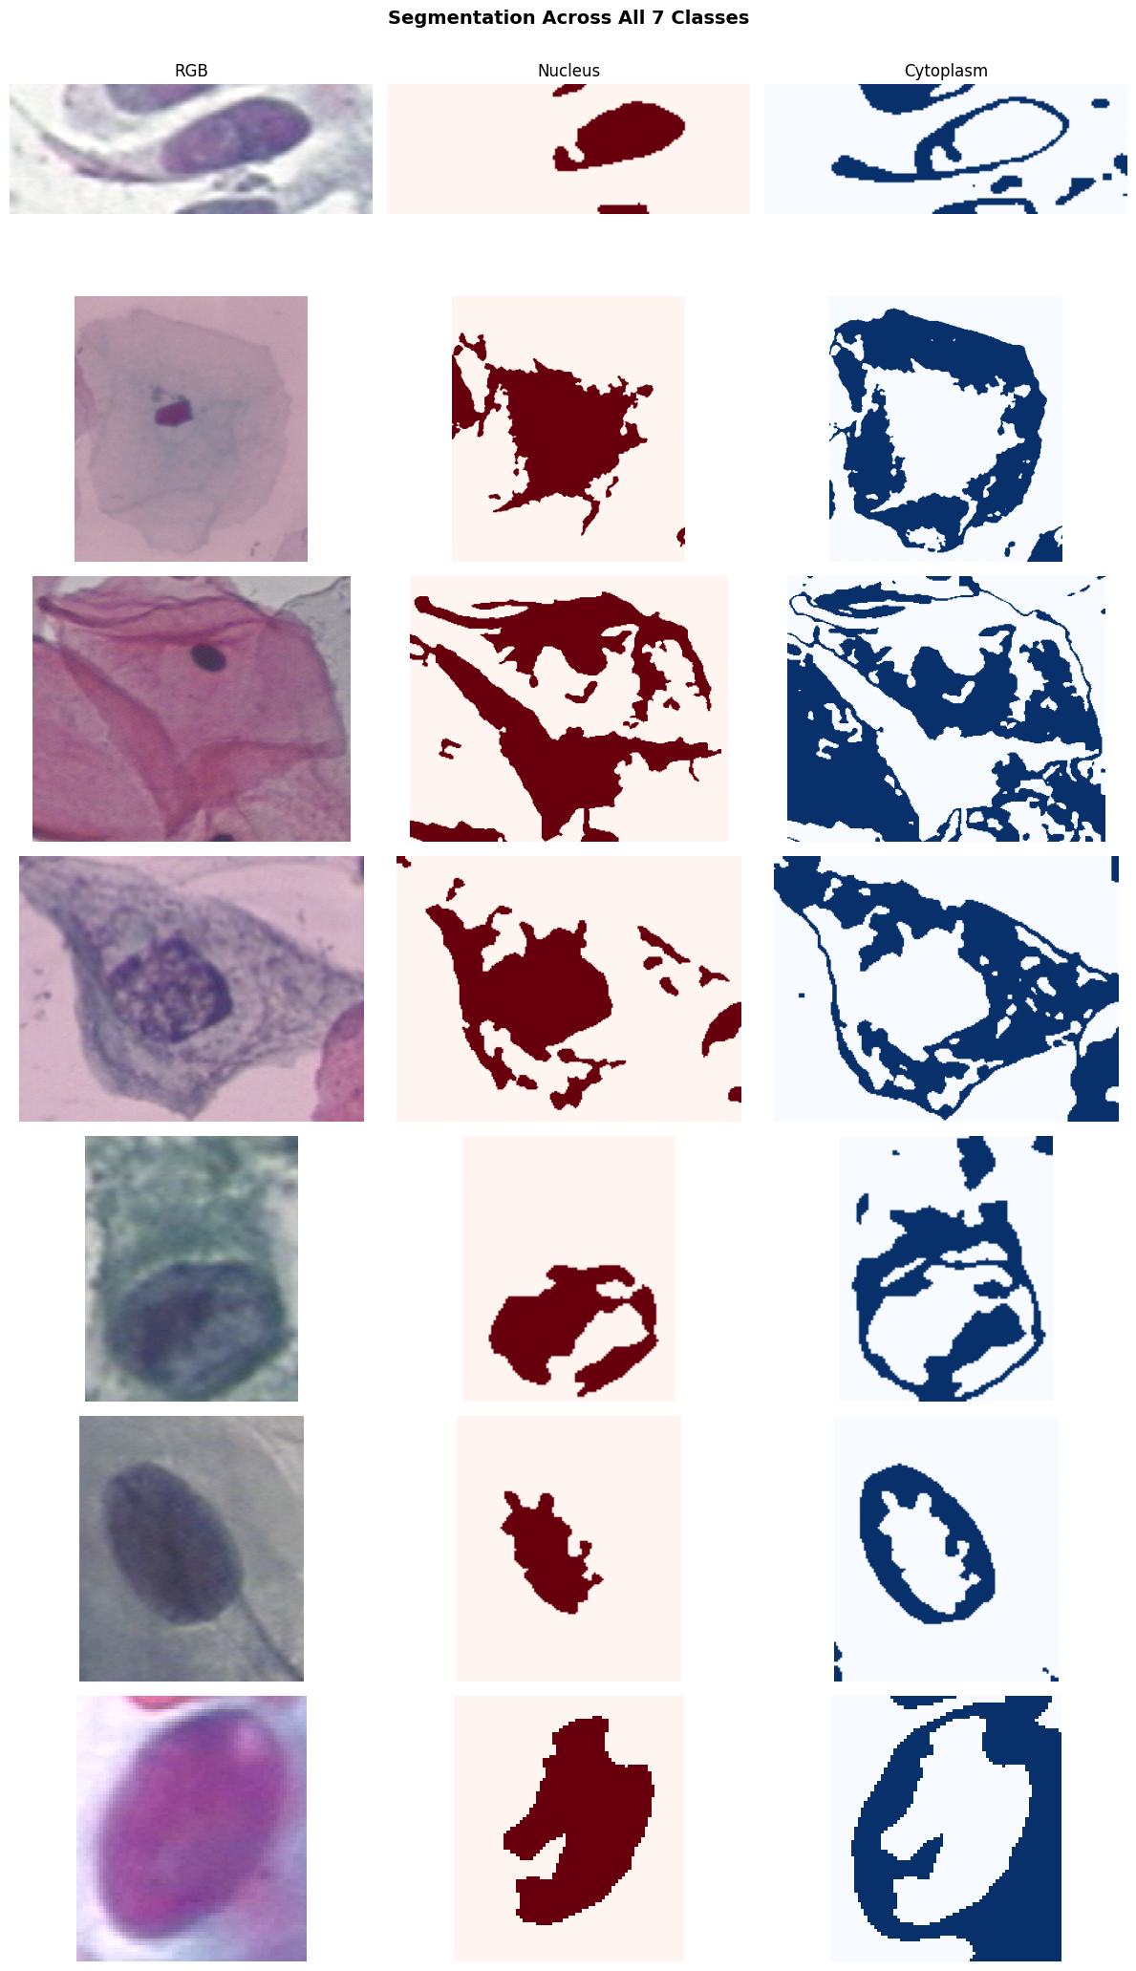
Feature Extraction — 13 Morphological Features per Cell
These features describe shape, size, and texture of the cell.
These are the raw features ALA will later filter down.
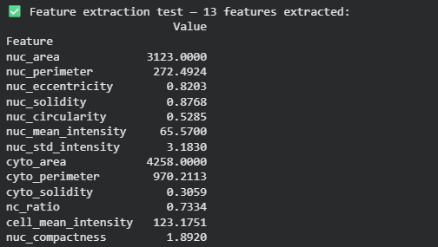
Extract Features for ALL Images
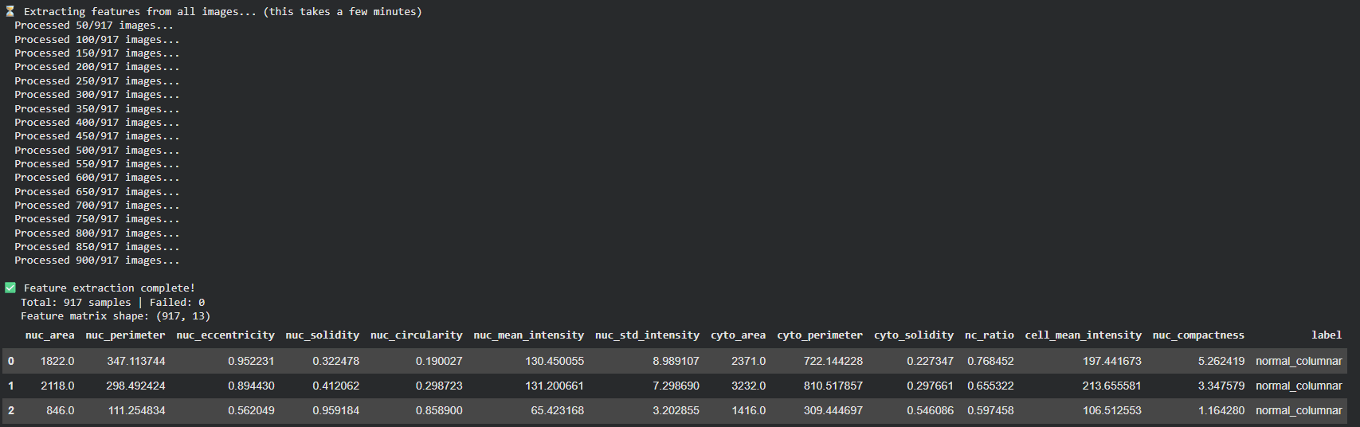
Feature Distributions by Class
See how key features separate normal vs abnormal cells.
The NC Ratio (nucleus-to-cytoplasm) is the most important one.
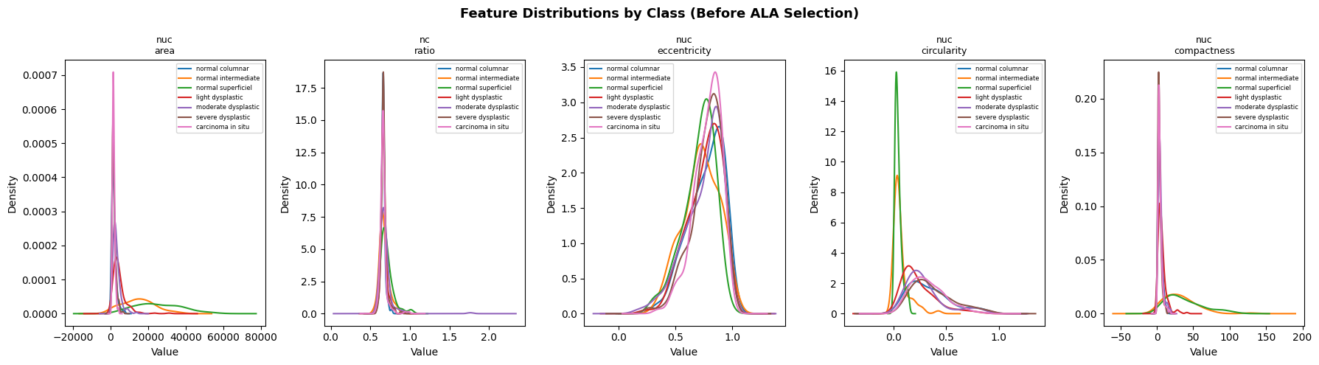

Correlation Heatmap of All Features
High correlation between features = redundancy.
ALA will remove redundant ones in the next step.
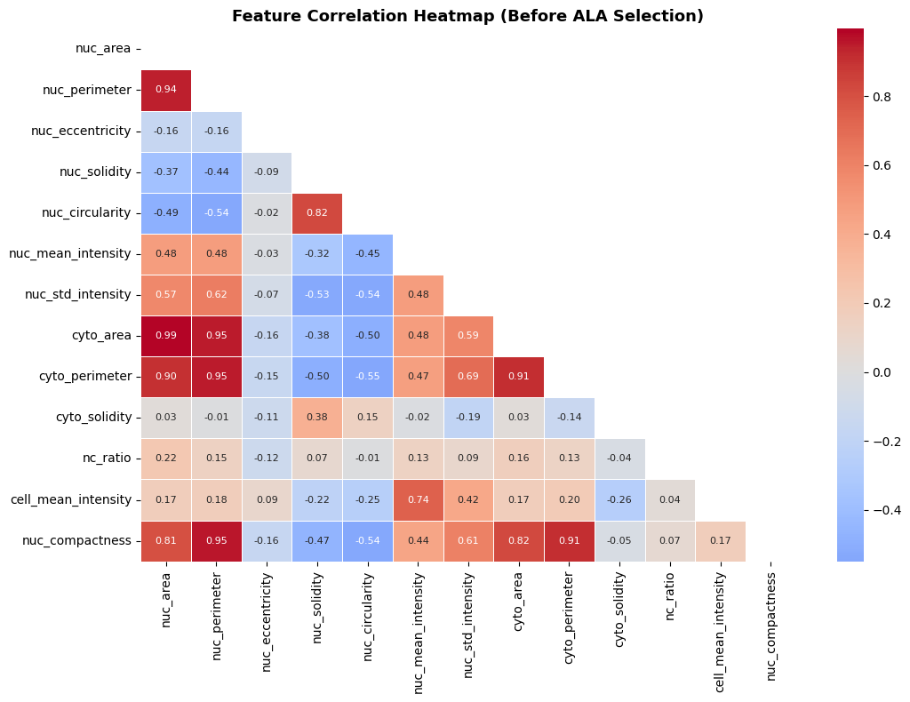
ALA — Artificial Lemming Algorithm for Feature Selection
HOW ALA WORKS:
- A "population" of Lemmings, each representing a random subset of features
- Each Lemming's fitness = classification accuracy using that feature subset
- Lemmings "migrate": they move toward the best solution found so far
- Over iterations, the population converges on the best feature subset
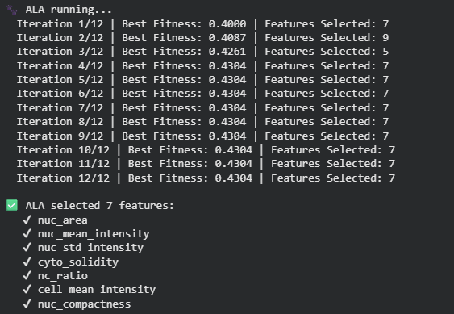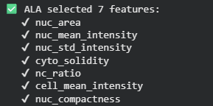

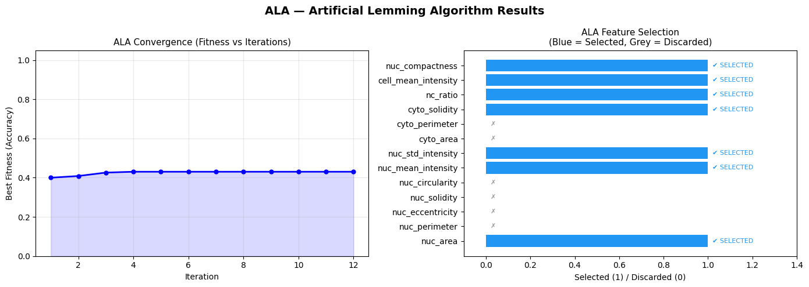
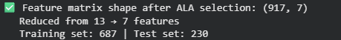

Graph Construction — Convert Each Cell to a Graph
HOW THE GRAPH IS BUILT:
- Each cell = one graph
- Node 0 = Nucleus (features: nucleus-level features)
- Nodes 1–3 = Cytoplasm boundary samples (features: cyto-level features)
- Edges connect the nucleus to each cytoplasm node (star topology)
This models the spatial relationship between nucleus and cytoplasm.
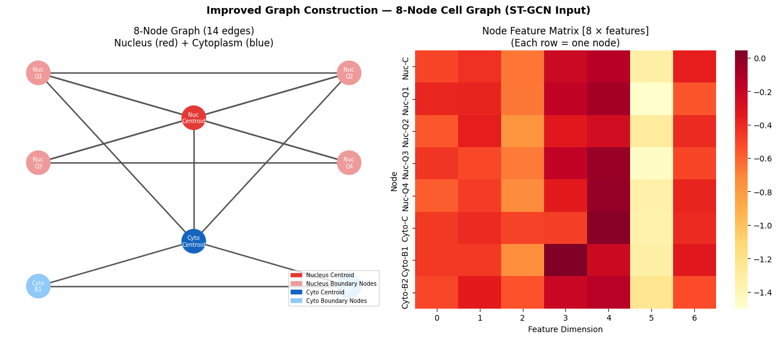
ST-GCN Model Definition
The Spatio-Temporal Graph Convolutional Network:
- Uses simple GCN-style message passing over the cell graph
- "Spatial" = learning from neighboring nodes (nucleus ↔ cytoplasm)
- "Temporal" = here we treat the 3 cytoplasm nodes as simulated
Z-stack layers (different focal depths), giving a temporal-like signal
- Final classification is done via a fully connected head
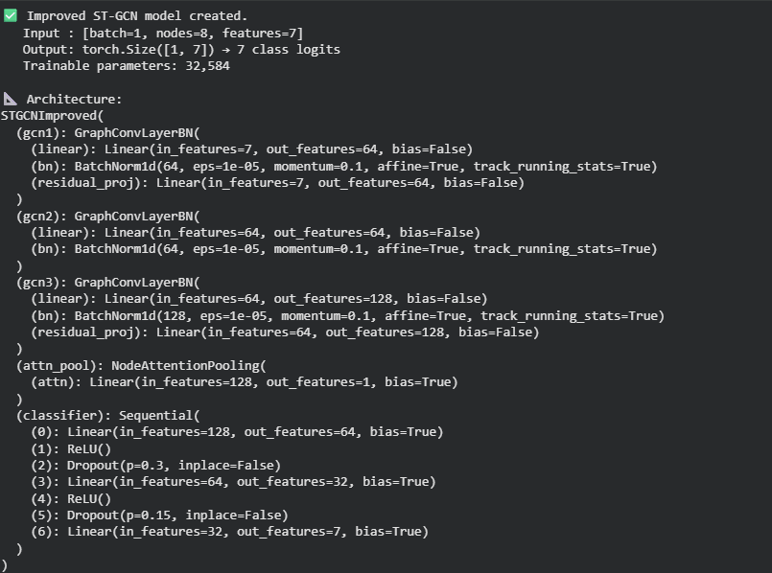
Dataset and DataLoader for ST-GCN
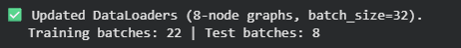
KOA — Kookaburra Optimization Algorithm
HOW KOA WORKS:
- Mimics the hunting behaviour of the kookaburra bird
- "Laughing call" phase: Global search — random exploration of hyperparameter space
- "Swooping" phase: Local search — exploit the best hyperparameters found so far
- Each "kookaburra" = a candidate hyperparameter configuration
- Fitness = validation accuracy of the model with those hyperparameters
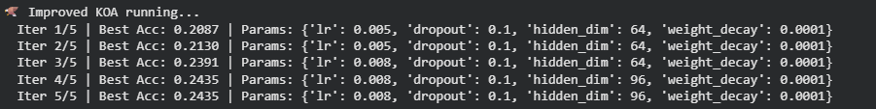
Best Hyperparameters using KOA
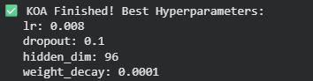
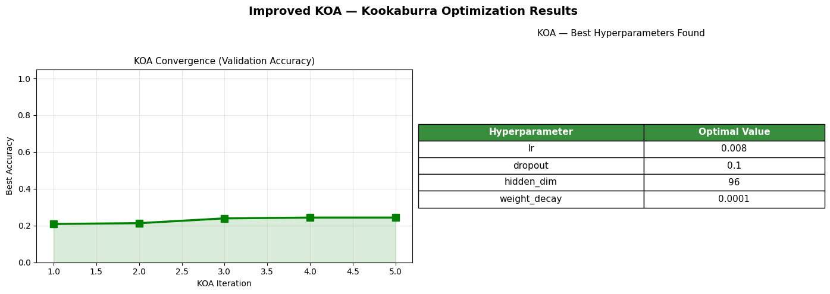

Federated Learning — Simulate 5 Clients (Hospitals)
HOW FEDERATED LEARNING WORKS HERE:
- We split the training data into 5 equal "client" subsets
- Each client trains its own local ST-GCN model
- Only the model WEIGHTS are shared with the central server
- The server averages the weights using FedAvg
- The global model is updated and sent back to clients
- This repeats for several "federated rounds"
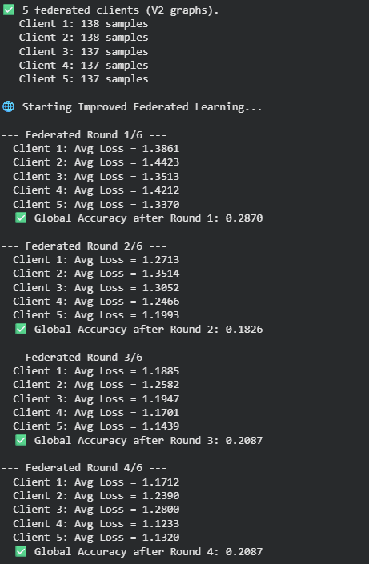
Federated Learning Progress
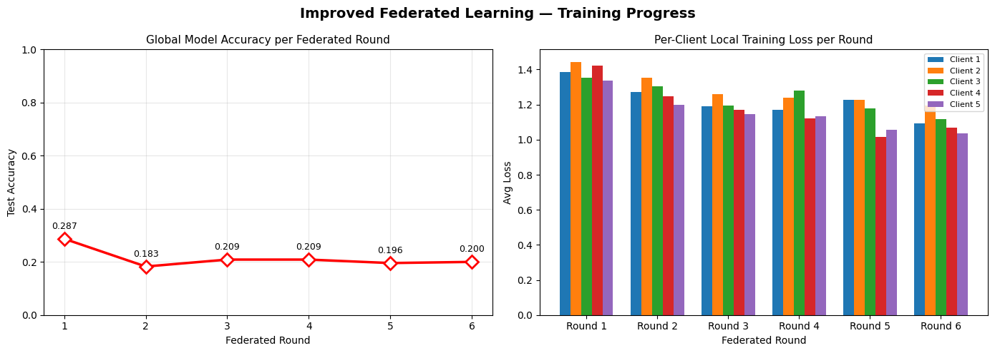
Confusion Matrix & Report
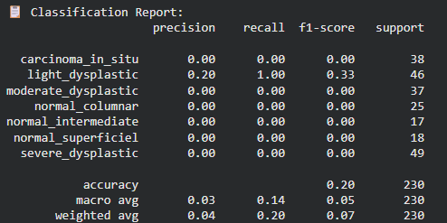
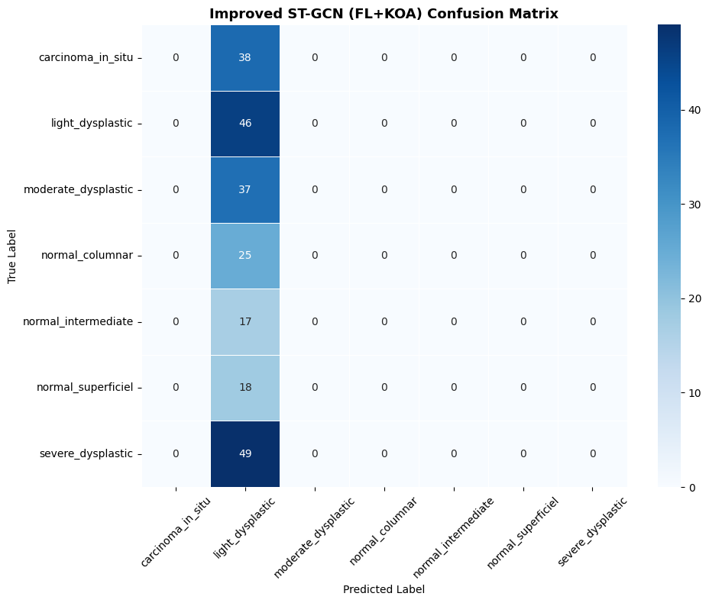

ALA-Classifier — Standalone Baseline
This is ALA used not just for feature selection, but as an
optimised classifier. We use the ALA-selected features with
the best traditional ML model found by ALA's fitness function.
Here we use KNN as the ALA-chosen classifier.
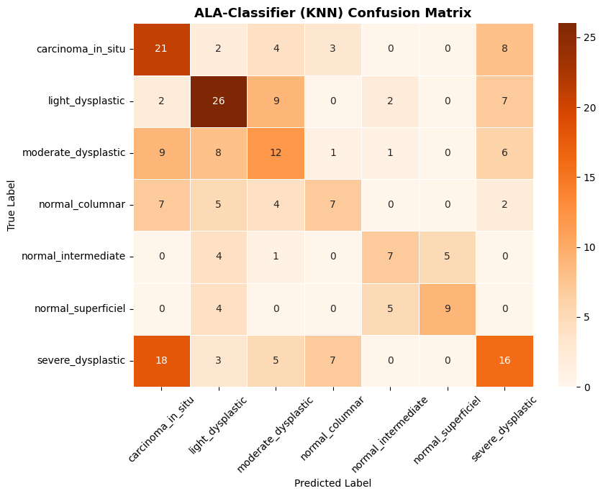
Comparison Models — KNN, DT, RF, SVM
