FinalEnsambleHyperparameterTunedTSO_FineTunedConvNeXt_NeurologicalDisorder
Dataset Info
Source: https://www.kaggle.com/datasets/alifatahi/multi-class-neurological-disorder-mcnd-dataset?select=Normal
Loading Multiclass Data
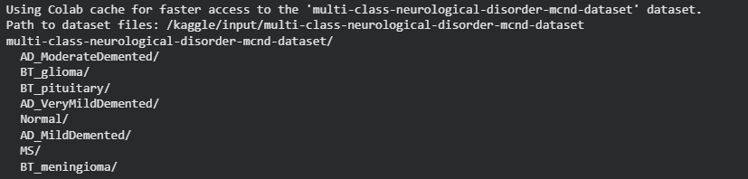
Data Segregation
Import Packages
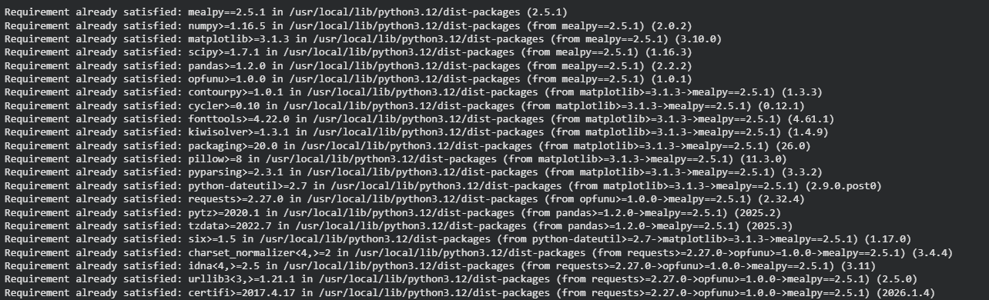
Data Preprocessing
EDA Analysis
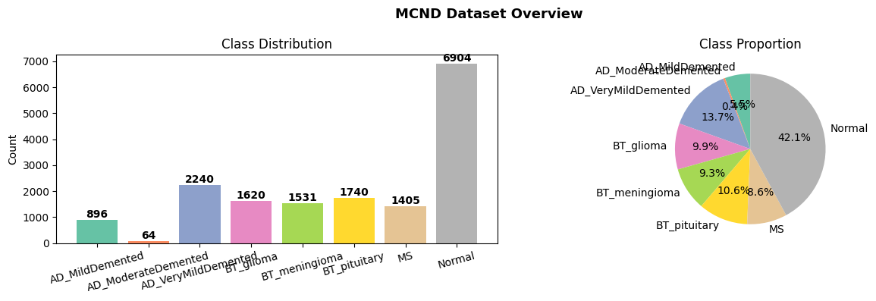
Data Samples
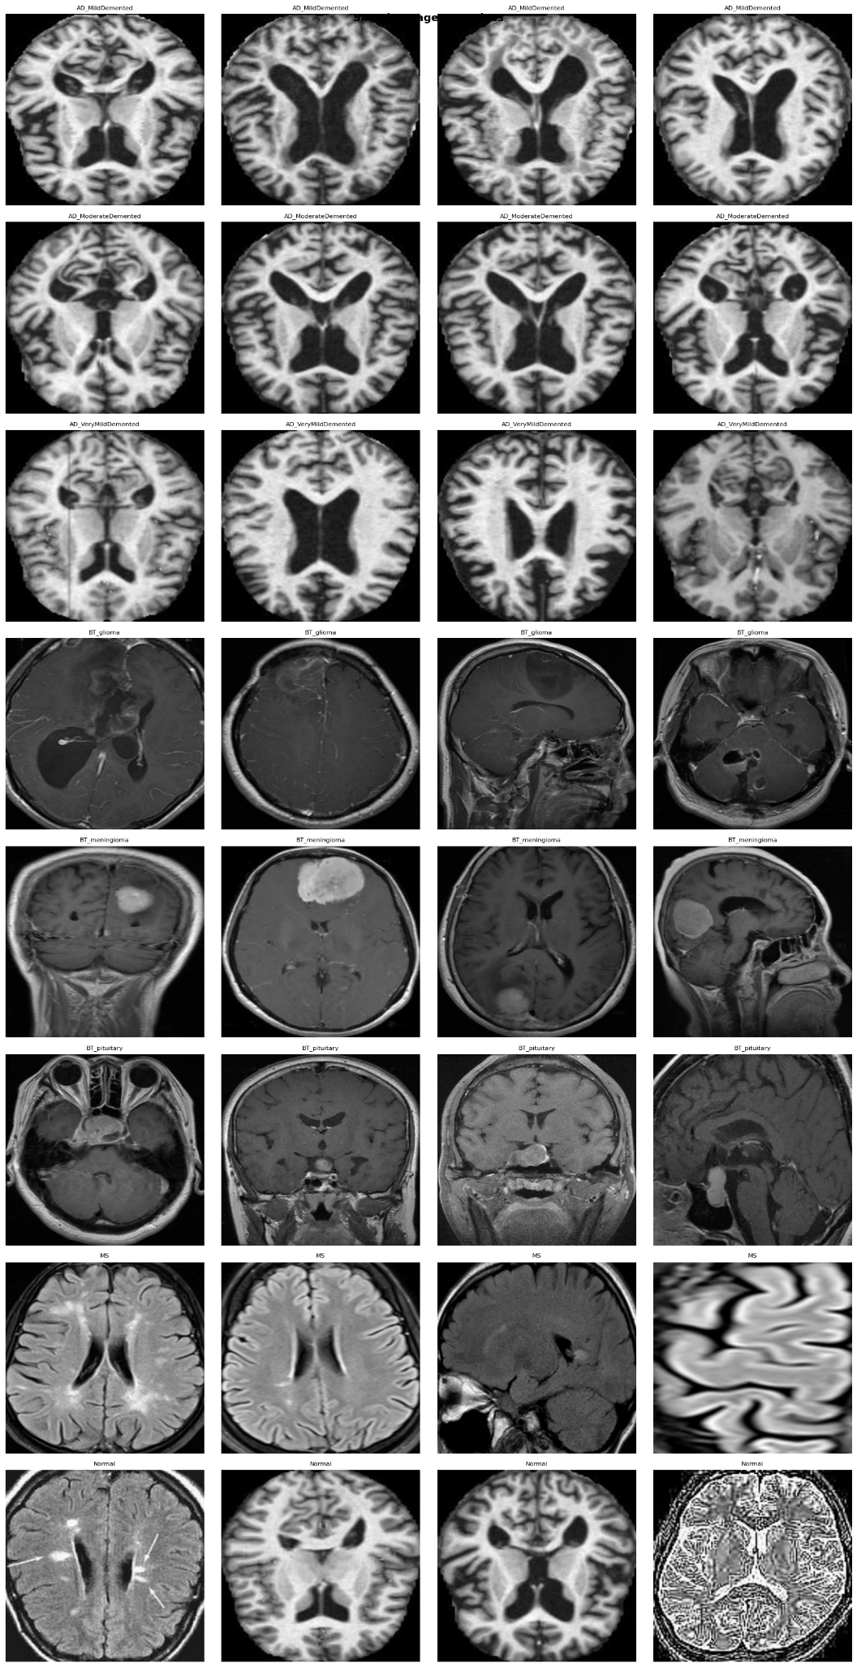
Data Normalisation and Input - Target Split
Image preprocessing [Class Distribution -> Outlier Removal -> Blur → CLAHE → Wavelet]
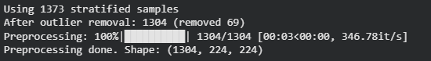
Visualisation of Pre-processed Images Samples
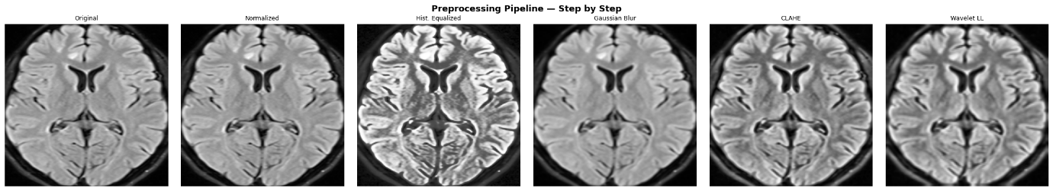
Preprocessing Sampling
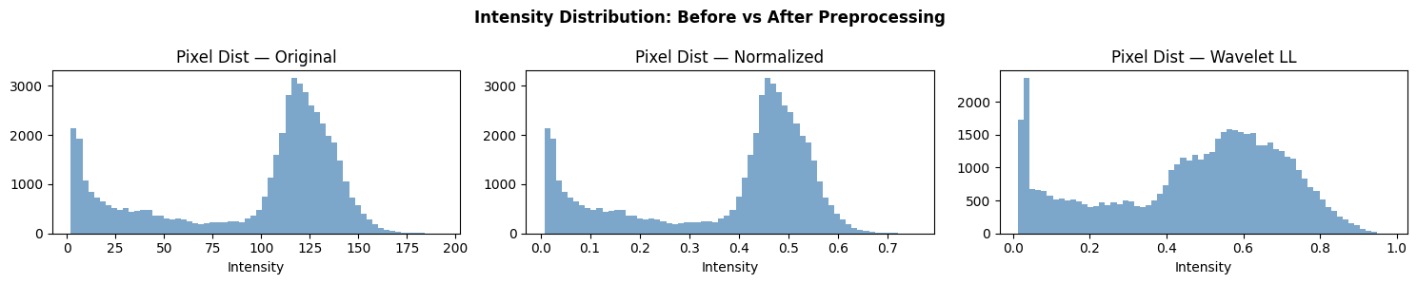
Train Test Split
SMOTE Data Balancing
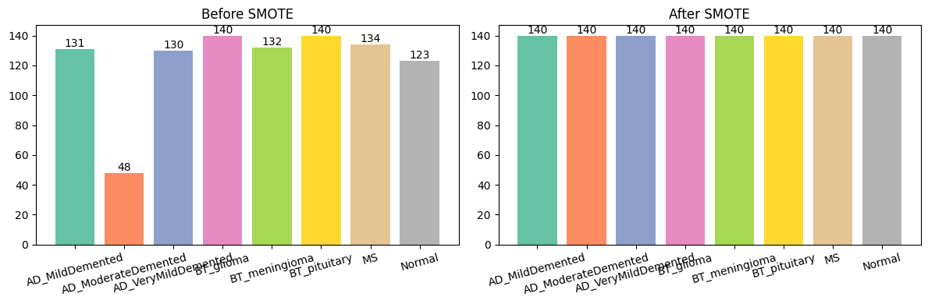

Comparison Models
KNN
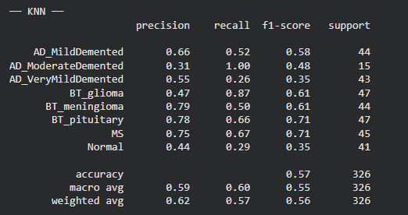
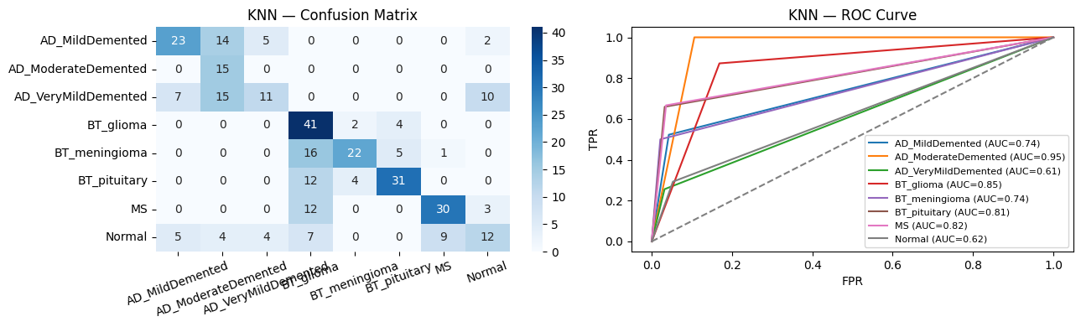
DecisionTree
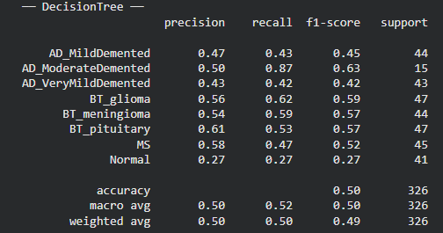
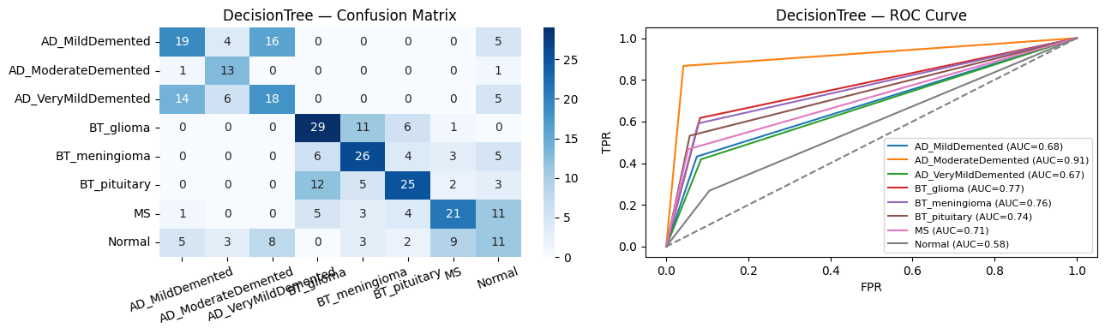
RandomForest
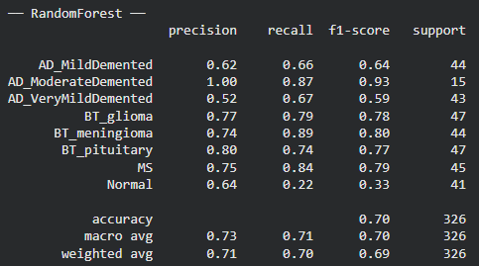
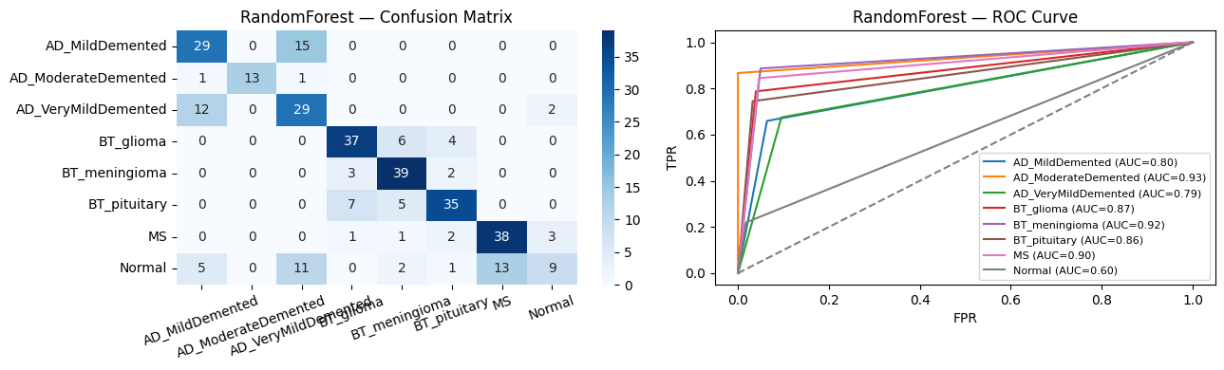
SVM
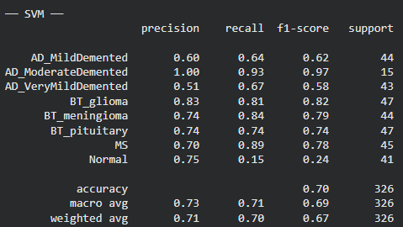
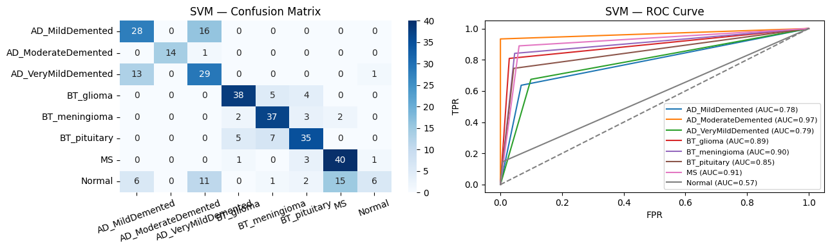
VGG16
VGG16’s Model Configuration and Summary
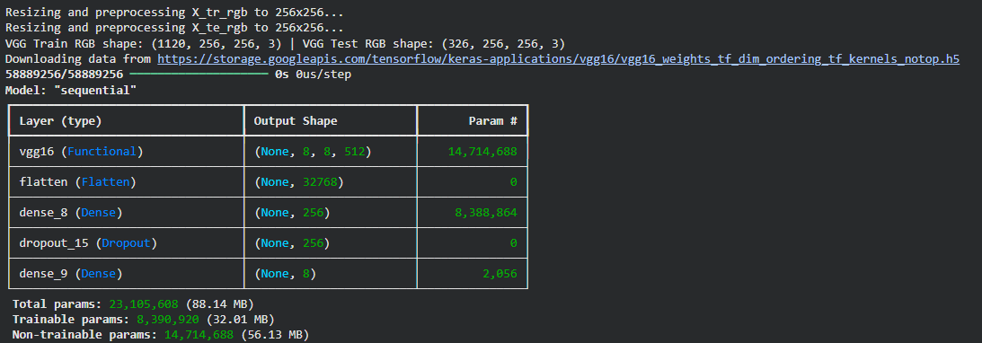
VGG16’s Training
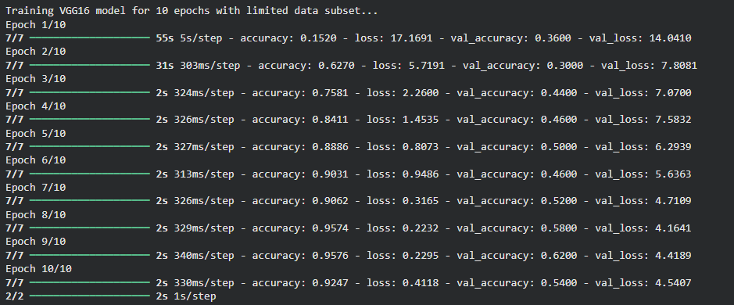
VGG16’s Classification Report
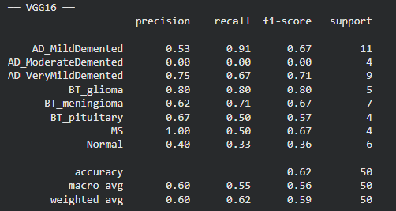

VGG16’s Performance Matrices
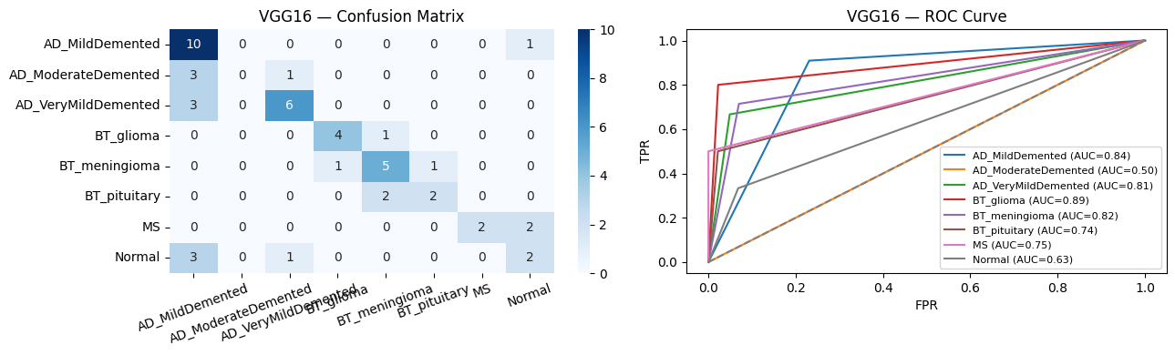

ConvNext Preprocessing RGB Conversion
TSO Configuration
https://mealpy.readthedocs.io/en/latest/pages/models/mealpy.swarm_based.html
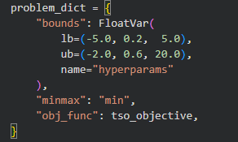
TSO Optimiser Hyperparameter Tuning
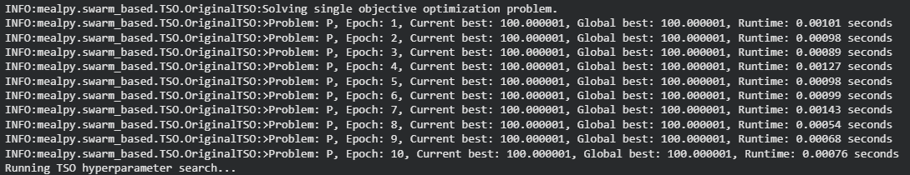
Best Optimum Results based on TSO
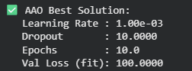
TSO Convergence Visualisation
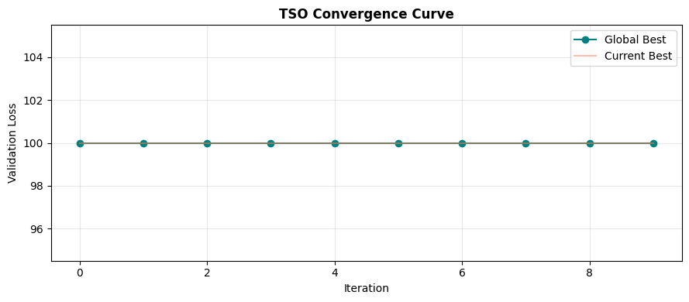
ConvNext Model Configuration and Summary
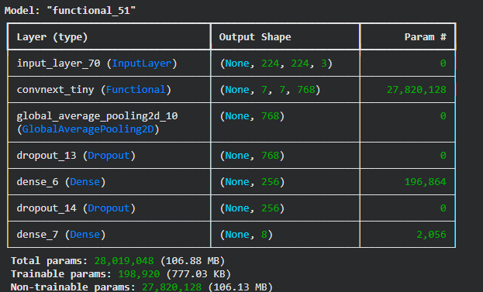
ConvNext Training with Best Optimum Parameter
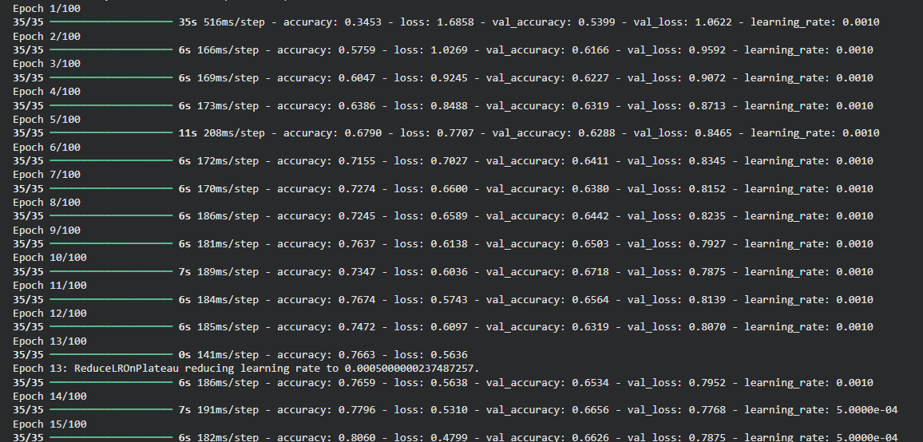
Model Accuracy to Loss Ratio
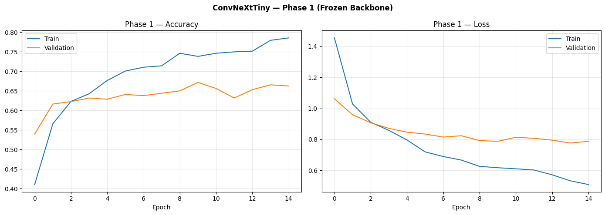
Classification Report
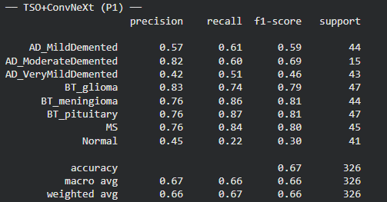
Performance Matrices
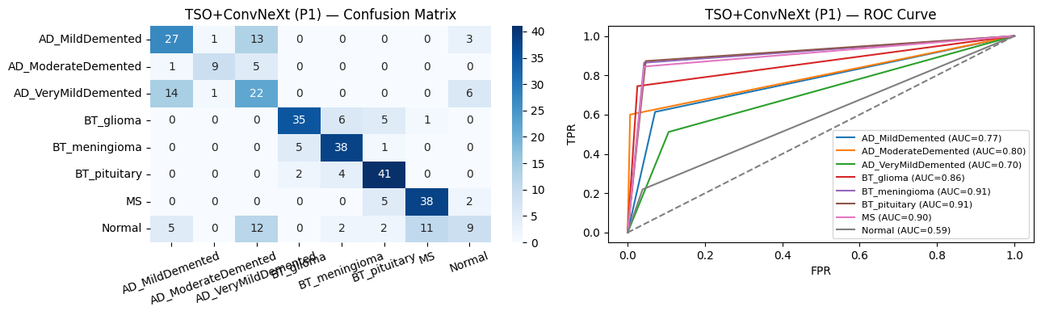

Fine-Tuning (Unfreeze Top Layers)
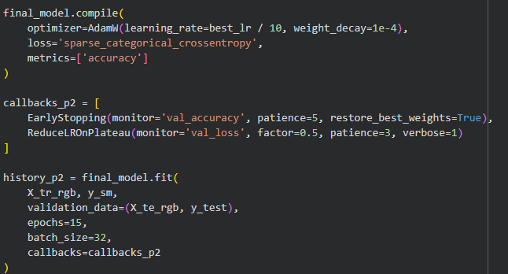
Model Fine Tuning and Retraining
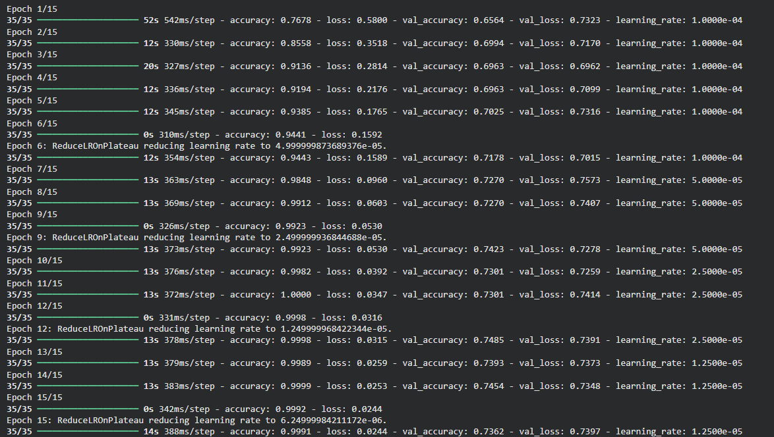
FT Model Accuracy to Loss Graph
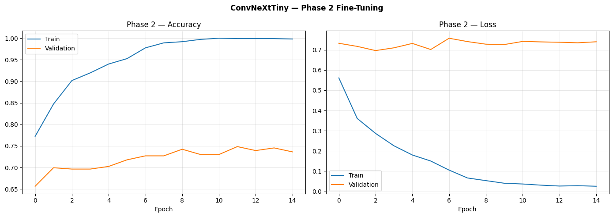
Classification Report
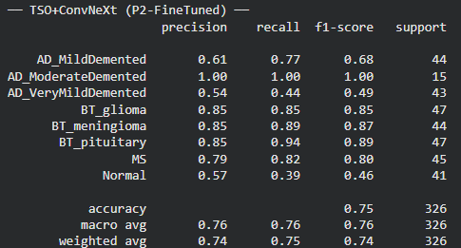
Performance Matrices
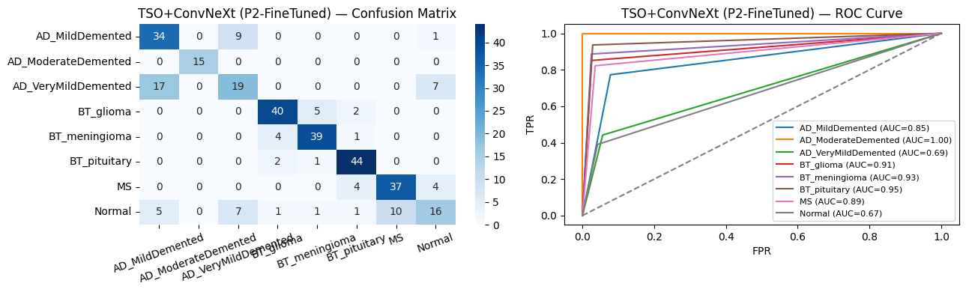
Final Model Comparison Table
