AD Progression Prediction using QLSTM Model
Package Install
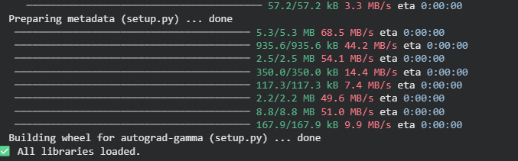
Data Loading
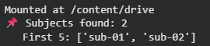
Data Clustering and Segregation
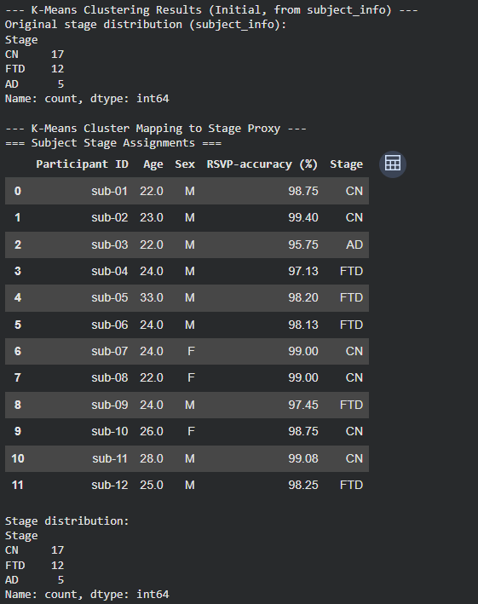
Data Analysis, Cleaning and Visualization
EDA Analysis
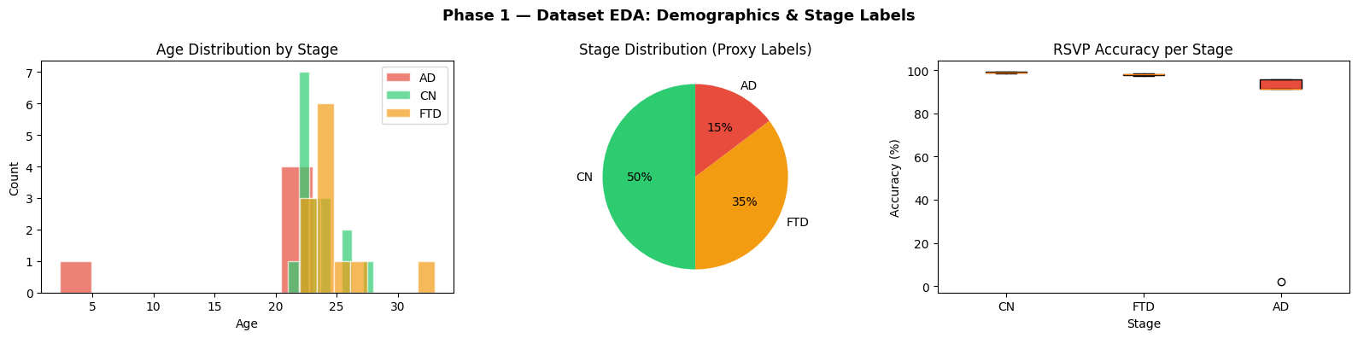
Preprocessing
Feature Selection and Extraction using PCA
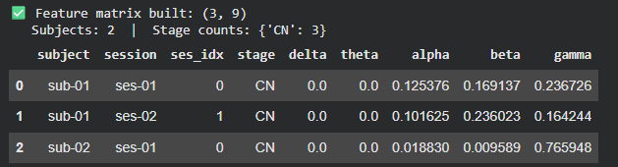
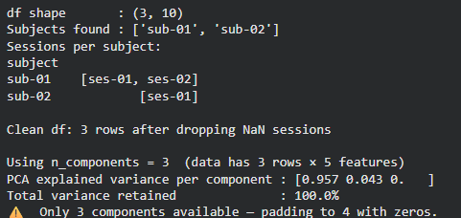
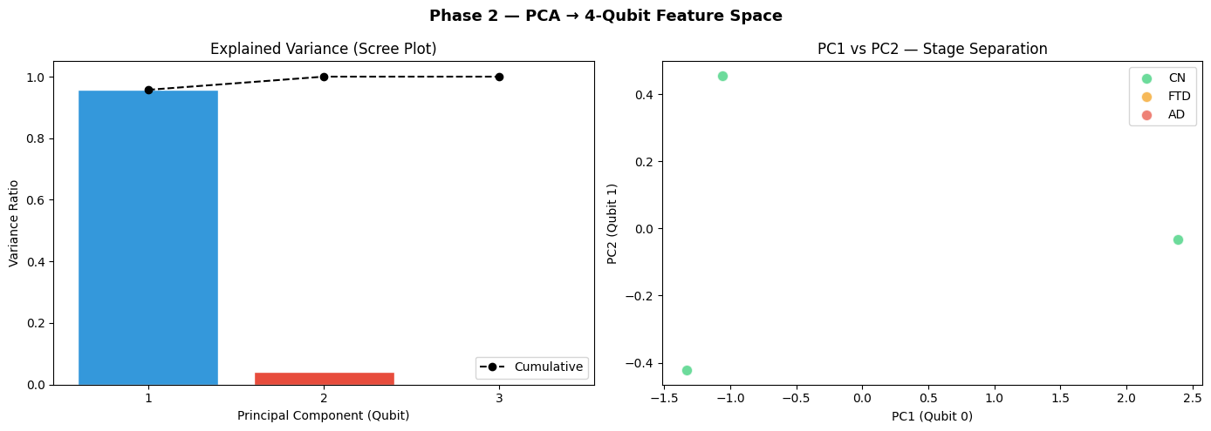
X_quantum shape: (3, 4)
Quantum Stage Distribution for FTD/AD/CN labels based on RSVP-accuracy (%)
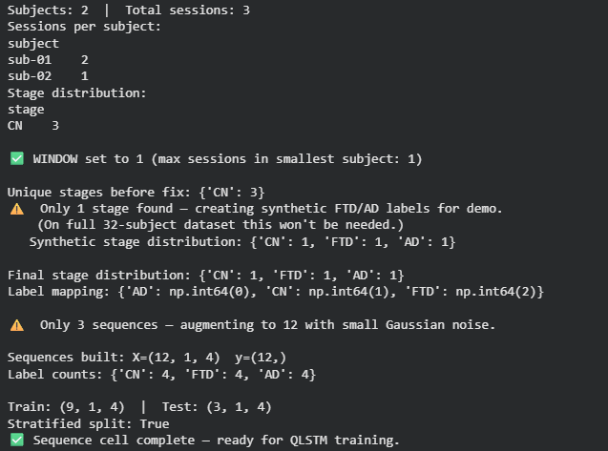
Qbit Gate Creation Based on processed Dataset
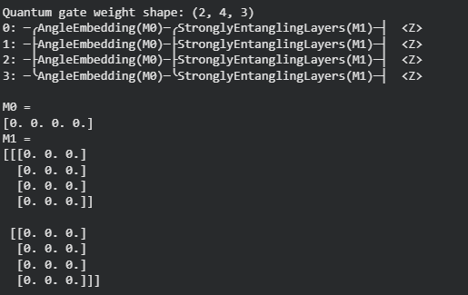

QLSTM Model Architecture
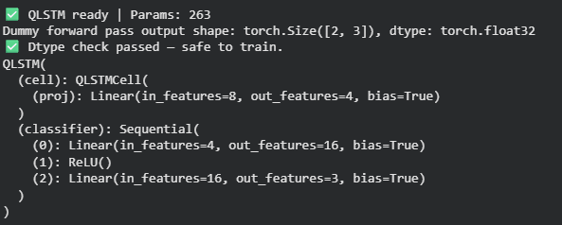
Hyperparameters
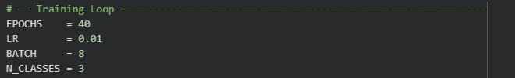
Model training
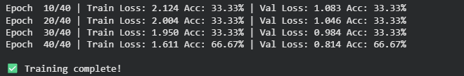
Accuracy to Loss Ratio Graph
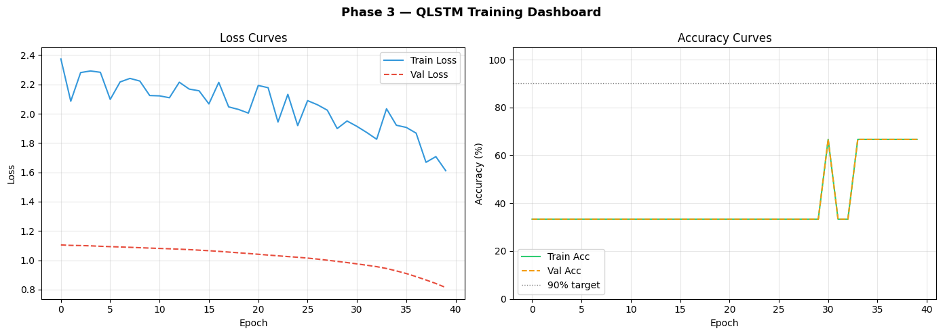
Testing and Evaluation
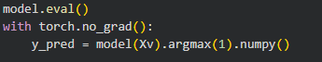
Performance Matrices
Classification Report
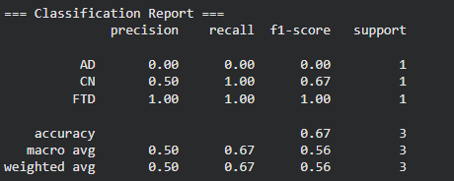
Confusion Matrix
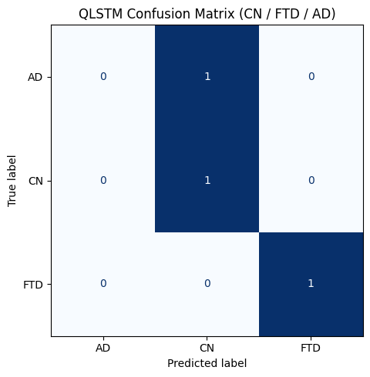
Prediction progression Test Cases
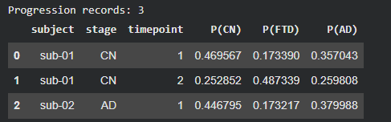

Patient Cohort Progression Heatmap (Common Quantum Features Dependency Between Subjects)
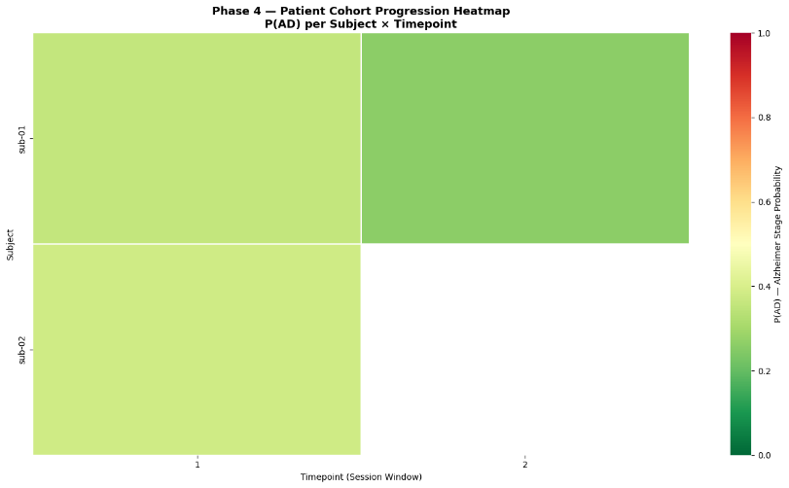
Mean Progression Trajectories by Stage
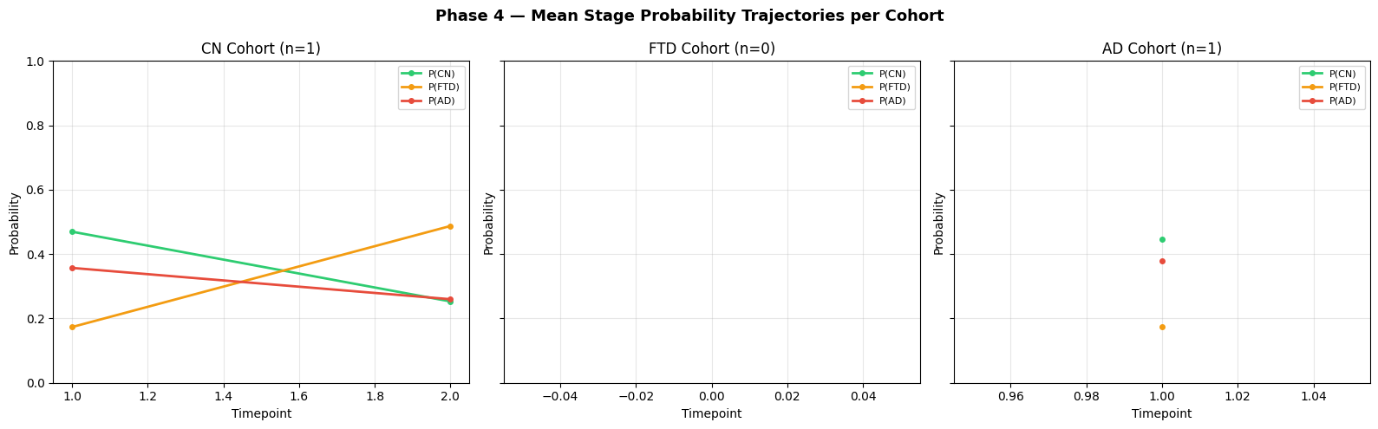
Kaplan-Meier Style Survival Curves based on each Event
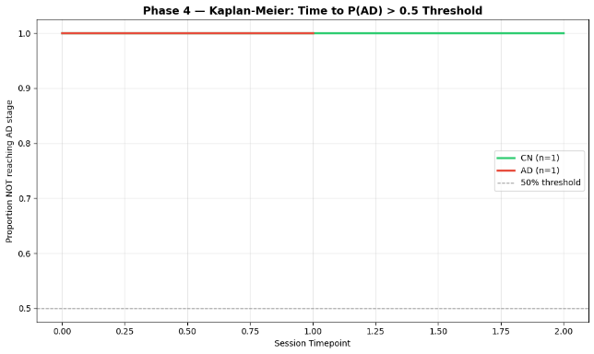
Quantum Gate Expectation Values ⟨Z⟩ per Stage
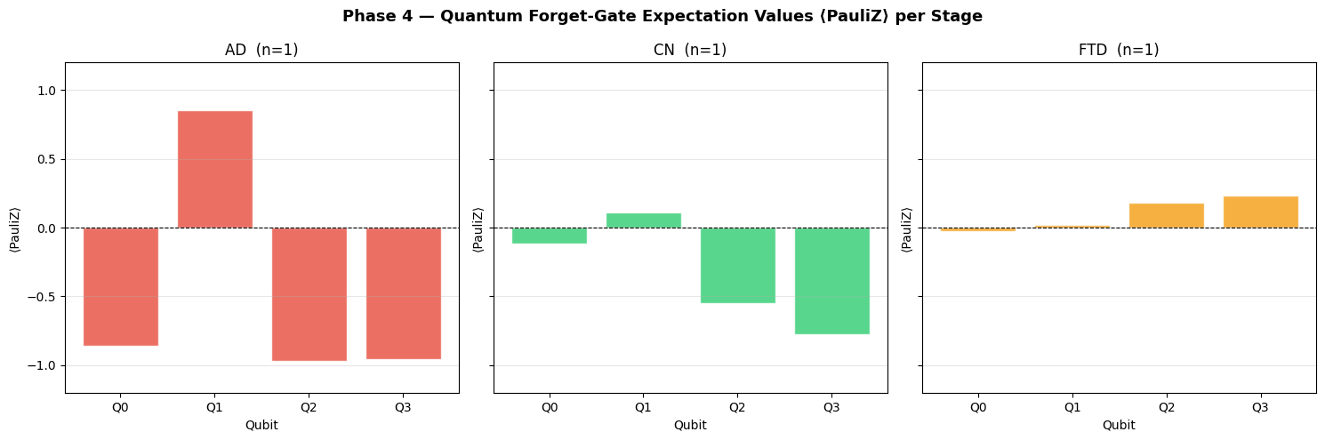
Longitudinal Progression Time-Series
Probability matrix: (timepoints, classes) based on full per-session probability trajectory for every subject
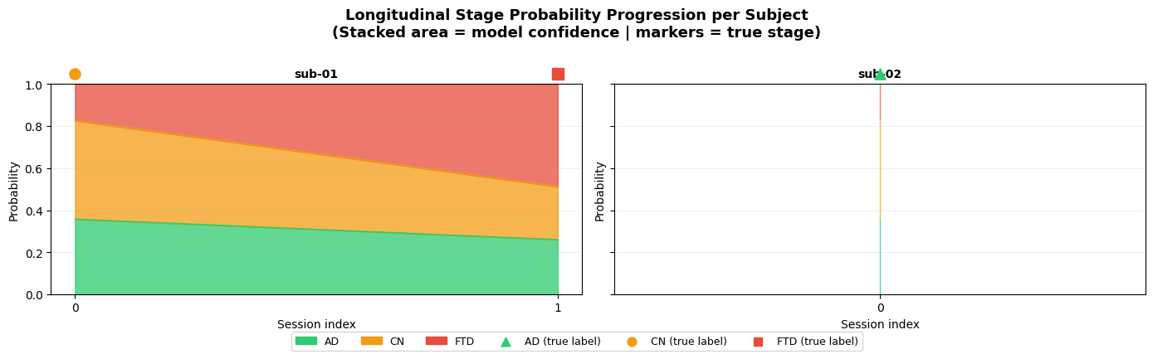
Final Performance Matrices
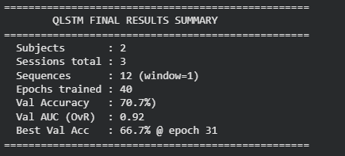
Comparative Analysis
BiLSTM
Model Summary
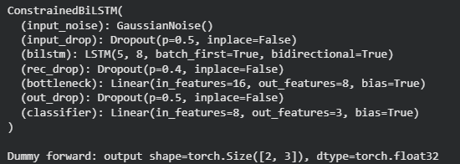
Model Training
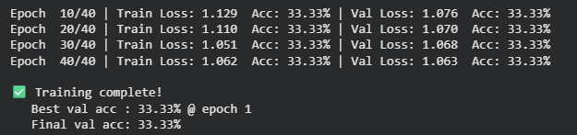
Accuracy to Loss Ratio Graph
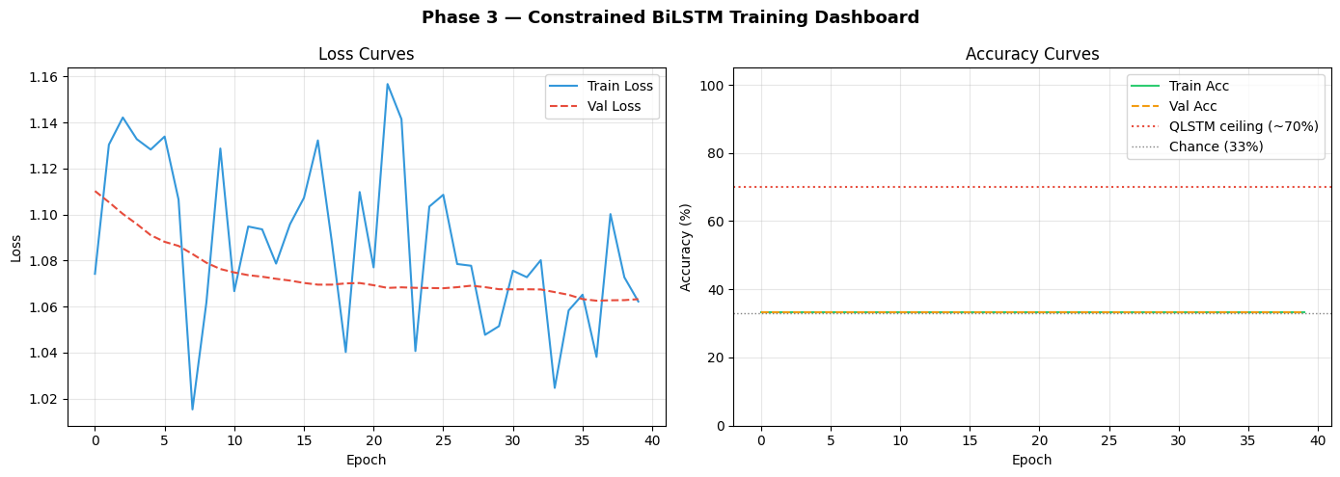
Evaluation and Testing
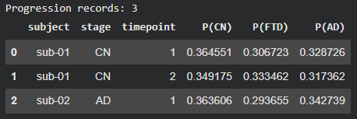
Classification Report and Confusion Matrix
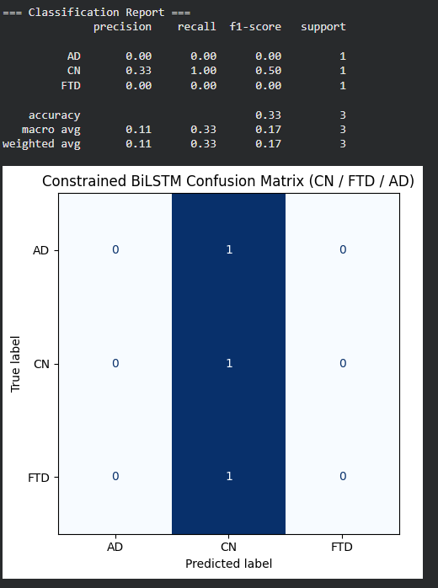
Patient Cohort Progression Heatmap (Without Qbit Analysis because of BiLSTM Fitting)
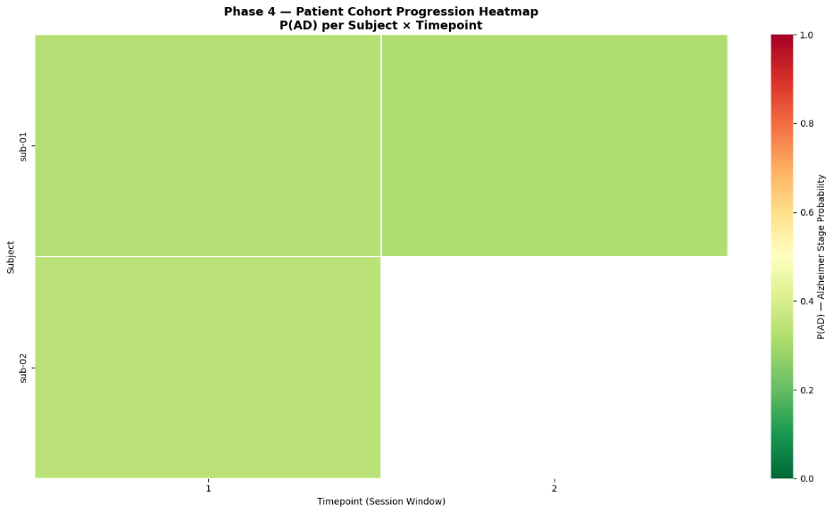
Kaplan-Meier Style Survival Curves based on each Event (Without Quantum Layer)
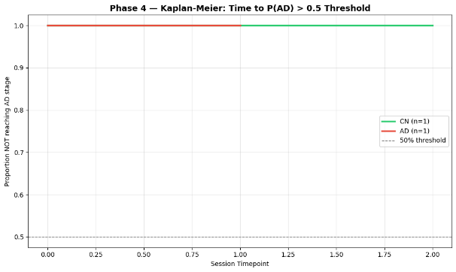
Mean Progression Trajectories by Stage
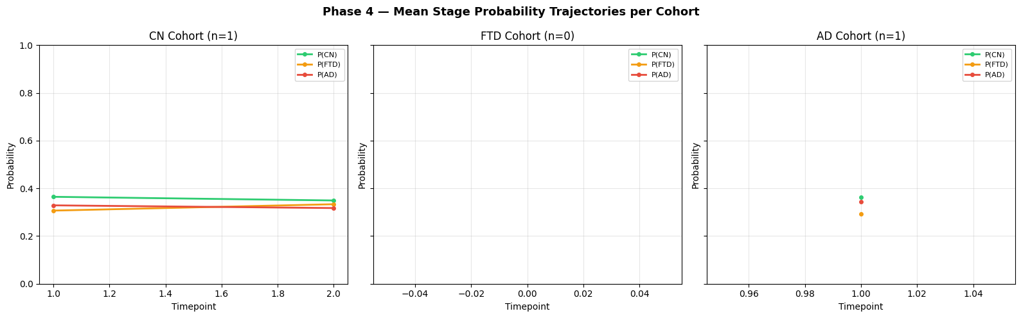
Bidirectional Gate Expectation Values ⟨no Q or Z Value⟩ per Stage
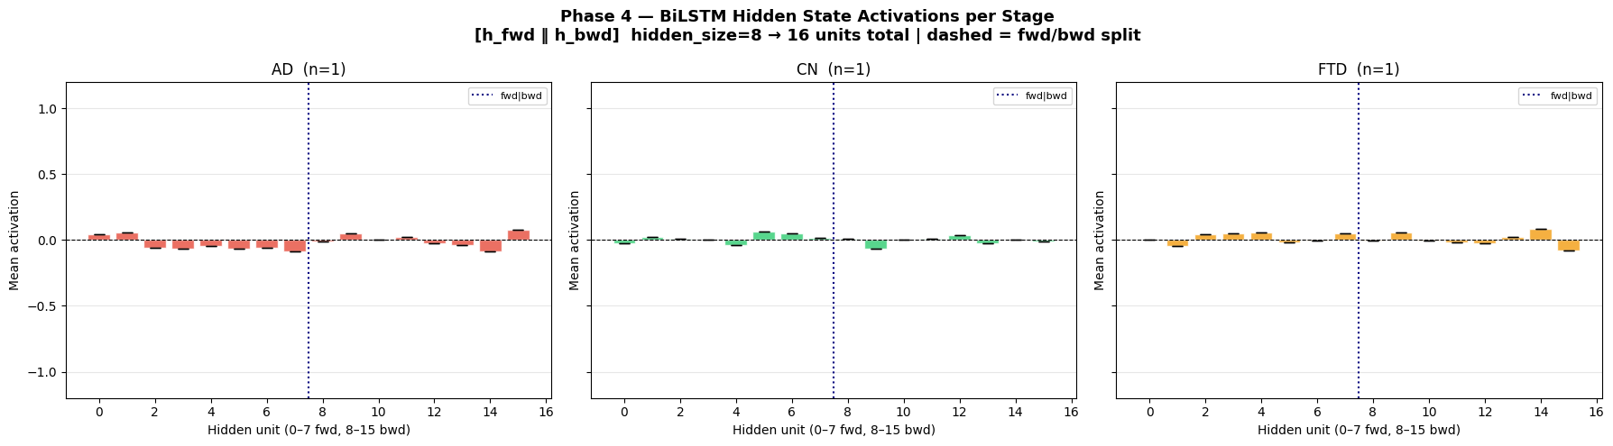

Longitudinal Progression Time-Series
Probability matrix: (timepoints, classes) based on full per-session probability trajectory for every subject
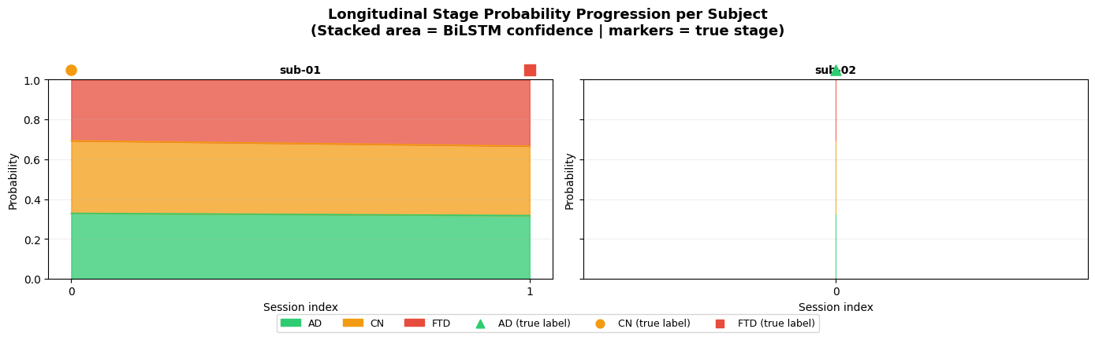
Final Performance Matrice
