CMPSC 445

M12 Assignment – Report on Python Backend Server with HTML/JS Frontend

Dhruv Shrivastava

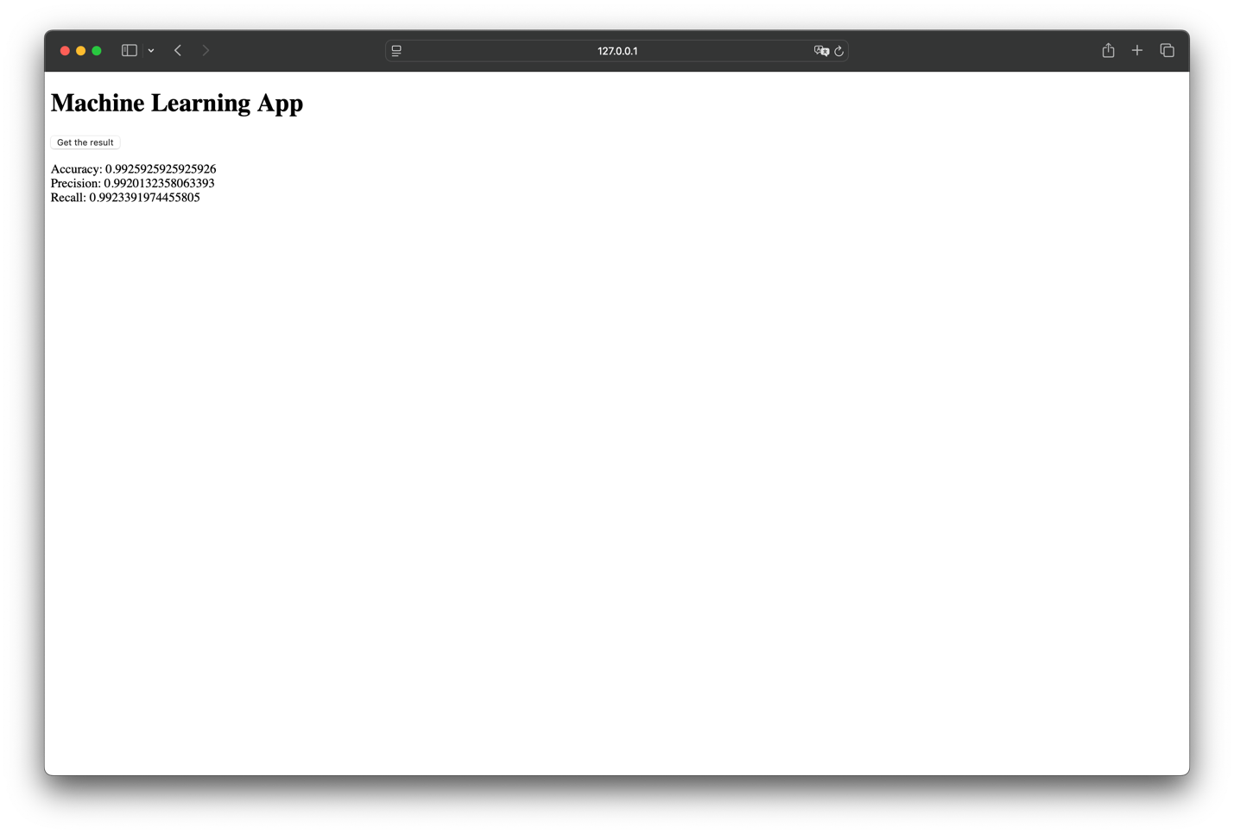Complete Content of Webpage at Localhost on port 8000

1. **Client Server Communication**

* The client (web page) sends a GET request to the server when we click the button.
* The server runs the machine learning model, calculates the metrics (accuracy, precision, recall), and returns them as a JSON response.
* The client then displays the results on the webpage.

1. **Server-Side Processing**

* The server (Flask) uses the k-Nearest Neighbors (kNN) classifier to classify images from the digits dataset (a dataset with lots of images of handwritten digits).
* It calculates accuracy, precision, recall, and then sends these metrics back to the client as JSON.
* The machine learning task is supervised classification of hand-written digits.