**Portfolio Selection**

Harry Markowitz

*The Journal of Finance*, Vol. 7, No. 1. (Mar., 1952), pp. 77-91.

Stable URL:

<http://links.jstor.org/sici?sici=0022-1082%28195203%297%3A1%3C77%3APS%3E2.0.CO%3B2-1>

*The Journal of Finance* is currently published by American Finance Association.

Your use of the JSTOR archive indicates your acceptance of JSTOR's Terms and Conditions of Use, available at <http://www.jstor.org/about/terms.html>. JSTOR's Terms and Conditions of Use provides, in part, that unless you have obtained prior permission, you may not download an entire issue of a journal or multiple copies of articles, and you may use content in the JSTOR archive only for your personal, non-commercial use.

Please contact the publisher regarding any further use of this work. Publisher contact information may be obtained at <http://www.jstor.org/journals/afina.html>.

Each copy of any part of a JSTOR transmission must contain the same copyright notice that appears on the screen or printed page of such transmission.

The JSTOR Archive is a trusted digital repository providing for long-term preservation and access to leading academic journals and scholarly literature from around the world. The Archive is supported by libraries, scholarly societies, publishers, and foundations. It is an initiative of JSTOR, a not-for-profit organization with a mission to help the scholarly community take advantage of advances in technology. For more information regarding JSTOR, please contact [support@jstor.org.](mailto:support@jstor.org)

[http://www.jstor.org](http://www.jstor.org/) Mon Sep 3 01:12:50 2007

PORTFOLIO SELECTION*

HARRY MARKOWITZ

*The Rand Corporation*

THE PROCESS OF SELECTING a portfolio may be divided into two stages. The first stage starts with observation and experience and ends with beliefs about the future performances of available securities. The second stage starts with the relevant beliefs about future performances and ends with the choice of portfolio. This paper is concerned with the second stage. We first consider the rule that the investor does (or should) maximize discounted expected, or anticipated, returns. This rule is re­ jected both as a hypothesis to explain, and as a maximum to guide in­ vestment behavior. We next consider the rule that the investor does (or should) consider expected return a desirable thing *and* variance of re­ turn an undesirable thing. This rule has many sound points, both as a maxim for, and hypothesis about, investment behavior. We illustrate geometrically relations between beliefs and choice of portfolio accord­ ing to the "expected returns-variance of returns" rule.

One type of rule concerning choice of portfolio is that the investor does (or should) maximize the discounted (or capitalized) value of future returns.1 Since the future is not known with certainty, it must be "expected" or ''anticipated" returns which we discount. Variations of this type of rule can be suggested. Following Hicks, we could let "anticipated" returns include an allowance for risk.2 Or, we could let the rate at which we capitalize the returns from particular securities vary with risk.

The hypothesis (or maxim) that the investor does (or should) maximize discounted return must be rejected. If we ignore market im­ perfections the foregoing rule never implies that there is a diversified portfolio which is preferable to all non-diversified portfolios. Diversi­ fication is both observed and sensible; a rule of behavior which does not imply the superiority of diversification must be rejected both as a hypothesis and as a maxim.

* This paper is based on work done by the author while at the Cowles Commission for Research in Economics and with the financial assistance of the Social Science Research Council. It will be reprinted as Cowles Commission Paper, New Series, No. 60.

1. See, for example, J.B. Williams, *The Theory of Investment Value* (Cambridge, Mass.: Harvard University Press, 1938), pp. 55-75.
2. J. R. Hicks, *Value and Capital* (New York: Oxford University Press, 1939), p. 126. Hicks applies the rule to a firm rather than a portfolio.

77

*The Journal of Finance*

The foregoing rule fails to imply diversification no matter how the anticipated returns are formed; whether the same or different discount rates are used for different securities; no matter how these discount rates are decided upon or how they vary over time.3 The hypothesis implies that the investor places all his funds in the security with the greatest discounted value. If two or more securities have. the same val­ ue, then any of these or any combination of these is as good as any other.

We can see this analytically: suppose there are *N* securities; let *ril* be the anticipated return (however decided upon) at time *t* per dollar in­ vested in security *i;* let *dil* be the rate at which the return on the *ith* security at time tis discounted back to the present; let *X,* be the rela­ tive amount invested in security *i.* We exclude short sales, thus *X,* 0 for all *i.* Then the discounted anticipated return of the portfolio is

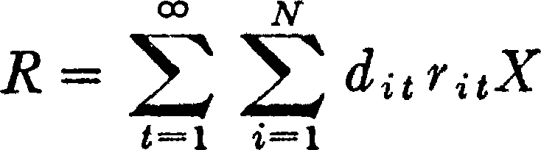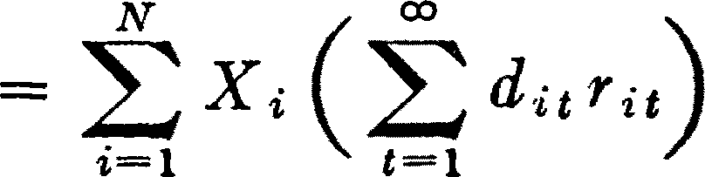

00

*R;* = *d;1 r;1* is the discounted return of the *ith* security, therefore

1-1

*R* = *'1:,X.R.* where *R.* is independent of *X •.* Since *X,* 0 for all *i* and *'l:,X;.* = 1, Risa weighted average of *R.* with the *X;* as non-nega­ tive weights. To maximize *R,* we let *X.* = 1 for *i* with maximum *R;.* If several *Raa, a* = 1, ... , *K* are maximum then any allocation with

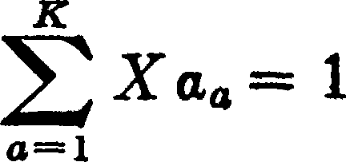

maximizes *R.* In no case is a diversified portfolio preferred to all non­ diversified portfolios.*4*

It will be convenient at this point to consider a static model. In­ stead of speaking of the time series of returns from the i'" security (r;1, *r;2,* ... , *ru,* ... ) we will speak of "the flow of returns" **(r.)** from the *ith* security. The flow of returns from the portfolio as a whole is

1. The results depend on the assumption that the anticipated returns and discount rates are independent of the particular investor's portfolio.
2. If short sales were allowed, an infinite amount of money would be placed in **the**

security with highest *r.*

*Portfolio Selection* 79

*R* = *1:X #'*;. As in the dynamic case if the investor wished to maximize "anticipated" return from the portfolio he would place all his funds in that security with maximum anticipated returns.

There is a rule which implies both that the investor should diversify and that he should maximize expected return. The rule states that the investor does (or should) diversify his funds among all those securities which give maximum expected return. The law of large numbers will insure that the actual yield of the portfolio will be almost the same as the expected yield.5 This rule is a special case of the expected returns­ variance of returns rule (to be presented below). It assumes that there is a portfolio which gives both maximum expected return and minimum variance, and it commends this portfolio to the investor.

This presumption, that the law of large numbers applies to a port­ folio of securities, cannot be accepted. The returns from securities are too intercorrelated. Diversification cannot eliminate all variance.

The portfolio with maximum expected return is not necessarily the one with minimum variance. There is a rate at which the investor can gain expected return by talcing on variance, or reduce variance by giv­ ing up expected return.

We saw that the expected returns or anticipated returns rule is in­ adequate. Let us now consider the expected returns-variance of re­ turns *(E-V)* rule. It will be necessary to first present a few elementary concepts and results of mathematical statistics. We will then show some implications of the *E-V* rule. After this we will discuss its plausi­ bility.

In our presentation we try to avoid complicated mathematical state­ ments and proofs. As a consequence a price is paid in terms of rigor and generality. The chief limitations from this source are (1) we do not derive our results analytically for the n-security case; instead, we present them geometrically for the 3 and 4 security cases; (2) we assume static probability beliefs. In a general presentation we must recognize that the probability distribution of yields of the various securities is a function of time. The writer intends to present, in the future, the gen­ eral, mathematical treatment which removes these limitations.

We will need the following elementary concepts and results of mathematical statistics:

Let *Y* be a random variable, i.e., a variable whose value is decided by chance. Suppose, for simplicity of exposition, that,.*Y* can take on a

finite number of values y1, )'2, ••• , *YN•* Let the probability that *Y* =

1. Williams, *op. cit.,* pp. 68, 69.

80 *The Journal of Finance*

*Yi,* be P1; that *Y* = *y2* be *P2* etc. The expected value (or mean) of *Y* is defined to be



The variance of *Y* is defined to be

*V* = P1 (y1 *-E)* 2+P2 (ya *-E)* 2+... +*PN (yN-E)* 2•

*Vis* the average squared deviation of *Y* from its expected value. *Vis* a commonly used measure of dispersion. Other measures of dispersion, closely related to *V* are the standard deviation, *<T* = *vV* and the co­

efficient of variation, *<TlE.*

Suppose we have a number of random variables: R1, ... , *Rn.* If *R* is a weighted sum (linear combination) of the *Ri*

*R* = a1R1+ *a a* +... + *anRn*

then *R* is also a random variable. (For example R1, may be the number which turns up on one die; *R2,* that of another die, and *R* the sum of these numbers. In this case *n* = 2, a1 = *a2* = 1).

It will be important for us to know how the expected value and variance of the weighted sum (R) are related to the probability dis­ tribution of the R1, ... , *Rn,* We state these relations below; we ref r the reader to any standard text for proof.6

The expected value of a weighted sum is the weighted sum of the expected values. I.e., *E(R)* = *a1E(R1)* + *a2E(R2)* + ... + *a11E(Rn)* The variance of a weighted sum is not as simple. To express it we must

define "covariance." The covariance of R1 and *R2* is



i.e., the expected value of [(the deviation of R1 from its mean) times (the deviation of *R2* from its mean)]. In general we define the covari­ ance between *R;* and *R1* as



*<T;f* may be expressed in terms of the familiar correlation coefficient (p;;). The covariance between *R;* and *Rf* is equal to [(their correlation) times (the standard deviation of *R,)* times (the standard deviation of *Ri)]:*



1. E.g., J. V. Uspensky, *Introduction to Mathematical Probability* (New York: McGraw­ Hill, 1937), chapter 9, pp. 161-81.

*Port/ olio Selection* 81

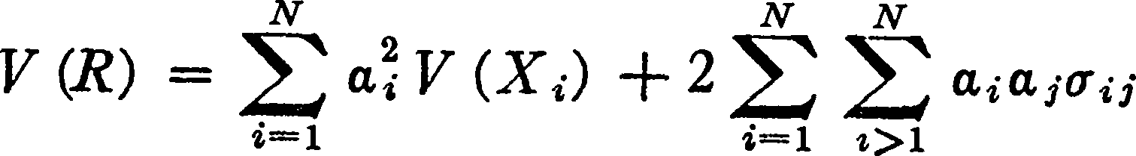The variance of a weighted sum is

If we use the fact that the variance of *R,* is *<1..* then

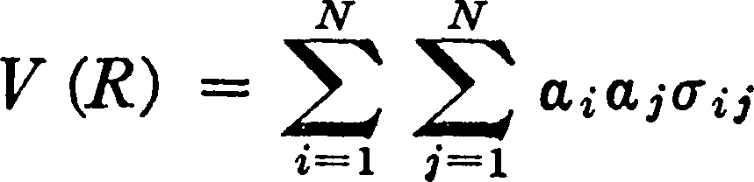

Let *R,* be the return on the *ith* security. Let *µ,* be the expected value of *Ri; <1;;,* be the covariance between *Ri* and *R;* (thus *<Tu* is the variance of *R.).* Let *X,* be the percentage of the investor's assets which are al­ located to the *,,,"'h* security. The yield *(R)* on the portfolio as a whole is

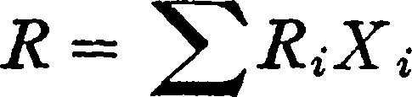

The *Ri* (and consequently *R)* are considered to be random variables.7 The *Xi* are not random variables, but are fixed by the investor. Since the *Xi* are percentages we have *Xi* = 1. In our analysis we will ex­ clude negative values of the *Xi* (i.e., short sales); therefore *Xi* 0 for all *i.*

The return *(R)* on the poitfolio as a whole is a weighted sum of ran­ dom variables (where the investor can choose the weights). From our discussion of such weighted sums we see that the expected return *E* from the portfolio as a whole is

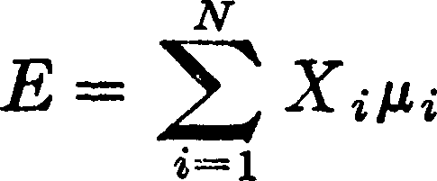

and the variance is

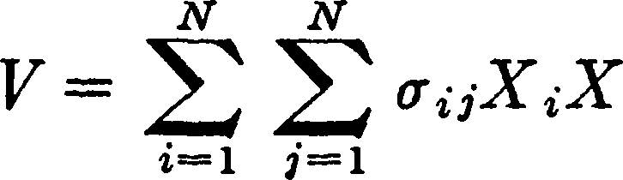

1. I.e., we assume that the investor does (and should) act as if he had probability beliefs concerning these variables. In general we would expect that the investor could tell us, for any two events (A and B), whether he personally considered A more likely than B, B more likely than A, or both equally likely. If the investor were consistent in his opinions on such matters, he would possess a system of probability beliefs. We cannot expect the investor to be consistent in every detail. We can, however, expect his probability beliefs to be roughly consistent on important matters that have been carefully considered. We should also expect that he will base his actions upon these probability beliefs-even though they be in part subjective.

This paper does not consider the difficult question of how investors do (or should) form their probability beliefs.

82 *The Journal of Finance*

For fixed probability beliefs (µi, *<T ii)* the investor has a choice of vari­ ous combinations of *E* and *V* depending on his choice of portfolio *Xi,* ... , *XN.* Suppose that the set of all obtainable (E, *V)* combina­ tions were as in Figure 1. The *E-V* rule states that the investor would (or should) want to select one of those portfolios which give rise to the (E, *V)* combinations indicated as efficient in the figure; i.e., those with minimum *V* for given *E* or more and maximum *E* for given *V* or less. There are techniques by which we can compute the set of efficient portfolios and efficient (E, *V)* combinations associated with given *µ;*

***V***

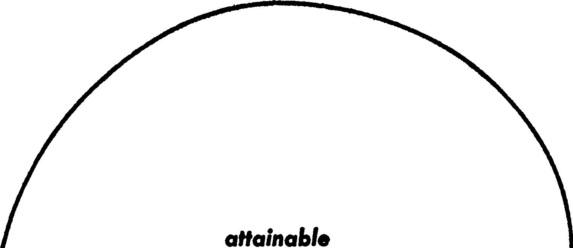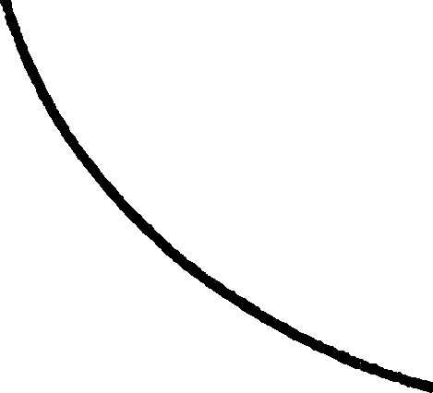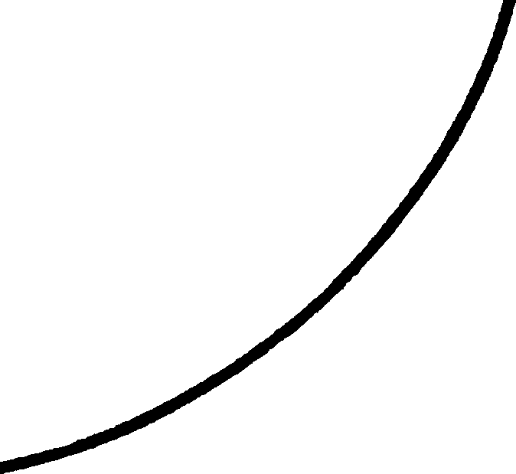

***E,V* com&inotions**

***efficient***

--- ***E,V com&lnotions***

***E***

FIG. 1

and *<Tii•* We will not present these techniques here. We will, however, illustrate geometrically the nature of the efficient surfaces for cases in which *N* (the number of available securities) is small.

The calculation of efficient surfaces might possibly be of practical use. Perhaps there are ways, by combining statistical techniques and the judgment of experts, to form reasonable probability beliefs (µ,, *u,;).* We could use these beliefs to compute the attainable efficient combinations of (E, *V).* The investor, being informed of what (E, *V)* combinations were attainable, could state which he desired. We could then find the portfolio which gave this desired combination.

*Portfolio Selection*

Two conditions-at least-must be satisfied before it would be prac­ tical to use efficient surfaces in the manner described above. First, the investor must desire to act according to the *E-V* maxim. Second, we must be able to arrive at reasonable *µi* and *<F;;.* We will return to these matters later.

Let us consider the case of three securities. In the three security case our model reduces to

3

1) *E= LX;µ;*

i=l

2) *V* ***=L***3 ***L***3

i=l i=l

*X;X;u;;*

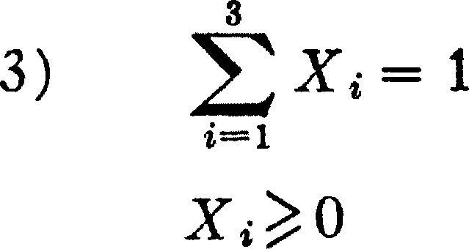4)

From (3) we get

for *i* = 1, 2, 3.

3') X3= l-X1-X2

If we substitute (3') in equation (1) and (2) we get *E* and Vas functions of X1 and *X2,* For example *we* find

1') *E=µa+X1(µ1-µa)* +X2(µ2-µs)

The exact formulas are not too important here (that of Vis given be­ low).8 We can simply write

1. . *E =E* (Xi, X2)
2. *V* = V(X1, X2)
3. X1;?:0,X2;?:0, 1-X1-X2;?:0

By using relations *(a), (b), (c),* we can work with two dimensional geometry.

The attainable set of portfolios consists of all portfolios which satisfy constraints *(c)* and (3') (or equivalently (3) and (4)). The at­ tainable combinations of X1, *X2* are represented by the triangle *abc* in Figure 2. Any point to the left of the *X2* axis is not attainable because it violates the condition that X1 ;?: 0. Any point below the X1 axis is not attainable because it violates the condition that *X2* ;?: 0. Any

+ 8. *V* = X1(1111 - 211u + 1133) + X;(1122 - 21123 + 113,) + 2X1X2(1112 - 11u - 1123 + 11s1)

2X1 (1113 - 1133) + 2Xl11;3 - 1133) + 1133

*The Journal of Finance*

point above the line **(1** - X1 - *X2* = O) is not attainable because it violates the condition that X3 = **1** - X1 - *X2* 0.

We define an *isomean* curve to be the set of all points (portfolios) with a given expected return. Similarly an *isovariance* line is defined to be the set of all points (portfolios) with a given variance of return.

An examination of the formulae for *E* and *V* tells us the shapes of the isomean and isovariance curves. Specifically they tell us that typically9 the isomean curves are a system of parallel straight lines; the isovari­ ance curves are a system of concentric ellipses (see Fig. 2). For example,

if *JJ.2* µ3 equation **1'** can be written in the familiar form *X2* = *a+*

*bX1;* specifically (1)

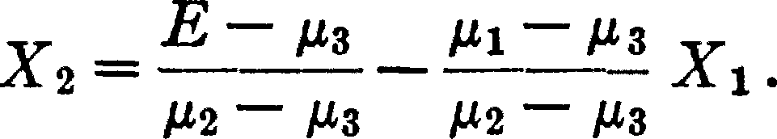

Thus the slope of the isomean line associated with *E* = *E0* is - (µ1 - µ3)/(µ2 - µ3) its intercept is *(E0* - µ3)/(µ2 - µ3). If we change *Ewe* change the intercept but not the slope of the isomean line. This con­ firms the contention that the isomean lines form a system of para:lel lines.

Similarly, by a somewhat less simple application of analytic geome­ try, we can confirm the contention that the isovariance lines form a family of concentric ellipses. The "center" of the system is the point which minimizes *V.* We will label this point ***X.*** Its expected return and variance we will label ***E*** and ***V.*** Variance increases as you move away from ***X.*** More precisely, if one isovariance curve, C1, lies closer to ***X*** than another, C2, then C1 is associated with a smaller variance than C2.

With the aid of the foregoing geometric apparatus let us seek the efficient sets.

***X,*** the center of the system of isovariance ellipses, may fall either inside or outside the attainable set. Figure 4 illustrates a case in which Xfalls inside the attainable set. In this case: **Xis** efficient. For no other portfolio has a *V* as low as ***X;*** therefore no portfolio can have either smaller *V* (with the same or greater *E)* or greater *E* with the same or smaller *V.* No point (portfolio) with expected return *E* less than ***E***

is efficient. For we have ***E*** > *E* and ***V*** < *V.*

Consider all points with a given expected return *E;* i.e., all points on the isomean line associated with *E.* The point of the isomean line at which *V* takes on its least value is the point at which the isomean line

1. The isomean "curves" are as described above except when µ1 = *µ2* = µ3• In the latter case all portfolios have the same expected return and the investor chooses the one with minimum variance.

As to the assumptions implicit in our description of the isovariance curves see footnote

**12.**

*Portfolio Selection* 85

**A**

is tangent to an isovariance curve. We call this point *X(E).* If we let

**A**

*E* vary, *X(E)* traces out a curve.

Algebraic considerations (which we omit here) show us that this curve is a straight line. We will call it the critical line *l.* The critical line passes through ***X*** for this point minimizes *V* for all points with *E(X1,* X2) = ***E.*** As we go along *l* in either direction from ***X,*** *V* increases. The segment of the critical line from ***X*** to the point where the critical line crosses

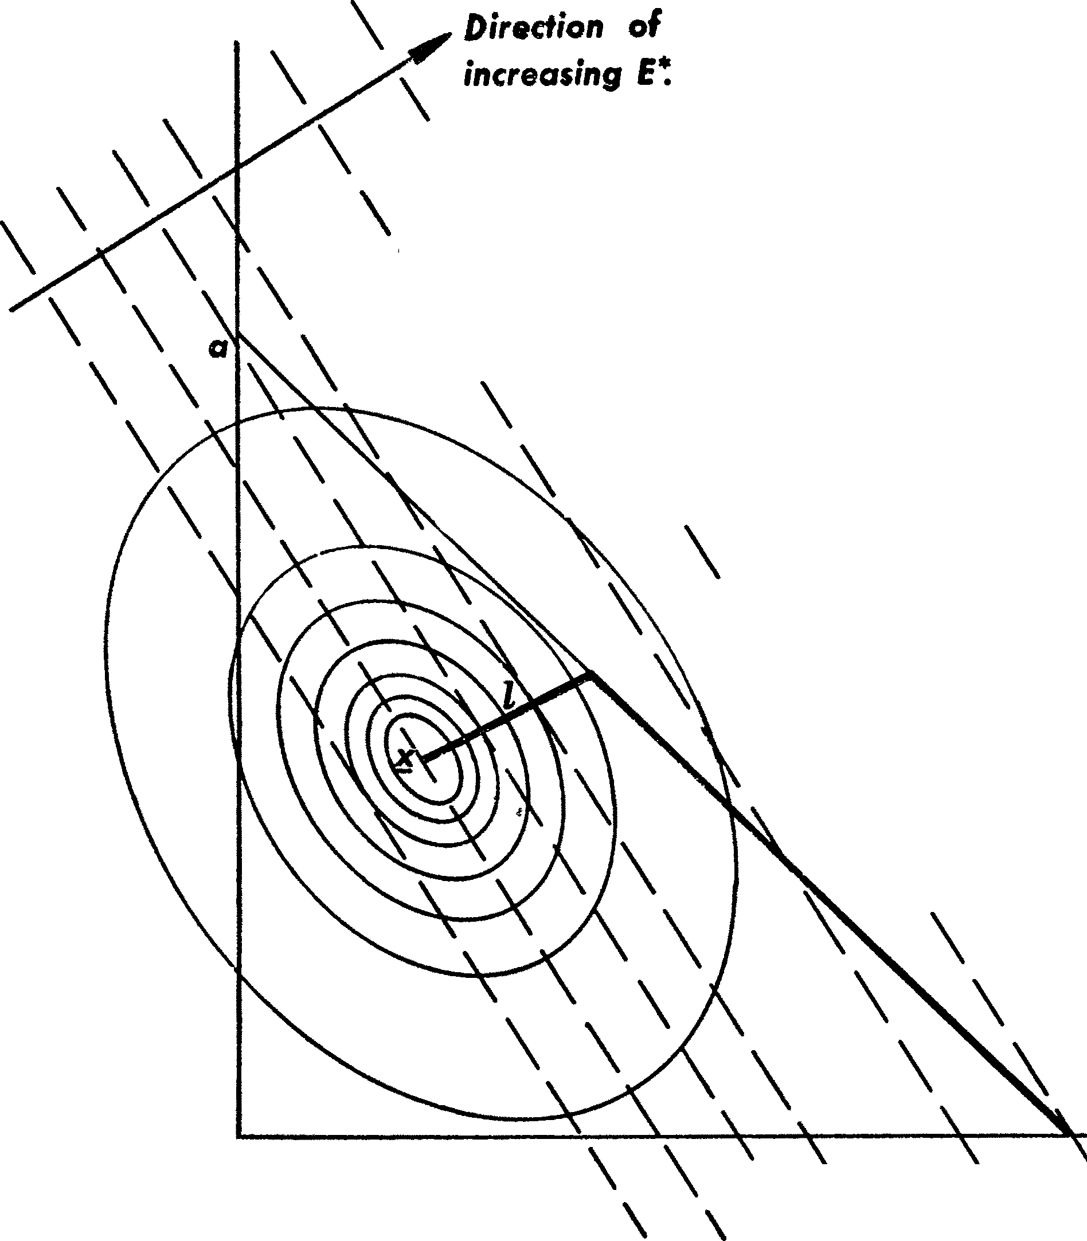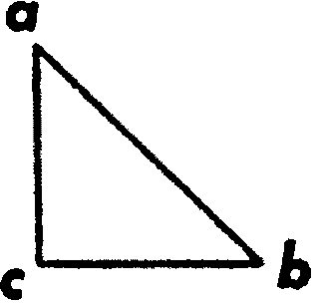

***X,***

\

\ \

\

**isomean lines** - - - -

\\

\

**isovariance curves**0

**efficient portfolios** ---

\ ***attainable* set**

\

\

\

\

\

**C**

\ \

&

\ \

***X,***

* ***direction* of *increasing E depends* on** *µ.,, µ.,. µ.,*

Fm. 2

the boundary of the attainable set is part of the efficient set. The rest of the efficient set is (in the case illustrated) the segment of the *ab* line from *d* to *b.* bis the point of maximum attainable *E.* In Figure 3, ***X*** lies outside the admissible area but the critical line cuts the admissible area. The efficient line begins at the attainable point with minimum variance (in this case on the *ab* line). It moves toward *b* until it inter­ sects the critical line, moves along the critical line until it intersects a boundary and finally moves along the boundary to *b.* The reader may

**a**

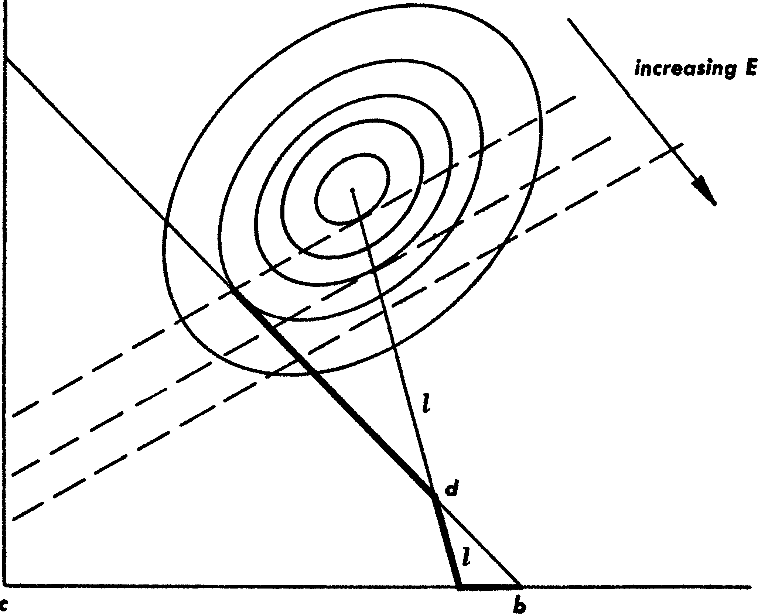

FIG. 3

**ell/c/ent porllol/os** -.,

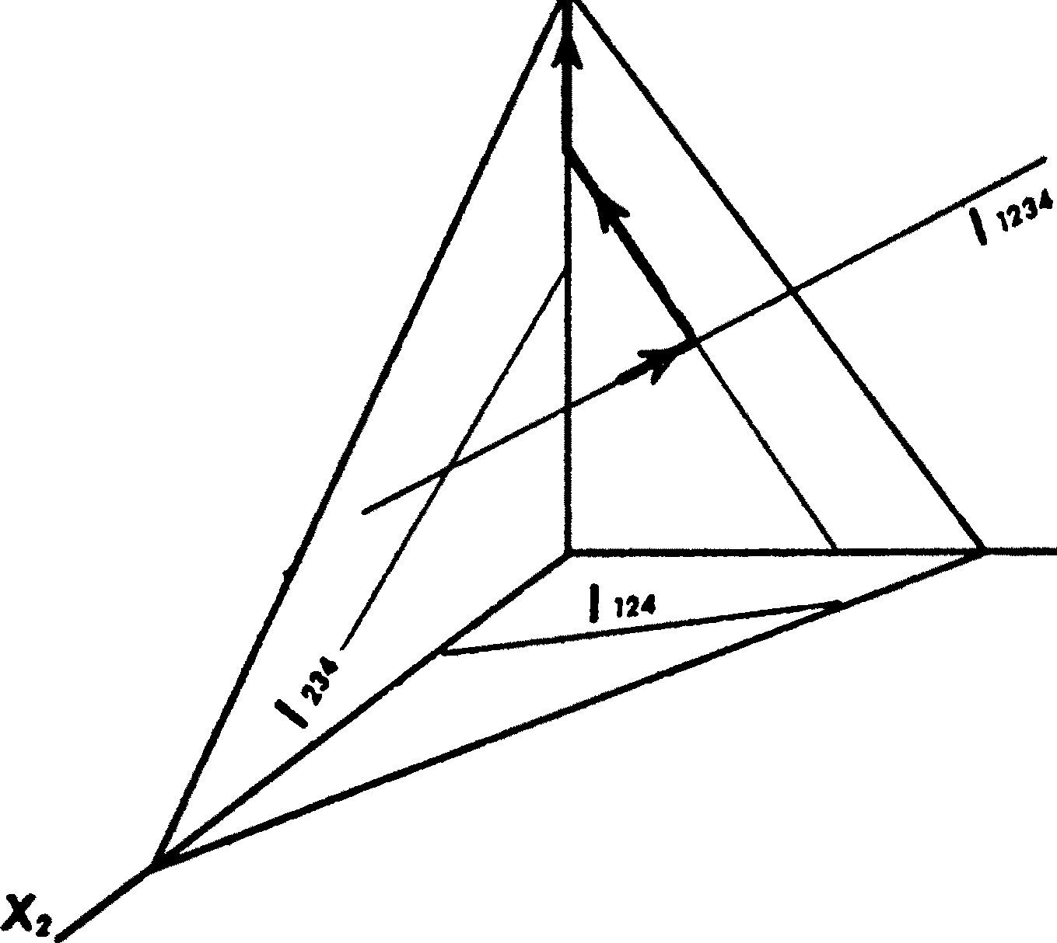

***x.***

FIG. 4

# *Portfolio Selection*

wish to construct and examine the following other cases: (1) ***X*** lies outside the attainable set and the critical line does not cut the attain­ able set. In this case there is a security which does not enter into any efficient portfolio. (2) Two securities have the same *µ,i.* In this case the isomean lines are parallel to a boundary line. It may happen that the efficient portfolio with maximum *E* is a diversified portfolio. (3) A case wherein only one portfolio is efficient.

The efficient set in the 4 security case is, as in the 3 security and also the *N* security case, a series of connected line segments. At one end of the efficient set is the point of minimum variance; at the other end is a point of maximum expected return10 (see Fig. 4).

Now that we have seen the nature of the set of efficient portfolios, it is not difficult to see the nature of the set of efficient (E, V) combina­

x:

+

tions. In the three security case *E* = ao a1X1 + *i½X2* is a plane; *V* = b0 + b1X1 + X2 + buX1X2 + *buX* + is a paraboloid.11 As shown in Figure 5, the section of the E-plane over the efficient portfolio

set is a series of connected line segments. The section of the V-parab­ oloid over the efficient portfolio set is a series of connected parabola segments. If we plotted *V* against *E* for efficient portfolios we would again get a series of connected parabola segments (see Fig. 6). This re­ sult obtains for any number of securities.

Various reasons recommend the use of the expected return-variance of return rule, both as a hypothesis to explain well-established invest­ ment behavior and as a maxim to guide one's own action. The rule serves better, we will see, as an explanation of, and guide to, "invest­ ment" as distinguished from "speculative" behavior.

1. Just as we used the equation ***L*4**

i=l

*X,* =

1 to reduce the dimensionality in the three

security case, we can use it to represent the four security case in 3 dimensional space. Eliminating *X,* we get *E* = *E(Xi,* X2, X3), *V* = *V(X1,* X2, X3). The attainable set is rep­ resented, in three-space, by the tetrahedron with vertices (0, 0, 0), (0, 0, 1), (0, 1, 0), (1, 0, 0),' representing portfolios with, respectively, *X,* = 1, X3 = 1, X2 = 1, X1 = 1.

Let *s123* be the subspace consisting of all points with *X,* = 0. Similarly we can define *Sai,* ... , *aa* to be the subspace consisting of all points with *X,* = 0, *i a1,* ... , *aa.* For each subspace *Sai,* ... , *aa* we can define a *critical line lai,* ••• *aa.* This line is the locus of

points *P* where *P* minimizes *V* for all points in *Sai,* ••• , *aa,* with the same *E* as *P.* If a point is in *sa1,* ... , *aa* and is efficient it must be on *la1,* ... , *aa.* The efficient set may be traced out by starting at the point of minimum available variance, moving continuously along various *la1,* ... , *aa,* according to definite rules, ending in a point which gives maximum *E.* As in the two dimensional case the point with minimum available variance may be in the interior of the available set or on one of its boundaries. Typically we proceed along a given critical line until either this line intersects one of a larger subspace or meets a boundary (and simultaneously the critical line of a lower dimensional subspace). In either of these cases the efficient line turns and continues along the new line. The efficient line terminates when a point with maximum *E* is reached.

1. See footnote 8.

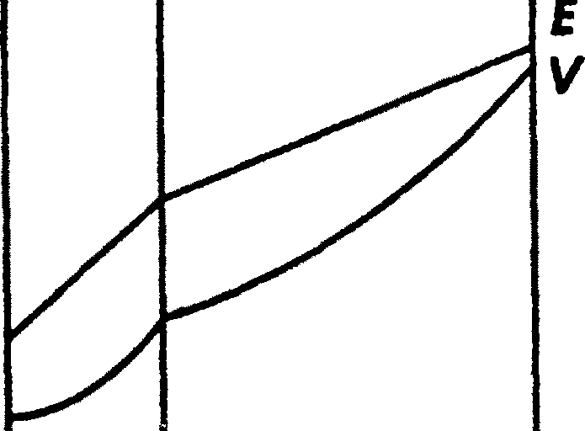

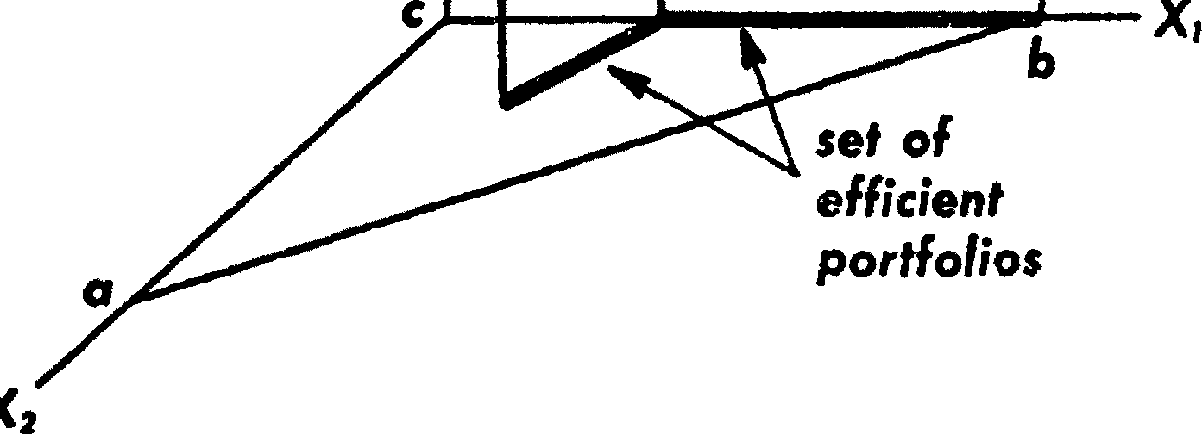

FIG. *5*

***V***

***efficient***

***E,V* comhinotlons**

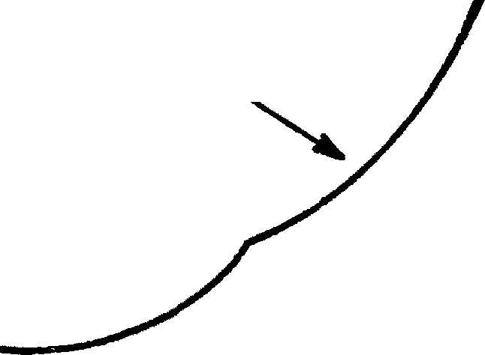

***E***

Fro. 6

# *Portfolio Selection*

Earlier we rejected the expected returns rule on the grounds that it never implied the superiority of diversification. The expected return­ variance of return rule, on the other hand, implies diversification for a wide range of *µi, Uii•* This does not mean that the *E-V* rule never im­ plies the superiority of an undiversi:fied portfolio. It is conceivable that one security might have an extremely higher yield and lower variance than all other securities; so much so that one particular undiversified portfolio would give maximum *E* and minimum *V.* But for a large, presumably representative range of *P.i, u.;* the *E-V* rule leads to efficient portfolios almost all of which are diversified.

Not only does the *E-V* hypothesis imply diversification, it implies the "right kind" of diversification for the "right reason." The adequacy of diversification is not thought by investors to depend solely on the number of different securities held. A portfolio with sixty different rail­ way securities, for example, would not be as well diversified as the same size portfolio with some railroad, some public utility, mining, various sort of manufacturing, etc. The reason is that it is generally more likely for firms within the same industry to do poorly at the same time than for firms in dissimilar industries.

Similarly in trying to make variance small it is not enough to invest in many securities. It is necessary to avoid investing in securities with high covariances among themselves. We should diversify across indus­ tries because firms in different industries, especially industries with different economic characteristics, have lower covariances than firms within an industry.

The concepts "yield" and "risk" appear frequently in :financial writings. Usually if the term "yield" were replaced by "expected yield" or "expected return," and "risk" by "variance of return," little change of apparent meaning would result.

Variance is a well-known measure of dispersion about the expected. If instead of variance the investor was concerned with standard error, *u* = vV, or with the coefficient of dispersion, *u/E,* his choice would

still lie in the set of efficient portfolios.

Suppose an investor diversifies between two portfolios (i.e., if he puts some of his money in one portfolio, the rest of his money in the other. An example of diversifying among portfolios is the buying of the shares of two different investment companies). If the two original portfolios have *equal* variance then typically12 the variance of the resulting (com­ pound) portfolio will be less than the variance of either original port-

1. In no case will variance be increased. The only case in which variance will not be decreased is if the return from both portfolios are perfectly correlated. To draw the iso­ variance curves as ellipses it is both necessary and sufficient to assume that no two distinct portfolios have perfectly correlated returns.

*The Journal of Finance*

folio. This is illustrated by Figure 7. To interpret Figure 7 we note that a portfolio *(P)* which is built out of two portfolios *P'* = *(X:, x;)* and *p"* = *(x:', x;')* is of the form *P* = *XP1* + (1 - *X)P"* = (XX: + (1 - X)x:', *xx;+* (1 - X)x;'). *P* is on the straight line connecting

*P'* andP".

The *E-V* principle is more plausible as a rule for investment behavior as distinguished from speculative behavior. The third moment13 *M* 3 of

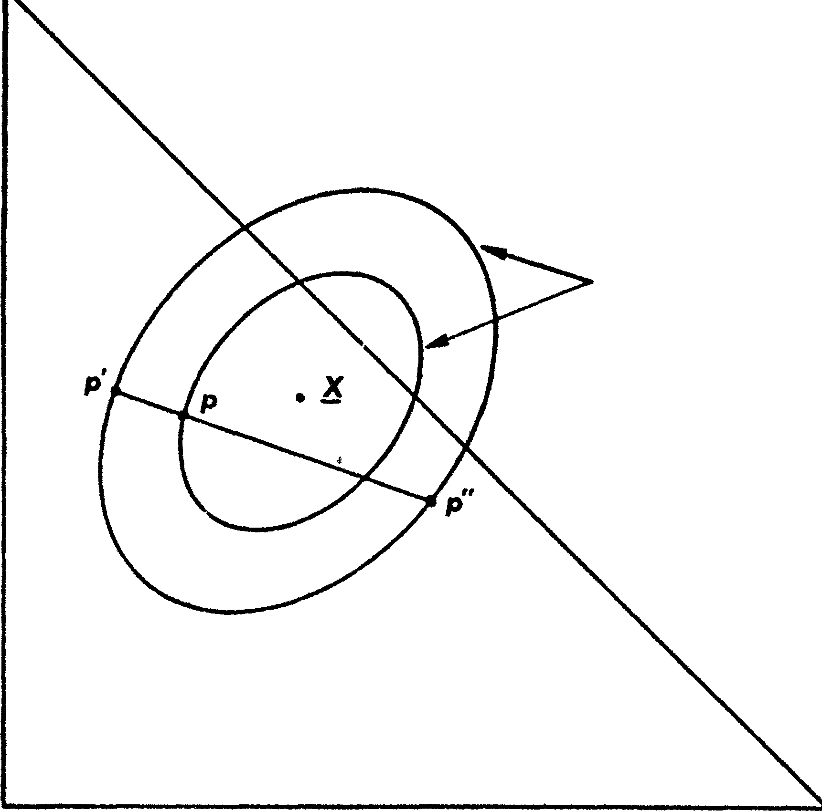

**isovariance fines**

,,

**X,**

***x.***

***a***

Fm. 7

the probability distribution of returns from the portfolio may be con­ nected with a propensity to gamble. For example if the investor maxi­ mizes utility *(U)* which depends on *E* and *V(U* = *U(E, V), au /aE* > 0, *au /iJE* < O) he will never accept an actuarially £air14 bet. But if

1. If *R* is a random variable that takes on a finite number of values *ri, .*.. , *r,.* with

probabilities *P1,* ... , *p,.* respectively, and expected value *E,* then *Ma* = ***L****n*

*p;(r;* - *E)3*

**i=l**

1. One in which the amount gained bv winning the bet times the probability of winning

*Portfolio Selection* 91

*U* = *U(E, V,* Ms) and if *aU/cJMs ¥-* 0 then there are some fair bets which would be accepted.

Perhaps-for a great variety of investing institutions which con­ sider yield to be a good thing; risk, a bad thing; gambling, to be avoided-E, *V* efficiency is reasonable as a working hypothesis and a working maxim.

Two uses of the *E-V* principle suggest themselves. We might use it in theoretical analyses or we might use it in the actual selection of portfolios.

In theoretical analyses we might inquire, for example, about the various effects of a change in the beliefs generally held about a firm, or a general change in preference as to expected return versus variance of return, or a change in the supply of a security. In our analyses the *Xi* might represent individual securities or they might represent aggre­ gates such as, say, bonds, stocks and real estate.15

To use the *E-V* rule in the selection of securities we must have pro­ cedures for finding reasonable *P.i* and *o-ii•* These procedures, I believe, should combine statistical techniques and the judgment of practical men. My feeling is that the statistical computations should be used to arrive at a tentative set of *P.i* and *O'ii•* Judgment should then be used in increasing or decreasing some of these *P.i* and *o-ii* on the basis of fac­ tors or nuances not taken into account by the formal computations. Using this revised set of *P.i* and *O'i;,* the set of efficient *E, V* combina­ tions could be computed, the investor could select the combination he preferred, and the portfolio which gave rise to this *E, V* combination could be found.

One suggestion as to tentative *µ.;, O'ii* is to use the observed *P.i, O'ii* for some period of the past. I believe that better methods, which take into account more information, can be found. I believe that what is needed is essentially a "probabilistic" reformulation of security analy­ sis. I will not pursue this subject here, for this is "another story." It is a story of which I have read only the first page of the first chapter. In this paper we have considered the second stage in the process of selecting a portfolio. This stage starts with the relevant beliefs about the securities involved and ends with the selection of a portfolio. We have not considered the first stage: the formation of the relevant be­

liefs on the basis of observation.

1. Care must be used in using and interpreting relations among aggregates. We cannot deal here with the problems and pitfalls of aggregation.