---

title: "Week 4 Project, Part 1 -- Simulation"

author: "Dhruv Singh"

date: "February 13, 2020"

output:

pdf_document: default

html_document: default

---

## PART 0: SETUP

echo settings for embedding code

```{r setup, include=FALSE}

knitr::opts_chunk$set(echo = TRUE)

library(knitr)

library(rmarkdown)

```

Setting Directory

```{r dir}

getwd()

setwd("C:/Dhruv/misc/data/R_6_statistical_inference/wk4_power_sampling")

```

## PART I: Simulation Exercise

Using starter code to motivate simulation

```{r random uniforms}

hist(runif(1000))

```

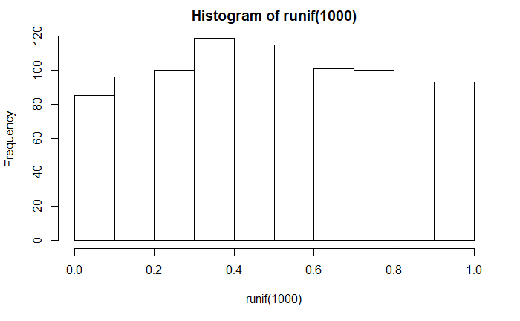

1000 avgs of 40 random unifs

```{r random uniform averages}

mns = NULL

for (i in 1 : 1000) mns = c(mns, mean(runif(40)))

hist(mns)

```

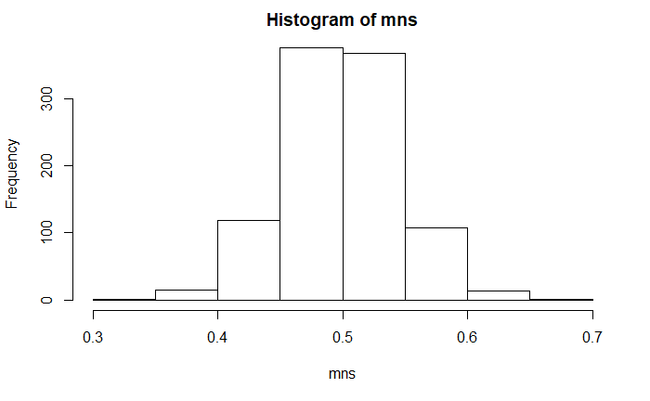

1. Simulating mean:

```{r mean sim}

# lambda = 0.2

# mean of one iteration/simulation

mean(rexp(40,0.2))

# mean of 1000 iterations / simulations

mean_simulation = NULL

for (i in 1 : 1000) mean_simulation = c(mean_simulation, mean(rexp(40, 0.2)))

{hist(mean_simulation)

abline(v=mean(mean_simulation), col = "red")

abline(v=1/0.2, col = "blue")}

```

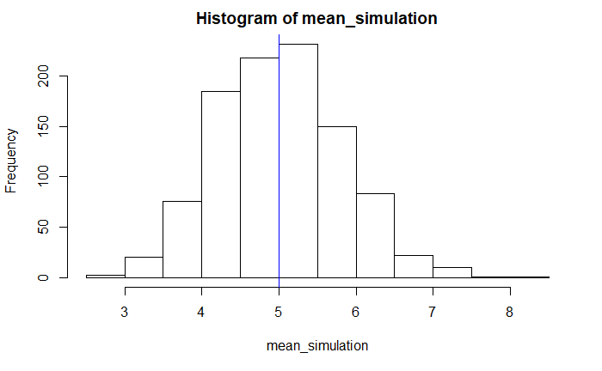

2. Simulating standard deviation:

```{r standard deviation simulation}

# lambda = 0.2

# std dev of one iteration/simulation

sd(rexp(40,0.2))

# std dev of 1000 iterations / simulations

stdev_simulation = NULL

for (i in 1 : 1000) stdev_simulation = c(stdev_simulation, sd(rexp(40, 0.2)))

{hist(stdev_simulation)

abline(v=sd(stdev_simulation), col = "red")

abline(v=1/0.2, col = "blue")}

# the returned standard deviation from the simulations (~1) is much smaller than the theorized standard deviation (~5)

```

