**Preliminary Findings of Market Research, with segments**

Methods Overview: Data representation of aggregates (groups) data by branch/district, and month, with roughly 8000 observations total.

(individual representations are contained separately)

Districts are classified as Low (L), Medium (M), and High (H) purchasers with respect to each of 4 products: Cook Stoves, Gobar Gas Plants, Jumbo Stoves, and Solar Lights.

**Product 1: Cook Stoves**

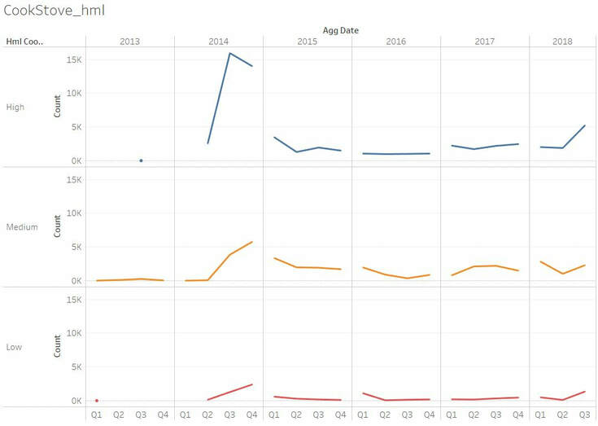 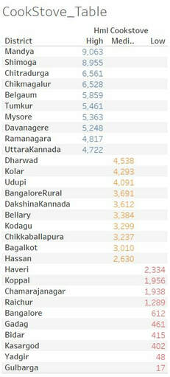

* Years offered: 2013 – 18, possibly shorter in some H and L areas.
* The general trend suggests an uptick in Cook Stove sales at the beginning of each year followed by a decline. There is a gradual overall decline in sales after the spike in 2014.

**Product 2: Gobar Gas Plant**

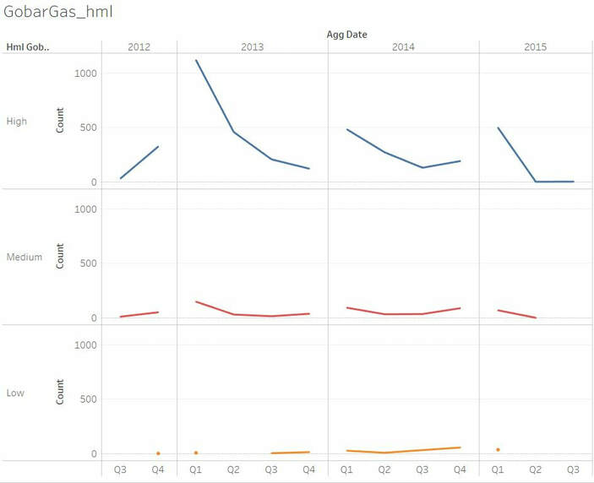 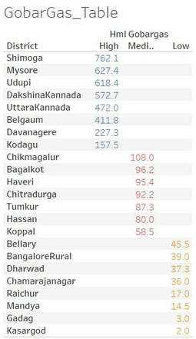

* Years offered: 2012 – 15.
* Places like Shimoga and Uttar Kannada continue to rank as H, while Raichur and Gadag are L. Spending on Gobar gas plants is higher towards the start of the year, in all 3 categories.

There is also see a slight increase towards the end of the year. Possibly because of dual use for heating. Absolute numbers are far lower than those of cookstoves.

**Product 3: Jumbo Stove**

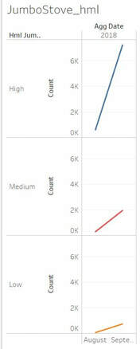 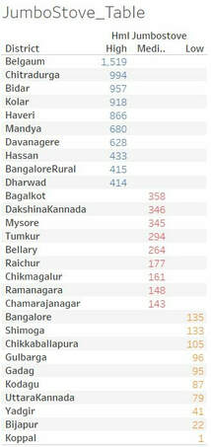

* Product offered late, 2018 – onward. High absolute sales considering late entry to market.
* Belgaum continues to rank as H, probably because it is one of the largest districts.

**Product 4: Solar Light**

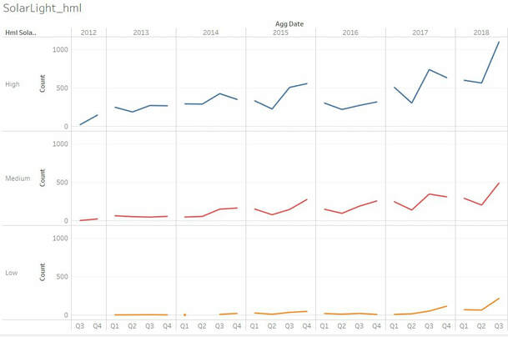 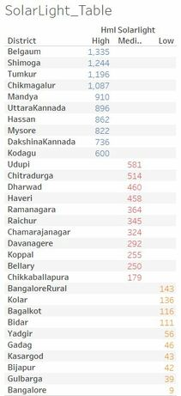

* Offered between 2012 and 2018.
* Sales for solar light increase over time. The yearly cycle for multiple years shows a min in 2nd quarter, and max in 3rd quarter. This must be owing to longer days in spring in summer, and shorter days around winter.