GET
FILE='C:\Dhruv\Week2_Nov4\data_training\SPSS\SPSS_Beginners_Tutorials\Introduction_to_SPSS\04_SPSS_Output–Basics,'+
'Tips&Tricks\bank.sav'.
DATASET NAME DataSet1 WINDOW=FRONT.
frequencies educ marit jtype
/barchart
/order variable.

Frequencies

Notes
Output Created |  | 08-NOV-2019 14:33:26
Comments
Input | Data | C:\Dhruv\Week2_Nov4\data_training\SPSS\SPSS_Beginners_Tutorials\Introduction_to_SPSS\04_SPSS_Output–Basics,Tips&Tricks\bank.sav
Input | Active Dataset | DataSet1
Input | Filter | <none>
Input | Weight | <none>
Input | Split File | <none>
Input | N of Rows in Working Data File | 464
Missing Value Handling | Definition of Missing | User-defined missing values are treated as missing.
Missing Value Handling | Cases Used | Statistics are based on all cases with valid data.
Syntax |  | frequencies educ marit jtype  /barchart  /order variable.
Resources | Processor Time | 00:00:01.56
Resources | Elapsed Time | 00:00:01.02

[DataSet1] C:\Dhruv\Week2_Nov4\data_training\SPSS\SPSS_Beginners_Tutorials\Introduction_to_SPSS\04_SPSS_Output–Basics,Tips&Tricks\bank.sav

Highest completed education level

Statistics
Highest completed education level
N | Valid | 447
N | Missing | 17

Highest completed education level
 |  | Frequency | Percent | Valid Percent | Cumulative Percent
Valid | Middle school or lower | 4 | .9 | .9 | .9
Valid | High school | 23 | 5.0 | 5.1 | 6.0
Valid | Undergraduate | 83 | 17.9 | 18.6 | 24.6
Valid | Bachelor's | 149 | 32.1 | 33.3 | 57.9
Valid | Master's | 136 | 29.3 | 30.4 | 88.4
Valid | PhD or higher | 47 | 10.1 | 10.5 | 98.9
Valid | No answer | 5 | 1.1 | 1.1 | 100.0
Valid | Total | 447 | 96.3 | 100.0
Missing | System | 17 | 3.7
Total |  | 464 | 100.0

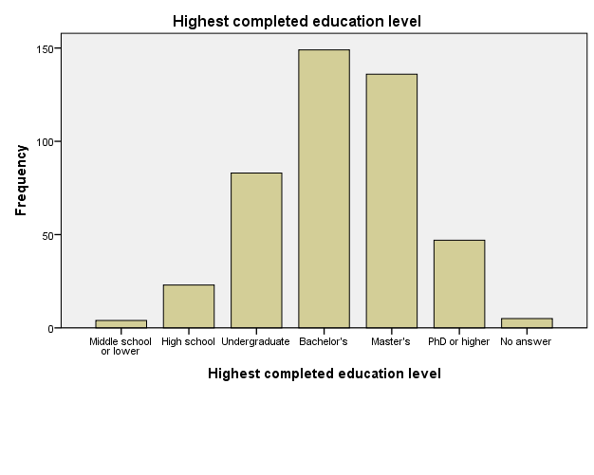

Marital status

Statistics
Marital status
N | Valid | 458
N | Missing | 6

Marital status
 |  | Frequency | Percent | Valid Percent | Cumulative Percent
Valid | never married | 129 | 27.8 | 28.2 | 28.2
Valid | currently married | 168 | 36.2 | 36.7 | 64.8
Valid | divorced | 110 | 23.7 | 24.0 | 88.9
Valid | widowed | 40 | 8.6 | 8.7 | 97.6
Valid | No answer | 11 | 2.4 | 2.4 | 100.0
Valid | Total | 458 | 98.7 | 100.0
Missing | System | 6 | 1.3
Total |  | 464 | 100.0

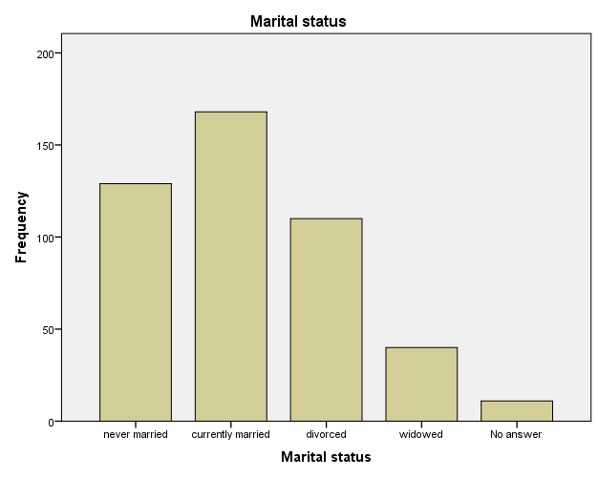

Current job type

Statistics
Current job type
N | Valid | 456
N | Missing | 8

Current job type
 |  | Frequency | Percent | Valid Percent | Cumulative Percent
Valid | Sales | 172 | 37.1 | 37.7 | 37.7
Valid | Marketing | 137 | 29.5 | 30.0 | 67.8
Valid | IT | 92 | 19.8 | 20.2 | 87.9
Valid | Middle Management | 30 | 6.5 | 6.6 | 94.5
Valid | Upper Management | 12 | 2.6 | 2.6 | 97.1
Valid | No answer | 13 | 2.8 | 2.9 | 100.0
Valid | Total | 456 | 98.3 | 100.0
Missing | System | 8 | 1.7
Total |  | 464 | 100.0

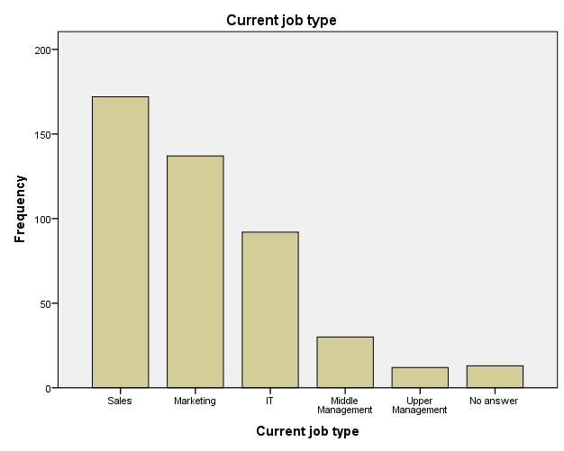

set
tnumbers labels
tvars labels.
set tlook 'C:\Program Files\IBM\SPSS\Statistics\24\Looks\Original.stt'.

Warning # 859 in column 11. Text: C:\Program Files\IBM\SPSS\Statistics\24\Looks\Original.stt
The TLOOK subcommand of the SET command has an invalid parameter. The
parameter must be either the keyword NONE or a file specification.
set tlook 'C:\Program Files\IBM\SPSS\Statistics\20\Looks\Original.stt'.

Warning # 859 in column 11. Text: C:\Program Files\IBM\SPSS\Statistics\20\Looks\Original.stt
The TLOOK subcommand of the SET command has an invalid parameter. The
parameter must be either the keyword NONE or a file specification.
set tlook 'C:\Program Files\IBM\SPSS\Statistics\20\Looks\Report.stt'.
frequencies educ marit jtype
/barchart
/order variable.

Frequencies

Notes
Output Created |  | 08-NOV-2019 16:11:44
Comments
Input | Data | C:\Dhruv\Week2_Nov4\data_training\SPSS\SPSS_Beginners_Tutorials\Introduction_to_SPSS\04_SPSS_Output–Basics,Tips&Tricks\bank.sav
Input | Active Dataset | DataSet1
Input | Filter | <none>
Input | Weight | <none>
Input | Split File | <none>
Input | N of Rows in Working Data File | 464
Missing Value Handling | Definition of Missing | User-defined missing values are treated as missing.
Missing Value Handling | Cases Used | Statistics are based on all cases with valid data.
Syntax |  | frequencies educ marit jtype  /barchart  /order variable.
Resources | Processor Time | 00:00:00.37
Resources | Elapsed Time | 00:00:00.37

[DataSet1] C:\Dhruv\Week2_Nov4\data_training\SPSS\SPSS_Beginners_Tutorials\Introduction_to_SPSS\04_SPSS_Output–Basics,Tips&Tricks\bank.sav

Highest completed education level

Statistics
Highest completed education level
N | Valid | 447
N | Missing | 17

Highest completed education level
 |  | Frequency | Percent | Valid Percent | Cumulative Percent
Valid | Middle school or lower | 4 | .9 | .9 | .9
Valid | High school | 23 | 5.0 | 5.1 | 6.0
Valid | Undergraduate | 83 | 17.9 | 18.6 | 24.6
Valid | Bachelor's | 149 | 32.1 | 33.3 | 57.9
Valid | Master's | 136 | 29.3 | 30.4 | 88.4
Valid | PhD or higher | 47 | 10.1 | 10.5 | 98.9
Valid | No answer | 5 | 1.1 | 1.1 | 100.0
Valid | Total | 447 | 96.3 | 100.0
Missing | System | 17 | 3.7
Total |  | 464 | 100.0

Marital status

Statistics
Marital status
N | Valid | 458
N | Missing | 6

Marital status
 |  | Frequency | Percent | Valid Percent | Cumulative Percent
Valid | never married | 129 | 27.8 | 28.2 | 28.2
Valid | currently married | 168 | 36.2 | 36.7 | 64.8
Valid | divorced | 110 | 23.7 | 24.0 | 88.9
Valid | widowed | 40 | 8.6 | 8.7 | 97.6
Valid | No answer | 11 | 2.4 | 2.4 | 100.0
Valid | Total | 458 | 98.7 | 100.0
Missing | System | 6 | 1.3
Total |  | 464 | 100.0

Current job type

Statistics
Current job type
N | Valid | 456
N | Missing | 8

Current job type
 |  | Frequency | Percent | Valid Percent | Cumulative Percent
Valid | Sales | 172 | 37.1 | 37.7 | 37.7
Valid | Marketing | 137 | 29.5 | 30.0 | 67.8
Valid | IT | 92 | 19.8 | 20.2 | 87.9
Valid | Middle Management | 30 | 6.5 | 6.6 | 94.5
Valid | Upper Management | 12 | 2.6 | 2.6 | 97.1
Valid | No answer | 13 | 2.8 | 2.9 | 100.0
Valid | Total | 456 | 98.3 | 100.0
Missing | System | 8 | 1.7
Total |  | 464 | 100.0

SET CTEMPLATE 'C:\Program Files\IBM\SPSS\Statistics\20\Looks\APA_Styles.sgt'.
SET CTEMPLATE 'C:\Program Files\IBM\SPSS\Statistics\20\Looks\APA_Styles.sgt'.
frequencies educ marit jtype
/barchart
/order variable.

Frequencies

Notes
Output Created |  | 08-NOV-2019 16:26:00
Comments
Input | Data | C:\Dhruv\Week2_Nov4\data_training\SPSS\SPSS_Beginners_Tutorials\Introduction_to_SPSS\04_SPSS_Output–Basics,Tips&Tricks\bank.sav
Input | Active Dataset | DataSet1
Input | Filter | <none>
Input | Weight | <none>
Input | Split File | <none>
Input | N of Rows in Working Data File | 464
Missing Value Handling | Definition of Missing | User-defined missing values are treated as missing.
Missing Value Handling | Cases Used | Statistics are based on all cases with valid data.
Syntax |  | frequencies educ marit jtype  /barchart  /order variable.
Resources | Processor Time | 00:00:00.31
Resources | Elapsed Time | 00:00:00.36

[DataSet1] C:\Dhruv\Week2_Nov4\data_training\SPSS\SPSS_Beginners_Tutorials\Introduction_to_SPSS\04_SPSS_Output–Basics,Tips&Tricks\bank.sav

Highest completed education level

Statistics
Highest completed education level
N | Valid | 447
N | Missing | 17

Highest completed education level
 |  | Frequency | Percent | Valid Percent | Cumulative Percent
Valid | Middle school or lower | 4 | .9 | .9 | .9
Valid | High school | 23 | 5.0 | 5.1 | 6.0
Valid | Undergraduate | 83 | 17.9 | 18.6 | 24.6
Valid | Bachelor's | 149 | 32.1 | 33.3 | 57.9
Valid | Master's | 136 | 29.3 | 30.4 | 88.4
Valid | PhD or higher | 47 | 10.1 | 10.5 | 98.9
Valid | No answer | 5 | 1.1 | 1.1 | 100.0
Valid | Total | 447 | 96.3 | 100.0
Missing | System | 17 | 3.7
Total |  | 464 | 100.0

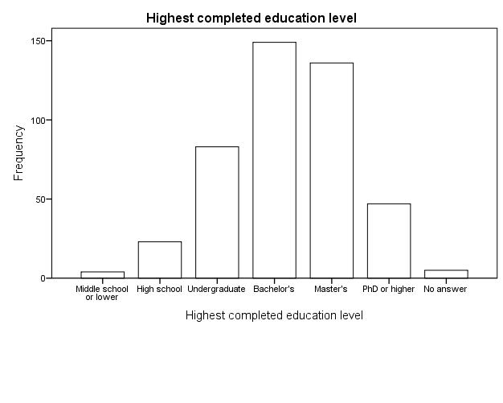

Marital status

Statistics
Marital status
N | Valid | 458
N | Missing | 6

Marital status
 |  | Frequency | Percent | Valid Percent | Cumulative Percent
Valid | never married | 129 | 27.8 | 28.2 | 28.2
Valid | currently married | 168 | 36.2 | 36.7 | 64.8
Valid | divorced | 110 | 23.7 | 24.0 | 88.9
Valid | widowed | 40 | 8.6 | 8.7 | 97.6
Valid | No answer | 11 | 2.4 | 2.4 | 100.0
Valid | Total | 458 | 98.7 | 100.0
Missing | System | 6 | 1.3
Total |  | 464 | 100.0

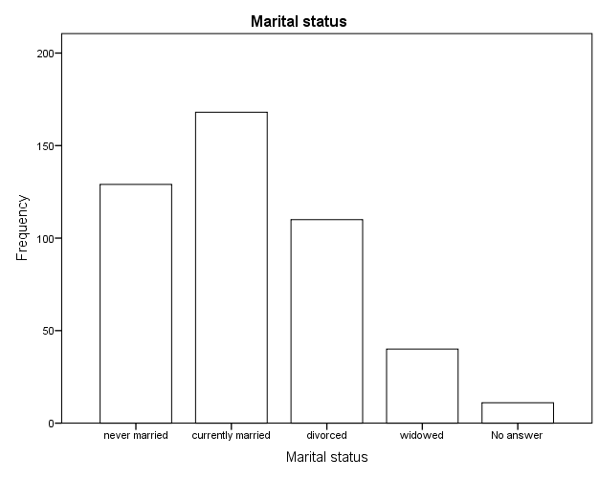

Current job type

Statistics
Current job type
N | Valid | 456
N | Missing | 8

Current job type
 |  | Frequency | Percent | Valid Percent | Cumulative Percent
Valid | Sales | 172 | 37.1 | 37.7 | 37.7
Valid | Marketing | 137 | 29.5 | 30.0 | 67.8
Valid | IT | 92 | 19.8 | 20.2 | 87.9
Valid | Middle Management | 30 | 6.5 | 6.6 | 94.5
Valid | Upper Management | 12 | 2.6 | 2.6 | 97.1
Valid | No answer | 13 | 2.8 | 2.9 | 100.0
Valid | Total | 456 | 98.3 | 100.0
Missing | System | 8 | 1.7
Total |  | 464 | 100.0

