Exercise Problems for Module 11

The exercise problems in Module 11 provide practice with falsify functional dependencies in sample rows and performing schema conversion and normalization together.

- For the big university database table, list FDs with the column StdCity as the determinant that are falsified by sample rows. For each FD, you should identify one falsification example or indicate that no falsification example exists in the sample rows. Remember that it takes two rows to falsify an FD in which the LHS is the same in both rows but the RHS is different.
Table 1: Sample Data for the Big University Database Table
StdNo | StdCity | StdClass | OfferNo | OffTerm | OffYear | EnrGrade | CourseNo | CrsDesc
s1 | seattle | jun | o1 | fall | 2017 | 3.5 | c1 | db
s1 | seattle | jun | o2 | fall | 2017 | 3.3 | c2 | vb
s2 | bothell | jun | o3 | SPRING | 2018 | 3.1 | c3 | oo
s2 | bothell | jun | o2 | fall | 2017 | 3.4 | c2 | vb

- You should add one or more sample rows to Table 1 for the FDs in problem 1 with no falsification example. For each non falsified FD with StdCity as the determinant, you should add one or more sample rows and then identify a falsification example involving the new row(s) and rows from Table 1.
- Convert the ERD in Figure 1 into tables and perform further normalization as needed. Your conversion result should show the list of tables with primary keys, foreign keys, and not null constraints. After converting the ERD to tables, specify FDs for each table. Since the primary key of each table determines the other columns, you should only identify FDs in which the LHS is not the primary key. If a table is not in BCNF, explain why and split it into two or more tables that are in BCNF.

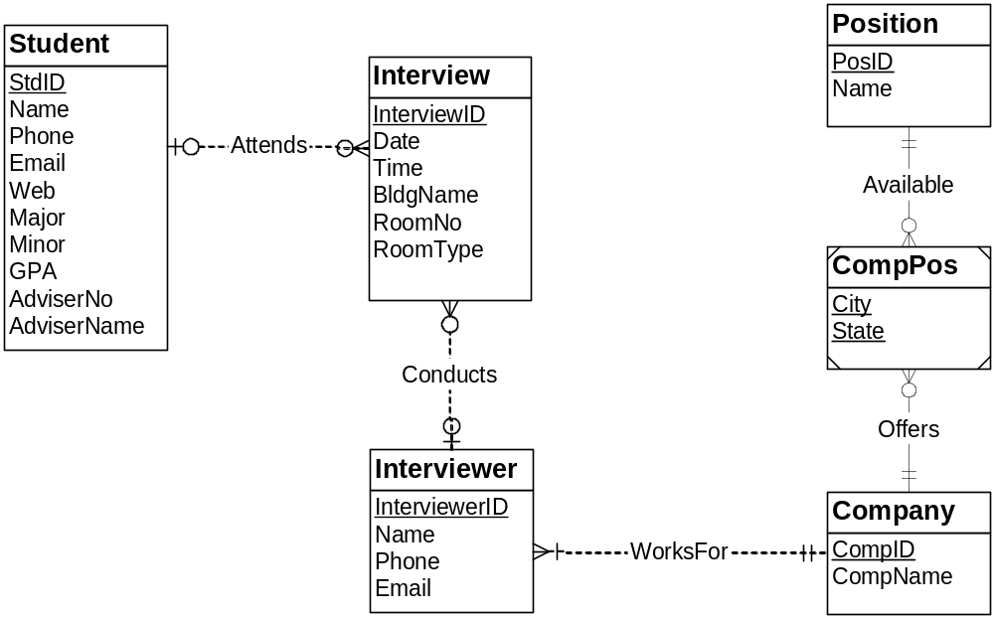
Figure 1: ERD for Problem 3
- Apply the simple BCNF procedure to the following list of FDs. Show the result of each step. In the final list of tables, you should show the primary keys, foreign keys, and unique constraints. You do not need to write CREATE TABLE statements.
AuthNo → AuthName
AuthEmail → AuthNo
PaperNo → Primary-AuthNo
AuthNo → AuthAddress
AuthNo → AuthEmail
PaperNo → PapTitle
PaperNo → PapAbstract
PaperNo → PapStatus
RevNo → RevName
RevNo → RevEmail
RevEmail → RevNo
RevNo, PaperNo → Auth-Comm
RevNo, PaperNo → Prog-Comm
RevNo, PaperNo → RevDate
RevNo, PaperNo → Rating
RevNo → RevAddress

