Assignment for Module 7, Q4

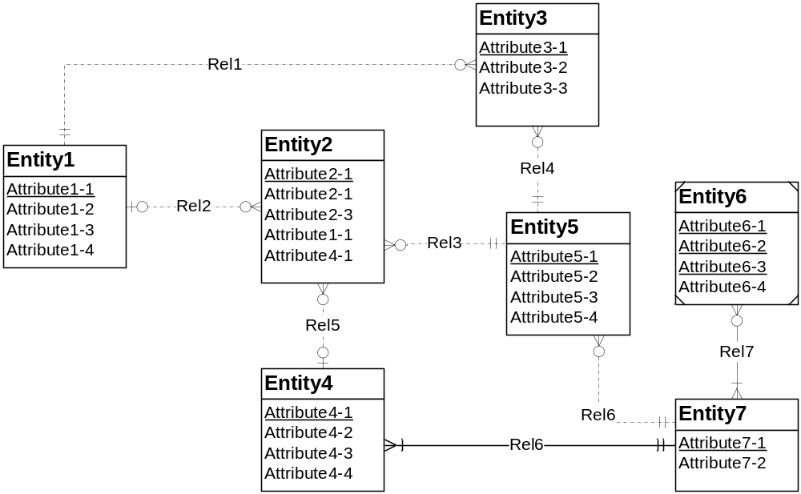
Figure 1: ERD for Problem 4

Consistency rule violations in above diagram are as follows:

- Entity 2: Redundant FK violation (1-1) (4-1)
- Entity 6: Weak entity type violation
- Entity 6: Multiple primary key violation
- Rel 6: Id dependency rule violation
- Rel 7: Indentifying relationship violation

