ECE 4310/6310 Introduction to Computer Vision
Lab #8 – Range Image Section
Name – Dhruv Thakkar
This lab was implemented using the following steps :-
1.) First, we performed thresholding on the Chair-range.ppm Image with an aim of removing the background in the image so that we are only left with chair and the floor in the image.
2.) Then, the c-code provided to obtain the 3-D coordinates was then modified and implemented to find the 3-D coordinates of the given image. It should be noted that the slant type was assumed to be scanned direction downward.
3.) We calculated the surface normals by taking the cross product of (B-X) x (A-X), where A and B are both image coordinates of the pixels. The distance chosen between the pixels for cross products were of value 3 (Pixel width defined in the code).
4.) The c-code provided in the class for queue-based region growing was modified and used to segment the regions on the thresholded image. The code was implemented to join the pixel based on the predicated that is within the threshold of the average orientation of pixels already in the region.
5.) The seed pixels of region growing were found by identifying a complete 5 x 5 window of still unlabeled region. The process followed that if any pixel within the 5x5window was masked out already or already labeled in the 5x5 region, then the pixel could not be considered a seed for a new region. The region growing stops when there are no more possible seed pixels in the image.
6.) The seed pixel was found out using the following steps:
a.) Scan through the whole thresholded image.
b.) Search for a seed pixel in 5x5 window.
c.) Calculate the angular difference using the dot product.
d.) If we find the angular difference to be less compared to angular threshold then:
1.) Add value to surface normals for each of the 3-D coordinates.
2.) Calculate average surface normal for each x, y and z coordinates.
3.) Label that pixel.
It should be noted that angular threshold value was taken as 0.65.

Results:
Original ‘Chair-range.ppm’ Image:
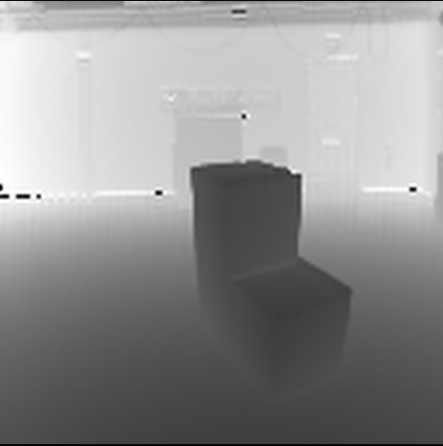
Thresholded Chair-range.ppm Image:
Threshold Value taken here is 137.
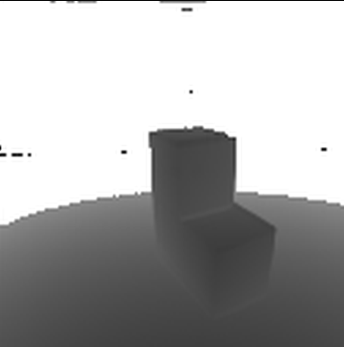
Segmented and thresholded Image:
Threshold Value = 137
Cross product Distance = 3
Angular Threshold = 0.65
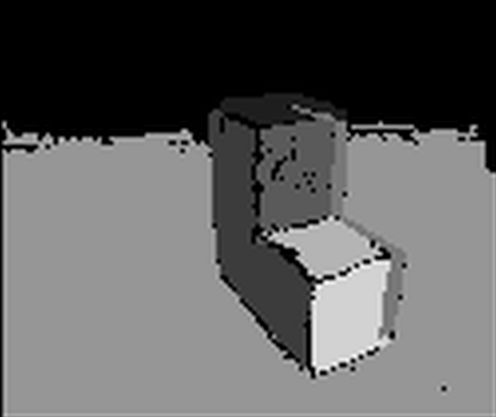
Region | No. of pixels | Average Surface Normals(X) | Average Surface Normal(Y) | Average Surface Normal (z)
1 | 163 | -7.982108 | 333.774 | -58.4797
2 | 744 | -52.121289 | 1.215533 | -8.658
3 | 454 | 2.596830 | -2.493379 | -4.463
4 | 205 | 104.818369 | -2.56256 | -27.820
5 | 6773 | -1.565296 | 28.785097 | -8.828
6 | 243 | -1.227892 | 8.642128 | -2.347
7 | 415 | 2.830629 | -1.639295 | -4.864

