**wedding hall management system**

**Group 6:**

|  |  |
| --- | --- |
| **S.M. KAMRUL HASAN** | **20-43405-1** |
| **MD. ISMAIL KHALIL** | **20-42583-1** |
| **MD. ABDUL HAMID** | **20-42602-1** |
| **ATIQUR RAHMAN AKASH** | **20-42566-1** |

**Case study:**

In a wedding hall management system a client reserve many event. One event reserved by exactly one client. The system also stores client_name, client_phone_number and client_id. A client name is composed of first_name and last_name. A event is identified by Event_manager, amount, event_id and event_name are store. While reserving a wedding hall, the date of the reservation is store. A event may be reserved by many member. To find the priority of the reservation the date of making the reservation is also store. A event is managing by many volunteer. A volunteer may manage many event but system store information of those volunteer of who has manage at least one event managing in the wedding hall. To identify an volunteer the system store volunteer_id along with volunteer_name. A event has two payment method. For payment there must be at least one event. Each payment has two property cash and card.

**Er diagram:**

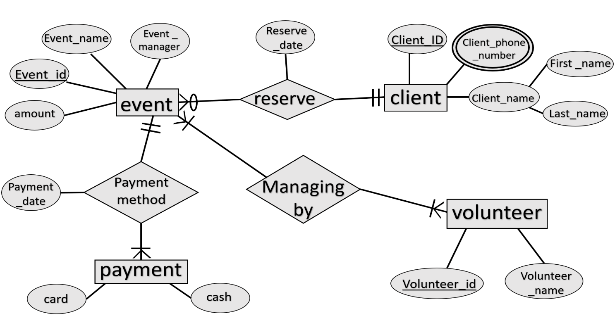

**Normalization:**

reserve (Event_id , amount, Event_name, Event_manager, client_id, Client_phone_number, Client_name, First_name, Last_name, reserve_date)

**1NF:**  
Client_phone_number multivalued attribute

**2NF:**  
Event_id, amount, Event_name, Event_manager, client_id

client_id, client_phone_number, client_name, first_name, last_name

reserve_id, Event_id, client_id, reserve_date

**3NF:**

Event_id, amount, Event_name, Event_manager, client_id

client_id, client_phone_number, name

name, client_name, first_name, last_name

reserve_id, Event_id, client_id, reserve_date

**table:**

**Event_id, amount, Event_name, Event_manager, client_id**

**client_id, client_phone_number, name**

**name, client_name, first_name, last_name**

**reserve_id, Event_id, client_id, reserve_date**

Payment method(Event_id , amount, Event_name, Event_manager, card, cash,Payment_date)

**1NF:**  
No multivalued attribute

**2NF:**

Event_id , amount, Event_name, Event_manager

Payment_id, card, cash, event_id

Payment_date_id, Event_id , Payment_id, Paymenty_date

**3NF:**

Event_id , amount, Event_name, Event_manager

Payment_id, card, cash, enent_id

Payment_date_id, Event_id , Payment_id, Paymenty_date

No transitive dependency

**Table:**

**Event_id , amount, Event_name, Event_manager**

**Payment_id, card, cash, event_id**

**Payment_date_id, Event_id , Payment_id, Paymenty_date**

Managing by ( Event_id , amount, Event_name, Event_manager, volunteer_id, Volunteer_name)

**1NF:**

No multivalued attribute

**2NF:**

Event_id , amount, Event_name, Event_manager

volunteer_id, Volunteer_name

Event_Volunteer_id, Event_id, volunteer_id

**3NF:**

Event_id , amount, Event_name, Event_manager

volunteer_id, Volunteer_name

Event_Volunteer_id, Event_id, volunteer_id

No transitive dependency

**Table:**

**Event_id , amount, Event_name, Event_manager**

**volunteer_id, Volunteer_name**

**Event_Volunteer_id, Event_id, volunteer_id**

**Total table:**

**Event_id, amount, Event_name, Event_manager, client_id**

**Client_id, client_phone_number, name**

**name, client_name, first_name, last_name**

**reserve_id, Event_id, client_id, reserve_date**

**~~Event_id , amount, Event_name, Event_manager~~**

**Payment_id, card, cash, event_id**

**Payment_date_id, Event_id , Payment_id, Paymenty_date**

**~~Event_id , amount, Event_name, Event_manager~~**

**volunteer_id, Volunteer_name**

**Event_Volunteer_id, Event_id, volunteer_id**

|  |
| --- |
| **Green** |

|  |
| --- |
| **Red** |

**à primary key à foreign key**

**Final table:**

1. **Event_id, amount, Event_name, Event_manager, client_id**
2. **Client_id, client_phone_number, name_serial**
3. **name_ serial, client_name, first_name, last_name**
4. **reserve_id, Event_id, client_id, reserve_date**
5. **Payment_id, card, cash, event_id**
6. **Payment_date_id, Event_id , Payment_id, Paymenty_date**
7. **volunteer_id, Volunteer_name**
8. **Event_Volunteer_id, Event_id, volunteer_id**

**TABLE CREATE:**

**TABLE 1:**

create table client(

name_serial number(35) constraint client_nameserial_pk primary key,

client_name varchar2(50),

first_name varchar2(25),

last_name varchar2(25)

)

Desc client

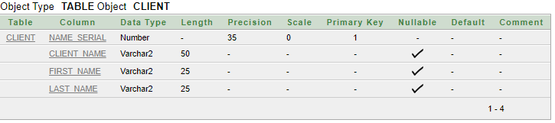

**TABLE 2:**

create table information

(

client_id number(35) constraint information_clientid_pk primary key,

client_phone_number number(35) unique,

name_serial number(35) constraint information_nameserial_fk references client(name_serial)

)

desc information

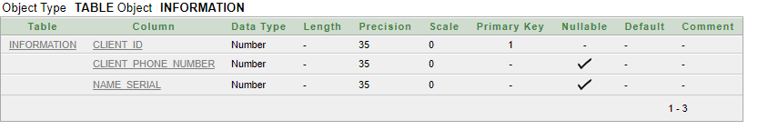

**TABLE 3:**

create table event_details

(

event_id number(35) constraint eventdetails_eventid_pk primary key,

amount number(30) default 5000,

event_name varchar2(50),

event_manager varchar2(50),

client_id number(35) constraint eventdetails_clientid_fk references information(client_id)

)

desc event_details

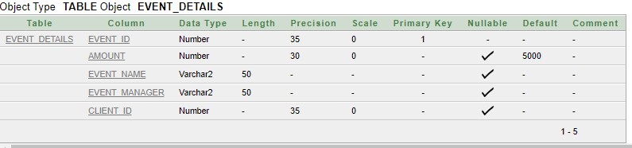

**TABLE 4:**

create table reservation

(

reserve_id number(30) constraint reservation_reserveid_pk primary key,

event_id number(35) constraint reservation_eventid_fk references event_details(event_id),

client_id number(35) constraint reservation_clientid_fk references information(client_id),

reserve_date date

)

desc reservation

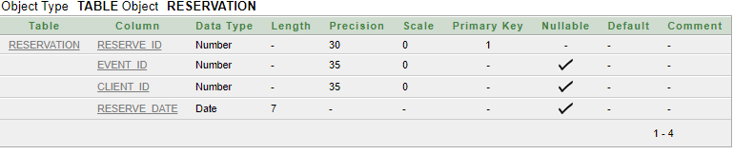

**TABLE 5:**

create table payment_method

(

payment_id number(30) constraint paymentmethod_paymentid_pk primary key,

card varchar2(10),

cash varchar2(10),

event_id number(35) constraint paymentmethod_eventid_fk references event_details(event_id)

)

desc payment_method

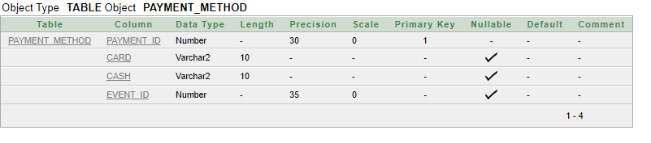

**TABLE 6:**

create table payment_record

(

payment_date_id number(30) constraint paymentrecord_paymentdateid_pk primary key,

event_id number(35) constraint paymentrecord_eventid_fk references event_details(event_id),

payment_id number(30) constraint paymentrecord_paymentid_fk references payment_method(payment_id),

payment_date date

)

desc payment_record

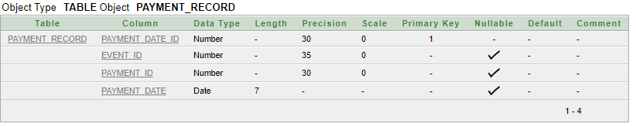

**TABLE 7:**

create table volunteer

(

volunteer_id number(30) constraint volunteer_volunteerid_pk primary key,

volunteer_name varchar2(10)

)

desc volunteer

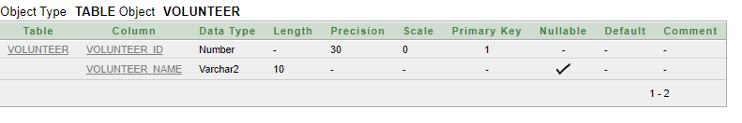

**TABLE 8:-**

create table volunteer_info

(

event_volunteer_id number(30) constraint volunteerdt_evvolid_pk primary key,

event_id number(35) constraint volunteerdt_eventid_fk references event_details(event_id),

volunteer_id number(30) constraint volunteerdt_volunteerid_fk references volunteer(volunteer_id)

)

desc volunteer_info

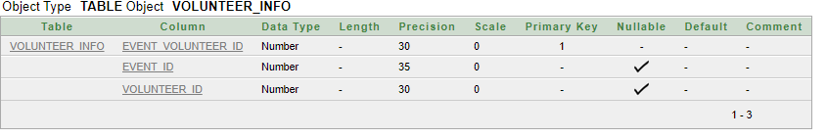

**Insertion:**

**TABLE 1:**

insert into client (name_serial, client_name, first_name, last_name) values(1,'steven-king','steven','king')

insert into client (name_serial, client_name, first_name, last_name) values(2,'jon-rasel','jon','rasel')

insert into client (name_serial, client_name, first_name, last_name) values(3,'anik-sen','anik','sen')

insert into client (name_serial, client_name, first_name, last_name) values(4,'fahim rahman','fahim','rahman')

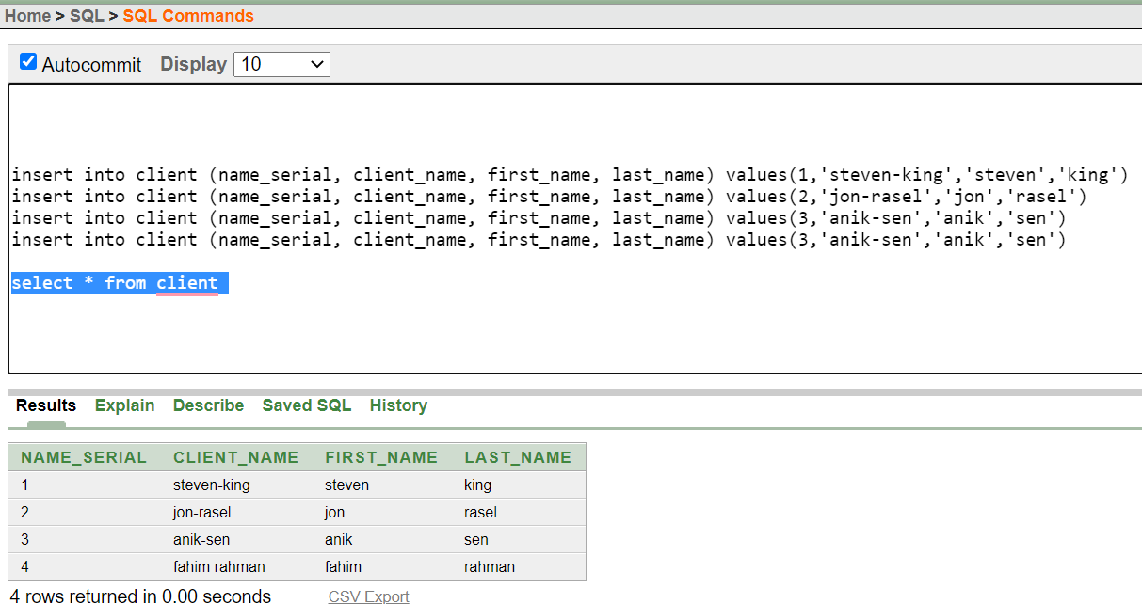

**TABLE 2:**

insert into information (client_id, client_phone_number , name_serial) values(101, 1776098757, 4)

insert into information (client_id, client_phone_number , name_serial) values(102, 177676157, 2)

insert into information (client_id, client_phone_number , name_serial) values(103, 01776761556, 1)

insert into information (client_id, client_phone_number , name_serial) values(104, 01453761556, 3)

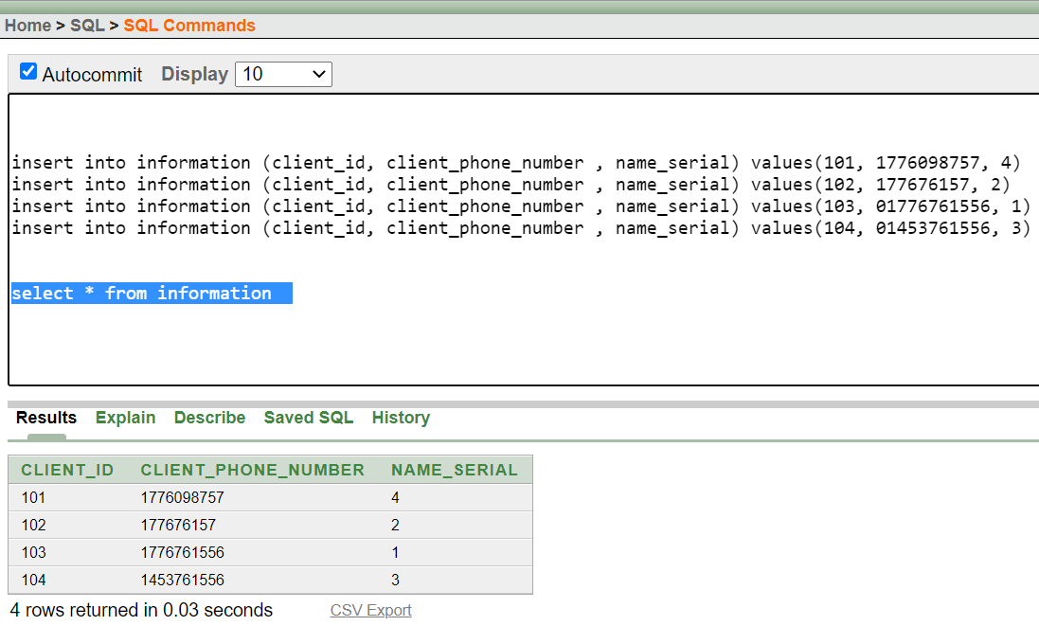

**TABLE 3:**

insert into event_details(event_id , amount , event_name , event_manager , client_id ) values (1001, 3000 , 'rose' , 'sakib' , 101)

insert into event_details(event_id , amount , event_name , event_manager , client_id ) values (1002, 3000 , 'lily' , 'sakib' , 102)

insert into event_details(event_id , event_name , event_manager , client_id ) values (1003, 'black' , 'sakib' , 103)

insert into event_details(event_id , amount , event_name , event_manager , client_id ) values (1004, 2000 , 'orange' , 'rakib' , 104)

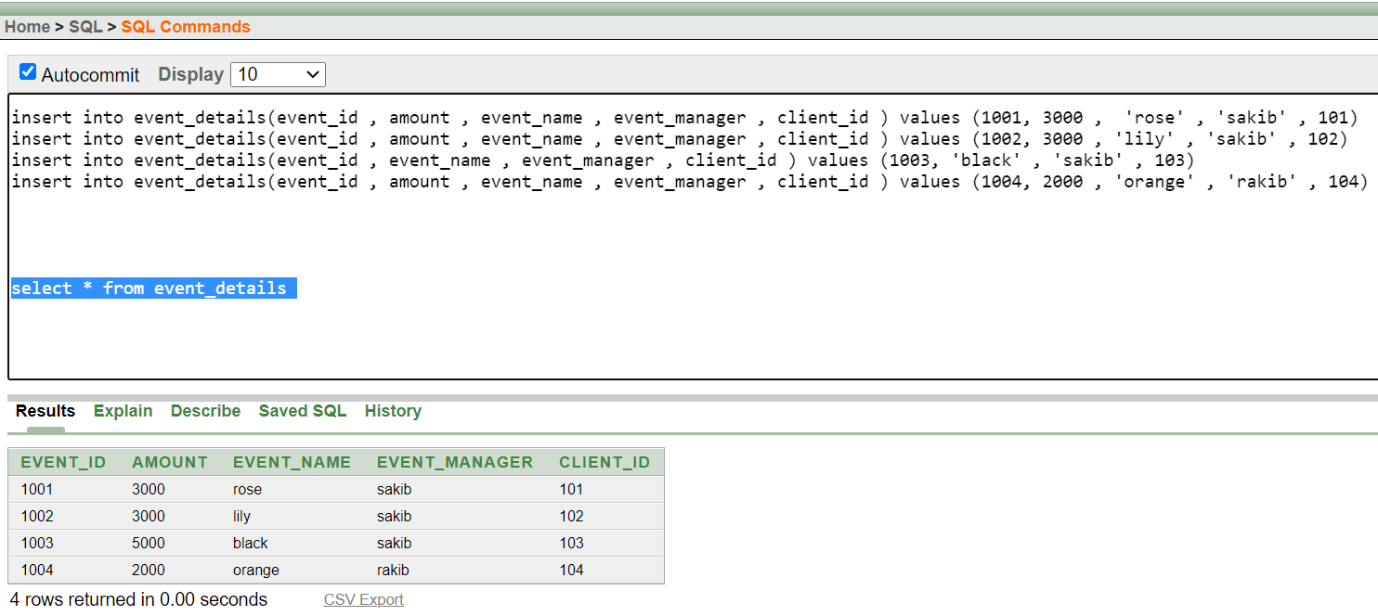

**TABLE 4:**

insert into reservation (reserve_id , event_id , client_id , reserve_date ) values (101, 1000 , 101 , '14-MAR-20')

insert into reservation (reserve_id , event_id , client_id , reserve_date ) values (102, 1001 , 102 , '16-JAN-20')

insert into reservation (reserve_id , event_id , client_id , reserve_date ) values (103, 1003 , 103 , '14-FEB-21')

insert into reservation (reserve_id , event_id , client_id , reserve_date ) values (104, 1004 , 104 , '14-MAR-21')

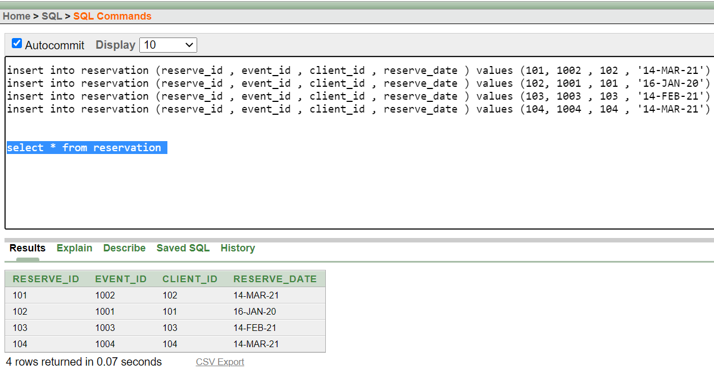

**TABLE 5:**

insert into payment_method(payment_id , card , event_id ) values (401, 'yes' , 1001 )

insert into payment_method(payment_id , cash , event_id ) values (402, 'yes' , 1002 )

insert into payment_method(payment_id , cash , event_id ) values (403, 'yes' , 1003 )

insert into payment_method(payment_id , card , event_id ) values (404, 'yes' , 1004 )

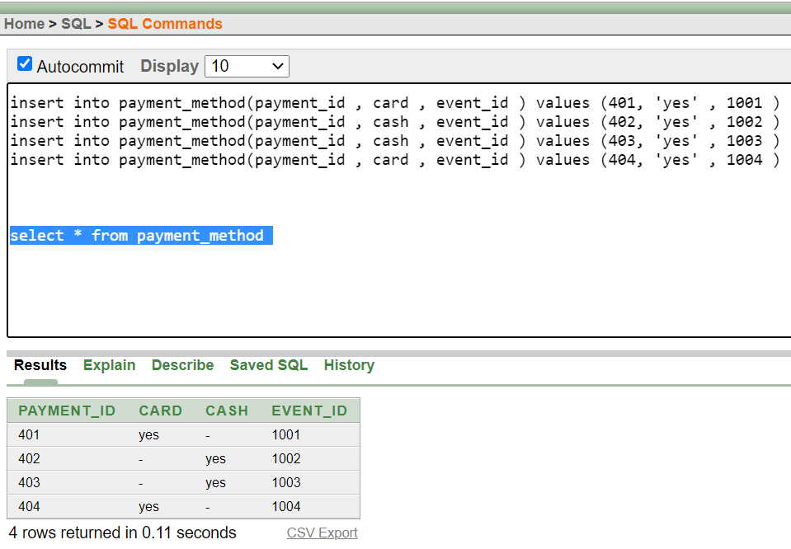

**TABLE 6:**

insert into payment_record(payment_date_id , event_id , payment_id, payment_date ) values (1401 , 1001, 401 , '14-MAR-21' )

insert into payment_record(payment_date_id , event_id , payment_id, payment_date ) values (2402 , 1002, 402 , '20-JAN-20' )

insert into payment_record(payment_date_id , event_id , payment_id, payment_date ) values (3403 , 1003, 403 , '28-FEB-21' )

insert into payment_record(payment_date_id , event_id , payment_id, payment_date ) values (4404 , 1004, 404 , '26-MAR-21' )

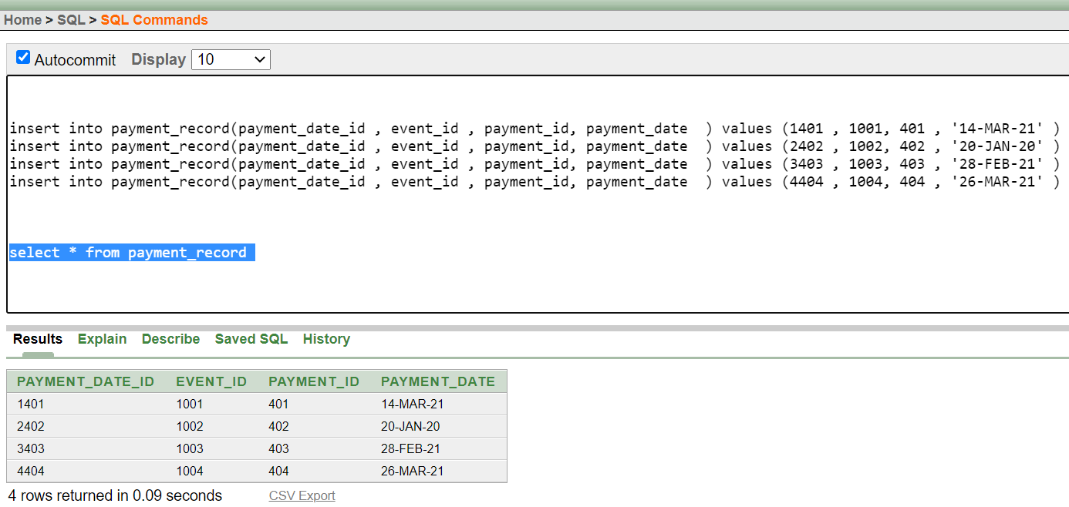

**TABLE 7:**

insert into volunteer(volunteer_id , volunteer_name ) values (701 , 'maruf' )

insert into volunteer(volunteer_id , volunteer_name ) values (702 , 'mekal' )

insert into volunteer(volunteer_id , volunteer_name ) values (703 , 'jonus' )

insert into volunteer(volunteer_id , volunteer_name ) values (704 , 'nelson' )

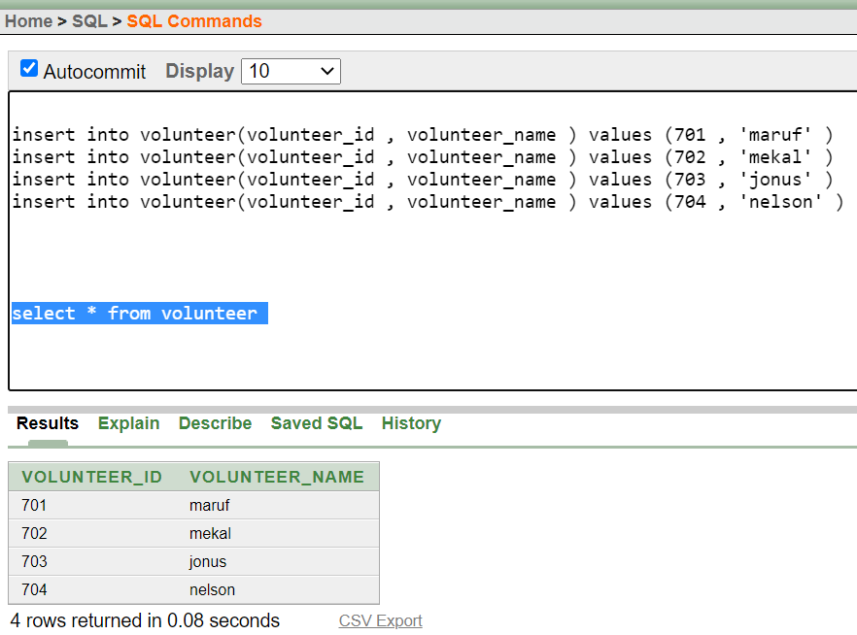

**TABLE 8:**

insert into volunteer_info(event_volunteer_id , event_id , volunteer_id ) values (7011001 , 1001 , 701 )

insert into volunteer_info(event_volunteer_id , event_id , volunteer_id ) values (7021002 , 1002 , 702 )

insert into volunteer_info(event_volunteer_id , event_id , volunteer_id ) values (7031003 , 1003 , 703 )

insert into volunteer_info(event_volunteer_id , event_id , volunteer_id ) values (7041004 , 1004 , 704 )

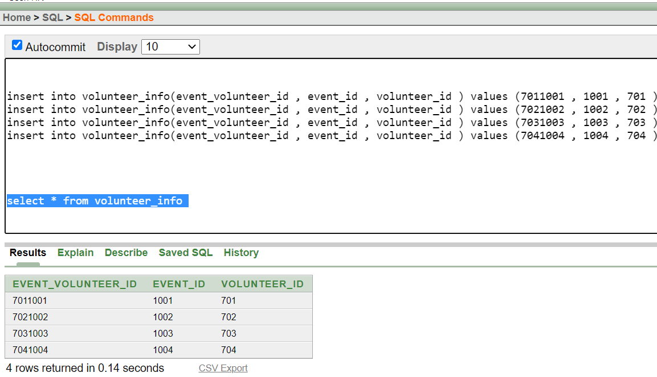

**QUERY WRITING:-**

**1.GROUP FUNCTION:**

**Q.DISPLAY MAX AMOUNT FROM EVENT DETAILS?**

**ANS:** select max(amount) from event_details

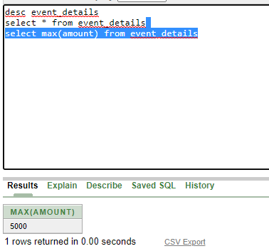

2)

**Q.DISPLAY MIN AMOUNT FROM EVENT DETAILS?**

**ANS**: select MIN(amount) from event_details

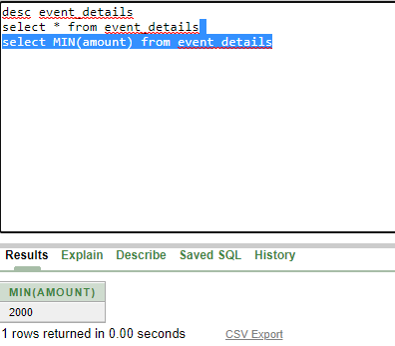

**3)SINGLE ROW FUNCTION:-**

**Q.DISPLAY EVENT MANAGERS NAME IN UPPER LETTER?**

**ANS:** SELECT UPPER(EVENT_MANAGER)FROM EVENT_DETAILS

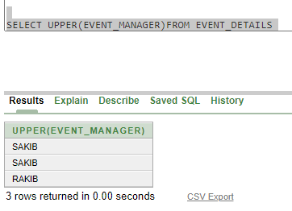

4)SUB QUERY:-

**Q.DISPLAY EVENT ID,AMOUNT WHOSE AMOUNT IS EQUAL TO MAX AMOUNT?**

**ANS**: select EVENT_ID,AMOUNT FROM EVENT_DETAILS WHERE AMOUNT=(SELECT MAX(amount) from event_details)

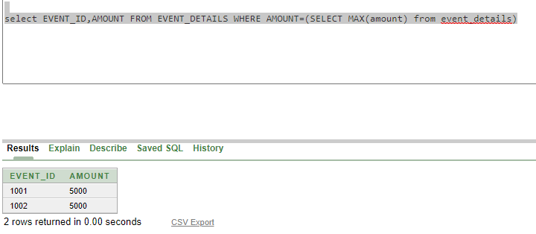

5)

**Q.DISPLAY EVENT ID WISE MAX AMOUNT?**

**ANS**: select EVENT_ID,AMOUNT FROM EVENT_DETAILS WHERE AMOUNT IN(SELECT MAX(amount) from event_details

GROUP BY EVENT_ID)

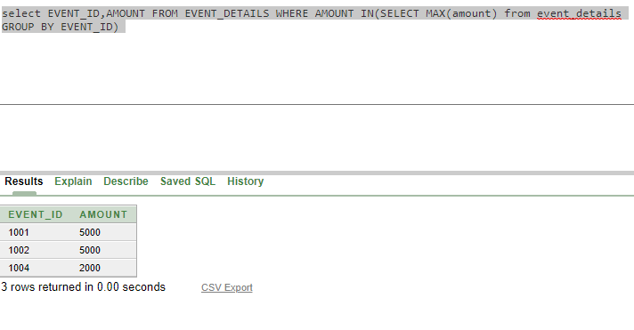

6)

**Q.DISPLAY EVENT ID ,AMOUNT WHOSE AMOUNT IS EQUAL TO MIN AMOUNT?**

**ANS**: select EVENT_ID,AMOUNT FROM EVENT_DETAILS WHERE AMOUNT=(SELECT MIN(amount) from event_details)

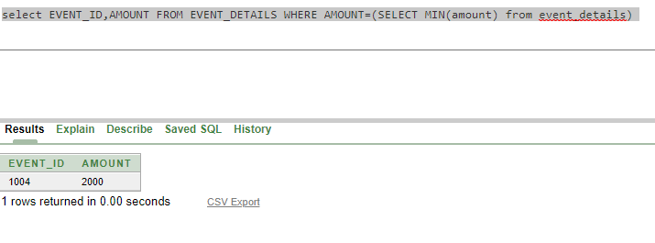

7) JOINING QUERY

**Q. display amount, event_name, and reserve_date**

**ANS**: select amount, event_name, reserve_date from event_details, reservation

where event_details.client_id = reservation.client_id

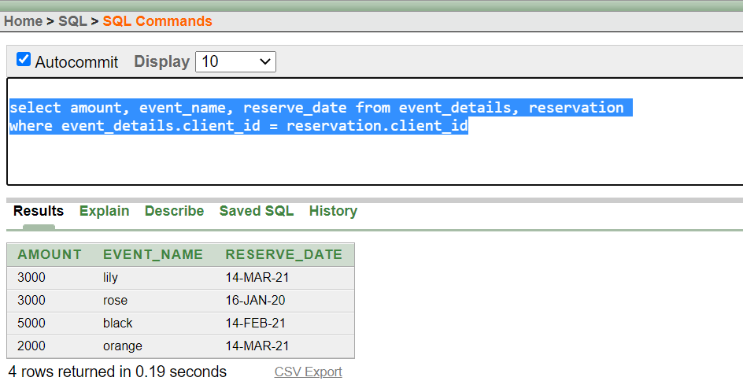

8) JOINING QUERY

**Q. display reserve_id, reserve_date, card, cash**

**ANS**: select reserve_id, reserve_date, card, cash from reservation, payment_method

where reservation.event_id = payment_method.event_id

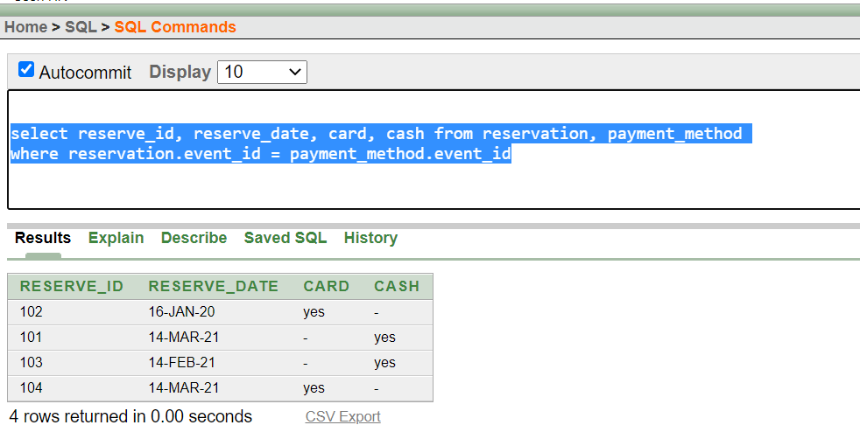

9) JOINING QUERY

**Q. display client_phone_number, first_name, last_name**

**ANS**: select client_phone_number, first_name, last_name from information, client

where information.name_serial = client.name_serial

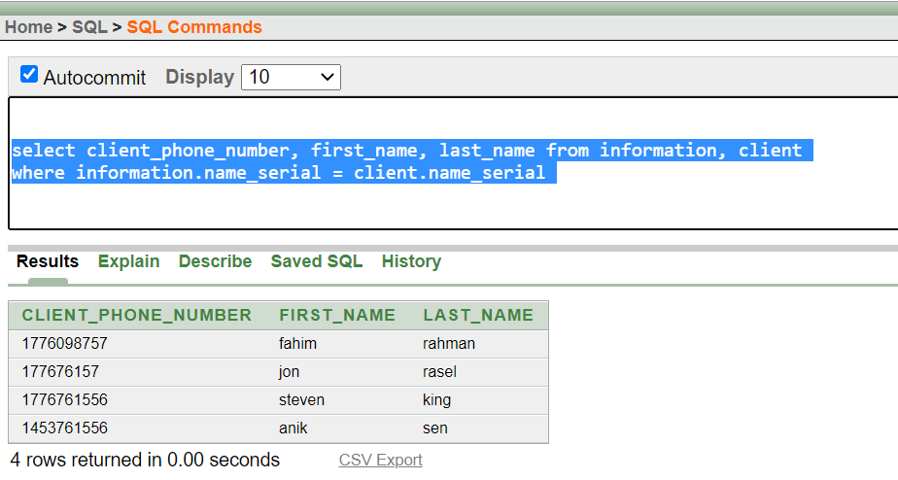

**10)** view

**Q. create a view those who manager name sakib**

**ANS:** create or replace view empvu

as select * from event_details

where event_manager = 'sakib'

