Don’t Let Them Run: Give Customers a Reason to Loiter
University of New Brunswick

Term Project
CS4403 – Data Mining

Dhruv Manishbhai Thumar | #3753860

The Problem
The project explores customer segmentation in retail using transaction data. The core problem is how to identify meaningful customer groups from an online retail sales history so that marketing, retention, and inventory strategies can be better targeted.

This problem is grounded in classic customer analytics:
- RFM segmentation is a well-established technique in marketing analytics (Recency, Frequency, Monetary).
- Clustering methods like K-Means are widely used to discover natural customer groups from behavioral data.
- Prior work includes classic marketing research on RFM-based customer scoring and later data-mining studies applying clustering to retail datasets.

In other words, the project sits at the intersection of retail analytics, customer segmentation, and unsupervised learning.

https://archive.org/details/strategicdatabas0000hugh [1]
https://doi.org/10.2307/2346328 [2]
https://pzs.dstu.dp.ua/DataMining/assoc/bibl/IntroductiontoDataMing.pdf [3]

Motivation
The motivation was to answer: If I start a business model someday ...

How do I keep my pockets full ???? that extends
?) Can I use retail transaction data to distinguish customer segments with different purchase behaviors?

?) Which customers are high-value, which are active repeat buyers, and which are at risk or dormant?

?) Is there a stable cluster structure in the data that supports business-relevant insights?

This is a practical question for any business model seeking to move beyond raw sales tables into actionable customer profiles.

The Data
The dataset is an online retail transaction history, from an UK Online Retail dataset. It contains individual invoice line items rather than customer-level summaries. Each row is one product line on a single invoice.

Key columns
- InvoiceNo: invoice identifier for the transaction.
- StockCode: product code for the item sold.
- Description: item description.
- Quantity: number of units sold on that line.
- InvoiceDate: timestamp of the transaction.
- UnitPrice: price per unit for that line.
- CustomerID: customer identifier, used to group purchases by customer.
- Country: the customer’s country.

What was done to make the data usable
- Converted InvoiceDate to datetime so time-based metrics are possible.
- Removed rows with negative Quantity because they usually indicate returns or cancellations, which distort purchase behavior.
- Cleaned InvoiceNo and StockCode to keep only valid invoice and product codes.
- Dropped rows without CustomerID, because customer segmentation requires a customer link.
- Removed rows where UnitPrice == 0, since free or invalid-price lines do not represent normal spending.
- Computed SalesLineTotal = Quantity * UnitPrice to get the transaction dollar value for each row.

How the data was transformed for analysis
- Aggregated row-level data into customer-level features:
  - MonetaryValue: total spend per customer
  - Frequency: number of unique invoices per customer
  - Recency: days since the last purchase, measured from the most recent invoice in the dataset
- Standardized these RFM features before clustering to ensure they were comparable.

Why these steps matter
- Raw transaction tables contain noise: returns, canceled invoices, missing customers.
- Customer segmentation works best on cleaned, aggregated customer profiles.
- RFM is a proven way to turn transaction history into actionable customer metrics.
What the data reveals
- It is heavily skewed: a small number of customers spend a lot or buy frequently.
- There is a significant amount of invalid or missing data, which required dropping around 27% of the rows.
- After cleaning, the dataset becomes suitable for clustering and customer-level insight.

3. Key Idea
The key idea that drove this project was to
- Deeply understand our customer base through the lens of RFM analysis and predictive modeling.
- Discover distinct customer segments based on their purchasing behavior and identify which customers are at risk of churning.
- I hoped to uncover actionable insights that would allow us to tailor our marketing strategies, improve customer retention, and ultimately increase our revenue.
- Identify our most valuable customers (the "Champions" and "Elite" segments) to ensure we provide them with exceptional service, while also recognizing those who are at risk of leaving so we can implement targeted win-back campaigns.

The goal was to move from a one-size-fits-all approach to a more personalized strategy that maximizes customer lifetime value and fosters long-term loyalty.

As a business person might want, I was also keen on understanding the financial implications of our customer segments and how I can optimize resources to focus on high impact areas. The insights from this project were expected to guide my marketing investments, product development, and customer service initiatives in a way that drives sustainable growth for the company.

From a business perspective, this project was about leveraging data to make informed decisions that enhance our customer relationships and boost our bottom line.

Efforts and Results

What was done?

Conducted EDA with head(), info(), and descriptive statistics.

Visualized RFM feature distributions with histograms and boxplots.

Used IQR-based outlier filtering on MonetaryValue and Frequency.

Created 3D scatter plots of customer RFM data.

Standardized features with StandardScaler.

Clustering
- Evaluated K-Means for k = 2..12.
- Used inertia and silhouette score for model selection.
- Chose k = 4 because it offered better silhouette separation than k = 5.

Interpretation
- Assigned each customer to one of 4 clusters.
- Visualized clusters in 3D and using violin plots for each RFM feature.
- Computed cluster-level mean and median values to profile each segment.

Insights
- RFM distributions were strongly skewed, confirming that a small subset of customers contributes disproportionate value.
- Outlier removal made clustering more stable and easier to interpret.
- The 4-cluster solution produced distinct customer groups suitable for business segmentation.

Summary of Learning
- Retail transaction data can be successfully cleaned and converted into meaningful RFM customer features.
- RFM + clustering provides a strong framework for customer segmentation.
- The final model suggested distinct customer groups with different recency, frequency, and spending behavior.
- Visualizations were essential to demonstrate data shape and cluster separation.

Visualizations
- Initial RFM diagnostics pair a trio of histograms (Monetary/Frequency/Recency) with matching boxplots so you can spot the skewed distributions and outliers before cleaning (“with RFM values…” explains the goal, and the charts are implemented right after in the Monetary/Recency section)
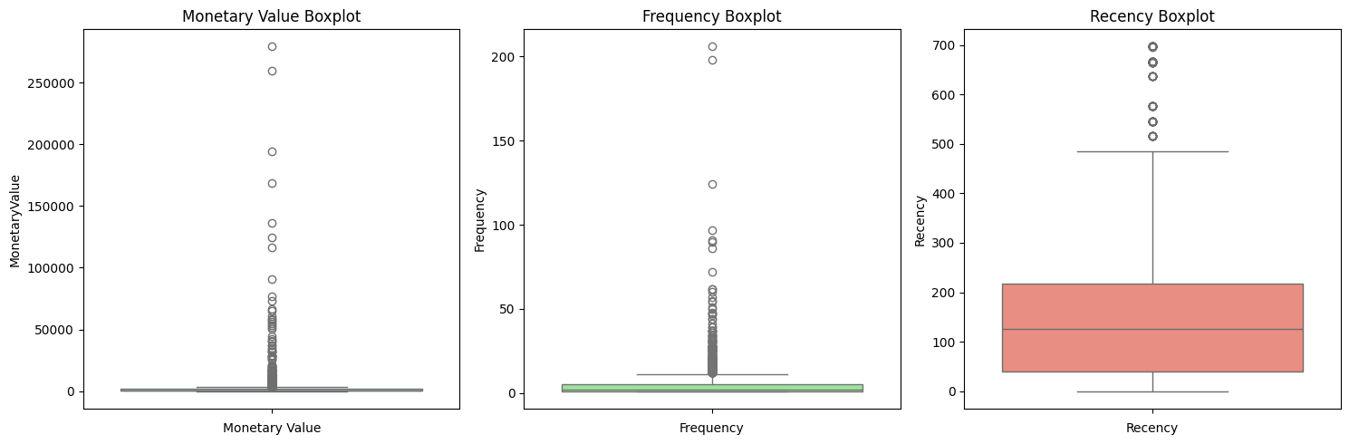
Figure 1 : boxplots before handling outliers

- After trimming the outliers, the notebook re-plots boxplots of the cleaned RFM metrics plus two 3D scatter views (raw and scaled) to verify that the remaining customers still show structure along all three dimensions.
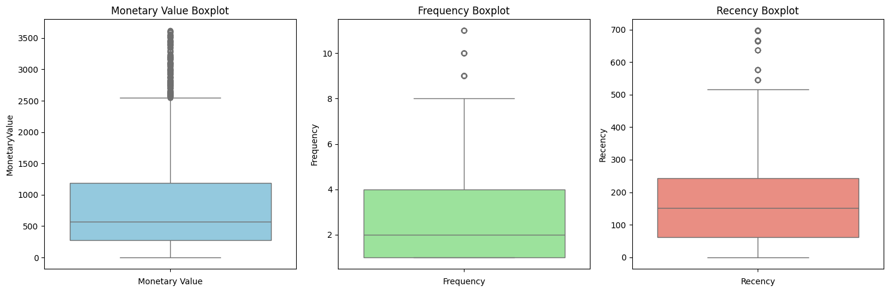
Figure 2 : boxplots after handling outliers by IQR method
- The elbow/silhouette panel visualizes inertia and silhouette score across k=2…12 so the text can justify choosing k=4 by showing where the elbow appears and how silhouette behaves as clusters grow.

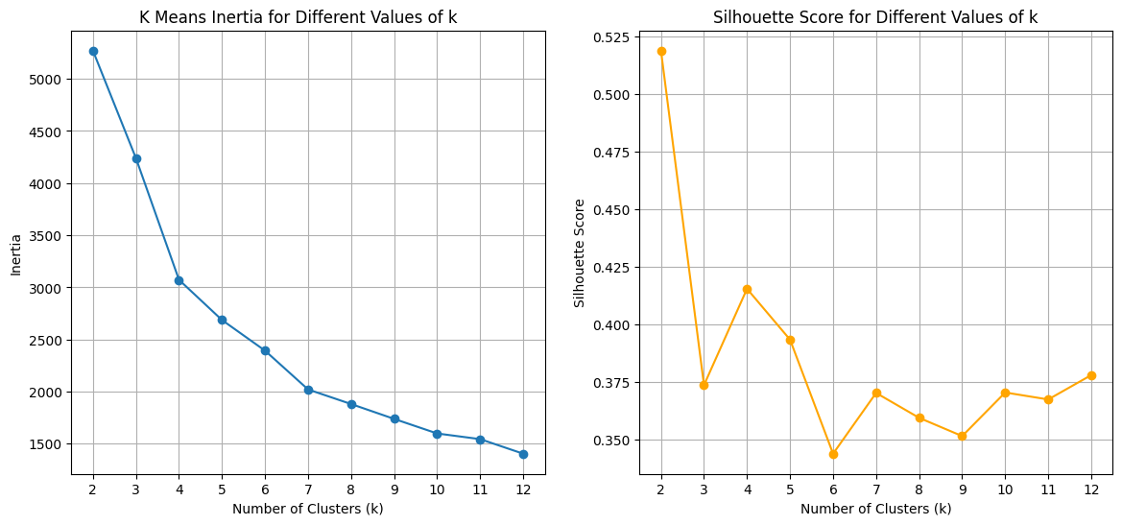

Figure 3 : Silhoutte score justifying k=4 clusters

- This 3D scatter plot illustrates the spatial separation of the four identified customer segments within the RFM coordinate system. The axes represent Monetary Value (x), Frequency (y), and Recency (z). Each data point represents an individual customer, color-coded by their assigned cluster membership (Elite, Champions, Promising, and At-Risk).
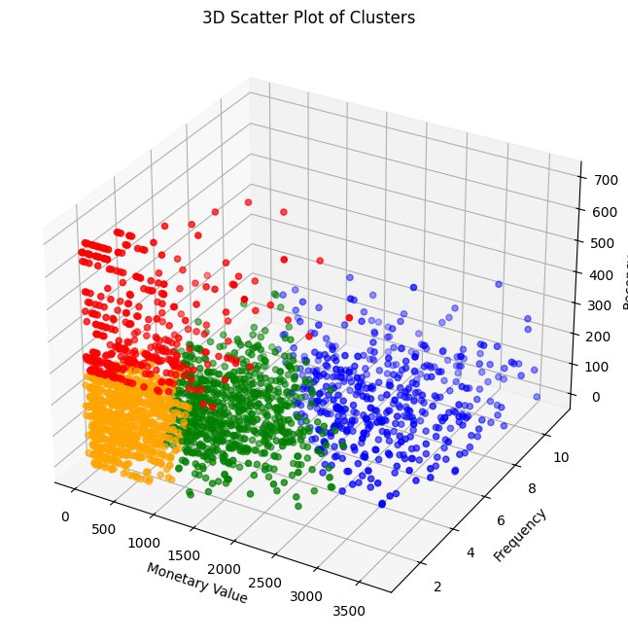
Figure 4 : 3D Scatter plot

- Cluster profiling uses stacked violin plots for each RFM feature plus an RFM profile heatmap, letting you read the “Cluster Interpretation & Business Insights” narrative (active vs. dormant vs. high-value segments) and see the relative strength of Recency/Frequency/Monetary per cluster

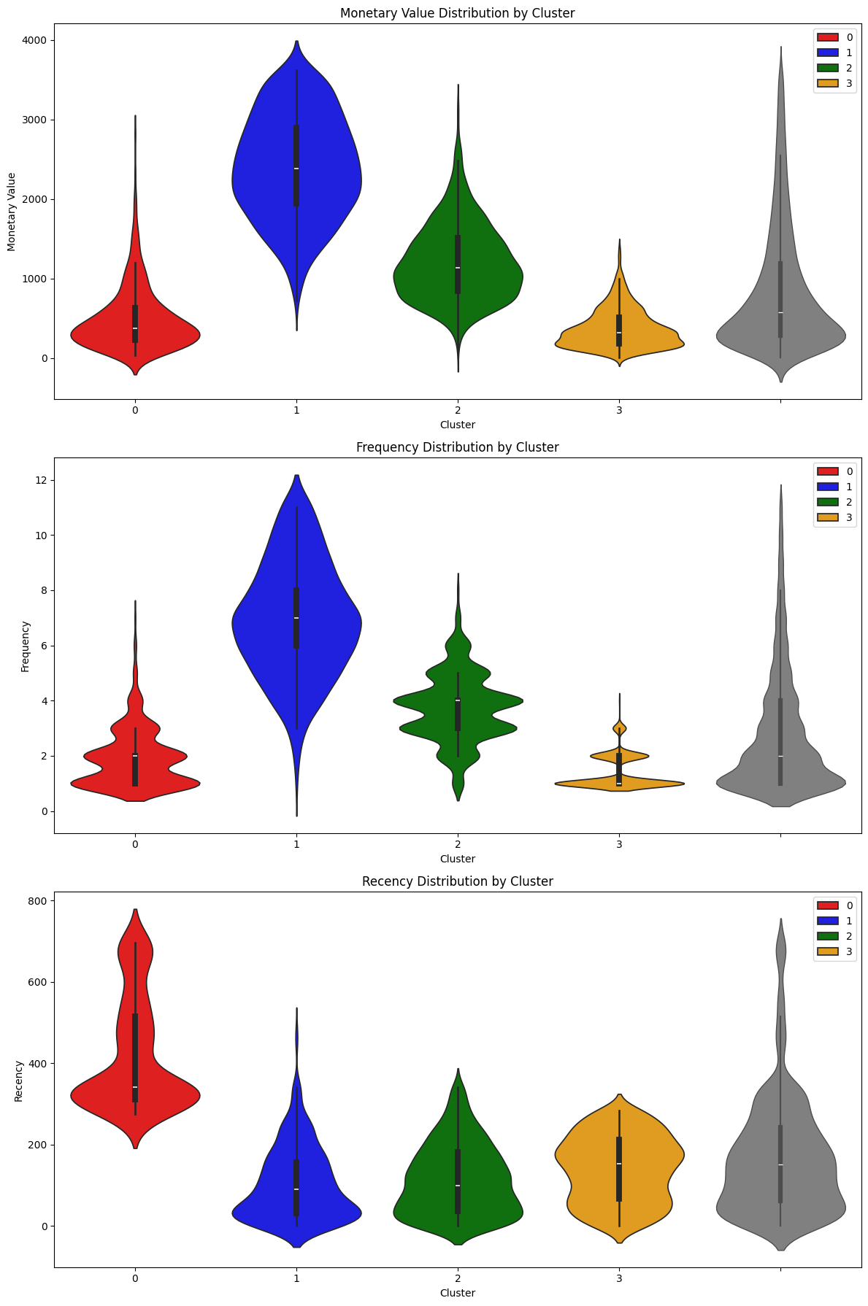

Figure 5 : Violin plots of clusters

- This heatmap visualizes the characteristics of four distinct customer segments identified through K-Means clustering. The features—Recency, Frequency, and Monetary Value—have been Min-Max scaled to a range of [0, 1] to represent "Relative Strength." This allows for a direct comparison of the importance of each RFM dimension across clusters, regardless of their original units.

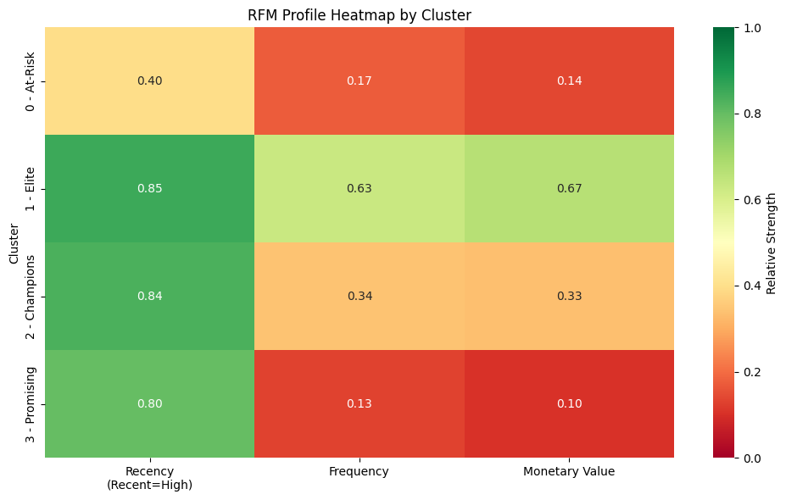
Figure 6 : RFM Heatmap

- In the “Advanced Steps” section the churn models are supported by a feature-importance bar chart and two ROC comparisons (Random Forest vs. XGBoost, then all three models) so you can interpret which predictors matter and how each classifier trades off true/false positives.
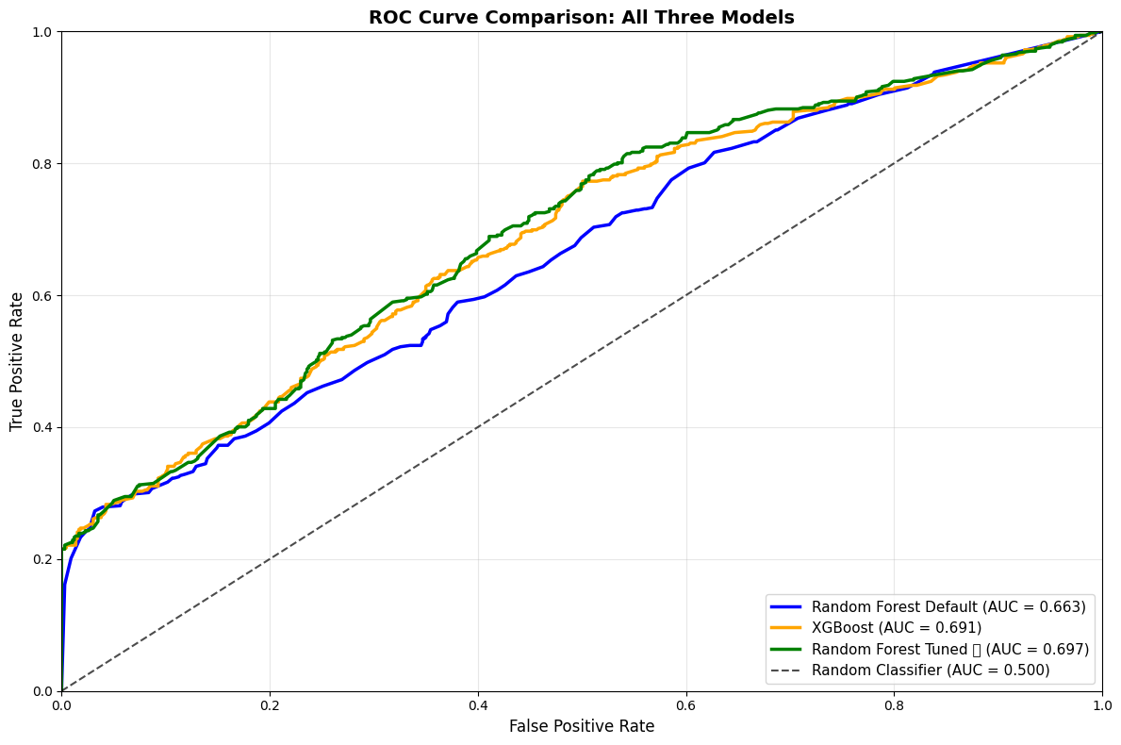
Figure 7 : ROC comparison curve of all models
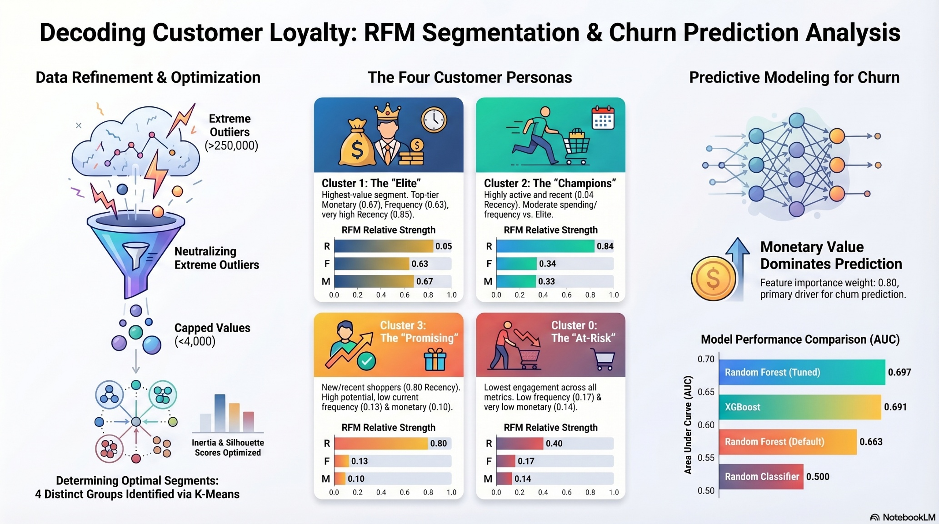
Figure 8 : A picture worth many words
Generated by Notebook LLM to summarize my work [5]

Github: https://github.com/dhruvthumar/Project_CS4403-retail-mining
Dataset: https://drive.google.com/file/d/1VflPJgqBUumgu5K1S6RmyG-jxmqMjGna/view?usp=drive_link

For some reason, UCI official website is not in service and gives a 502:gateway error so I have attached a gdrive link that I downloaded in the beginning of my project work.

Bibliography
[1] Hughes, A. M. (1994). Strategic Database Marketing. Chicago: Probus Publishing. https://archive.org/details/strategicdatabas0000hugh

[2] C. Chatfield, G. J. Goodhardt, The Beta-Binomial Model for Consumer Purchasing Behaviour, Journal of the Royal Statistical Society Series C: Applied Statistics, Volume 19, Issue 3, November 1970, Pages 240–250, https://doi.org/10.2307/2346328

[3] Tan, P.-N., Steinbach, M., & Kumar, V. (2019). Introduction to Data Mining (classic discussion of K-Means and clustering for customer segmentation).
https://pzs.dstu.dp.ua/DataMining/assoc/bibl/IntroductiontoDataMing.pdf

[4] Finding methods to advancements of this project are sourced from Claude.
Only ideas were gathered.

[5] A picture worth many words is generated from Notebook LLM

