Connect 4 Pattern Recognition
University of New Brunswick

Term Project
CS4795 - Introduction to Artificial Intelligence

Dhruv Manishbhai Thumar | #3753860

Abstract
This paper presents the summary of a machine learning approach to pattern recognition in the board game Connect 4. Using the UCI Connect-4 dataset, which contains 67,557 labeled board positions. I have tried and tested three classification algorithms and evaluated: Random Forest, XGBoost (Gradient Boosting), and an MLP Neural Network. My primary goal was to predict game outcomes — win, loss, or draw — from any given board state which were encoded as a 42-feature numeric vector.

Out of those 3 models, Random Forest achieved the highest accuracy at 82.59%, outperforming XGBoost (81.00%) and MLP (81.22%) on 13,512 unseen positions. The most significant finding was that the model independently discovered the strategic importance of the center column — a fact well-known to expert players — without being given any game rules. The most significant failure was draw detection: only 202 of 1,290 draw positions were correctly classified, a direct consequence of class imbalance in the dataset (draws represent only 9.5% of examples in whole dataset). A rule-based threat detection heuristic was also implemented as a real-time move advisor in a playable tkinter GUI game.

1. Introduction
Connect 4 is a two-player strategy game played on a 6-row by 7-column grid. Players alternately drop colored discs into columns, and the first player to form a horizontal, vertical, or diagonal line of four discs wins. Despite its simple rules, Connect 4 is a game of significant strategic depth — it was mathematically proven to be a solved game by Victor Allis in 1988, who showed that the first player always wins with optimal play [1].

The motivation for this project was to explore how well a machine learning model could learn Connect 4 strategy purely from labeled board states, without explicit knowledge of the game's rules. This question sits at the intersection of pattern recognition and game theory, and has direct parallels to real-world applications such as image classification, fraud detection, and medical diagnosis — all domains where models must learn to recognize patterns from data rather than from hardcoded rules.

The UCI Connect-4 dataset [2] provides an ideal benchmark for this problem as it contains 67,557 board positions documented from actual game play, each labeled with the outcome (win, loss, or draw) assuming both players play optimally from that position forward. The dataset was originally contributed by John Tromp and is one of the classic classification benchmarks in the UCI Machine Learning Repository.

From this project, the key learning was that feature importance analysis reveals genuine strategic insight — the model learned to prioritize center columns even though no rules were provided. Additionally, class imbalance is a critical practical challenge that significantly degrades model performance on minority classes, regardless of the algorithm used.

2. The Problem
Imagine you are playing Connect 4 with a friend. Every time it is your turn, you look at the board and try to figure out: "If both of us keep playing our best moves, who is going to win?" This is actually a really hard question — even computers struggle to answer it perfectly for every board position.
The problem this project solves is: given a photograph of any Connect 4 board — where each of the 42 squares is either empty, occupied by the red player, or occupied by the yellow player — can a computer program look at that snapshot and correctly predict whether the red player will win, lose, or draw?
To teach the computer, I showed it 67,557 example board photographs, each labeled with the correct answer. The computer then learned patterns: which arrangements of pieces tend to lead to wins, which tend to lead to losses, and which tend to end in draws. After training, I tested it on 13,512 boards it had never seen before. The challenge is that draws are rare being only about 1 in 10 boards in the dataset ends in a draw — so the computer has much less practice recognizing them.

3. Key Idea
The core idea is to treat a Connect 4 board as a vector of 42 numbers and train a supervised classification model to map that vector to one of three outcome labels.
Each board cell is encoded as an integer: blank = 0, player X = 1, player O = 2. The 42 cells (columns a through g, rows 1 through 6) become the feature vector. The label is one of {draw, loss, win}, encoded as {0, 1, 2} respectively using scikit-learn's LabelEncoder.
A Random Forest classifier — as we know an ensemble of 100 decision trees that each vote on the outcome — was chosen as the primary model. The intuition is that each tree learns a slightly different set of patterns, and their combined majority vote produces a more robust and accurate prediction than any single tree.

Alongside the ML model, a rule-based heuristic was implemented: after each opponent move, the system simulates dropping the opponent's piece into every remaining column. If any simulated drop results in four in a row, that column is flagged as a threat and highlighted red in the game interface. This heuristic requires no training data and operates with perfect accuracy for immediate one-move threats.

4. The Details

4.1 Dataset and Preprocessing
The UCI Connect-4 dataset (ID 26) was fetched programmatically via the ucimlrepo Python library. It contains 67,557 rows representing board positions, with the following class distribution:
- Win: 44,473 rows (65.8%)
- Loss: 16,635 rows (24.6%)
- Draw: 6,449 rows (9.6%)

Each of the 42 feature columns (a1 through g6) was encoded using a fixed mapping: {'b': 0, 'x': 1, 'o': 2}. The class label was encoded using sklearn's LabelEncoder, yielding {draw: 0, loss: 1, win: 2}. The dataset was split 80/20 into training (54,045 rows) and test (13,512 rows) sets using stratified sampling to preserve class ratios.

4.2 Models Trained
Three classification algorithms were trained on identical train/test splits:
- Random Forest: 100 trees, random_state=42, n_jobs=-1 (parallel training)
- XGBoost: 100 boosted trees, max_depth=6, learning_rate=0.1
- MLP Neural Network: hidden layers (128, 64), ReLU activation, max_iter=1000 (converged at iteration 343)

4.3 Overall Performance
Algorithm | Accuracy | Rank | Notes
Random Forest | 82.59% | 1st | Best overall
MLP Neural Network | 81.22% | 2nd | 343 iterations
XGBoost | 81.00% | 3rd | 100 boosted trees

All three models were evaluated on the same 13,512 unseen test positions. Random Forest achieved the best accuracy at 82.59%. The following table shows the per-class breakdown for Random Forest:

Class | Precision | Recall | F1-Score | Support
draw | 0.56 | 0.16 | 0.24 | 1,290
loss | 0.81 | 0.73 | 0.77 | 3,327
win | 0.84 | 0.96 | 0.90 | 8,895

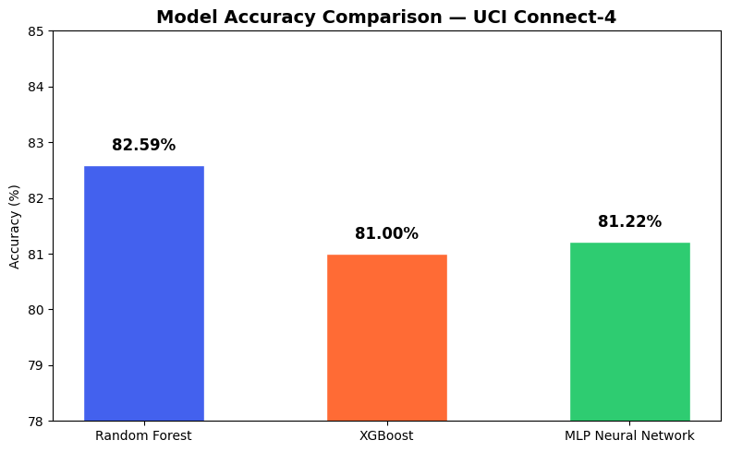
Figure 1: Model accuracy comparison across all three algorithms.

4.4 Striking Successes
The most striking success was win detection. Random Forest correctly identified 8,519 out of 8,895 win positions (95.8% recall), demonstrating that the model had learned strong generalizable patterns for winning board configurations.
Even more remarkable was the feature importance analysis. Without being told any game rules, the model assigned the highest importance scores to the center column (column d) and its adjacent cells. This mirrors expert Connect 4 strategy: controlling the center provides more winning opportunities than edge columns. The model arrived at this strategic insight purely through statistical pattern learning across 67,557 game positions.
The rule-based win detector achieved perfect accuracy on all four test cases horizontal, vertical, diagonal (↘), and diagonal (↗) demonstrating that the deterministic rule logic was correctly implemented.
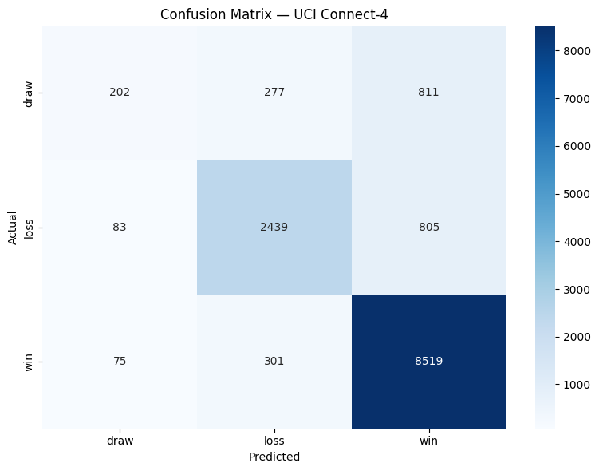
Figure 2: Confusion matrix for Random Forest on 13,512 test positions.

4.5 Striking Failures
The most striking failure was draw detection. Of 1,290 draw positions in the test set, only 202 (15.7% recall) were correctly classified. A total of 811 draw positions were misclassified as wins — nearly 63% of all draw examples.
The root cause is clear class imbalance. Draw positions represent only 9.6% of the dataset. With fewer than 5,160 training examples of draws, the model simply did not observe enough draw patterns to learn them reliably. This is compounded by the fact that draws and wins can share similar board configurations near the end game, making them hard to distinguish without sufficient examples of each.
This failure is consistent across all three algorithms — none of the models demonstrated strong draw detection, confirming that the problem is fundamentally a data insufficiency issue rather than an algorithmic limitation.
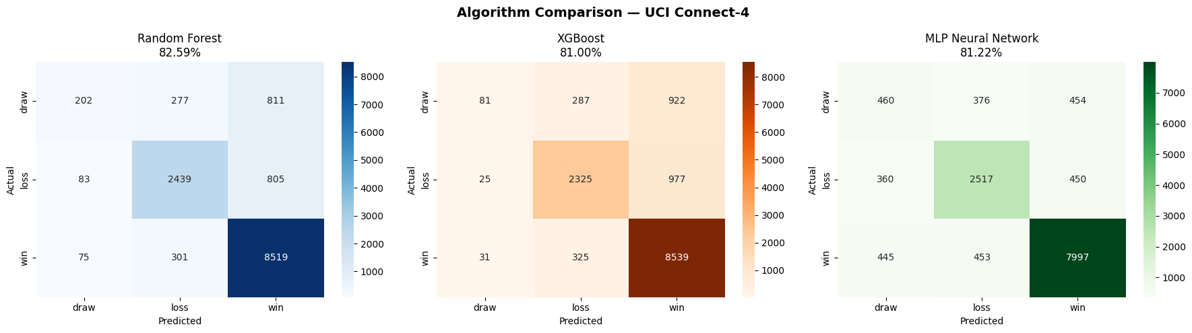
Figure 3: Confusion matrices for all three algorithms side by side.
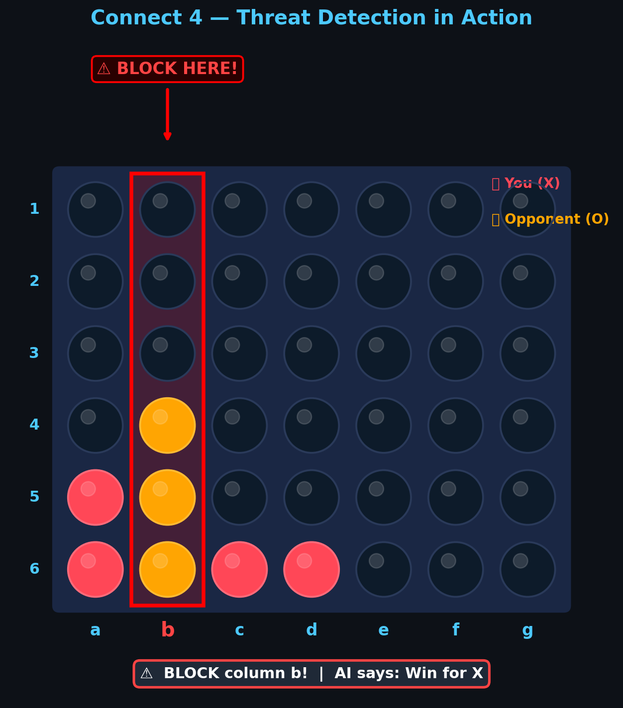
Figure 4: Threat detection heuristic in the live game GUI. Column b is highlighted red, warning the player to block.

4.6 Heuristic: Threat Detection
A one-move look-ahead heuristic was implemented in the game.py GUI. After each opponent move, the system iterates over all 7 columns and simulates the opponent dropping a piece into each empty column. If the simulated drop creates a four-in-a-row for the opponent in any direction, that column is flagged as a threat. The threat column is highlighted with a red border in the game board, and the status bar displays a warning such as "BLOCK column b! | AI says: Win for X".
This heuristic operates independently of the trained ML model and requires no training data. It serves as a concrete, interpretable layer of game intelligence layered on top of the statistical model's outcome prediction.

5. Related Works

5.1 Minimax with Alpha-Beta Pruning
The classical approach to game-playing is the Minimax algorithm, which searches the game tree recursively to find the move that maximizes the player's outcome while minimizing the opponent's. With Alpha-Beta pruning, the search space is reduced by eliminating branches that cannot affect the final decision. Modern Connect 4 solvers using this approach, such as Pascal Pons' solver [3], can evaluate a complete game tree in milliseconds on modern hardware and if played perfectly.
This approach was not chosen because it requires a game simulator — a function that can apply any move to any board state and generate the resulting state. While such a simulator can be built for Connect 4, this project's goal was pattern recognition from static board states rather than game-tree search. Additionally, Minimax does not generalize to unseen games or domains, whereas a trained ML model can be applied to any game with similar structure.

5.2 Convolutional Neural Networks (CNNs)
CNNs are the state of the art for visual pattern recognition. A Connect 4 board can be treated as a 6x7 pixel image where each cell has a discrete color value. CNNs are specifically designed to learn hierarchical spatial features — edges, patterns, regions — from 2D grid data, and would naturally capture the spatial relationships between board cells (e.g., four adjacent cells of the same color) [4].
CNNs were not used in this project because the UCI dataset stores board states as structured tabular data (42 numeric features) rather than image data. Tabular data is the natural domain of tree-based models like Random Forest, which treat each feature independently and efficiently. Converting the tabular representation to a 6x7 image matrix and adding convolutional layers would be a valid future improvement, but adds significant architectural complexity for a marginal expected gain on this dataset.

5.3 Recurrent Neural Networks (RNNs / LSTMs)
RNNs, particularly Long Short-Term Memory (LSTM) networks, are designed for sequential data where the order of events matters [5]. A Connect 4 game can be represented as a sequence of moves rather than a static board snapshot. An LSTM could potentially learn temporal patterns such as "opening sequences that tend to lead to wins" or "opponent move patterns that signal a threat."
This approach was not used because the UCI dataset contains only static board snapshots, not move sequences. Reconstructing complete move sequences from snapshots would require additional processing and external data. Furthermore, sequence-based models introduce significantly higher training complexity and hyperparameter sensitivity compared to Random Forest.

5.4 Reinforcement Learning (RL)
Reinforcement Learning, particularly algorithms like Proximal Policy Optimization (PPO) and Deep Q-Networks (DQN), learn game strategy through self-play the agent plays thousands of games against itself and receives reward signals for winning [6]. AlphaGo [7] and its successor AlphaZero demonstrated that RL combined with Monte Carlo Tree Search can achieve superhuman performance in board games.
RL was not used because it requires a full game environment and the ability to execute moves, transition between states, and assign rewards. Building a reliable game environment and running sufficient self-play episodes to achieve good performance typically requires significant computational resources and engineering effort, which was beyond the scope of this introductory course project. Additionally, RL models are harder to interpret and explain compared to the feature importance output of Random Forest.

6. Conclusion
This project demonstrated that a Random Forest classifier can learn meaningful Connect 4 strategy from labeled board positions, achieving 82.59% accuracy on unseen positions without any explicit game rules. The model independently discovered that center-column control is strategically important a finding that validates the approach's ability to learn genuine game patterns.
The primary limitation is draw detection, caused by class imbalance in the UCI dataset. This is a practical lesson applicable far beyond Connect 4: whenever a dataset has a minority class, standard accuracy metrics can be misleading, and special techniques such as oversampling (SMOTE), class weighting, or ensemble methods targeting minority classes are required.

6.1 Contribution
For anyone working on game AI or classification projects, this work demonstrates:
- How to fetch, preprocess, and encode a classic UCI benchmark dataset end to-end using Python and scikit-learn
- How to train, compare, and evaluate three classification algorithms (Random Forest, XGBoost, MLP) on identical train/test splits
- How class imbalance produces high overall accuracy while failing on minority classes
- How feature importance analysis can reveal domain knowledge — the model's discovery of center-column priority required no human expertise
- How to combine a statistical ML model with a deterministic rule-based heuristic (threat detection) in a live game interface

6.2 Future Work
- Apply SMOTE (Synthetic Minority Over-sampling Technique) to generate synthetic draw positions and retrain — expected to dramatically improve draw recall
- Treat the 6x7 board as a 2D image and train a CNN to capture spatial patterns that the flat feature vector representation cannot express
- Implement a self-play Reinforcement Learning agent using PPO or DQN to learn optimal strategy through game experience rather than from a static dataset
- Increase Minimax search depth in the GUI's move advisor (currently single-step threat detection) to provide multi-move recommendations
- Collect or generate additional draw game positions to supplement the UCI dataset's underrepresentation of draws

Bibliography
[1] Allis, Victor. “A Knowledge-Based Approach of Connect-Four.” ICGA Journal 11 (1988): 165 - 165.

[2] Tromp, J. (1995). Connect-4 [Dataset]. UCI Machine Learning Repository. https://doi.org/10.24432/C59P43.

[3] P. Pons, "Solving Connect 4: How to build a perfect AI," 2019. [Online]. Available: https://tum-csc.github.io/c43d/

[4] LeCun, Y., Bengio, Y. & Hinton, G. Deep learning. Nature 521, 436–444 (2015). https://doi.org/10.1038/nature14539

[5] Hochreiter S, Schmidhuber J. Long short-term memory. Neural Comput. 1997 Nov 15;9(8):1735-80. doi: 10.1162/neco.1997.9.8.1735. PMID: 9377276.

[6] J. Schulman, F. Wolski, P. Dhariwal, A. Radford, and O. Klimov, "Proximal Policy Optimization Algorithms," arXiv preprint arXiv:1707.06347, 2017. [Online]. Available: https://arxiv.org/abs/1707.06347

[7] Silver D, Huang A, Maddison CJ, Guez A, Sifre L, van den Driessche G, Schrittwieser J, Antonoglou I, Panneershelvam V, Lanctot M, Dieleman S, Grewe D, Nham J, Kalchbrenner N, Sutskever I, Lillicrap T, Leach M, Kavukcuoglu K, Graepel T, Hassabis D. Mastering the game of Go with deep neural networks and tree search. Nature. 2016 Jan 28;529(7587):484-9. doi: 10.1038/nature16961. PMID: 26819042.

[8] Breiman, L. Random Forests. Machine Learning 45, 5–32 (2001). https://doi.org/10.1023/A:1010933404324

[9] Tianqi Chen and Carlos Guestrin. 2016. XGBoost: A Scalable Tree Boosting System. In Proceedings of the 22nd ACM SIGKDD International Conference on Knowledge Discovery and Data Mining (KDD '16). Association for Computing Machinery, New York, NY, USA, 785–794. https://doi.org/10.1145/2939672.2939785

[10] F. Pedregosa et al., "Scikit-learn: Machine Learning in Python," Journal of Machine Learning Research, vol. 12, pp. 2825–2830, 2011. [Online]. Available: https://jmlr.org/papers/volume12/pedregosa11a/pedregosa11a.pdf

Appendix A: Source Code
Full source code is available at: https://github.com/dhruvthumar/project_AI-Connect4

A.1 Data Loading and Preprocessing
from ucimlrepo import fetch_ucirepo
from sklearn.preprocessing import LabelEncoder
from sklearn.model_selection import train_test_split
import pandas as pd

COLUMNS = ["a1","a2","a3","a4","a5","a6",
"b1","b2","b3","b4","b5","b6",
"c1","c2","c3","c4","c5","c6",
"d1","d2","d3","d4","d5","d6",
"e1","e2","e3","e4","e5","e6",
"f1","f2","f3","f4","f5","f6",
"g1","g2","g3","g4","g5","g6","class"]

dataset = fetch_ucirepo(id=26)
X = dataset.data.features
y = dataset.data.targets
df = pd.concat([X, y], axis=1)
df.columns = COLUMNS

# Encode cells
CELL_MAP = {"b": 0, "x": 1, "o": 2}
feature_cols = [c for c in df.columns if c != "class"]
for col in feature_cols:
df[col] = df[col].map(CELL_MAP)

# Encode labels
le = LabelEncoder()
df["label"] = le.fit_transform(df["class"])

X = df[feature_cols].values
y = df["label"].values

X_train, X_test, y_train, y_test = train_test_split(
X, y, test_size=0.2, random_state=42, stratify=y
)

A.2 Random Forest Training
from sklearn.ensemble import RandomForestClassifier
from sklearn.metrics import accuracy_score, classification_report

model = RandomForestClassifier(
n_estimators=100, random_state=42, n_jobs=-1
)
model.fit(X_train, y_train)
y_pred = model.predict(X_test)
print(f"Accuracy: {accuracy_score(y_test, y_pred)*100:.2f}%")
print(classification_report(y_test, y_pred, target_names=le.classes_))

A.3 XGBoost Training
from xgboost import XGBClassifier

xgb_model = XGBClassifier(
n_estimators=100, max_depth=6, learning_rate=0.1,
random_state=42, n_jobs=-1
)
xgb_model.fit(X_train, y_train)
y_pred_xgb = xgb_model.predict(X_test)
print(f"XGBoost Accuracy: {accuracy_score(y_test, y_pred_xgb)*100:.2f}%")

A.4 MLP Neural Network Training
from sklearn.neural_network import MLPClassifier

mlp_model = MLPClassifier(
hidden_layer_sizes=(128, 64), activation="relu",
max_iter=1000, random_state=42
)
mlp_model.fit(X_train, y_train)
y_pred_mlp = mlp_model.predict(X_test)
print(f"MLP Accuracy: {accuracy_score(y_test, y_pred_mlp)*100:.2f}%")

A.5 Rule-Based Win Detector
ROWS, COLS = 6, 7

def check_winner(board, player):
# Horizontal
for r in range(ROWS):
for c in range(COLS-3):
if all(board[r][c+i]==player for i in range(4)):
return True
# Vertical
for r in range(ROWS-3):
for c in range(COLS):
if all(board[r+i][c]==player for i in range(4)):
return True
# Diagonal ↘
for r in range(ROWS-3):
for c in range(COLS-3):
if all(board[r+i][c+i]==player for i in range(4)):
return True
# Diagonal ↗
for r in range(3, ROWS):
for c in range(COLS-3):
if all(board[r-i][c+i]==player for i in range(4)):
return True
return False

A.6 Threat Detection Heuristic
def find_threat_col(board):
for col in range(COLS):
if board[0][col] != 0: # column full
continue
temp = [row[:] for row in board]
drop_piece(temp, col, 2) # simulate opponent drop
if check_winner(temp, 2):
return col # this column is a threat
return None

Appendix B: Sample Misclassified Positions
The following table shows three sample board positions that the Random Forest model predicted incorrectly. These rows were extracted from the failed predictions dataset (report/failed_cases.csv) generated during evaluation.

Each row represents one board state. Columns a1–g6 contain the encoded cell values (0 = blank, 1 = X, 2 = O). The 'actual' column shows the true game outcome, and 'predicted' shows what the model incorrectly predicted.

Row | a1 | b1 | c1 | d1 | e1 | f1 | g1 | ... | actual | predicted
3 | 1 | 1 | 0 | 0 | 0 | 0 | 0 | ... | win | draw
16 | 0 | 1 | 2 | 2 | 0 | 0 | 1 | ... | draw | loss
27 | 1 | 0 | 0 | 0 | 0 | 0 | 1 | ... | loss | win

Total wrong predictions on test set: 2,352 out of 13,512 (17.41%). The complete failed_cases.csv file is available in the project's report directory in the GitHub repository.

