Task-1:
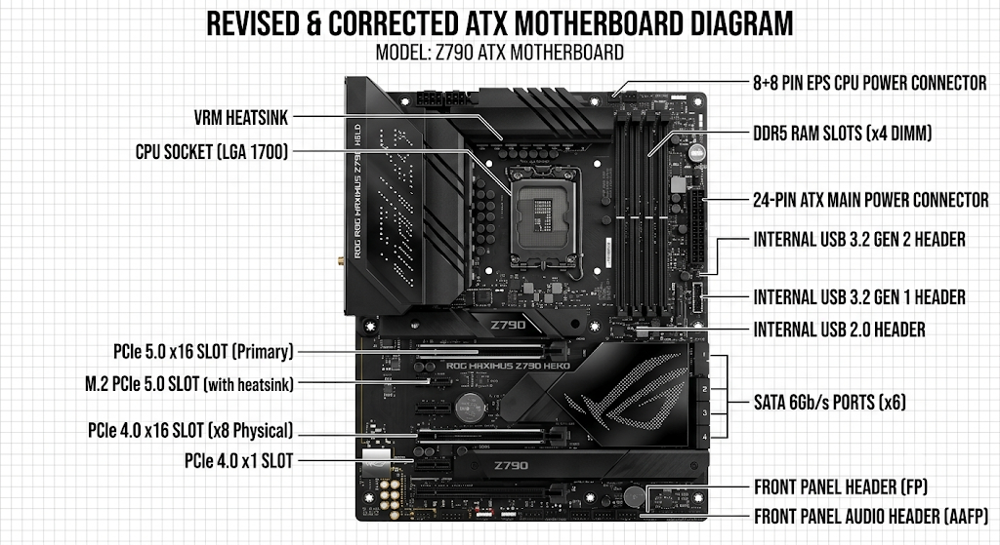

Task-2:
- LGA 1718
- LGA 1700
- PGA 1331
LGA 1718 AMD Ryzen 7 7800X3D
LGA 1700 Intel Core i5-13600K
PGA 1331 AMD Ryzen 5 5600X

Task-3:
Primary functions of CPU:
processes instructions
perform calculations
Data management
system control.
Chipset on motherboard:
The chipset manages communication between hardware components.

When we open Spotify
The chipset’s role: The chipset receives the request from the OS to fetch Spotify's data. It communicates with your SSD via the PCIe lanes or SATA ports it controls, grabs the program files, and routes them up to the CPU.
The CPU’s role: Modern CPUs have a built-in memory controller. The CPU takes the incoming data from the chipset and floods it directly into your ultra-fast RAM slots so it can access the code instantly.

Task-4:
