Task-1:
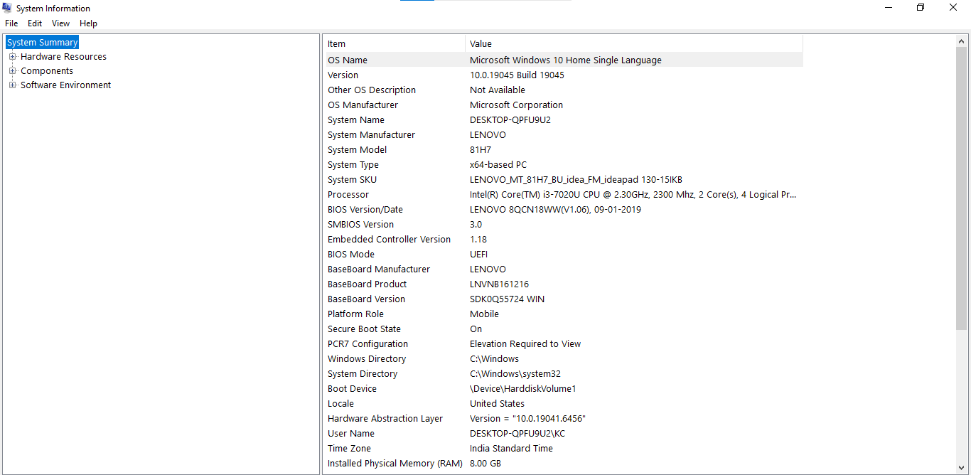
Task-4:
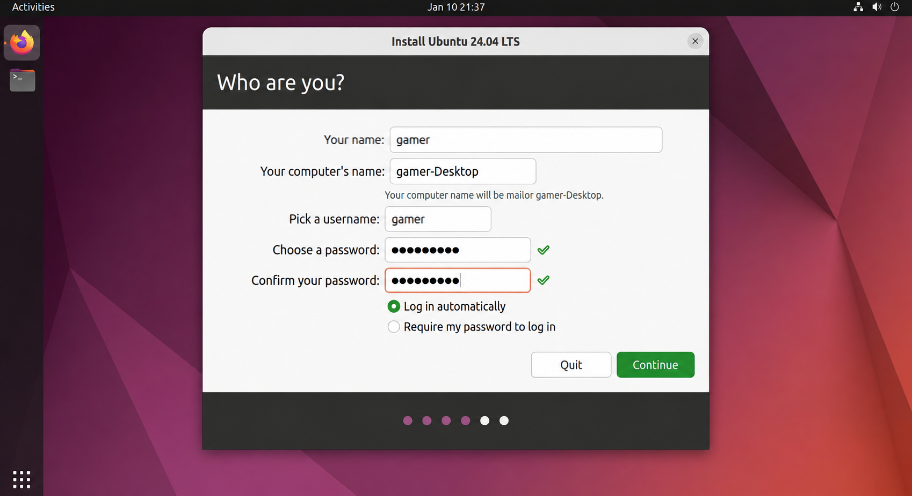
Task-5:

Step-by-Step Guide for Installing Windows 10 on a Laptop

Step 1: Prepare the Requirements
- A laptop that supports Windows 10.
- A USB flash drive (at least 8 GB).
- A Windows 10 bootable USB created using the Microsoft Media Creation Tool.
- A stable internet connection (recommended).

Step 2: Boot from the USB Drive
- Insert the bootable USB into the laptop.
- Restart the laptop.
- Open the Boot Menu (F12, F9, Esc, or another key depending on the manufacturer).
- Select the USB drive to start Windows Setup.

Step 3: Start Windows Setup
- Select the language, time, and keyboard layout.
- Click Next.
- Click Install Now.

Step 4: Enter the Product Key
- Enter the Windows product key if available.
- Otherwise, select I don't have a product key to continue.

Step 5: Select Windows Edition
Choose the Windows edition that matches your license (Windows 10 Home or Windows 10 Pro).

Step 6: Accept the License Agreement
- Accept the Microsoft Software License Terms.
- Click Next.

Step 7: Choose Installation Type
Select Custom: Install Windows only (Advanced) for a clean installation.

Step 8: Partition the Drive

For a New Drive
- Select the unallocated space.
- Click New to create a partition.
- Allow Windows to create the required system partitions automatically.

For Reinstalling Windows
- Delete the existing partitions only if all important data has been backed up.
- Select the unallocated space and click Next.
Partitioning Tip:
- C: Drive: 150–200 GB for Windows and applications.
- D: Drive: Remaining storage for personal files.

Step 9: Install Windows
Windows will copy files, install features, and restart several times. Wait until the installation is complete.

Step 10: Complete Initial Setup
- Select your region and keyboard layout.
- Connect to a Wi-Fi network (optional).
- Sign in with a Microsoft account or create a local account.
- Create a password or PIN.

Step 11: Configure Privacy Settings
Review and adjust the following settings:
- Disable the Advertising ID if not required.
- Turn off optional diagnostic data.
- Disable location services if not needed.
- Turn off tailored experiences if preferred.

Step 12: Install Windows Updates
- Open Settings → Update & Security → Windows Update.
- Click Check for updates.
- Install all available updates.
- Restart the computer if prompted.

Step 13: Install Device Drivers
Install the latest drivers for:
- Graphics
- Audio
- Wi-Fi
- Bluetooth
- Chipset
- Touchpad

Step 14: Verify Security Settings
- Ensure Windows Security (Microsoft Defender) is enabled.
- Enable the Windows Firewall.
- Configure BitLocker if supported and required.

Step 15: Install Essential Software
Install commonly used applications such as:
- Web browser
- Microsoft Office or LibreOffice
- PDF reader
- Media player
- Compression software

Reflection: Steps That Were Unclear or Missing
After reviewing the guide, I found that most of the installation process was explained clearly. However, a few points could have been explained in more detail:
- The guide did not explain how to create a bootable USB using the Microsoft Media Creation Tool.
- It did not mention how to change the boot order in the BIOS/UEFI if the laptop does not boot from the USB drive automatically.
- More information about the different partition types (EFI, Recovery, MSR, and Primary) would help beginners understand their purpose.
- The guide did not explain how to activate Windows after installation if the product key is entered later.
- It could also include instructions on creating a system restore point after completing the installation.
Overall, the guide provides a clear overview of the Windows 10 installation process and is suitable for beginners with a basic understanding of computers.

