Task-1:
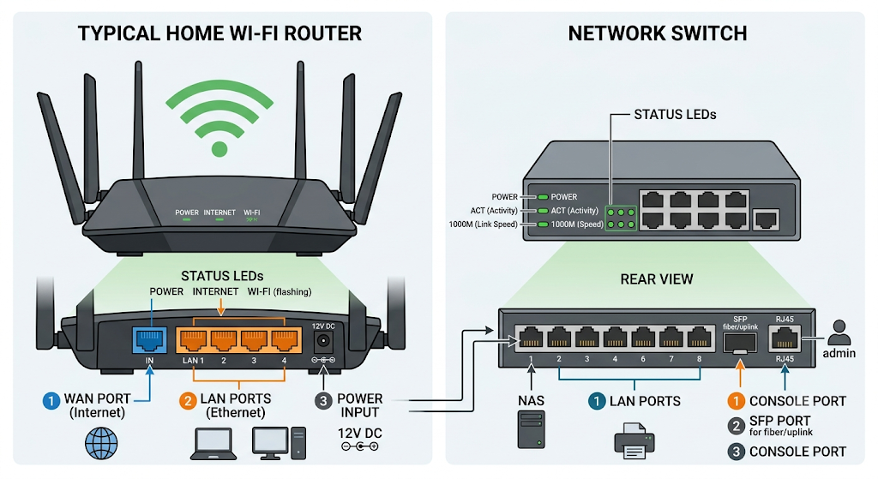
Task-2:
Key Differences: Router vs Switch
Feature | Router | Switch
1. Networks Connected | Connects different networks together, like your home network to the internet. | Connects multiple devices together inside the same local network.
2. Addressing Used | Uses IP addresses (Layer 3) to route data between networks. | Uses MAC addresses (Layer 2) to send data to specific devices.
3. Traffic Handling | Finds the best path to send data packets across external networks. | Forwards data directly to the specific port where the receiving device is connected.

Task-3:

Router
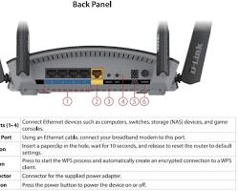
1. Power Port
- Position: Located on the far right or left side of the back panel, next to the ON/OFF power button.
- Purpose: Plugs into the DC power adapter to supply electrical power to the router.

2. Ethernet Ports (At Least 2 Ports)
- Position: Located along the back panel of the router.
  - WAN/Internet Port: Usually highlighted in a distinct color (blue or yellow) and set slightly apart.
  - LAN Ports (LAN 1, LAN 2, LAN 3, LAN 4): A row of identical RJ-45 ports next to the WAN port.
- Purpose:
  - WAN Port: Connects the router to the modem or main internet source.
  - LAN Ports: Connect local wired devices (like laptops, desktop PCs, smart TVs, or switches) using Ethernet cables.

3. LED Indicators
- Position: Located across the front panel or top panel of the router.
- Purpose: Small light icons that show the operational status:
  - Power LED: Solid light means the router is powered on.
  - Internet/WAN LED: Solid green/blue means connected to the internet; orange/red means no internet access.
  - Wi-Fi LEDs (2.4GHz / 5GHz): Flashing lights indicate active wireless data transfer.
  - LAN LEDs: Shows which physical Ethernet ports currently have active wired connections.
Switch
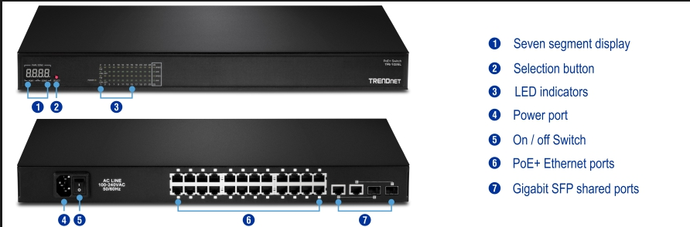

1. Power Port
- Position: Located on the rear panel (or side panel on small desktop models).
- Purpose: Plugs into a power adapter or AC power cord to supply electricity to run the switch.

2. Ethernet Ports (At Least 2 Ports)
- Position: Arranged in a row (numbered 1, 2, 3, 4, 5, etc.) across the front panel.
- Purpose: Used to plug in Ethernet cables (RJ-45) from devices like computers, routers, printers, or smart TVs so they can communicate on the same local network.

3. LED Indicators
- Position:
  - System/Power LED: Located on the front panel next to the brand logo or port row.
  - Port Link/Activity LEDs: Built directly into the top corners of each Ethernet port or listed in a status panel above the ports.
- Purpose:
  - Power LED: Solid light indicates the switch is turned on and receiving power.
  - Port LEDs:
    - Solid Light: A device is connected and linked to that port.
    - Blinking Light: Active data is currently being transmitted or received through that port.
    - Color Change (e.g., Green vs. Amber): Indicates connection speed (Green = 1 Gbps / Gigabit speed, Amber = 100 Mbps speed).

Task-4:

1. What to connect first to the ISP line?
Connect the Router first.
- Why: The ISP line connects directly to the Router (via its WAN port) because the router is the gateway that receives the single public IP address from your internet provider, protects the network, and shares the internet connection.

2. How to connect the 8 Gaming PCs?
Connect an 8-port (or 16-port) Network Switch to the Router, then plug all 8 PCs into the Switch.
- Why: Routers usually don't have enough Ethernet ports for 8 PCs. Adding a Switch gives you plenty of extra ports. Plugging the gaming PCs directly into the switch using Ethernet cables guarantees the fast speed, low latency, and stability needed for online gaming and lag-free IPL streaming.

