Task-1:
Device Type | Specific Model / Type | Real-Life Use Case
Printers | 1. Inkjet Printer | Printing college assignments and high-quality color documents at home or small offices.
 | 2. Laser Printer | Handling heavy workloads and fast printing in large office environments.
 | 3. Thermal Printer | Printing digital receipts, shipping labels, and barcodes quickly without ink.
Scanners | 1. Flatbed Scanner | Scanning and preserving fragile family history, old photos, or delicate documents.
 | 2. Document Scanner | Digitizing tax season paperwork or business receipts in bulk.
Webcams | 1. Integrated Webcam | Quickly joining a casual remote-work team sync or attending an online school lecture.
 | 2. External Webcam | Live streaming high-quality gameplay on Twitch or hosting professional webinars.

Task-2:
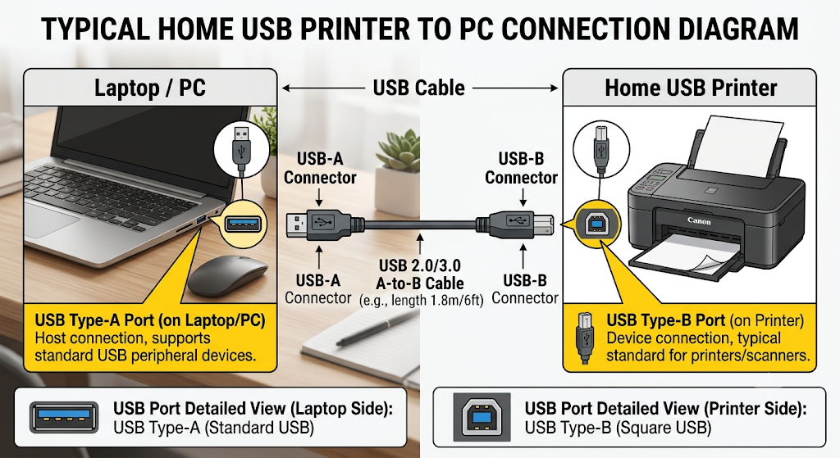
Task-3:

1. USB (Wired Connection)
This is the most common cable-based connection used to plug printers, scanners, and webcams directly into a computer.
- Advantage (Speed & Stability): It provides a highly stable and fast connection with zero lag or signal drops, making it perfect for streaming high-definition video on webcams or scanning large documents quickly.
- Disadvantage (Convenience): It lacks mobility because it requires a physical cable, meaning you can only use the device if it is placed close to your computer.

2. Wi-Fi (Wireless Network Connection)
This interface connects devices like printers and scanners to your computer through your home or office wireless network.
- Advantage (Convenience): It offers great flexibility because multiple computers or smartphones can use the same printer or scanner from anywhere in the house without any cables.
- Disadvantage (Compatibility & Setup): The initial setup can sometimes be complicated, and if your Wi-Fi network goes down or has a weak signal, the device will stop working.

3. Bluetooth (Short-Range Wireless Connection)
This is a wireless interface used for quick, direct connections between devices over a short distance, commonly found in portable printers or webcams.
- Advantage (Convenience & Compatibility): It is incredibly easy to pair with almost any modern device (like laptops and smartphones) instantly without needing a network router or password.
- Disadvantage (Speed): It has slow data transfer speeds and a short range, making it poorly suited for sending large print jobs or streaming high-resolution video.

Task-4:

Step 1: Place and Power On the Printer
- Plug the power cord into the wall outlet and turn the printer on.

Step 2: Connect the USB Cable
- Take your printer's USB cable (the one with a square end and a flat end).
- Plug the square end (USB-B) into the back of the printer.
- Plug the flat end (USB-A) into any open USB port on your laptop or computer.

Step 3: Let the Computer Detect the Printer
- Once connected, your computer will usually make a sound and show a notification saying, "Setting up a device" or "Device is ready."
- Modern operating systems (like Windows or macOS) will automatically find and install the right software (drivers) for your printer.

Step 4: Verify the Connection (Test Print)
- Open any document or college assignment on your computer.
- Press Ctrl + P (on Windows) or Cmd + P (on Mac).
- Select your printer's name from the list and click Print to make sure it is working perfectly!

