Computer Hardware, Windows Administration & Troubleshooting

Theory + Practical Examination

Section A – Theory

Q1. Answer Questions.
- Differentiate between SMPS and UPS.
An SMPS powers the system during continuous electricity supply, while a UPS powers the system during a power outage or blackout.
- What is the purpose of Device Manager?
The Device Manager is a built-in Windows tool used to view, manage, and troubleshoot all the hardware components and devices connected to your computer.
- Explain the use of DNS Cache.
A DNS Cache temporarily stores the IP addresses of recently visited websites on your device so your browser can load them instantly on the next visit.
- What is the function of a Device Driver?
A device driver acts as a translator between your computer's operating system and its hardware components, allowing them to communicate and work together properly.
- What is the difference between HDD and SSD?
HDD have moving parts, cheap & slow, but SSD have not moving parts, expensive( as compare to HDD) and faster than HDD.
- Explain the use of Task Manager.
The Task Manager is a built-in Windows utility that allows you to monitor system performance and view, manage, or force-close active applications and background processes.
- What is the purpose of Battery Report?
It is basically use for gathering information about health of battery and historical usage data over time.

Section B – Command & Troubleshooting

Q2. Write the appropriate command for the following.
Task | Command
Find computer name | __hostname_______
Find current user | ___whoami______
Display IP address | __ipconfig_______
View active network connections | _ arp -a________
Open Device Manager | _devmgmt.msc________

Q3. Scenario-Based Questions

Scenario 1
A printer is connected but not printing.
- Mention any 3 troubleshooting steps.
First, check if the printer wires are properly connected.
Check if the printer ink is empty or full.
Check if the paper is stuck inside the printer.

Scenario 2
A webcam is not detected.
- Which Windows tool will you use first and why?
First I will use device manager, because it will quickly show you if Windows detects the webcam.

Section C – Practical Examination

Q4. Perform Tasks
- Find the Computer Name using CMD. hostname(DESKTOP-QPFU9U2)
- Find the Current Logged-in User. whoami(desktop-qpfu9u2\kc)
- Display detailed Network Information. ipconfig /all
- Generate a Battery Report. powercfg /batteryreport
- Open Device Manager using Run Command. devmgmt.msc
- Find CPU Name using CMD. wmic cpu get name
- Find System Serial Number.
- Display Installed Drivers.

Section D – Advanced Challenge

Q5. Complete Tasks

Task A
Using CMD, find:
- CPU Name
- RAM Capacity
- BIOS Version
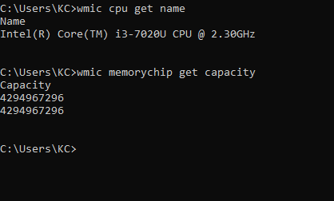

Task B
Using CMD, identify:
- Active Network Connections
- Saved Wi-Fi Profiles
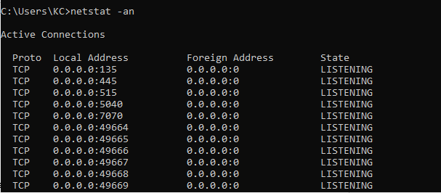
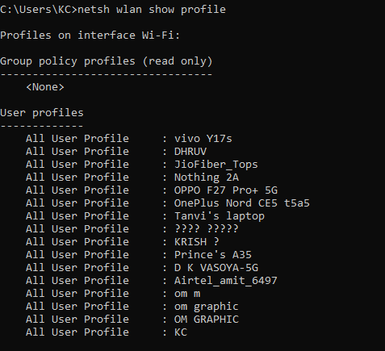

Task C
Create a hidden folder named Exam and then make it visible again.
Commands:
attrib +h Exam
attrib -h Exam

