Task-1:
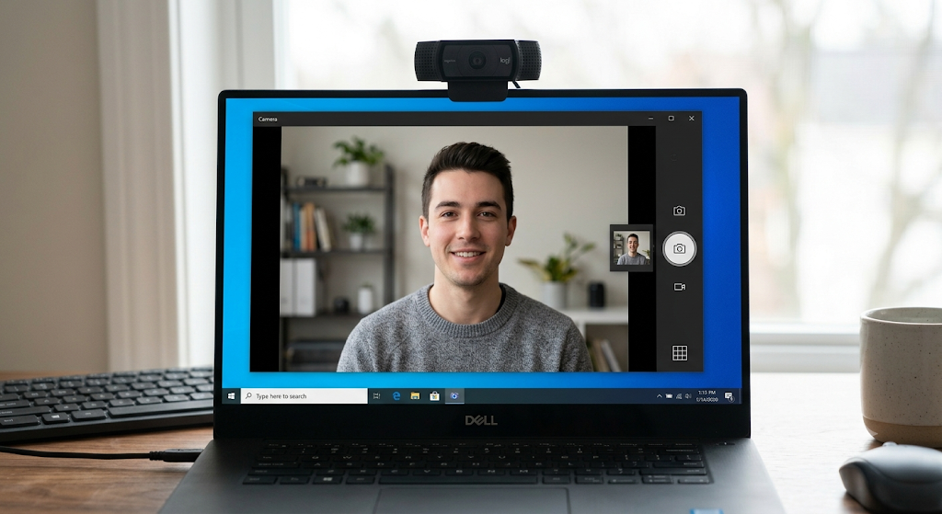

Task-2:

Step 1: Connect the Printer
- For USB: Connect the printer to a power source, turn it on, and plug the USB cable directly into your computer.
- For Network (Wi-Fi/Ethernet): Turn on the printer and connect it to your local Wi-Fi network (using the printer's screen) or plug an Ethernet cable into your router.

Step 2: Install the Driver
- Windows usually detects and installs basic drivers automatically when connected.
- If it doesn't, go to the manufacturer's official website (HP, Canon, Epson, etc.), enter your printer's model number, and download the latest driver software package. Run the installer and follow the prompts.

Step 3: Print a Test Page
- Open the Start menu and type Printers & scanners, then select it from the results.
- Click on your newly added printer from the list and select Manage.
- Click Print a test page. If the page prints successfully, your installation is complete.

Task-3:
• Simulate the Issue: Unplug the printer's USB cable from your computer while the printer is turned on.
• Open Device Manager: Right-click the Windows Start button and select Device Manager.
• Identify the Problem: Look for a yellow exclamation mark icon or an "Unknown device" entry under the Printers or Universal Serial Bus controllers categories.
• Reconnect the Cable: Plug the USB cable firmly back into a different USB port on your computer.
• Scan for Changes: Click on any item in the Device Manager list, then click the Action menu at the top and select Scan for hardware changes.
• Verify Resolution: Confirm that the error icon disappears and your printer's correct name shows up normally in the list.
Task-4:
• Close Conflicting Apps: Completely close the default camera app (or any other program like Teams or Skype) because Windows only allows one application to use the webcam at a time.
• Grant Zoom Permissions: Go to Settings > Privacy > Camera, ensure "Allow desktop apps to access your camera" is toggled On, and make sure Zoom is permitted in the list below.

