Task-1:

• Motherboard: This is the "main hub" or heart of the computer, which connects all the components (CPU, RAM, GPU) to each other and enables communication between them.
• CPU (Processor): This is the "brain" of the computer. Whatever command you give, it processes it and handles all the calculations.
• GPU (Graphics Card): Its job is to render (visualize) everything displayed on the screen, especially during heavy gaming and video editing.
• RAM: This is the temporary memory of the computer. It holds the data of the apps or files you are actively running at that moment so that the system runs fast.
• HDD/SSD (Storage): This is your permanent storage where your Windows (OS), software, photos, and files are saved forever (SSDs are always much faster than HDDs).
• SMPS (Power Supply): This is the "powerhouse" of the computer. If you look closely, many wires come out of it, which convert the electricity coming from the switchboard and supply it according to the needs of all components.

Task-2:

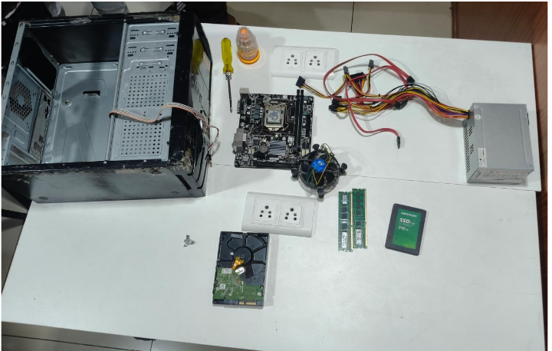
1.Unplug Power and External Cables:Safety First.
Turn off the SMPS switch at the back, unplug the main power cord from the wall, and disconnect all external cables (Monitor, Keyboard, Mouse, etc.). Press and hold the PC's power button for 5-10 seconds to drain any leftover power.
2.Remove the Side Panels:Opening the Cabinet.Lay the cabinet flat on a non-slip surface (like a wooden table). Unscrew the thumb screws at the back of the side panels and slide them off to expose the internal components.

3.Disconnect SMPS and Front Panel Cables:Clearing the Wires.
Carefully unplug all power cables coming from the SMPS connected to the motherboard (the large 24-pin cable and the 4/8-pin CPU power cable), GPU, and storage drives. Also, unplug the smaller front-panel wires (Power SW, Reset SW, USB, Audio).
4.Remove the RAM Modules:Component Removal.
Locate the RAM sticks. Push down on the small plastic clips at either one or both ends of the RAM slots. The RAM stick will pop up slightly; lift it straight out by its edges.
5.Remove the GPU (Graphics Card):Component Removal.
Unscrew the bracket holding the GPU to the back of the cabinet case. Press down on the small plastic release latch on the motherboard slot beneath the GPU, then gently pull the card straight out.
6.Remove HDD / SSD Storage:Component Removal.
Unplug the SATA data cables connecting the drives to the motherboard. Unscrew the mounting screws holding the HDD or SSD inside its bay or bracket, and slide the drive out.
7.Remove the SMPS (Power Supply Unit):Component Removal.
Support the SMPS with one hand and remove the 4 screws on the back of the cabinet that hold it in place. Carefully lift the SMPS and its bunch of wires out of the case.
8.Remove the Motherboard:Final Step.
Unscrew the CPU cooler/fan if it's blocking any screws (optional but helpful). Locate and remove all the screws securing the motherboard to the cabinet standoffs (usually 6 to 9 screws). Carefully lift the motherboard out by its edges.

Task-3:
Step 1: Outside the Cabinet.
What & Why: Install the CPU, RAM sticks, and any tiny M.2 NVMe SSDs onto the motherboard before putting it inside the case.
Why Order Matters: Doing this on a flat table gives you full visibility and leverage to press the RAM down until it clicks and align the CPU perfectly without being cramped inside the dark cabinet.
Step 2: Outside the Cabinet.
What & Why: Apply thermal paste (if not pre-applied) and screw down the CPU cooler over the processor. Plug the fan wire into the CPU_FAN header on the motherboard.
Why Order Matters: CPU coolers often feature large heatsinks or brackets that require access to the back of the motherboard. Trying to install this inside the cabinet is incredibly difficult.

Step 3: Inside the Cabinet.
What & Why: Push the silver I/O shield (rear port panel) into the back of the case until it clicks. Then, align the motherboard with the brass standoffs inside the cabinet and screw it down firmly.
Why Order Matters: If you forget the I/O shield, you have to unscrew the entire motherboard later to put it in. The motherboard goes in now because it acts as the foundation for all other internal connections.
Step 4: Power Foundation.
What & Why: Slide the SMPS into its bay at the bottom or top of the case and secure it with 4 screws from the back. Route the thick cables through the cabinet's cutouts.
Why Order Matters: You want the power cables ready to plug in before the case gets crowded with big components like the graphics card.
Step 5: Wiring Phase 1.
What & Why: Plug in the large 24-pin main motherboard power cable, the 4/8-pin CPU power cable (top left), and the tiny front panel wires (Power SW, Reset, USB, Audio).
Why Order Matters: The top-left CPU power connector and front panel pins are notoriously small and hard to reach. If you install the GPU or large storage drives first, your hands won't fit to plug these in.

Task-4:
Discharging Static Electricity
Touch a metal table leg or the unpainted metal of your PC case before touching any parts. Your body carries static electricity, and a single invisible spark from your fingers can instantly fry the delicate microchips on your motherboard or RAM.
The Power Drain Rule
Unplug the power cord from the wall and hold the PC’s power button down for 5 to 10 seconds. This drains the leftover electricity stored inside the SMPS and motherboard, preventing accidental short circuits or shocks when you pull out wires.
Choosing a Static-Free Workspace
Always work on a hard, flat surface like a wooden or plastic table—never on a carpet, bed, or rug. Fabric surfaces generate massive amounts of static electricity and lint, which can ruin components or clog up your RAM and PCIe slots.

Handling Parts by the Edges
Pick up your components (RAM, GPU, Motherboard) strictly by their plastic edges or metal brackets. Never touch the gold pins or circuit boards, as the natural oils and sweat from your fingers can corrode the metal contacts and cause connection errors.
The "Never Force It" Rule
PC parts are designed to fit only one way. If a cable or component isn't sliding in easily, stop and check the alignment notches—never force it, or you will easily bend delicate pins, break plastic clips, or crack the circuit boards.

