Section A — Concept Application
Q1: Explain the process of selecting a compatible motherboard, CPU, RAM, and storage device for a new office workstation, and justify how you would confirm they will work together.
Answer: First I check the CPU brand (Intel or AMD) and pick a motherboard with the same CPU socket type. Then I check the RAM type (like DDR4 or DDR5) that the motherboard supports, and buy RAM of that type and speed. For storage, I check if the motherboard has a SATA port or an M.2 slot, and pick a hard disk or SSD that matches. To confirm everything works together, I read the motherboard manual and the maker's website, and check the CPU support list (QVL). I can also use a website like PCPartPicker to check compatibility before buying.

Q2: Explain the differences between HDD, SSD, and NVMe storage, and recommend the most suitable option for this workload, giving technical reasons for your choice.
Answer: HDD (hard disk drive) uses a spinning disk and a moving arm to read data. It is slow but cheap and gives more storage space. SSD (solid state drive) uses flash memory chips with no moving parts, so it is much faster and more reliable than HDD. NVMe is a type of SSD that connects directly to the M.2 slot and is even faster than a normal SATA SSD. For office and productivity work, I recommend a SATA SSD or NVMe SSD. It gives fast boot time, fast file opening, and better reliability, which helps employees work without delay.

Q3: Explain the role of the GPU and the cooling system in maintaining performance and stability under this kind of sustained load.
Answer: The GPU (graphics card) does the heavy work of drawing images and graphics, so the design software runs smoothly without lag. When the GPU works for many hours, it becomes hot. The cooling system (fans or heatsinks) removes this heat and keeps the temperature safe. If cooling is not good, the GPU or CPU can slow down itself (this is called thermal throttling) or even get damaged. So good cooling keeps performance steady during long work hours.

Q4: Explain why hardware compatibility matters when assembling a computer, and identify potential issues that could arise from incompatible components.
Answer: Compatibility matters because all parts must physically fit and work together electrically. For example, the CPU socket must match the motherboard, the RAM type must match, and the power supply must have the right connectors. If parts are not compatible, the computer may not turn on, parts may get damaged, the system may not boot, or some features (like fast RAM speed) may not work fully. This wastes money and time.

Q5: Explain how you would choose an appropriately rated PSU for this build and describe the safety and connection checks you would carry out before powering it on.
Answer: To choose the PSU, I add up the power needed by the CPU, GPU, RAM, storage, and fans, then choose a PSU with some extra wattage headroom (for example 20% more) for safety. I also check that the PSU has the correct connectors (24-pin motherboard, CPU 4/8-pin, PCIe for GPU, SATA power for storage). Before powering on, I check that all cables are firmly connected, no wires are pinched, the voltage switch (if present) is set correctly for my country, and I touch a grounded metal surface to avoid static (ESD) damage. I also make sure no metal tools are left inside the case.

Q6: Explain the checks you would perform to confirm the system passes POST successfully, and what you would do if it did not.
Answer: After powering on, I check that fans spin, the monitor shows the BIOS/manufacturer screen, and there are no beep error codes. I also check that the keyboard lights turn on and the system reaches the BIOS setup or boot screen without error messages. If POST fails, I turn off the power, reseat the RAM and GPU, check all power cables are connected properly, and check the motherboard's beep code or debug LED to find which part is causing the problem. I test one part at a time until I find the fault.

Section B — Practical Coding Tasks

Task 1: Component Identification & Functions
Component | Function | Make / Model (example)
Motherboard | Connects all parts together and lets them talk to each other. | ASUS Prime B450M-A
CPU | The main brain of the computer. It does all calculations. | AMD Ryzen 5 3600
RAM | Temporary fast memory used while programs are running. | 8GB DDR4 3200MHz
GPU | Handles graphics and video output. | NVIDIA GTX 1650
Storage Device | Saves the operating system and files permanently. | 500GB SATA SSD
Cooling System | Removes heat from CPU/GPU to keep them safe. | Stock CPU air cooler

Task 2: Motherboard Ports & Socket Identification
Major ports and their purpose:
- SATA ports — connect hard disk or SSD for data transfer.
- 24-pin power connector — gives main power to the motherboard.
- USB headers — connect front-panel USB ports of the case.
- Fan headers — connect case and CPU fans for cooling.
Expansion slots and purpose:
- PCIe x16 slot — used for the graphics card (GPU).
- PCIe x1 slot — used for smaller cards like sound or network cards.
- M.2 slot — used for a fast NVMe SSD.
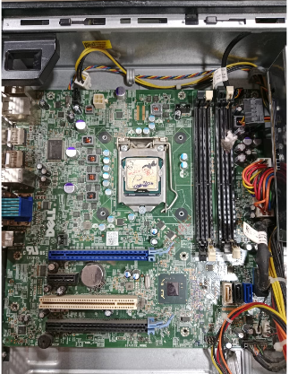

Task 3: RAM & Storage Installation
- ESD precaution: I switched off the power, unplugged the PC, and touched a grounded metal part before touching any component. I also used an anti-static wrist strap if available.
- RAM removal: I pushed the side clips of the RAM slot outward, and the RAM popped up. I lifted it out carefully by the edges.
- RAM reinstall: I aligned the notch on the RAM stick with the notch in the slot, and pushed down firmly until both side clips locked in place.
- Storage removal and type: The storage device used SATA connection. I unplugged the SATA data cable and power cable, then removed the mounting screws to take it out.
- Storage reinstall: I placed the drive back, fixed it with screws, and reconnected the SATA data and power cables.
- Confirmation: After restart, I entered BIOS and checked that RAM size and storage device both appeared correctly. The operating system also detected both without any error.

Task 4: Full Desktop PC Assembly

- Installed the CPU onto the motherboard, matching the socket arrow with the corner marking.
- Applied thermal paste and attached the CPU cooler.

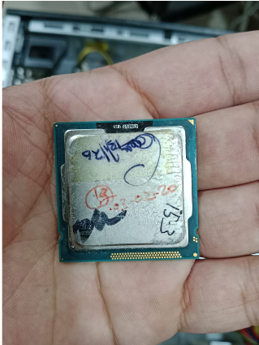

Then After:
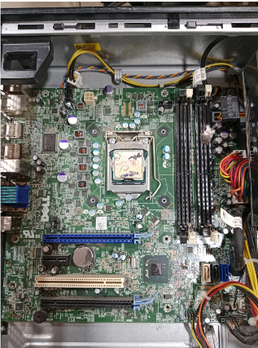
- Installed RAM sticks into the correct slots.
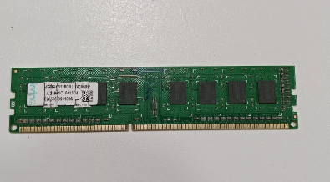
- Fixed the motherboard inside the case using the correct standoffs and screws.
- Installed the storage device (SSD/HDD) and connected its cables.
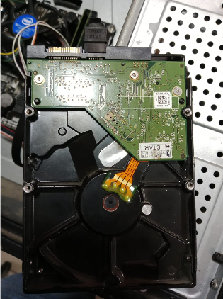
- Installed the GPU into the PCIe x16 slot and secured it with a screw.
- Installed the PSU and connected all power cables (24-pin, CPU power, GPU power, SATA power).
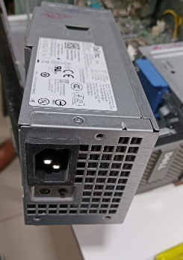
- Connected front-panel case cables (power button, USB, audio) to the motherboard.
- Powered on the system and confirmed it passed POST, showing the BIOS/boot screen with no errors.

Section C — Mini Capstone Project
1. Three components to check first when a PC fails to boot:
I would first check the RAM (it may not be seated properly), the power connections (PSU cables may be loose), and the GPU (it may not be firmly in its slot). These three are the most common reasons for a boot failure right after assembly, because they are easy to leave loose during assembly.

2. How motherboard–CPU compatibility affects system functionality:
The CPU socket type must match the motherboard socket type, or the CPU will not even fit. In the system I assembled, the CPU socket was AM4 and I used a motherboard that also had an AM4 socket, so the CPU worked correctly. If the socket did not match, the system would not power on at all, and if the motherboard's BIOS did not support that CPU model, the system may not boot until a BIOS update.

3. How to verify RAM and storage are installed correctly:
I check that RAM sticks are pushed in fully with both side clips locked. For storage, I check that the data and power cables are fully connected. Then I enter the BIOS/UEFI setup: it should show the correct RAM size (for example 8GB) and should list the storage device by its correct model name. If BIOS does not show them, they are not installed correctly.

4. Hardware-installation checklist (at least 3 steps) to prevent future failures:
- Always ground yourself (touch metal or use anti-static strap) before touching any part, to avoid ESD damage.
- Check that RAM and GPU are fully seated and side clips/screws are locked, not just placed in the slot.
- Double check all power cables (24-pin, CPU power, GPU power, SATA power) are firmly plugged in before powering on.
- Enter BIOS after first boot to confirm all parts (RAM size, storage, CPU) are detected correctly.

5. Technical justification for using SSDs instead of HDDs in office workstations:
SSDs have no moving parts, so they are faster and less likely to break from shocks or vibration. They make the operating system start faster and open office programs (like Word, Excel, browser) quickly. For a computer lab like ABC Solutions, where many employees use the systems daily for office work, SSDs reduce waiting time and reduce the chance of drive failure, saving IT support time and cost.

Section D — AI-Augmented Learning

Step 1 — Exact Prompt Given to AI Tool
"Create a step-by-step troubleshooting checklist for a junior IT technician to diagnose a desktop PC that fails to boot right after assembly. Cover motherboard, RAM, storage, and PSU as possible failure points, in correct priority order, as a simple checklist a technician can follow on-site. Then show how this checklist would catch the boot problem in the ABC Solutions computer lab scenario, where some PCs fail to start and others show hardware detection errors after assembly."

Step 2 — AI's Original Checklist
- Check if the power button and power light turn on.
- Check if the monitor shows any picture.
- Open the PC case and check the RAM.
- Check the storage device connection.
- Check the software and driver settings.
- Check the motherboard and PSU last.

Step 2 — My Corrected Checklist (Without AI)
- 1. Ground yourself first (touch metal or use anti-static strap) before opening the case, to avoid ESD damage.
- 2. Check that the power cable and PSU switch are on, and the power button/light responds.
- 3. Open the case and check that all power connectors (24-pin, CPU power) are firmly plugged into the motherboard.
- 4. Reseat the RAM sticks, making sure both side clips lock.
- 5. Check the GPU and storage device cables are firmly connected.
- 6. Listen for beep codes or check the motherboard debug LED to find the faulty part.
- 7. Only after confirming hardware boots and shows BIOS screen, check software/driver settings.

Applied to ABC Solutions Scenario
In the ABC Solutions lab, some PCs failed to start and some showed hardware detection errors. Using my corrected checklist, step 1 (ESD grounding) and step 4 (reseating RAM) would likely catch the problem, because loose or wrongly seated RAM is a very common cause of both 'PC not starting' and 'hardware not detected' errors right after assembly.

3–4 Line Note: What I Changed and Why
The AI's checklist checked software and driver settings before fully checking the physical hardware connections, which is not safe and wastes time. It also did not mention ESD (anti-static) precautions at the start, which can damage parts. I moved the ESD step to the very beginning, moved physical checks (power cables, RAM, GPU, storage) before any software check, and added a step to check beep codes/debug LED to find the exact faulty part faster.

