Task-1:
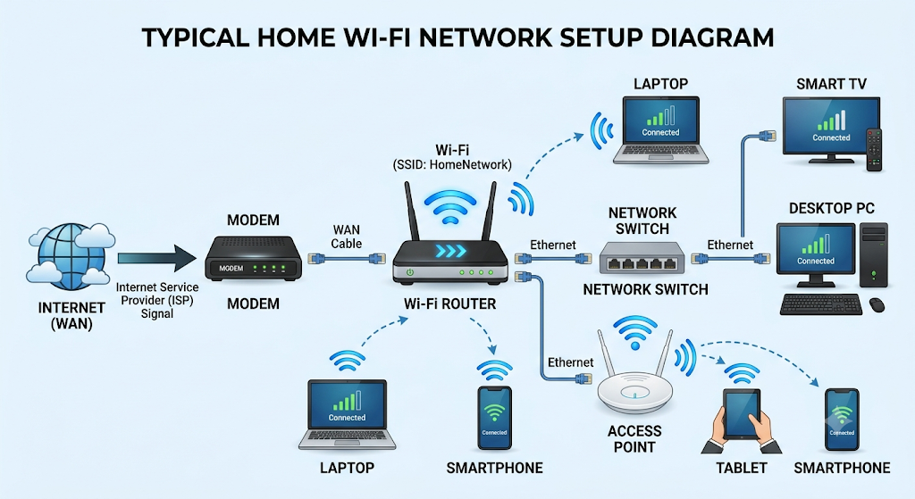

Task-2:

1. Modem
- Function: Brings the internet into your home from your internet provider.
- Example: The box in your home connected to the wall cable.

2. Router
- Function: Shares that internet connection with all your home devices.
- Example: At home or in a cafe to connect your phone to Wi-Fi.

3. Switch
- Function: Adds more cable ports to connect multiple wired devices.
- Example: In an office or computer lab to plug in many computers.

4. Access Point
- Function: Expands Wi-Fi signal to rooms where Wi-Fi is weak.
- Example: Fixed on a hotel or school ceiling so every room gets Wi-Fi.

5. Network Cable (Ethernet)
- Function: A wire that connects devices together for fast internet.
- Example: The cable plugged into a smart TV or gaming console for smooth streaming.

Task-3:
- Ethernet Cable
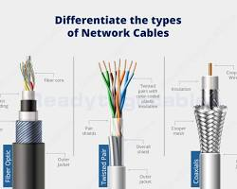
Where it is used: Commonly used in homes and offices to connect computers, routers, smart TVs, and gaming consoles to a local network.

- Coaxial Cable
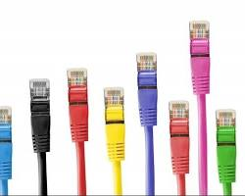

Where it is used: Commonly used to deliver cable TV signals and bring broadband internet from wall outlets into cable modems.

- Fiber Optic Cable
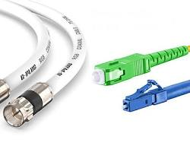
Where it is used: Commonly used by internet providers for ultra-fast, high-speed internet over long distances and inside data centers.
Task-4:
Difference | Router | Switch
Main Use | It connects different networks together to share internet access. | It connects multiple devices together inside the same local network.
Data Handling | It uses IP addresses to send data to the correct device. | It uses MAC addresses to send data to specific devices on the network.
Typical Location | It is placed between your home network and the internet modem. | It is placed inside a local network, like an office or computer lab.
Network Level | It operates at Layer 3 (Network Layer) of the OSI model. | It operates at Layer 2 (Data Link Layer) of the OSI model.
Ports & Connections | It usually has fewer ports and includes built-in Wi-Fi support. | It usually has many Ethernet ports and supports only wired connections.

