Task-1:
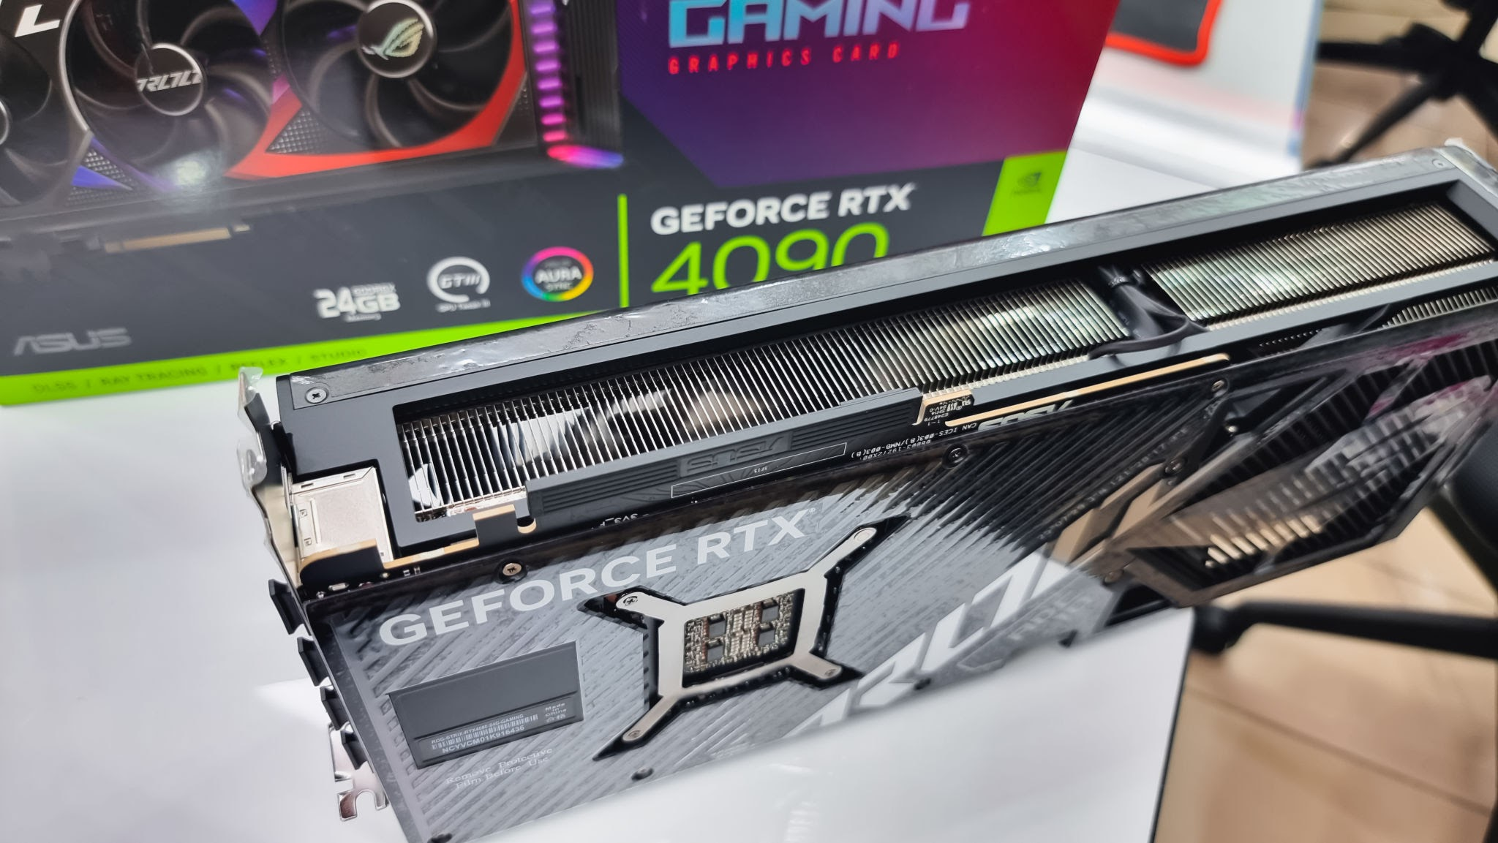

• Brand: NVIDIA (Custom board manufactured by ASUS under the ROG Strix line)
• Model Number: GeForce RTX 4090
• Type: Dedicated

Task-2:
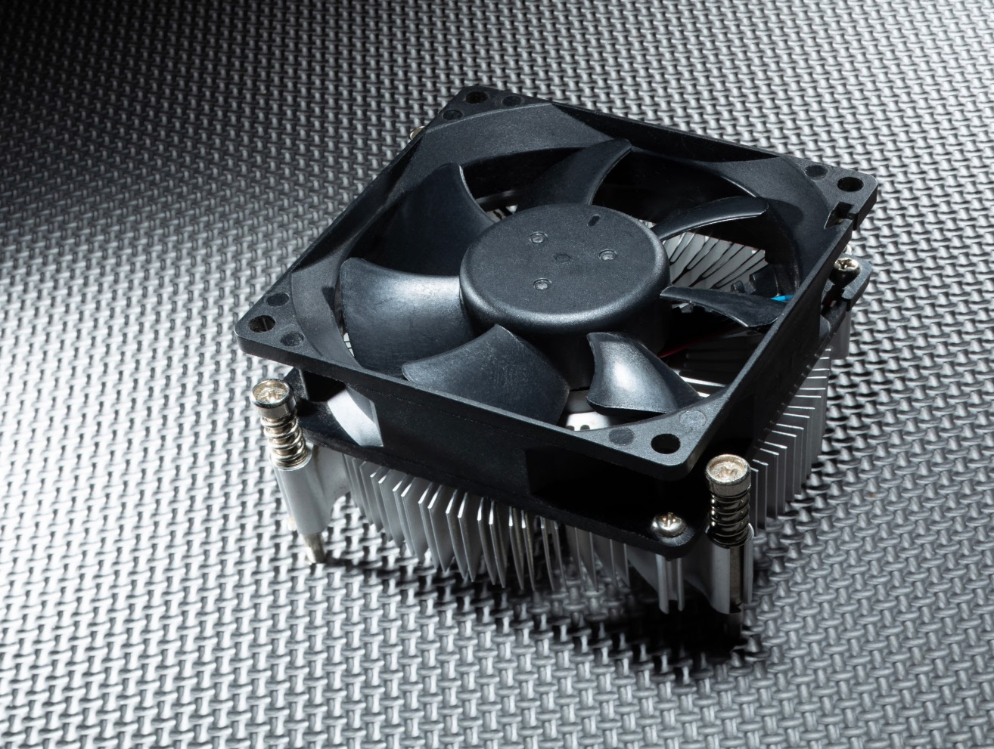

This is the CPU cooling fan and heatsink. Its main function is to cool down the CPU whenever it overheats. It is an excellent, cost-effective cooling option for the system.

Task-3:
Factor | Air Cooling System | Liquid Cooling System
Cost | It is highly affordable and budget-friendly with no extra component costs. | It is significantly more expensive due to specialized radiators, pumps, and custom loops.
Performance | It provides reliable cooling for daily tasks but temperatures rise under heavy gaming. | It offers superior thermal efficiency and keeps temperatures low even during intense overclocking.
Maintenance | It requires virtually zero maintenance except for occasional dust cleaning. | It demands regular maintenance, coolant refills, and careful monitoring for potential liquid leaks.
Noise | It becomes noticeably loud when the fans spin at maximum speeds under heavy load. | It operates very quietly because the large radiators allow fans to spin much slower.
Space & Setup | It is easy to plug-and-play but the bulky heatsink occupies significant PCIe slot space. | It features a slim GPU block but requires a large PC case to install the radiator and tubes.

Task-4:
If I use a dedicated GPU to run high-graphics games and IPL games on my PC, I will use a liquid cooling system to keep it cool. Even though a liquid cooling system is a bit more expensive than an air cooling system, it delivers much better performance and operates noise-free.

