Task-1:
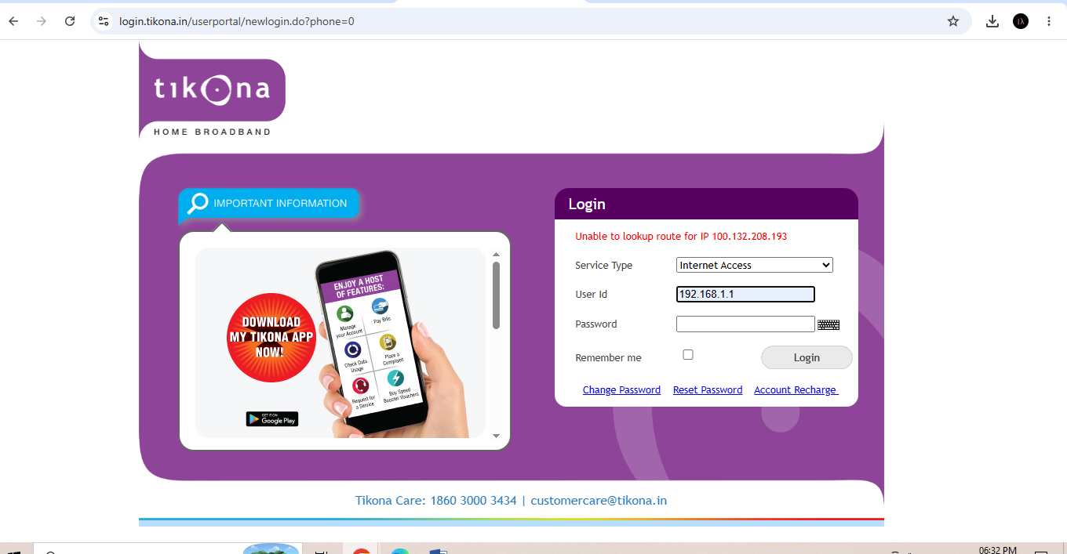

Task-2:
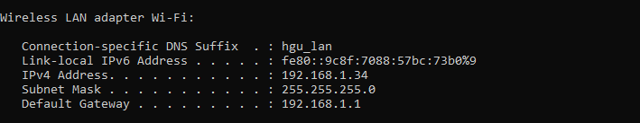

Task-4:
• Internet stops working: The router gets confused about where to send information, so internet drops on one or both devices.
• Error message pops up: You will see a notification on your screen saying "IP Address Conflict Detected".
• Slow or broken connection: Even if it connects for a moment, it will keep disconnecting.

