Task-1:

Key Differences
- Material: Ethernet cables use copper wire (electricity), while fiber optic cables use glass or plastic threads (light).
- Speed & Distance: Fiber optic is much faster and can send data over long distances without losing signal, whereas Ethernet slows down over long distances.
- Durability & Interference: Ethernet cables can suffer from electrical interference; fiber optic cables are completely immune to it.

Real-World Examples
- Ethernet Cable: Connecting a gaming PC or smart TV directly to your home Wi-Fi router.
- Fiber Optic Cable: Connecting high-speed internet between major cities or undersea data lines connecting countries.

Task-2: 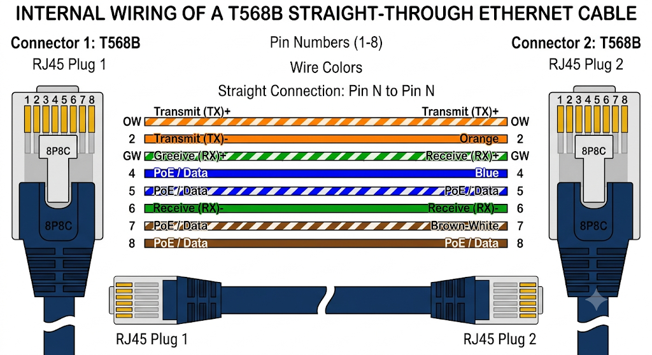

Task-3:

Steps to Crimp the Cable:
- Strip the Outer Jacket
  - Use a cable stripper to strip off about 1.5 inches (3–4 cm) of the outer plastic jacket from the end of the cable. Be careful not to nick the internal copper wires.

- Remove the Center Plastic Core (Spline)
  - CAT6 cables usually have a plastic separator (spline) in the middle. Cut this plastic core as close to the jacket base as possible using small wire cutters or scissors.

- Untwist and Straighten the Wires
  - Untwist all 4 pairs of colored wires completely and flatten them out straight using your fingers so they are easy to arrange.

- Arrange Wires in T568B Order
  - Line up the wires side-by-side in this exact order from left to right:
    - White-Orange
    - Orange
    - White-Green
    - Blue
    - White-Blue
    - Green
    - White-Brown
    - Brown

- Trim the Wires Straight
  - Pinch the arranged wires tightly together. Cut them completely straight across, leaving about half an inch (1.2 cm) exposed from the outer jacket edge.

- Insert Wires into the RJ45 Connector
  - Hold the RJ45 connector with the plastic release clip facing down (pins facing up).
  - Push the wires firmly into the connector until all 8 copper ends reach the very tip of the plug. Make sure the outer jacket is pushed slightly inside the back of the plug for extra strain relief.

- Crimp the Plug
  - Insert the loaded RJ45 connector into the matching slot on your crimping tool.
  - Squeeze the handles firmly together until you feel the tool lock and press the metallic pins down into the wires.
Task-4:
For a 10-PC LAN gaming cafe, Ethernet cables and an RJ45 crimper are the best choice. Since all computers are close together in one room, Ethernet provides plenty of speed at a much lower cost and is easy to set up. Fiber optics and expensive tools like fiber cleavers are unnecessary for short distances and would unnecessarily raise setup costs.

