Task-2:
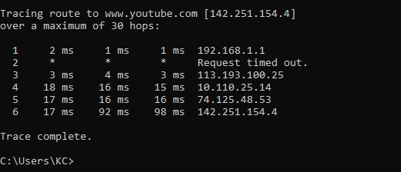
Task-3:
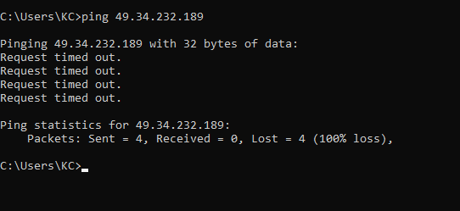
Task-4:
49.34.232.189 | Smart phone
192.168.1.34 | Laptop
49.34.232.145 | Smart phone-2

