Practical Session

Practical 1: Identify Your Network Information

Command:
ipconfig

Task:
- Find IPv4 Address
- Find Subnet Mask
- Find Default Gateway

Learning:
Students will understand how a computer gets a network address from a router.

Practical 2: Detailed Network Information

Command:
ipconfig /all

Task:
Identify:
- Computer Name
- MAC Address (Physical Address)
- DHCP Enabled Status
- DNS Server

Learning:
Students learn how devices are uniquely identified on a network.

Practical 3: Test Internet Connectivity

Command:
ping google.com

Task:
Observe:
- Reply from server
- Time (ms)
- Packets Sent/Received

Learning:
Understand how to test if the internet connection is working.

Practical 4: Continuous Ping Monitoring

Command:
ping -t google.com

Stop:
Ctrl + C

Learning:
Monitor network stability in real time.

Practical 5: View Saved Wi-Fi Networks

Command:
netsh wlan show profiles

Task:
List all Wi-Fi networks previously connected to the system.

Learning:
Understand how Windows stores wireless network profiles.

Practical 6: Display Connected Network Information

Command:
netsh wlan show interfaces

Task:
Find:
- Wi-Fi Name (SSID)
- Signal Strength
- Radio Type
- Connection State

Learning:
Understand wireless network connection details.

Practical 7: Check Active Network Connections

Command:
netstat

Learning:
See active network sessions and communication.

Practical 8: View Network Adapter Details

Command:
getmac

Task:
Find MAC Address of Ethernet and Wi-Fi adapters.

Learning:
Understand hardware identification in networking.

Hands-On Activity 1: Identify Networking Hardware
Provide actual devices and ask students to identify:
- Router
- Switch
- Access Point
- Ethernet Cable
- Fiber Cable (if available)
- RJ45 Connector

Task:
Write the name and purpose of each device.

Hands-On Activity 2: Cable Identification Challenge
Show different cables:
- HDMI
- USB
- Ethernet
- VGA

Task:
Students identify:
- Cable Name
- Purpose
- Network Cable or Not

Hands-On Activity 3: Build a Basic Network Diagram
Students draw:
Internet
↓
Modem
↓
Router
↓
Switch
↓
PC1 PC2 Printer

Learning:
Understand network topology.

Networking Tips & Tricks

Tip 1: Find Your Computer Name
hostname

Tip 2: Find Default Gateway Quickly
ipconfig | find "Default Gateway"

Tip 3: Check DNS Servers
nslookup google.com

Tip 4: Display Routing Table
route print
Shows how data travels through the network.

Tip 5: Flush DNS Cache
ipconfig /flushdns
Useful when websites are not opening correctly.

Tip 6: Renew IP Address
ipconfig /release
ipconfig /renew
Useful for troubleshooting network connectivity issues.

Mini Troubleshooting Task

Scenario:
Internet is not working on a PC.

Student Checklist:
- Check Ethernet cable connection.
- Check router power.
- Run:
- Ipconfig
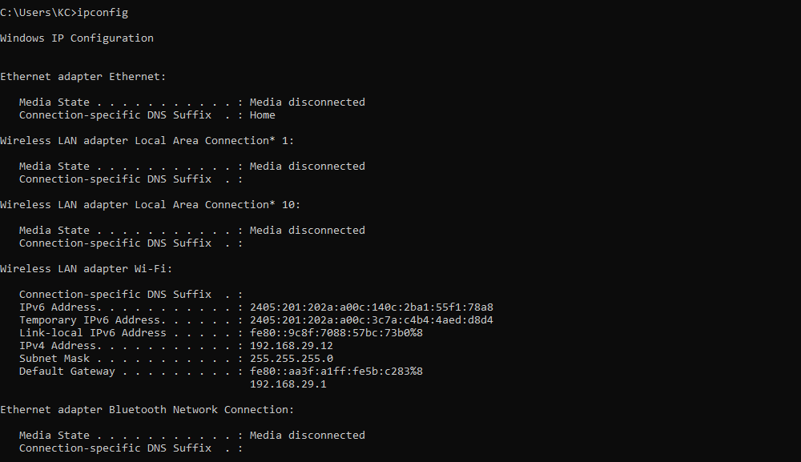
- Ping:
- ping 127.0.0.1
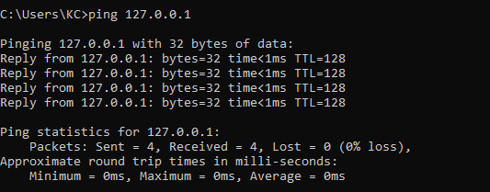
- Ping:
- ping google.com
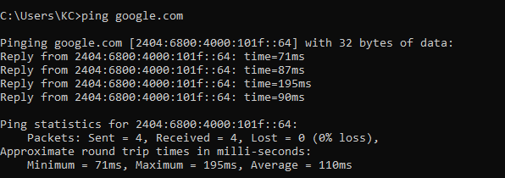
- Identify whether the problem is:
  - Cable issue
  - Router issue
  - ISP issue
  - DNS issue

