Task-1:

SMPS (Switched Mode Power Supply) Devices
- Desktop Computer: It needs an SMPS to efficiently convert high-voltage AC electricity into multiple low-voltage DC outputs required by internal components like the CPU and motherboard.
- Mobile Phone Charger: It uses a compact SMPS to step down voltage and safely charge your phone quickly without wasting energy as heat.
- LED Television: It requires an SMPS to provide a stable, constant DC voltage to the screen and internal circuits while keeping the TV slim and lightweight.

UPS (Uninterruptible Power Supply) Devices
- Wi-Fi Router: It needs a UPS to keep the internet connection running smoothly during a sudden power outage.
- College Lab Server: It uses a UPS to prevent critical data loss and stop the server from shutting down instantly when the main power fails.

Task-2:
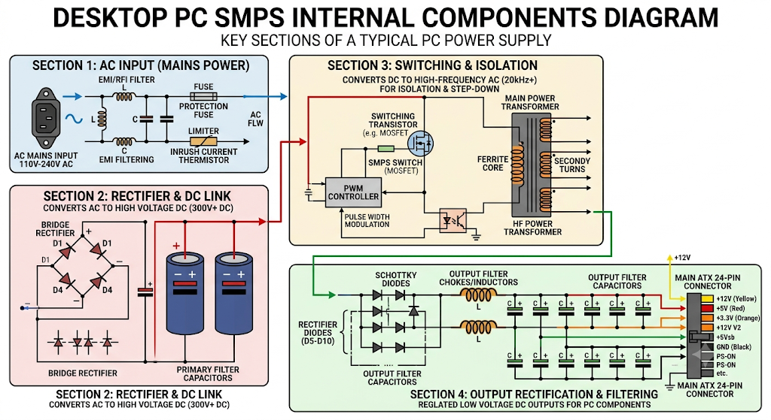

Task-3:
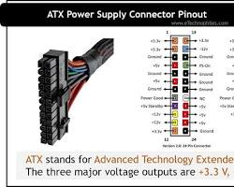

1. ATX 24-Pin Motherboard Connector
- Devices it powers: It provides the main power to the entire motherboard, chipset, and memory slots.
- Safety tip: Always press down firmly on the plastic safety latch to unlock it before pulling, and gently rock it side-to-side rather than pulling straight up to avoid cracking the motherboard.

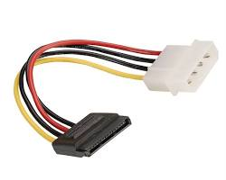

2. SATA Power Connector
- Devices it powers: It powers internal storage drives like Hard Disk Drives (HDDs), Solid State Drives (SSDs), and optical drives (DVD/Blu-ray).
- Safety tip: The connector has an L-shaped slot; never force it in backwards as the thin plastic guide tab inside can snap easily.

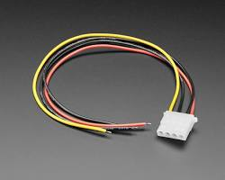

3. Molex Connector (Peripheral 4-Pin)
- Devices it powers: It powers older hard drives, internal case fans, liquid cooling pumps, and legacy expansion cards.
- Safety tip: Because the metal pins inside can easily come loose or misalign, verify that all four pins line up properly with the receiver before pushing them together.

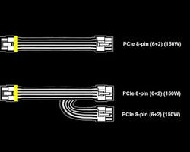

4. PCIe 6/8-Pin Connector
- Devices it powers: It supplies dedicated, high-wattage power to dedicated Graphics Processing Units (GPUs / Video Cards).
- Safety tip: Ensure the connector is fully inserted until you hear a click, as a loose connection under a heavy gaming load can cause high heat buildup and melt the plastic housing.

Task-4:

Step 1: Connect the Motherboard
- Cable used: ATX 24-Pin Cable (The largest, wide connector).
- Action: Plug the 24-pin cable firmly into the long matching slot on the right side of the motherboard until the plastic latch clicks.
- CPU Power: Plug the 4+4 pin (or 8-pin) EPS cable into the power socket near the top-left corner of the motherboard (near the CPU).

Step 2: Connect the Graphics Card (GPU)
- Cable used: PCIe 6+2 Pin (or 8-pin) Cable (It usually says "PCI-E" on it).
- Action: Plug the required number of 6-pin or 8-pin connectors into the top or side of your graphics card until they click into place.

Step 3: Connect the Storage Devices (SSD / HDD)
- Cable used: SATA Power Cable (A thin, flat connector with an L-shaped slot inside).
- Action: Plug the SATA power cable into the back of your 2.5-inch SSD or 3.5-inch Hard Drive.

