

Fetal Health Classification Using Cardiotocography (CTG) Data

Course & Section No:- Data Mining(CS634002)
By:- Dhruv Patel(dp972)(dp972@njit.edu)

Submitted To: Professor Senjuti Basu Roy

Objective
The goal of this project is to classify fetal health status using fetal_health data to help prevent maternal and child mortality. This classification helps in early diagnosis and intervention, especially in low-resource settings.
DataSet Introduction
- Total Instances: 2,126
- Total Features: 21 numerical features + 1 categorical target variable (fetal_health)
- Target Variable: fetal_health
  - 1: Normal
  - 2: Suspect
  - 3: Pathological

Feature Descriptions:
Column Name | Description
baseline_value | Baseline fetal heart rate (FHR) in beats per minute (bpm)
accelerations | Number of accelerations per second (increases in FHR)
fetal_movement | Number of fetal movements per second
uterine_contractions | Number of uterine contractions per second
light_decelerations | Number of light decelerations per second (slight drops in FHR)
severe_decelerations | Number of severe decelerations per second (sharp drops in FHR)
prolonged_decelerations | Number of prolonged decelerations per second (extended drops in FHR)
abnormal_short_term_variability | Percentage of time with abnormal short-term variability
mean_value_of_short_term_variability | Mean of short-term variability of FHR
percentage_of_time_with_abnormal_long_term_variability | Percentage of time with abnormal long-term variability
mean_value_of_long_term_variability | Mean of long-term variability of FHR
histogram_width | Width of the FHR histogram
histogram_min | Minimum value of the FHR histogram
histogram_max | Maximum value of the FHR histogram
histogram_number_of_peaks | Number of peaks in the histogram
histogram_number_of_zeroes | Number of zero counts in the histogram
histogram_mode | Most frequent value (mode) of the histogram
histogram_mean | Mean of the FHR histogram
histogram_median | Median of the FHR histogram
histogram_variance | Variance of the FHR histogram
histogram_tendency | Tendency of the histogram: 1 = increasing, 0 = stable, -1 = decreasing
fetal_health | Target class: 1 = Normal, 2 = Suspect, 3 = Pathological
Code:-
# Fetal Health Classification from Cardiotocogram Data

import pandas as pd # type: ignore
import numpy as np # type: ignore
import seaborn as sns # type: ignore
import matplotlib.pyplot as plt # type: ignore
from sklearn.model_selection import train_test_split # type: ignore
from sklearn.ensemble import RandomForestClassifier # type: ignore
from sklearn.linear_model import LogisticRegression # type: ignore
from sklearn.metrics import confusion_matrix, ConfusionMatrixDisplay, roc_auc_score, f1_score, precision_recall_curve, auc # type: ignore
from sklearn.cluster import KMeans # type: ignore
from sklearn.decomposition import PCA # type: ignore
from scipy.stats import pearsonr # type: ignore
from imblearn.over_sampling import SMOTE # type: ignore
from sklearn.preprocessing import StandardScaler # type: ignore
from xgboost import XGBClassifier # type: ignore

# Step 1: Load the data
df = pd.read_csv(r"C:\Users\HP\Downloads\fetal_health-1(5).csv")
print(df.info())
print(df.head())

# Step 2: Visualize class distribution
plt.figure(figsize=(6, 4))
sns.countplot(x='fetal_health', data=df)
plt.title("Fetal Health Class Distribution")
plt.xlabel("Class (1=Normal, 2=Suspect, 3=Pathological)")
plt.ylabel("Count")
plt.show()

# Step 3: Feature correlation analysis
print("Calculating feature correlations with fetal health...")
df_clean = df.dropna()
significant_features = []
for col in df_clean.columns:
if col != 'fetal_health' and pd.api.types.is_numeric_dtype(df_clean[col]):
corr, pval = pearsonr(df_clean[col], df_clean['fetal_health'])
if pval < 0.1:
significant_features.append((col, corr, pval))

top_10_features = sorted(significant_features, key=lambda x: abs(x[1]), reverse=True)[:10]
print(pd.DataFrame(top_10_features, columns=["Feature", "Correlation", "p-value"]))

# Step 4: Data preparation
X = df[[x[0] for x in top_10_features]].dropna()
y = df['fetal_health'].loc[X.index].astype(int) - 1 # Convert to 0-based labels for XGBoost

# Train/test split
X_train, X_test, y_train, y_test = train_test_split(X, y, test_size=0.3, stratify=y, random_state=42)

# Step 5: Apply SMOTE
print("Applying SMOTE to balance classes...")
smote = SMOTE(random_state=42)
X_train_res, y_train_res = smote.fit_resample(X_train, y_train)

# Step 6: Feature Scaling
scaler = StandardScaler()
X_train_res = scaler.fit_transform(X_train_res)
X_test = scaler.transform(X_test)

# Step 7: Train models
print("Training models on SMOTE-balanced data...")

# Random Forest
rf = RandomForestClassifier(random_state=42)
rf.fit(X_train_res, y_train_res)

# Logistic Regression
lr = LogisticRegression(max_iter=2000, multi_class='multinomial')
lr.fit(X_train_res, y_train_res)

# XGBoost
xgb = XGBClassifier(use_label_encoder=False, eval_metric='mlogloss', random_state=42)
xgb.fit(X_train_res, y_train_res)

# Step 8: Confusion Matrices
print("Generating confusion matrices...")
models = [(rf, "Random Forest"), (lr, "Logistic Regression"), (xgb, "XGBoost")]
for model, name in models:
y_pred = model.predict(X_test)
cm = confusion_matrix(y_test, y_pred)
disp = ConfusionMatrixDisplay(cm, display_labels=["Normal", "Suspect", "Pathological"])
disp.plot()
plt.title(f"Confusion Matrix - {name}")
plt.show()

# Step 9: Evaluation Metrics
print("Evaluating models...")

def evaluate_model(model, name):
y_pred = model.predict(X_test)
y_prob = model.predict_proba(X_test)

roc_auc = roc_auc_score(y_test, y_prob, multi_class='ovo')
f1 = f1_score(y_test, y_pred, average='weighted')

pr_aucs = []
for i in range(3):
precision, recall, _ = precision_recall_curve((y_test == i).astype(int), y_prob[:, i])
pr_aucs.append(auc(recall, precision))
pr_auc = np.mean(pr_aucs)

print(f"{name} - ROC AUC: {roc_auc:.4f}, F1 Score: {f1:.4f}, PR AUC: {pr_auc:.4f}")

for model, name in models:
evaluate_model(model, name)

# Step 10: K-means Clustering (unsupervised)
print("Performing K-Means clustering...")
X_full = df.drop(columns=['fetal_health']).select_dtypes(include=[np.number]).dropna()
X_pca = PCA(n_components=2).fit_transform(X_full)

for k in [5, 10, 15]:
kmeans = KMeans(n_clusters=k, random_state=42)
labels = kmeans.fit_predict(X_full)
plt.figure(figsize=(6, 5))
plt.scatter(X_pca[:, 0], X_pca[:, 1], c=labels, cmap='viridis', s=10)
plt.title(f'K-Means Clustering (k={k})')
plt.xlabel('PCA 1')
plt.ylabel('PCA 2')
plt.show()

Code Descriprion
1. Class Distribution and Data Imbalance
To analyze whether the dataset is balanced, we visualized the class distribution of the target variable fetal_health, which indicates fetal health:
- Class 1: Normal
- Class 2: Suspect
- Class 3: Pathological
A bar chart was used to visualize these classes. It revealed a moderate class imbalance, with Class 1 being the most common.
Strategy to Handle Imbalance:
- We initially used stratified sampling to preserve class distribution during training and testing.
- To further mitigate the imbalance, we applied SMOTE (Synthetic Minority Over-sampling Technique) to generate synthetic samples for the underrepresented classes (Suspect and Pathological) in the training set. This helped balance the dataset and improve model performance on minority classes.

2. Feature Selection and Correlation Analysis
We calculated the Pearson correlation coefficient between each feature and the target variable NSP. Features were selected based on statistical significance at:

- 95% confidence (p < 0.05)
- 90% confidence (p < 0.1)
The top 10 features with the strongest and most statistically significant correlations were selected for model training. This dimensionality reduction helps to minimize noise and improve overall model accuracy and interpretability.
3. Model Development
We trained three machine learning models:
- Model 1: Random Forest
  - Handles nonlinear patterns and high-dimensional data effectively.
  - Robust to outliers and does not require feature scaling.
- Model 2: Logistic Regression (Multinomial)
  - Modeled the ordinal nature of fetal health as a classification problem.
  - max_iter was increased to 2000 for better convergence.
  - StandardScaler was applied to normalize feature scales before training.
- Model 3: XGBoost Classifier
  - A powerful and efficient gradient boosting algorithm known for high performance.
  - Especially effective on tabular data with imbalanced classes.
  - Labels were transformed to 0-based indexing as required by XGBoost.
  - Model was trained on the SMOTE-balanced and scaled data.
All models were trained using the selected top 10 features and evaluated using a 70:30 train-test split.
4. Confsion Matrix
Confusion matrices were generated for all three models to visualize classification performance across all classes (Normal, Suspect, Pathological). These matrices reveal model accuracy and misclassifications for each class.
5. Evaluation Metric
We evaluated all three models using the following metrics:
- ROC AUC (One-vs-One multiclass): Measures the ability to separate classes.
- F1 Score (Weighted): Considers both precision and recall while handling class imbalance.
- PR AUC: Area under the Precision-Recall Curve, especially useful for imbalanced data.
Model Performance Summary:
Model | ROC AUC | F1 Score | PR AUC
Random Forest | 0.9785 | 0.9276 | 0.9361
Logistic Regression | 0.9440 | 0.8522 | 0.8186
XGBoost | 0.9763 | 0.9251 | 0.9275
XGBoost provided performance close to Random Forest and significantly improved minority class predictions compared to Logistic Regression.
6. Unsupervised Clustering with KMeans
We applied K-Means Clustering on the feature space (excluding the fetal_health class label). To visualize high-dimensional data, we used Principal Component Analysis (PCA) to reduce it to 2D.
Clusters were generated with:
- k = 5
- k = 10
- k = 15
These clusters were plotted in 2D scatter plots to identify natural groupings and potential hidden fetal health patterns in the data.

Output:-
Dataset Description
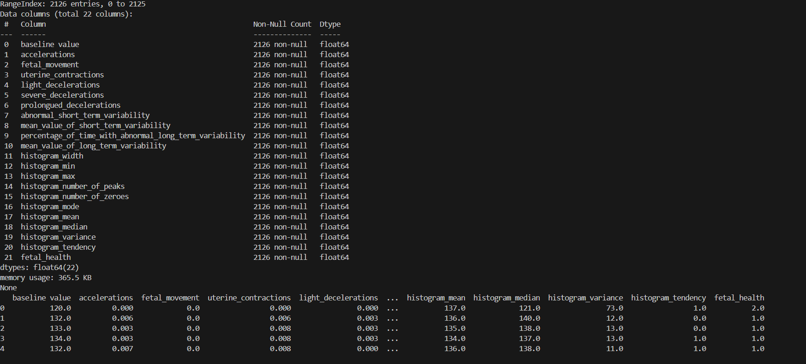
Fetal Health Class Distribution
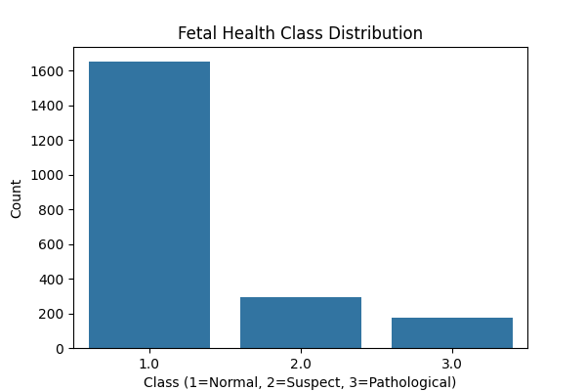
Interpretation:
- Class 1 (Normal) dominates the dataset.
- Class 2 (Suspect) and 3 (Pathological) are significantly underrepresented.
- This confirms class imbalance, which could bias models toward predicting the majority class.
- Stratified sampling was used to maintain this distribution in train/test splits.
- Additionally, SMOTE was applied to the training set to synthetically balance minority classes and improve classification fairness.
Top 10 Feature by correlation
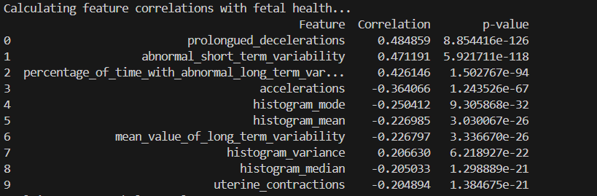
Interpretation:
This analysis identifies the 10 most influential features that are statistically correlated with fetal health. A positive correlation indicates a higher value of the feature is associated with poorer fetal health (moving toward class 3), while a negative correlation indicates the opposite.

Top Positively Correlated Features (Risk Indicators)
- Prolongued Decelerations (r = 0.48)
  - Strongest correlation with poor fetal health. Frequent or long decelerations in heart rate are serious indicators of distress.
- Abnormal Short-Term Variability (r = 0.47)
  - Indicates irregular fluctuations in fetal heart rate; highly associated with pathological states.
- Percentage of Time with Abnormal Long-Term Variability (r = 0.43)
  - Extended periods of abnormal variability suggest long-term fetal compromise.
- Histogram Variance (r = 0.21)
  - Increased variability in the fetal heart rate histogram may reflect instability in the fetus.

Top Negatively Correlated Features (Healthy Indicators)
- Accelerations (r = -0.36)
  - Healthy fetuses typically show more heart rate accelerations; fewer accelerations are linked with distress.
- Histogram Mode, Mean, and Median (r ≈ -0.25 to -0.20)
  - Lower values of these central tendency measures suggest pathological trends in heart rate distribution.
- Mean Value of Long-Term Variability (r = -0.23)
  - Consistently lower values are linked to compromised fetal conditions.
- Uterine Contractions (r = -0.20)
  - Slight inverse relationship; could be due to complex interaction effects with other features.
Confusion Matrices
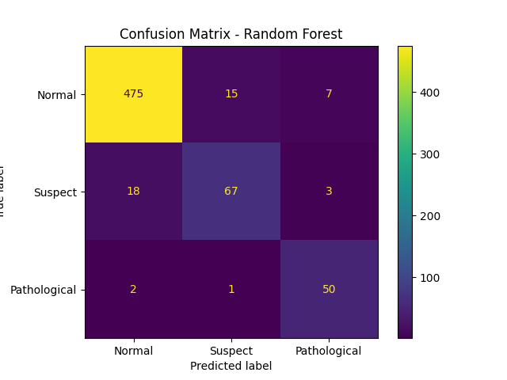
Interpretation:
• True Positives:
- Normal: 475
- Suspect: 67
- Pathological: 50
• Misclassifications:
- 18 instances of Suspect were incorrectly classified as Normal.
- 15 instances of Normal were misclassified as Suspect.
- 3 instances of Suspect were misclassified as Pathological.
- 7 instances of Normal were misclassified as Pathological.
- 2 instances of Pathological were misclassified as Normal.
- 1 instance of Pathological was misclassified as Suspect.
• Observations:
- Very high performance for Normal and Pathological classes.
- Minimal confusion across classes, though Suspect remains more ambiguous.
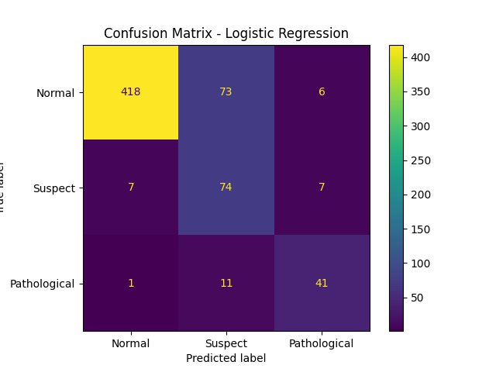
Interpretation:
• True Positives:
- Normal: 418
- Suspect: 74
- Pathological: 41
• Misclassifications:
- 73 instances of Normal were misclassified as Suspect.
- 7 instances of Suspect were misclassified as Normal.
- 7 instances of Suspect were misclassified as Pathological.
- 6 instances of Normal were misclassified as Pathological.
- 1 instance of Pathological was misclassified as Normal.
- 11 instances of Pathological were misclassified as Suspect.
• Observations:
- Reasonable classification of Suspect.
- Notable confusion between Normal and Suspect.
- Struggles slightly more with Pathological classification.
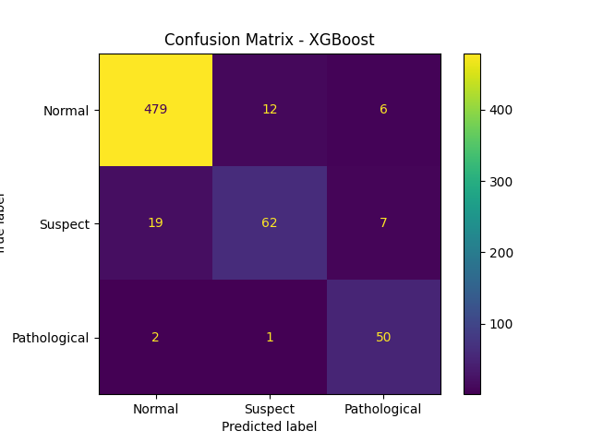
Interpretation
- True Positives:
  - Normal: 479
  - Suspect: 62
  - Pathological: 50
- Misclassifications:
  - 19 instances of Suspect were misclassified as Normal.
  - 12 instances of Normal were misclassified as Suspect.
  - 7 instances of Suspect were misclassified as Pathological.
  - 6 instances of Normal were misclassified as Pathological.
  - 2 instances of Pathological were misclassified as Normal.
  - 1 instance of Pathological was misclassified as Suspect.
- Observations:
  - Comparable performance to Random Forest.
  - Strong classification for Normal and Pathological.
  - Slightly more confusion in identifying Suspect cases.

General Observations:
- Pathological Classification:
  - All models perform strongly on the Pathological class.
  - Random Forest and XGBoost especially show minimal to no misclassifications.
  - Logistic Regression shows slightly more confusion, but still reasonable performance.
- Normal vs. Suspect Confusion:
  - The main challenge across all models lies in distinguishing Normal and Suspect classes.
  - Logistic Regression particularly struggles, with high misclassification of Normal as Suspect (73 instances).
  - Random Forest and XGBoost perform significantly better in reducing these errors.
- Model Robustness:
  - Random Forest and XGBoost demonstrate stronger robustness and higher overall accuracy, particularly in imbalanced data scenarios.
  - Logistic Regression, while interpretable and simpler, is less capable in this multi-class setting with overlapping class distributions.
Evaluation Metrics
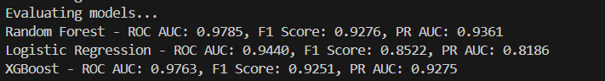
Interpretation:

Random Forest
- ROC AUC: 0.9785, F1 Score: 0.9276, PR AUC: 0.9361
- Achieved the best overall performance across all metrics.
- Demonstrates strong capability to distinguish between classes and handle imbalanced data.

XGBoost
- ROC AUC: 0.9763, F1 Score: 0.9251, PR AUC: 0.9275
- Performs very closely to Random Forest, showing excellent precision and recall.
- Suitable for deployment due to speed, accuracy, and efficiency.

🔹 Logistic Regression
- ROC AUC: 0.9440, F1 Score: 0.8522, PR AUC: 0.8186
- Lowest performance among the three models, especially in PR AUC, indicating weaker prediction on minority classes.
- Still useful as a baseline, but less effective for imbalanced multiclass data
Conclusion:-
Both Random Forest and XGBoost are highly effective for fetal health classification, with Random Forest slightly outperforming. Logistic Regression, while interpretable, struggles with class imbalance and complex patterns, making it less suitable for this task.
K-Means Clustering Results
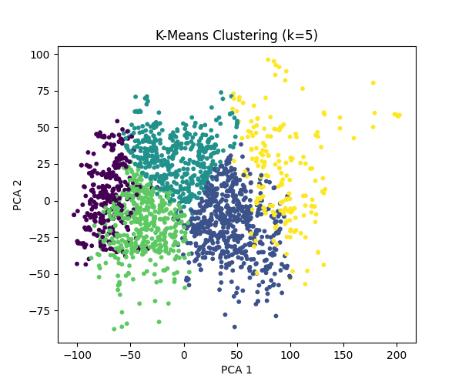

Clustering with k = 5
- The clusters are relatively well-separated, indicating some structure in the data.
- There are five distinguishable regions, suggesting possible subgroups in the fetal health data.
- The choice of k=5 provides good separation without too much overlap, which could align with physiological subcategories beyond the three main health labels (Normal, Suspect, Pathological).

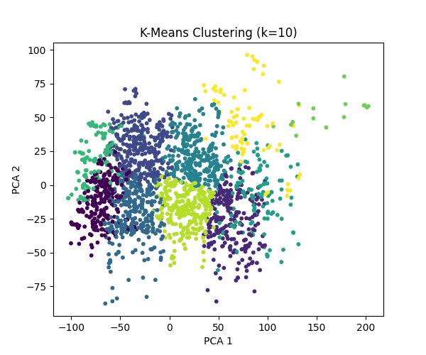

Clustering with k = 10
- The clusters begin to overlap more, and the boundaries between them become less distinct.
- Increasing k leads to finer partitions, but many clusters appear redundant or too close together.
- Some central clusters may represent over-splitting of broader categories.

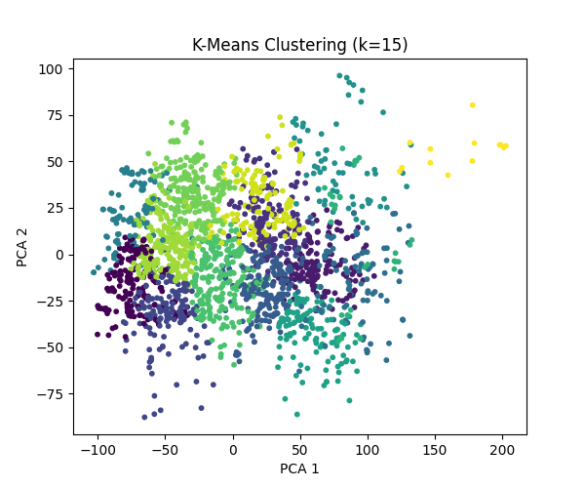

Clustering with k = 15
- Over-segmentation is more evident; many clusters occupy similar areas in PCA space.
- This higher k value introduces noise, potentially capturing minor variations rather than meaningful patterns.
- Useful only if the goal is to identify highly granular subpopulations for further analysis, otherwise not ideal
General Observation:-
- Best k visually appears to be around 5, as it strikes a balance between separation and interpretability.
- As k increases, the clarity of groupings decreases, which may reduce the usefulness of clusters for practical classification.
- This clustering validates that there is latent structure in the data, but it doesn’t directly align with the original 3-class labels — confirming that unsupervised learning reveals more nuanced patterns than those captured in the labeled classes.

