THE PRACTICAL GUIDE
Automate Your Content Creation with Claude
Turn Claude into a repeatable content engine using Skills + your own brand context.
This guide turns the 7-step carousel into a do-it-now playbook. The idea is simple: Skills teach Claude what to do (write a carousel, brainstorm hooks, plan a campaign), and context files teach Claude how to do it in your voice. Put both in place once, and a single prompt produces a full batch of on-brand content.
THE MENTAL MODEL How the system works
Four layers stack together. Once they are set up, you only ever touch the last two.
Layer | Its job | Example
Skills | The “what” — reusable workflows Claude can run on command | “Write an 8-slide carousel”, “Brainstorm lead magnets”
Context files | The “how” — your brand, audience, and offers | brand_voice.md, audience.md, offers_cta.md
Your prompt | The “go” — one instruction that triggers everything | “Create ideas, hooks, captions, and visuals for my niche.”
The output | The result — a ready-to-use content batch | Ideas, hooks, captions, carousel outlines, graphic direction

Remember: Skills tell Claude WHAT to do. Context tells Claude HOW to do it in your style. You need both for output that actually sounds like you.
THE WORKFLOW All 7 steps at a glance
# | What you do | Outcome | Time
1 | Open Claude at claude.ai/customize | You reach the hub that controls how Claude works for you | 1 min
2 | Click Skills | You open your personal Skills library | 30 sec
3 | Browse skills | You see the ready-made workflows Claude can run | 2 min
4 | Download the right skills | You grab the exact skills your content needs | 5–10 min
5 | Add each skill to Claude | Claude can now trigger that workflow on demand | 2 min each
6 | Give Claude context | Your brand + audience files make output sound like you | 15–30 min (once)
7 | Prompt and produce | One prompt returns a full content batch | 2 min / batch
BEFORE YOU START What you need
You need | Why | Notes
A Claude account | Skills and the Customize hub live inside claude.ai | A paid plan gives more usage headroom for batch generation
Your brand basics | Context files only work if you know your voice and audience | Even rough notes beat nothing — you can refine later
6 short .md files | These carry your brand into every prompt (see Step 6) | Plain text. 1 page each is plenty to start
A place to publish | So the content engine actually ships | Canva / scheduler / your CMS of choice

STEP 1 Open Claude
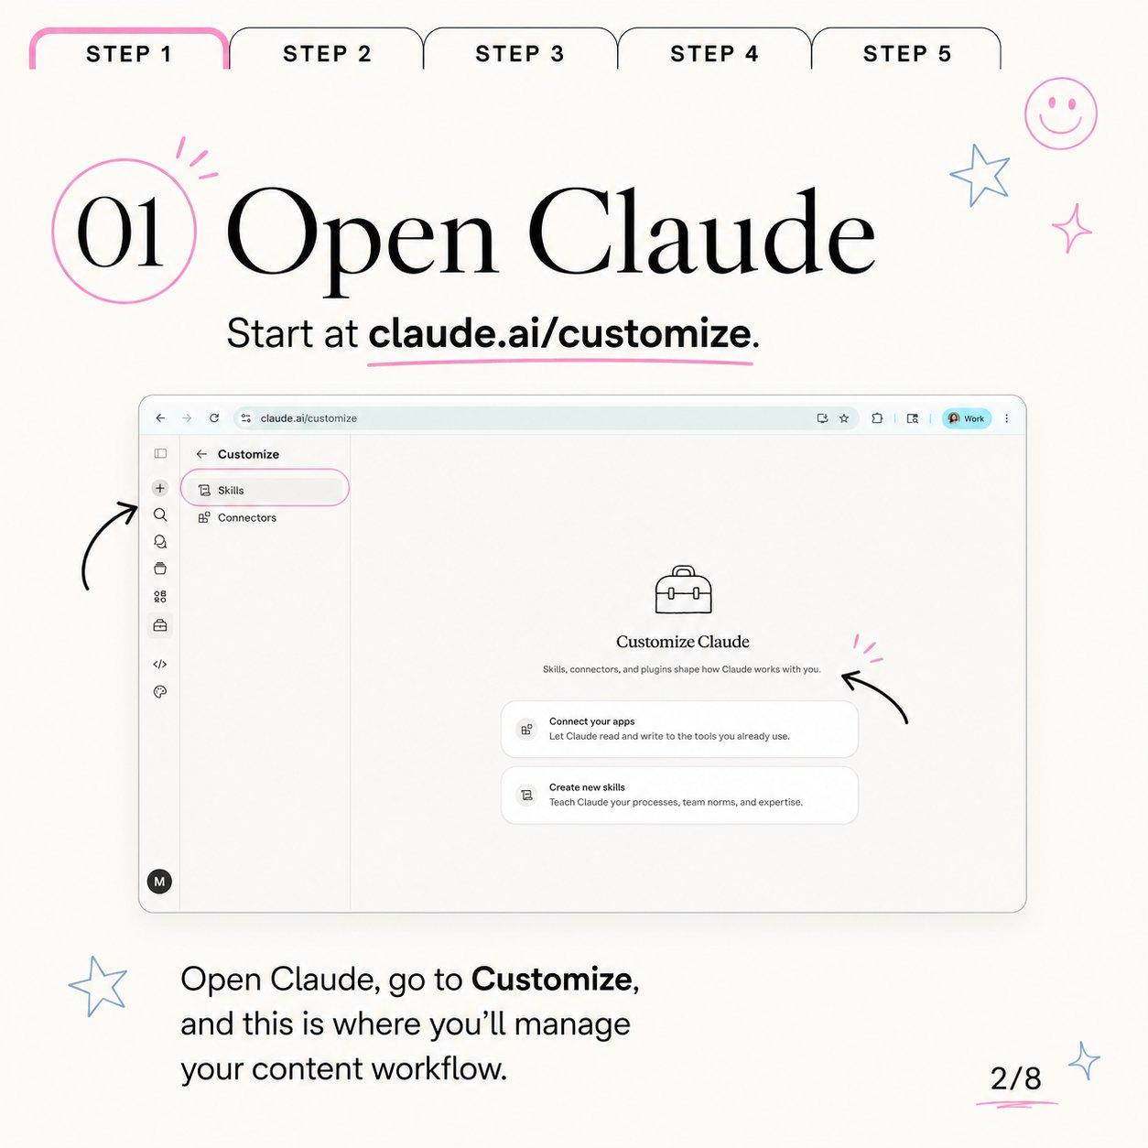
Slide 1 — start at claude.ai/customize, the home for Skills and Connectors.
Go to claude.ai/customize. This is the control room for how Claude works with you — Skills, connectors, and the context that shapes every reply.
Do this | Where to look | Why it matters
Open the URL claude.ai/customize | Browser address bar | Drops you straight into the Customize hub
Note the left sidebar: Skills + Connectors | Top-left of the Customize panel | Skills = workflows; Connectors = apps Claude can read/write
Stay signed in to the right workspace | Profile badge (top-right) | Skills are per-workspace, so pick the one you publish from
STEP 2 Click Skills
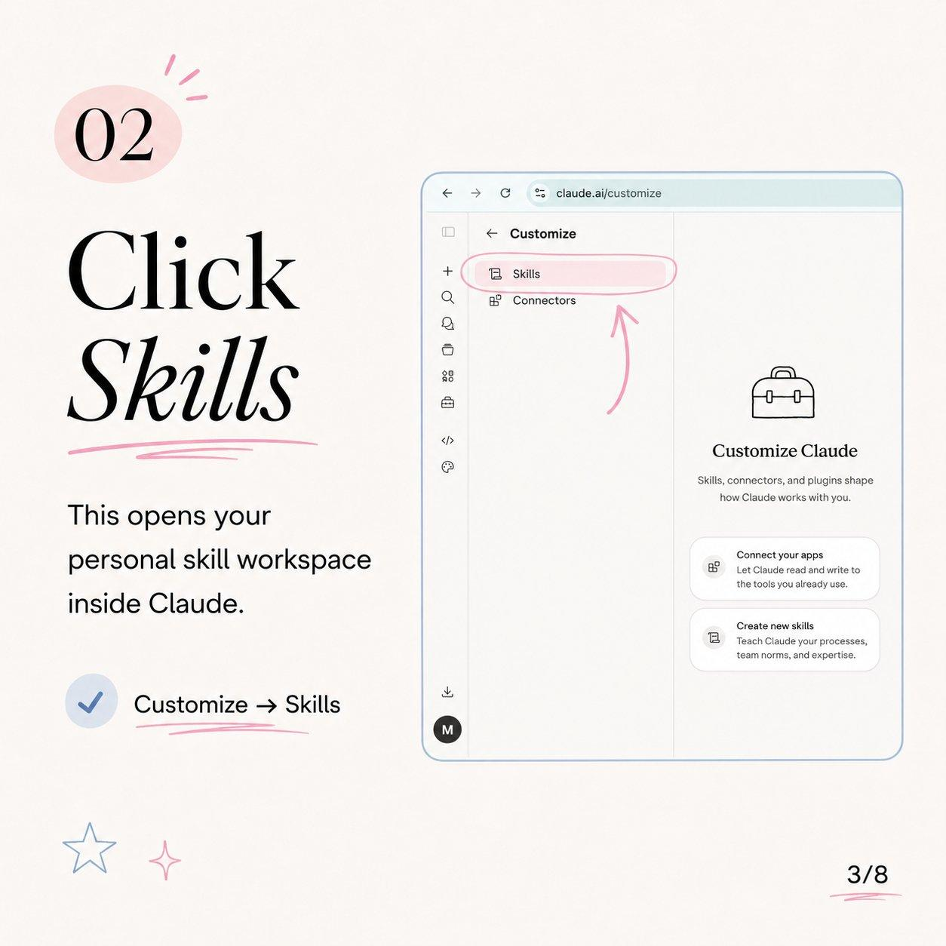
Slide 2 — Customize → Skills opens your personal skill workspace.
In the Customize sidebar, click Skills. This opens your personal skill workspace — the library of workflows Claude can run for you.
Shortcut: The whole path is just Customize → Skills. Bookmark claude.ai/customize/skills to land here in one click next time.
STEP 3 Browse skills
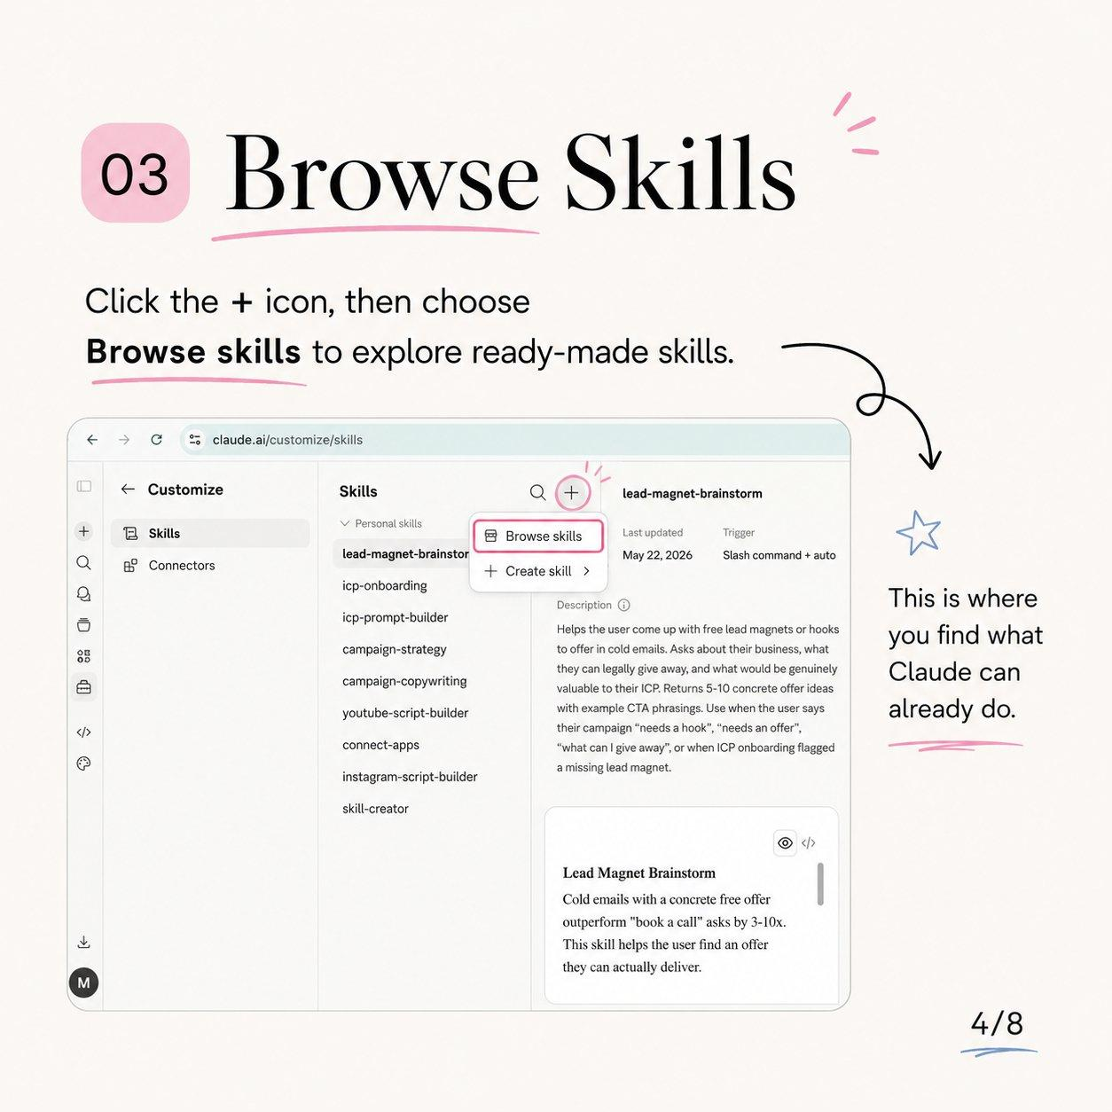
Slide 3 — click the + icon, then “Browse skills” to explore ready-made workflows.
Click the + icon at the top of the Skills panel, then choose Browse skills. This is where you see what Claude can already do out of the box. Click any skill to read its description, trigger, and preview before adding it.
What each part of a skill tells you
Field | What it means | Why you care
Name | The skill’s handle (e.g. lead-magnet-brainstorm) | Use it in prompts to trigger the skill directly
Description | What the skill does and when it fires | Confirms it matches the job you have in mind
Trigger | How it activates (slash command + auto) | “Auto” means Claude can invoke it from natural language
Last updated | When the skill was last edited | Newer usually means better-tuned instructions
Preview | A sample of the skill’s content | Lets you sanity-check quality before installing

STEP 4 Download the right skills
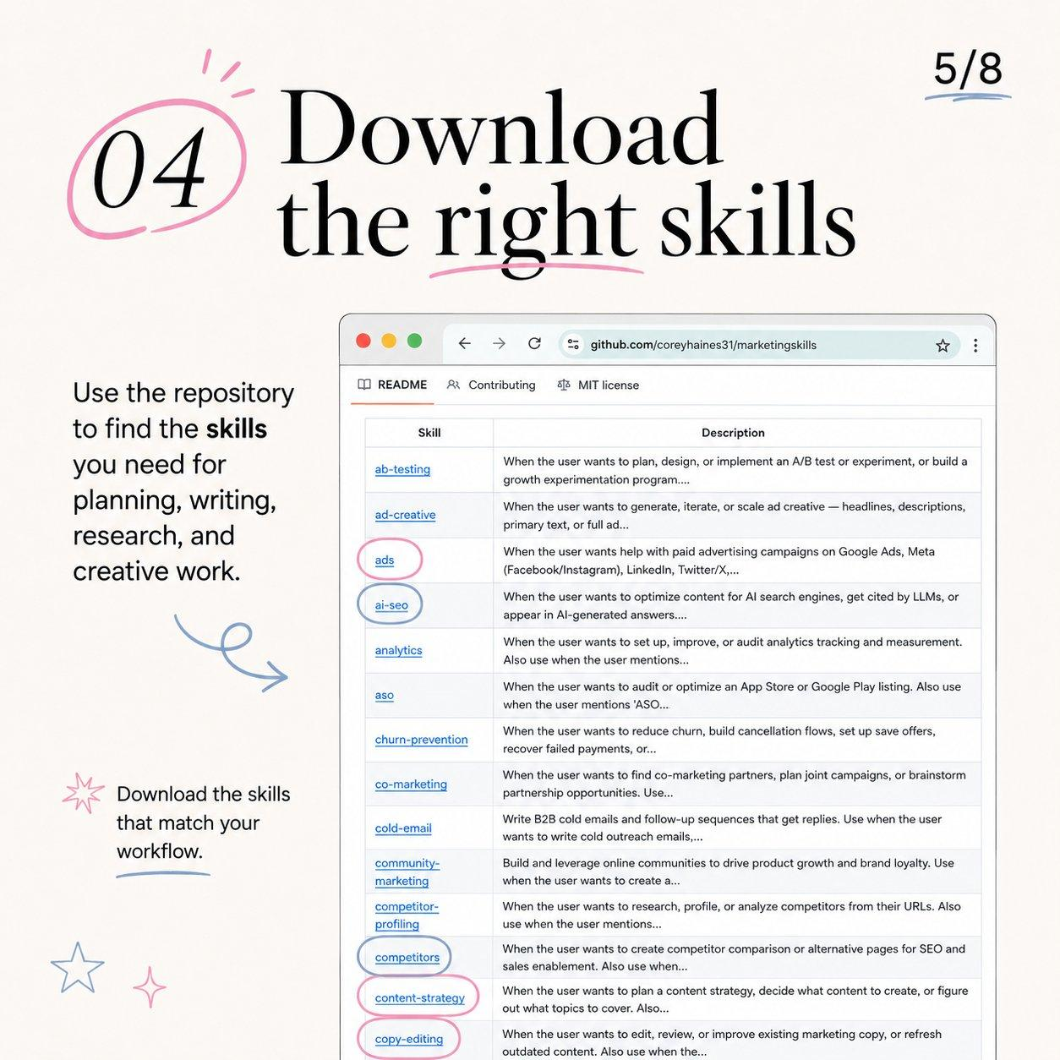
Slide 4 — pull skills from the marketing repo at github.com/coreyhaines31/marketingskills.
Open the skills repository at github.com/coreyhaines31/marketingskills. The README lists every skill with a one-line description of when to use it. Download only the ones that match your workflow — planning, writing, research, and creative work.
Pick skills by the job you’re hiring them for
Your goal | Skills to grab | What they unlock
Plan what to post | content-strategy, campaign-strategy, competitor-profiling, competitors | Topics, angles, and a calendar built from your pillars
Write copy & captions | copy-editing, ad-creative, cold-email | On-brand captions, ad text, and tightened drafts
Make short-form video | instagram-script-builder, youtube-script-builder | Hooks, scripts, and shot directions for Reels & long-form
Grow & convert | ads, ai-seo, aso, churn-prevention, co-marketing, community-marketing | Paid, search, app-store, and retention plays
Set up the system | icp-onboarding, icp-prompt-builder, lead-magnet-brainstorm, skill-creator, connect-apps | Define your ICP, build offers, and wire up apps

Don’t over-buy: Start with 3–5 skills that cover your real weekly tasks. You can always add more — too many unused skills just clutter the library.

STEP 5 Add the skill to Claude
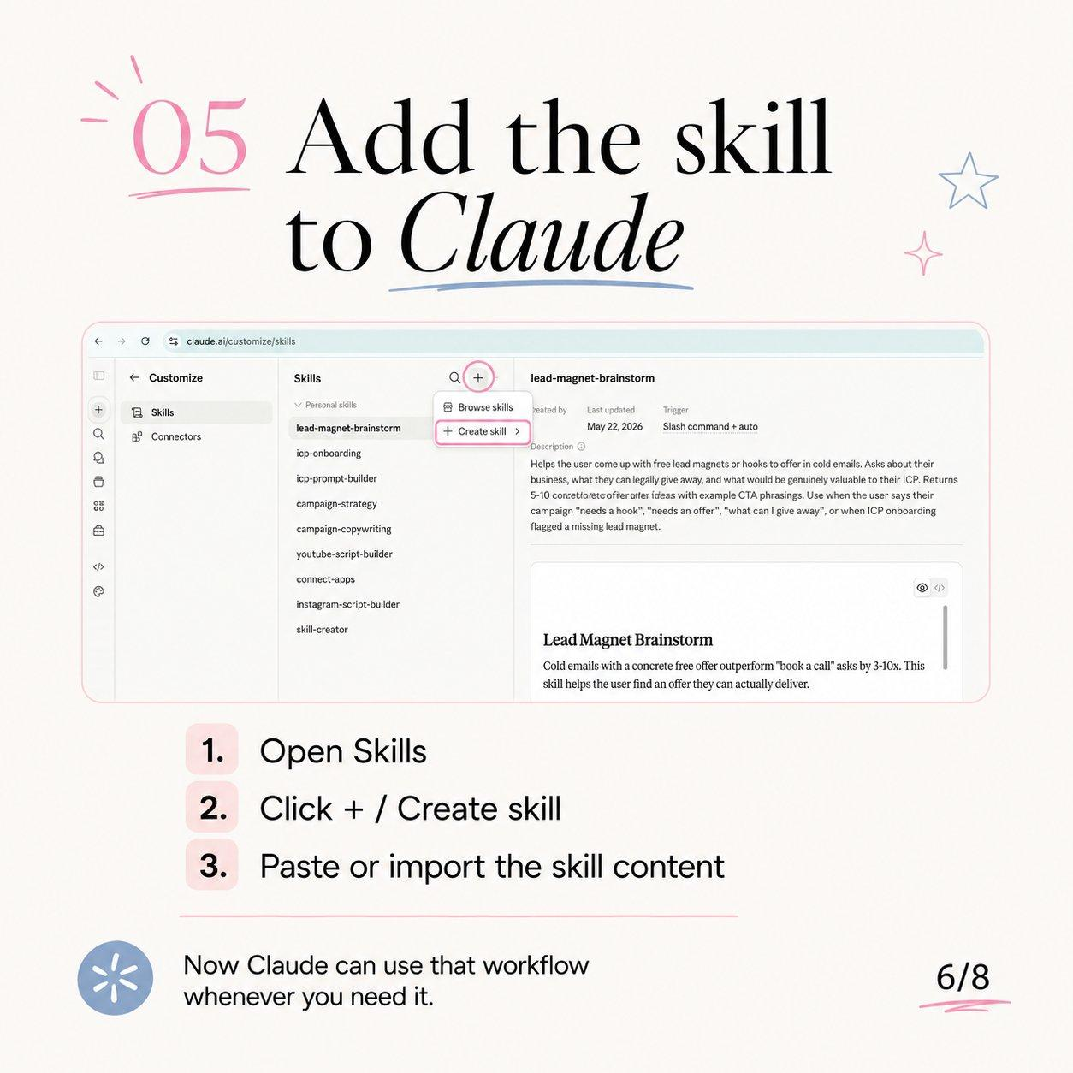
Slide 5 — Skills → + → Create skill → paste or import the content.
Installing a skill takes three clicks. Repeat for each skill you downloaded in Step 4.
# | Action | Detail
1 | Open Skills | From Customize → Skills (where you’ve been working)
2 | Click + / Create skill | Use the + menu and choose Create skill
3 | Paste or import the skill content | Drop in the SKILL.md text from the repo, then save

Result: Now Claude can use that workflow whenever you need it — either automatically from your wording, or by naming the skill in your prompt.

STEP 6 Give Claude context
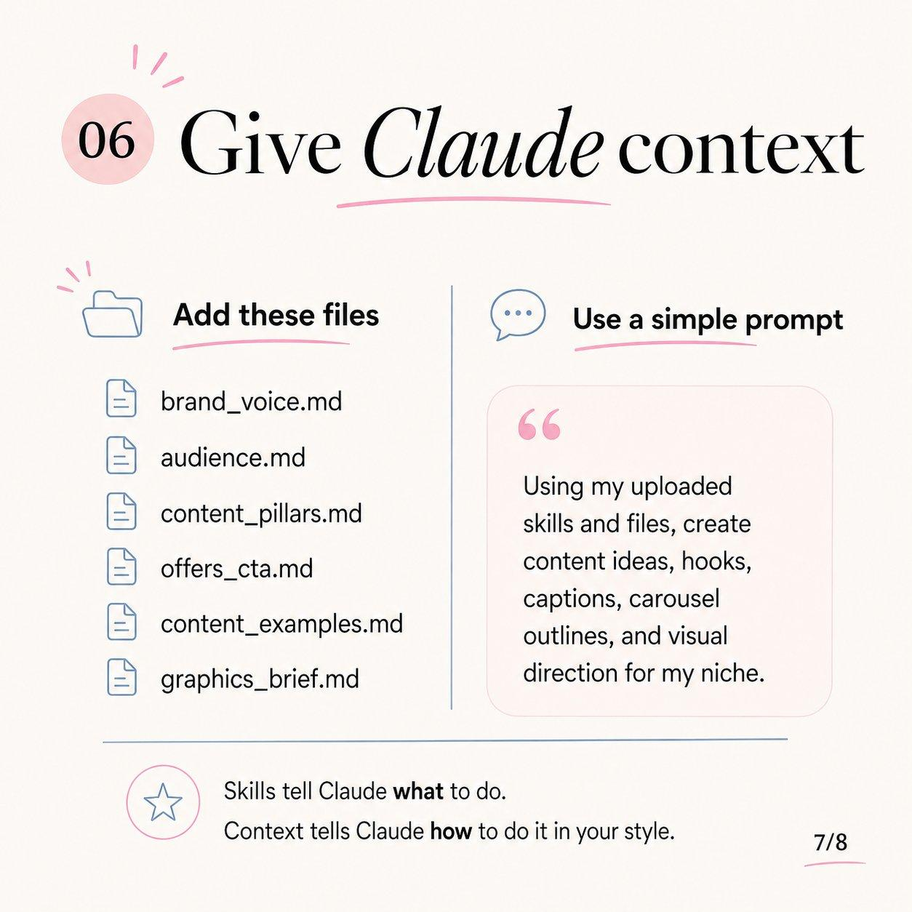
Slide 6 — upload your brand files, then run one simple prompt.
Skills are the engine; context is the fuel. Upload these six short Markdown files so Claude writes in your voice, for your audience, toward your offers. Each can be a single page — done is better than perfect.
The 6 context files — what to put in each
File | What goes inside | A quick example
brand_voice.md | Tone, vocabulary, sentence style, phrases you use and avoid, POV | “Casual but sharp. Short sentences. We say ‘folks’. No corporate jargon, no emojis in headlines.”
audience.md | Who you serve, their pains, desires, objections, and the words they use | “Solo founders, 0–10 staff. Overwhelmed by marketing. Want done-for-them systems, not theory.”
content_pillars.md | Your 3–5 recurring themes | “1) AI workflows 2) Founder stories 3) Tactical playbooks 4) Behind-the-scenes”
offers_cta.md | Products, prices, links, and the action each post should drive | “Free: skills guide. Paid: $49 template pack. Default CTA: comment ‘Yeah’.”
content_examples.md | 5–10 of your best past posts (hooks + captions) | Paste top-performers so Claude has a pattern to imitate
graphics_brief.md | Colors, fonts, layout rules, visual do’s and don’ts | “Cream background, pink + soft-blue accents, serif headers, hand-drawn doodles.”

The one prompt that runs it all
“Using my uploaded skills and files, create content ideas, hooks, captions, carousel outlines, and visual direction for my niche.”
PROMPT LIBRARY More prompts to run with the same setup
When you want… | Paste this
A full weekly batch | “Using my skills and files, give me this week’s content batch: 10 ideas, 20 hooks, 5 captions, and 2 carousel outlines.”
One carousel | “Write an 8-slide carousel on [topic]: hook on slide 1, one idea per slide, CTA on the last slide — in my brand voice.”
Hooks only | “Give me 20 scroll-stopping hooks for [topic], matched to my audience’s pains.”
To repurpose | “Turn this [blog/video/transcript] into 1 carousel, 3 captions, and 5 hooks using my files.”
A content calendar | “Plan 2 weeks of posts across my content pillars — give format, hook, and CTA for each.”
Graphic direction | “For these 3 carousels, write a graphics brief per slide using graphics_brief.md.”

STEP 7 What you get
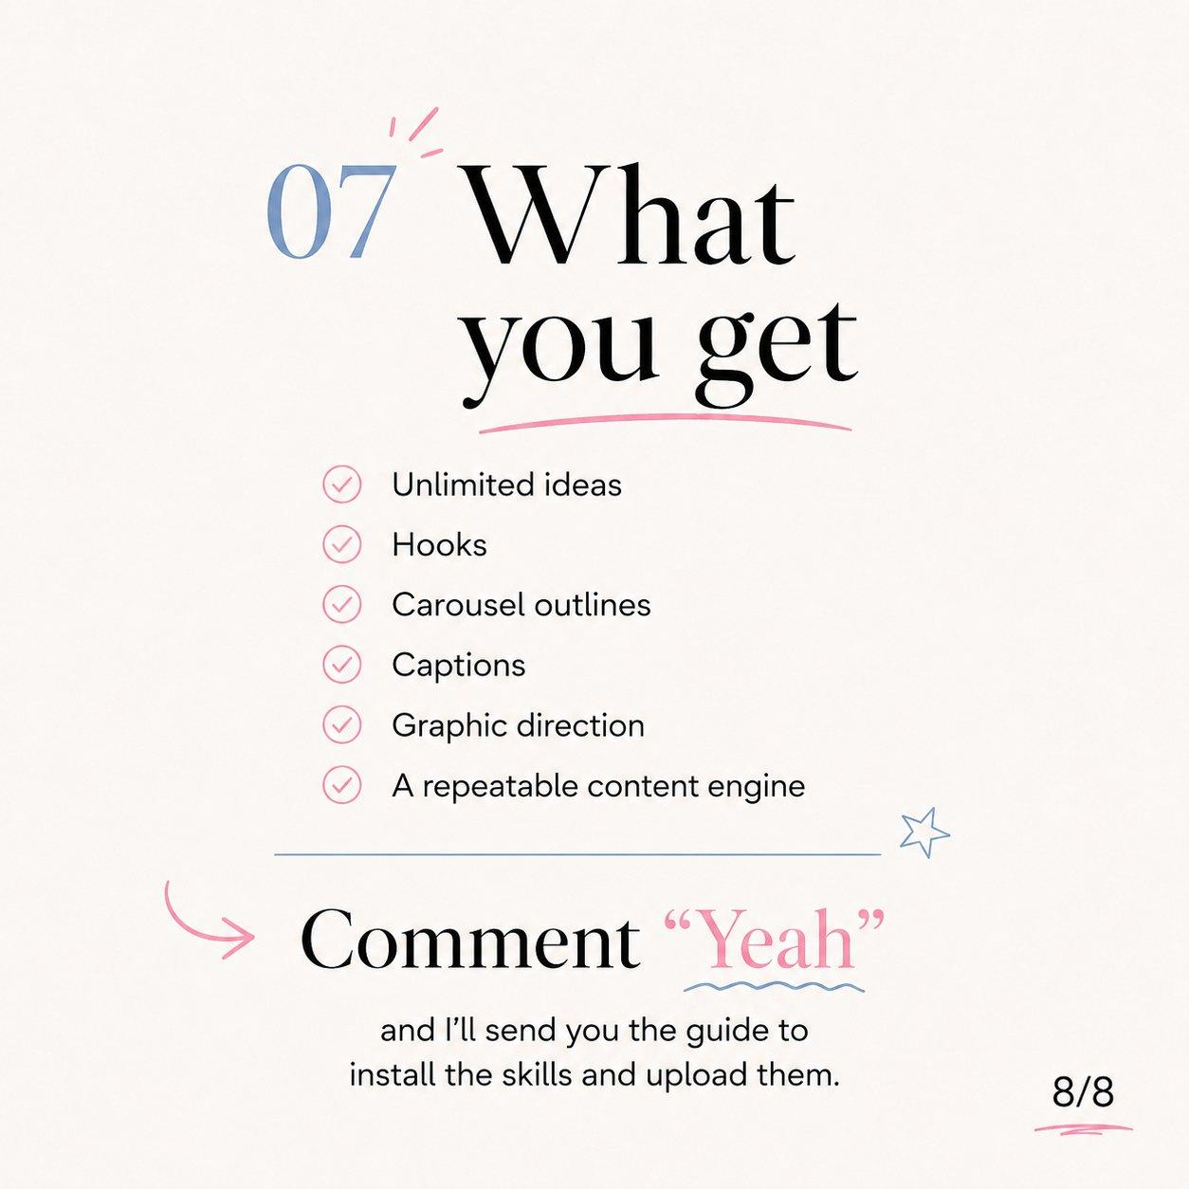
Slide 7 — the payoff: a repeatable content engine.
Once Skills + context + a prompt are in place, every run produces:
You get | What it looks like in practice
Unlimited ideas | Fresh, on-pillar topics whenever you ask — no blank-page paralysis
Hooks | Scroll-stopping opening lines tuned to your audience’s pains
Carousel outlines | Slide-by-slide structure with a hook and a CTA already placed
Captions | Ready-to-post copy in your voice, with the right call to action
Graphic direction | A visual brief per slide that matches your brand’s look
A repeatable content engine | The same prompt → a full batch, every week, on demand
KEEP IT SHARP Troubleshooting
Problem | Likely cause | Fix
Output sounds generic | Thin or missing context files | Flesh out brand_voice.md and content_examples.md, then re-run
The skill didn’t fire | Wrong trigger wording | Name the skill directly or use its keywords in your prompt
Ideas feel off-brand | No content_pillars.md | Add 3–5 pillars and ask Claude to map ideas to them
CTAs are missing | offers_cta.md not uploaded | Upload it and ask Claude to add a CTA to every piece
Wrong format/length | You didn’t specify | State slide count, word length, or platform in the prompt
Voice drifts over time | Examples are stale | Refresh content_examples.md with new top-performers monthly
THE ROUTINE Your repeatable weekly workflow
Here’s how the engine runs once it’s built. Total hands-on time: roughly one hour a week.
Day | Action | Time
Mon | Run the batch prompt → get the week’s ideas + hooks | 10 min
Tue | Pick winners → ask Claude for full carousels + captions | 20 min
Wed | Generate graphic direction → build in Canva / hand to designer | 15 min
Thu | Schedule everything in your publishing tool | 15 min
Fri | Ask Claude to repurpose the top performer into new formats | 10 min
DO IT NOW Quick-start checklist
- Open claude.ai/customize
- Click Skills to open your skill workspace
- Click + → Browse skills to see what’s available
- Visit github.com/coreyhaines31/marketingskills and download 3–5 skills
- Add each skill: + → Create skill → paste the content
- Write your 6 context files and upload them
- Run the master prompt and review the batch
- Schedule, publish, and repeat the weekly routine

The whole point: Build it once. After setup, you go from blank page to a full week of on-brand content in about two minutes of prompting.

