Day 3 Assignment

Submitted By

Dhruv Joshi

# 

# Step 1: Creating a file

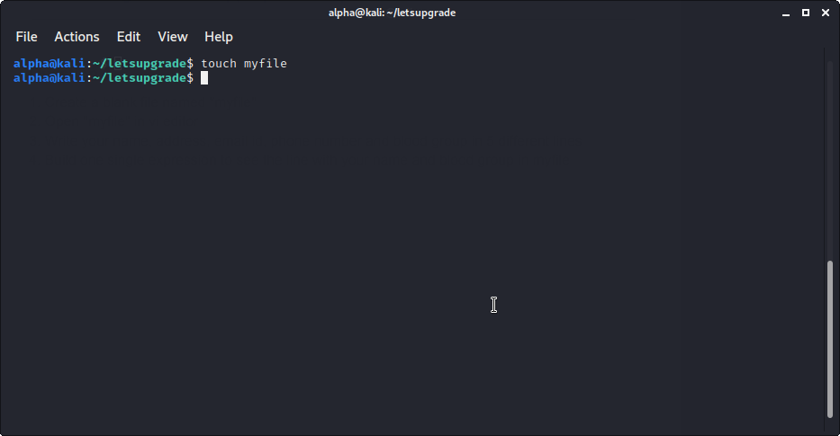

# Step 2 : Opening in vi editor

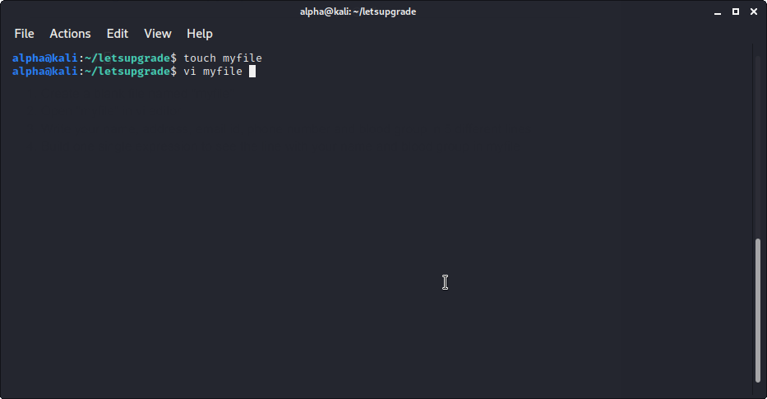

# **Step 3:** Editing the file in vi editor

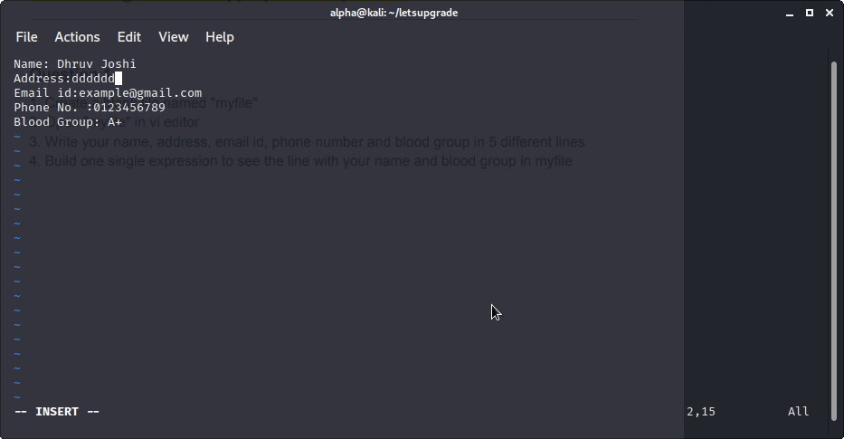

# Step 4: Saving the file in vi editor

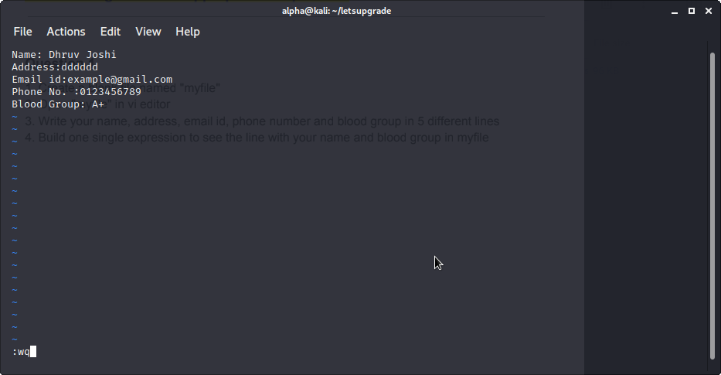

# **Step 5:** Single Line Expression to View Name and Blood Group from the file

