Day 5 Assignment

Submitted By

Dhruv Joshi

# 

# Step 1: Adding 10 GB Disk

After adding disk we can check the disk with *fdisk -l* command

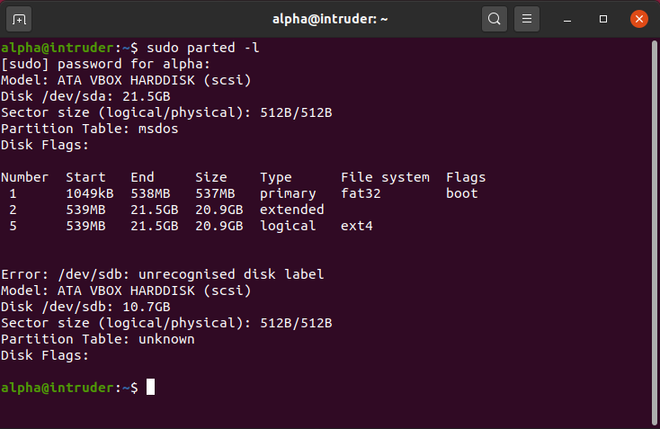

We can see that the disk is at */dev/sdb*

# Step 2: Creating 2 partitions of 4GB and 6GB respectively

* Selecting the disk in which we want to make partitions

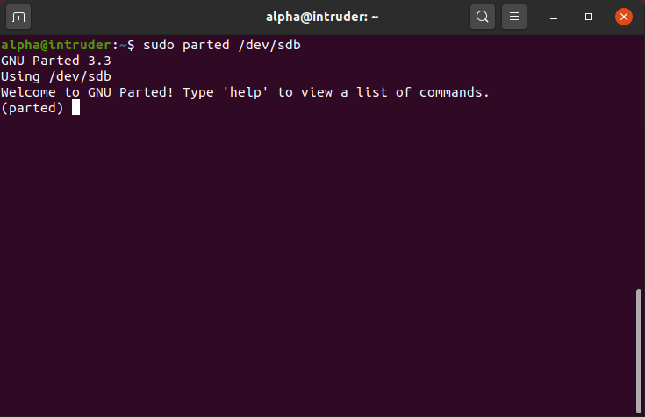

* Creating a partition of 4GB

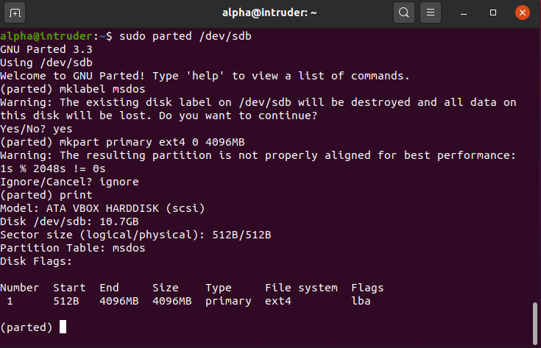

* Creating a partition of 6GB

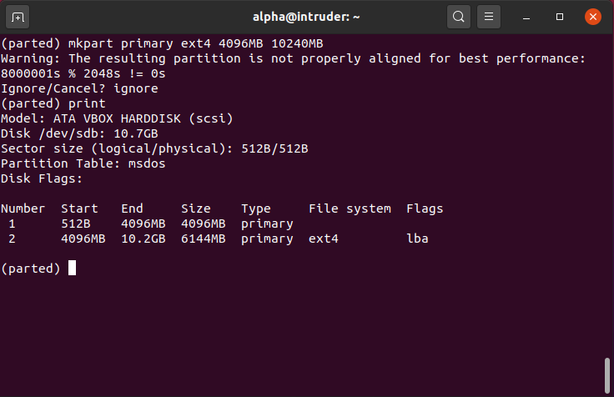

# 

# **Step 3:** Formatting 4GB partition and 6GB partition with *xfe* and *ext4* format respectively

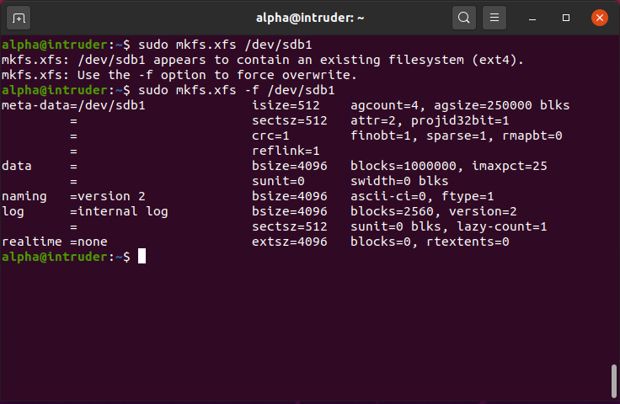

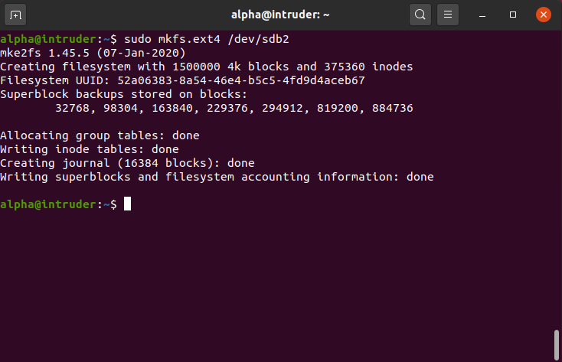

# Step 4: Mounting 4GB and 6GB partition in *data* and *music* respectively

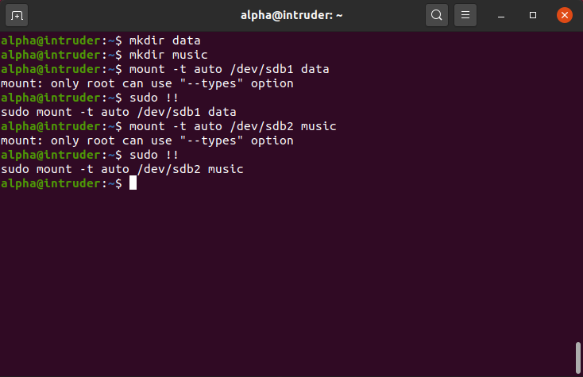

# 

# **Step 5:** Creating one file of 1GB in each of the mount point created above.

* Creating 1GB file in first partition

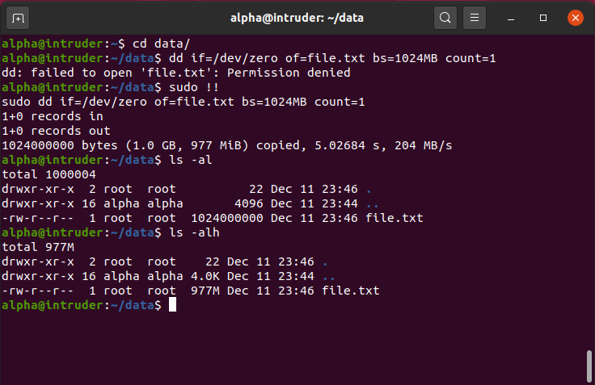

* Creating 1GB file in second partition

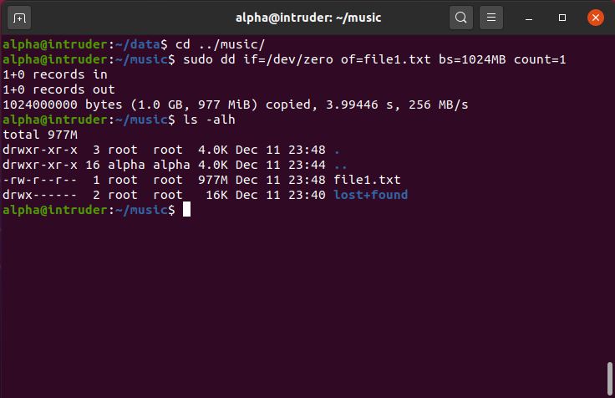

# Step 6: Verifying the disk Consumption and disk space free in the mounted partitions.

