Day 6 Assignment

Submitted By

Dhruv Joshi

# Step 1: *ps* command to search for the “systemd” process by name.

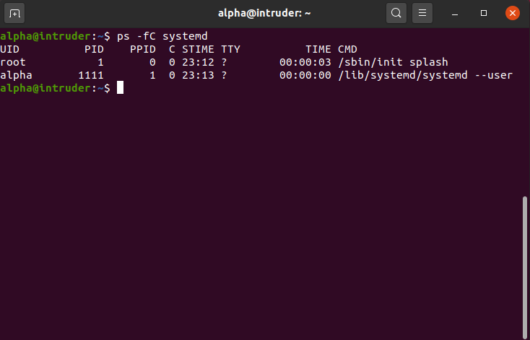

# Step 2: Finding all processes associated with the current terminal.

# 

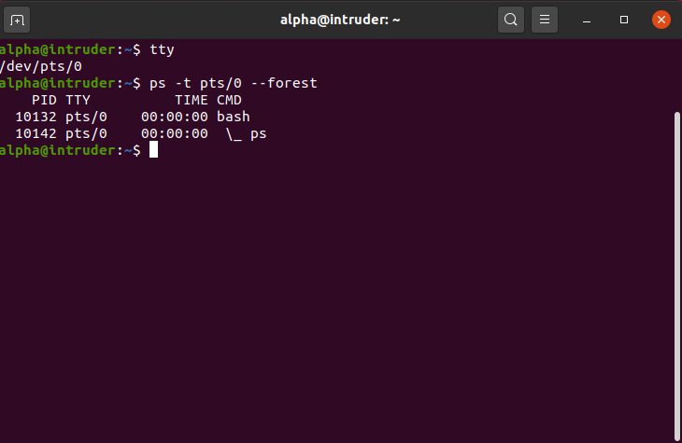

# **Step 3:** Process id of the Shell

From the above command in *Step2* we can see that the process id of our

Shell is *10132* and as we are running ps command on this shell we can also

see that it the child process of out terminal with pid *10142*

# Step 4: Starting 3 instances of “sleep 123” as background processes.

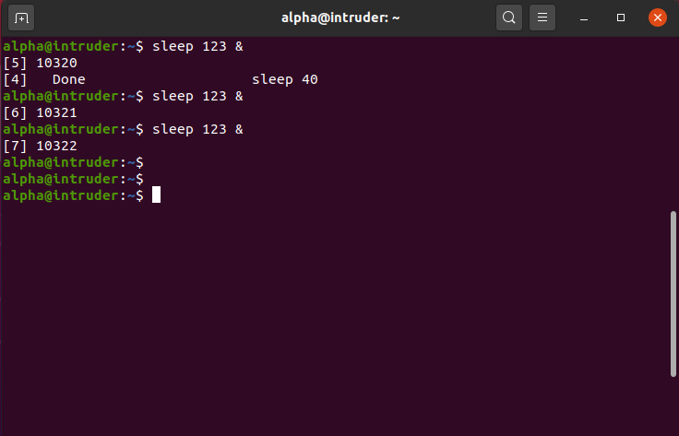

# **Step 5:** Check and note the process id’s of all sleep processes.

The id of all the 3 Sleep 123 process are 10320, 10321 and 10322

# 

# Step 6: Display only those three sleep processes in top.

