Forecasting



Professor
Filip Van den Bossche
Fernando Diazgonzalez

Exam Assignment

By
Son Quy Dam

Contents
Exercise 1 3
1. Introduction 3
2. Data preparation and exploration 3
3. Seasonality: subseries plot 4
4. Model 1 - Holt-Winters 5
5. Model 2 - Forecasting with ETS on Log-Transformed Data 5
6. Model 3 - Forecasting with seasonal ARIMA on Log-Transformed Data 6
7. Model comparison and final selection 7
Exercise 2 8
1. Introduction 8
2. Data exploration 9
3. Transformation and adjustments 10
4. ETS modeling 10
5. ARIMA modeling 12
6. Model comparison: ETS vs ARIMA 13
7. Forecast using the final model 14

Exercise 1

1. Introduction
This part aims to conduct a comprehensive time series forecasting analysis of monthly household expenditure on food services in Australia, specifically focusing on cafes, restaurants, and takeaway services. We consider the period from Feb 1995 to Sep 2017 - over two decades of consumer spending behavior with evident trends and seasonal components. The dataset was split into two subsets: a training set spanning from Feb 1995 to Dec 2014, and a test set covering the period from Jan 2015 to Sep 2017.

The methodological approach involves the construction, estimation, and comparison of several forecasting models, primarily from the ETS and ARIMA. Both are evaluated using standard statistical criteria such as RMSE on the test set and the Ljung-Box test on residuals to assess adequacy of model fit.

By comparing the forecasts and diagnostic metrics across these models, the objective is to determine the most appropriate model for accurately predicting future expenditure trends in the Australian food service sector. The findings contribute to a deeper understanding of the time series modeling best practices and the strengths and limitations of different forecasting methodologies.

2. Data preparation and exploration
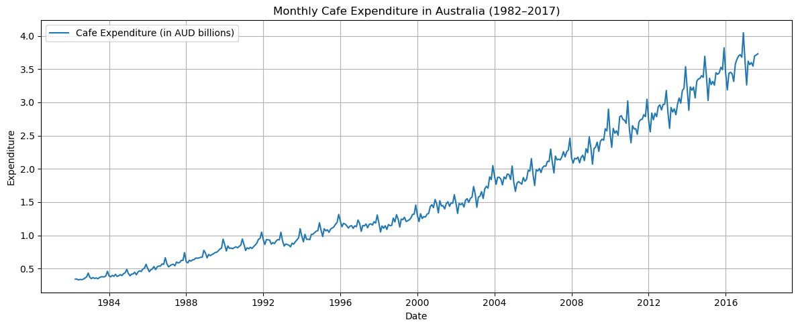
A visual inspection of the time series reveals the presence of a strong and consistent upward trend over time. In addition, a clear seasonal component is apparent, with consistent expenditure peaks in December — likely driven by increased consumption during the holiday season — and troughs typically occurring around February, potentially associated with post-holiday slowdowns.

However, closer observation also indicates that the amplitude of seasonal fluctuations appears to increase over time, which suggests the presence of non-constant variance — a violation of the homoskedasticity assumption common to many linear forecasting models. In such cases, forecasts made on the original scale may be biased or inefficient. To address this, we apply the Box-Cox transformation, a widely used method to adjust for non-constant variance by identifying a suitable power transformation

The optimal transformation parameter is selected based on the training set (February 1995 to December 2014). The estimated λ value is –0.0898, which indicates that the raw series has moderate variance instability, which can be effectively corrected by applying a transformation very close to the natural logarithm. This transformation leads to a more robust modeling process and ultimately more accurate and reliable forecasts.

3. Seasonality: subseries plot
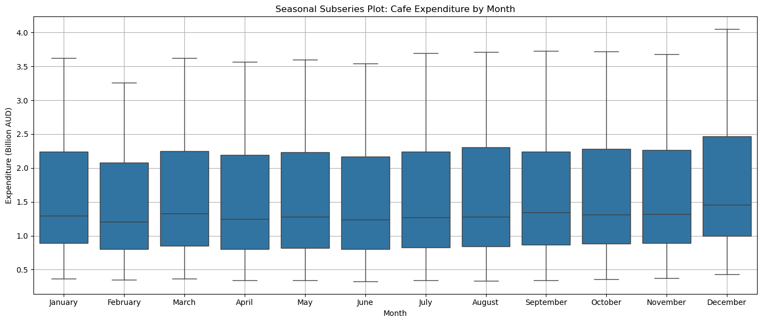
The seasonal subseries plot of the training data (Feb 1995 – Dec 2014) shows a very clear and stable seasonal pattern in monthly café and restaurant spending in Australia.
- December consistently shows the highest expenditure, likely due to holiday-related dining and social activities.
- January and February exhibit the lowest spending, possibly because of post-holiday restraint or vacation habits.
- The rest of the year is relatively stable, with minor fluctuations but no major spikes or drops.
This seasonal pattern repeats almost identically each year, indicating that seasonality is strong and predictable. There is no major shift in the timing or shape of the seasonal cycle, although the December peaks appear to get slightly higher over time — which may suggest a mild increase in seasonal amplitude.

These findings justify the use of seasonal models, such as Holt-Winters, ETS with seasonal components, or seasonal ARIMA. Including seasonality in forecasting is essential to capture the predictable monthly variation in consumer behavior.

4. Model 1 - Holt-Winters
As an initial model, we applied the Holt-Winters exponential smoothing method using an additive trend and multiplicative seasonality, which is well-suited for data with strong, regular seasonal fluctuations and a growing trend. The model was fitted to the training set (February 1995 – December 2014) without any transformation.

Model Estimates and Forecast
The estimated smoothing parameters are as follows:
- Level (α): 0.6856
- Trend (β): 0.0000
- Seasonality (γ): 0.0000
These values indicate that the model relies strongly on recent values for updating the level, while the trend and seasonal components remain almost fixed over time. This suggests that while the model acknowledges seasonal structure, it does not allow it to evolve, potentially limiting its adaptability.

The point forecast for January 2015 is: 3.3223

Model Evaluation
- RMSE on test set (33 months): 0.0634
- Ljung-Box test (lag 12): p-value = 0.291
The relatively low RMSE suggests that the model performs well on average in forecasting the test period. Furthermore, the Ljung-Box test indicates that the residuals do not exhibit significant autocorrelation at lag 12, meaning the model has captured the main temporal dependencies in the training data.

Although the Holt-Winters model achieves a decent RMSE and clean residuals, the zero trend and seasonality smoothing parameters suggest that the model is overly rigid. It captures the average seasonal pattern and level but does not adapt to subtle changes over time. This rigidity is reflected in the January 2015 forecast (3.3223), which underestimates the actual value. While this model provides a solid baseline, it may be outperformed by more flexible approaches like ETS or ARIMA, particularly those that accommodate evolving trends and seasonal structures.

5. Model 2 - Forecasting with ETS on Log-Transformed Data
To better handle the increasing seasonal amplitude and stabilize variance over time, we first applied a logarithmic transformation to the training data. This step is especially beneficial when using additive models, as it minimizes the influence of extreme values and ensures that the model assumptions (e.g., constant variance) are better satisfied.

We then fitted an ETS (Error, Trend, Seasonal) model using automatic selection on the log-transformed series. The selected specification is:
- ETS(A,A,A) — Additive error, additive trend, additive seasonality
- Seasonal period: 12 months (monthly seasonality)
This model structure suggests that the data is best represented by a linearly evolving level and trend, with seasonal effects that repeat in a consistent additive way each year. After generating forecasts on the log scale, we applied a bias adjustment to account for the log-to-original scale conversion. The corrected forecast is computed as:
forecast = exp(forecast_log + 0.5 * residual_variance)

Model performance and interpretation
- Test set RMSE: 0.1116
- Ljung-Box test p-value (lag 12): 0.489
The RMSE indicates that the model achieves a reasonably good level of forecast accuracy on the 33-month test period. Furthermore, the Ljung-Box test result suggests that the residuals are uncorrelated, meaning the model has effectively captured the main time-dependent structure of the data.
The estimated smoothing parameters are:
- Level (α) ≈ 0.667
- Trend (β) and seasonality (γ) are both near zero
This means the model reacts quickly to recent changes in the level, while treating trend and seasonal components as relatively stable. The initial seasonal values are also well distributed across months, further confirming the presence of a regular seasonal cycle in the data.

Justification for choosing ETS(A,A,A)
The ETS(A,A,A) model was not only selected through automated fitting but is also supported by the data characteristics observed during exploration:
- After log transformation, the seasonal peaks and troughs remain consistent, which supports additive seasonality.
- The underlying trend is linear, making additive trend appropriate.
- The residuals show no significant heteroskedasticity or autocorrelation, which validates the use of additive error.
This model provides a balance between accuracy, interpretability, and stability, making it a suitable choice for forecasting this time series. While its RMSE is slightly higher than the Holt-Winters model, its use of variance stabilization and bias correction makes it more robust for long-term forecasting.

6. Model 3 - Forecasting with seasonal ARIMA on Log-Transformed Data
To model both the trend and strong monthly seasonality in the data, we fitted a seasonal ARIMA (SARIMA) model on the log-transformed training series. The log transformation was used to stabilize the variance and ensure a better fit, especially since seasonal fluctuations became more pronounced over time.

We used the auto_arima procedure with stepwise selection and seasonal components (m = 12), allowing for automatic identification of the best model based on the AIC criterion. The selected model was: ARIMA(1,1,2)(2,0,2)[12] with intercept

This model includes both regular and seasonal autoregressive (AR) and moving average (MA) terms. It captures short-term dependencies, yearly seasonal cycles, and a first-order difference to account for the trend.

Forecasting and Bias Adjustment
Forecasts were generated on the log scale and then converted back to the original scale using bias adjustment: forecast = exp(log_forecast + 0.5 * residual_variance). This adjustment corrects for underestimation that can occur when exponentiating the log predictions.

Model evaluation
- RMSE on the test set: 0.1589
- Ljung-Box test p-value (lag 12): 0.479
Although the model fits the data well, the RMSE is higher than both ETS and Holt-Winters models, indicating that its predictive accuracy on the test set is weaker. However, the Ljung-Box p-value is high, showing no significant autocorrelation in residuals, which confirms that the model has adequately captured the structure of the training data.

Model Summary and Coefficients
Key estimated parameters from the model summary include:
- AR(1): –0.894
- MA(1): 0.562
- MA(2): –0.366
- Seasonal AR(L12): 0.069
- Seasonal AR(L24): 0.922
- Seasonal MA(L12): 0.022
- Seasonal MA(L24): –0.690
These values suggest that the model places heavy emphasis on both recent values and past seasonal components, especially 12 and 24 months ago. The presence of multiple significant AR and MA terms indicates a complex but flexible structure, capable of capturing layered dependencies in the data.

Conclusion
While the ARIMA(1,1,2)(2,0,2)[12] model captures the seasonality and trend dynamics effectively and shows no autocorrelation in residuals, its forecast accuracy on the test set is lower than simpler models. This might be due to potential overfitting or higher sensitivity to the log transformation. Nevertheless, it remains a theoretically sound and statistically valid model, and its performance should be weighed carefully against that of ETS and Holt-Winters in the final model selection.

7. Model comparison and final selection
To determine the best forecasting approach for this dataset, we compare the three models—Holt-Winters (m1), ETS (m2), and ARIMA (m3)—based on two main criteria: forecast accuracy (measured by RMSE) and residual diagnostics (via Ljung-Box test).
Model | Transformation | RMSE | Ljung-Box p-value | Comments
Holt-Winters | None | 0.0634 | 0.291 | Lowest RMSE, simple but rigid (no trend or seasonal update)
ETS (A,A,A) | Log + bias adj. | 0.1116 | 0.489 | Stable model, well-behaved residuals, strong theoretical support
ARIMA | Log + bias adj. | 0.1589 | 0.479 | Complex structure, clean residuals, but highest RMSE

Interpretation of Results
- The Holt-Winters model achieves the lowest RMSE on the test set, indicating the best raw predictive accuracy. However, both the trend and seasonal smoothing parameters are near zero, which suggests that the model is overly static and does not adapt over time. It essentially captures average patterns rather than reacting to change.
- The ETS model, although slightly less accurate in terms of RMSE, shows well-behaved residuals and benefits from the log transformation and bias correction. It captures trend and seasonal effects in a more interpretable and flexible way while remaining relatively simple.
- The ARIMA model, despite passing residual diagnostics, has the highest RMSE. Its structure is more complex with multiple seasonal AR and MA terms, which may lead to overfitting. It performs less effectively than expected on out-of-sample data.

Final Model Selection
Considering both forecast accuracy and model robustness, the ETS(A,A,A) model is selected as the final model. While Holt-Winters achieves a lower RMSE, its inability to update trend and seasonality limits its usefulness for future forecasting. The ETS model provides a good balance between interpretability, adaptability, and residual quality, making it a reliable and consistent choice for forecasting monthly food service expenditure in Australia.

Exercise 2

1. Introduction
This part presents a comprehensive time series forecasting analysis of monthly retail sales for Clothing and Clothing Accessories Stores in the United States. The dataset spans from January 1992 to December 2024, covering a substantial 33-year period that provides rich temporal dynamics for model development. The primary objective is to construct and evaluate forecasting models using two major methodological families: ETS and ARIMA. The analysis includes examination of data characteristics, appropriate transformations, model selection, and forecast accuracy assessment. Additionally, the report culminates in generating and interpreting out-of-sample forecasts for the year 2025.

2. Data exploration
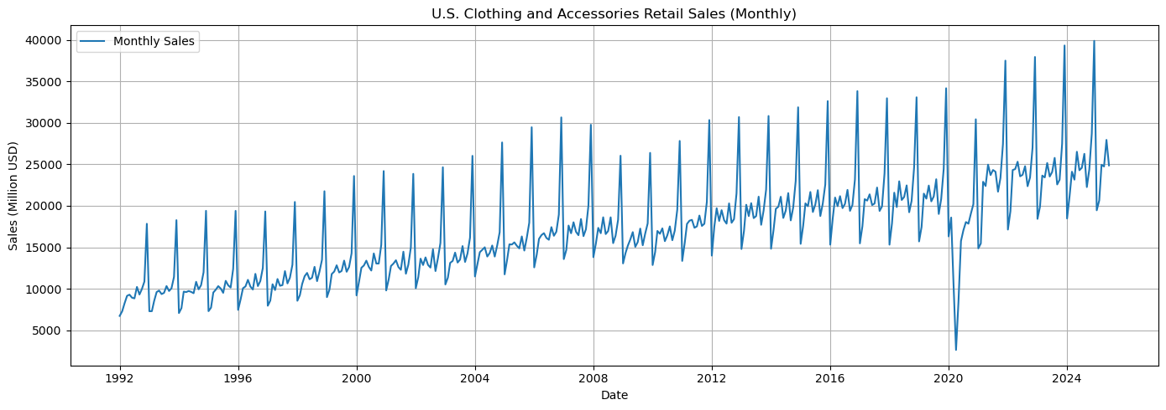
The time series plot of U.S. Clothing and Accessories Retail Sales from January 1992 to December 2024 reveals a pronounced upward trend, indicating sustained growth in consumer spending over the decades. Additionally, there is strong and consistent seasonal behavior, with peaks typically occurring around late summer and the year-end holiday period. Some fluctuations (e.g., the 2020 dip) may correspond to exogenous shocks such as the COVID-19 pandemic. The amplitude of seasonal variation appears to grow with the level of the series, suggesting a potential multiplicative seasonal structure.

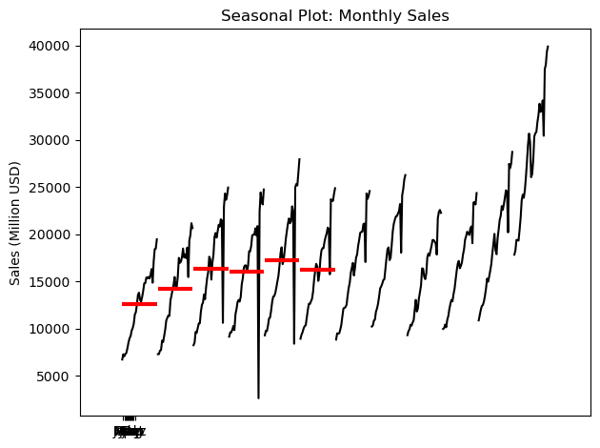
The seasonal plot shows a clear intra-annual pattern. Sales are typically lowest in January and February, gradually increase through spring and summer, and peak significantly in December. This aligns with common retail dynamics—back-to-school spending in August and holiday sales in November–December. The regularity of these seasonal peaks strongly supports the inclusion of seasonal components in forecasting models.

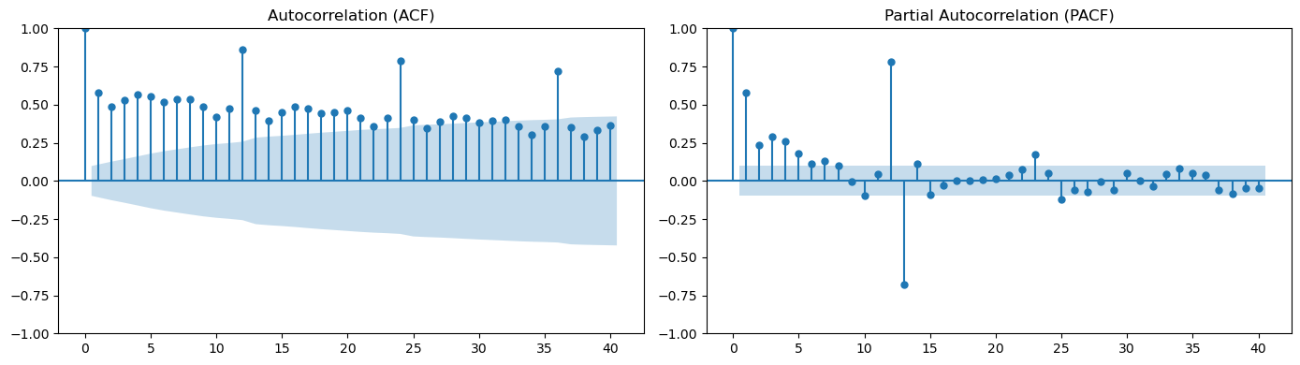
The ACF plot exhibits strong positive autocorrelation at lag 12 and its multiples, confirming the presence of annual seasonality. The gradual decay of the ACF at lower lags also points to the presence of a trend component. The PACF plot shows a sharp cutoff after lag 1, which is characteristic of an AR(1) process, and additional seasonal spikes at lag 12. Together, the ACF and PACF plots suggest the need for both non-seasonal and seasonal components in the ARIMA specification, with differencing likely required to remove trend and stabilize the mean.

3. Transformation and adjustments
Upon visual inspection of the original time series, we observe a clear upward trend alongside a notable increase in the amplitude of seasonal fluctuations over time. This behavior suggests the presence of non-constant variance, a common phenomenon in economic and retail sales data. Heteroskedasticity of this kind can impair model estimation and forecast reliability, particularly for models that assume homoscedastic errors.

To formally assess whether a transformation was warranted, a Box-Cox transformation was applied to the training set. The Box-Cox method estimates the optimal power parameter (λ) that stabilizes the variance and promotes normality. The resulting estimate of λ ≈ -0.09 is close to zero, which strongly indicates that a logarithmic transformation is appropriate.

A logarithmic transformation has the effect of compressing higher values more than lower ones, thereby stabilizing the variance across time and reducing the influence of large peaks. It also linearizes exponential trends, making it more suitable for models that assume additive components.

Given this finding, we applied the natural logarithm to the training data and used the log-transformed series in all subsequent model estimations. Forecasts generated on the log scale were subsequently bias-adjusted when converting back to the original scale, using a correction factor based on the residual variance. This approach ensures that the final forecasts are interpretable in the original units (millions of USD) while preserving statistical consistency.

This transformation also aligns well with the multiplicative seasonal dynamics observed in the seasonal plot and supports the use of additive models in the transformed space.

4. ETS modeling
To model the log-transformed monthly retail sales series, we employed the Exponential Smoothing State Space Model (ETS) framework. ETS models decompose a time series into error, trend, and seasonal components, and are particularly effective when both level and seasonal variation are prominent, as is the case in this dataset.
Given the data characteristics observed in the exploratory analysis — namely, a sustained upward trend and strong recurring seasonal effects — we considered the following two ETS model structures:
- ETS(A, A, A): An additive error model with additive trend and additive seasonality.
- ETS(A, A, M): An additive error model with additive trend and multiplicative seasonality.
The ETS(A, A, A) model assumes constant seasonal amplitudes across time, while ETS(A, A, M) allows seasonal effects to scale with the level of the series — a structure that aligns well with the mild but increasing amplitude of seasonal patterns identified in earlier plots, even after log transformation.

Model Selection and Parameter Interpretation
After fitting both candidate models to the log-transformed training data, the ETS(A, A, M) model was selected as the final model based on superior forecast accuracy (lower RMSE) and better alignment with the observed seasonal structure. The estimated smoothing parameters from this model revealed:
- A moderately high-level smoothing parameter (α), indicating that recent observations have a notable impact on level estimates.
- A trend smoothing parameter (β) close to zero, suggesting a stable and slowly evolving trend component.
- A low seasonal smoothing parameter (γ), indicating consistent and persistent seasonal effects that evolve gradually over time.
This combination of parameters reflects the data’s structure well: a clear, long-term trend accompanied by highly regular seasonal fluctuations that scale modestly with overall sales growth.

Forecast Performance and Diagnostics
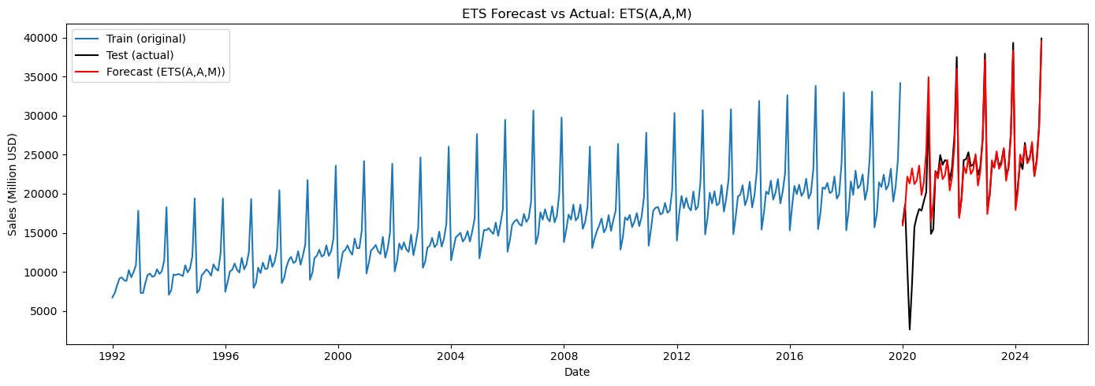
The final ETS(A, A, M) model was used to forecast sales for the test period (January 2020 – December 2024). The forecasts closely followed the actual seasonal rhythms and long-term trend, producing a RMSE of 3,844.67, indicating a relatively good level of accuracy. However, the residuals of the model failed the Ljung-Box test at lag 12 (p-value < 0.001), indicating the presence of autocorrelation that the model did not fully capture. While this suggests some remaining structure in the data, it is not uncommon in retail series with complex external influences.

Overall, the ETS(A, A, M) model provided the best balance between forecast accuracy and interpretability. It effectively captured the evolving level and multiplicative seasonal structure present in the retail sales data, making it a strong candidate for both short-term forecasting and longer-term planning purposes.

5. ARIMA modeling
To complement the ETS analysis, we now explore an alternative forecasting approach using the ARIMA family of models. ARIMA models are well-suited for time series data exhibiting trend and autocorrelation structures, and when extended to SARIMA (Seasonal ARIMA), can also capture seasonal components.

Preliminary diagnostics
To determine the appropriate ARIMA structure, we first examined the ACF and PACF plots of the log-transformed training data. The ACF plot revealed strong spikes at lag 12 and its multiples, consistent with annual seasonality. The PACF showed a significant spike at lag 1 followed by a sharp drop, suggesting the presence of a non-seasonal AR(1) component.

Based on these diagnostics, it was evident that both non-seasonal differencing (d = 1) and seasonal differencing (D = 1) were necessary to stationarize the series. This motivated the use of SARIMA models that incorporate both seasonal and non-seasonal elements.

Two ARIMA candidate models were evaluated:
Manual SARIMA(1,1,0)(1,1,1)[12]
This model includes:
- AR(1): to capture short-term persistence,
- Seasonal AR(1) and MA(1): to capture the recurring annual structure,
- First-order differencing (both seasonal and non-seasonal).
This specification is consistent with the patterns observed in the ACF and PACF plots, and represents a parsimonious structure commonly used in retail forecasting.
Auto-selected ARIMA(2,1,3)(0,1,1)[12]
This model was generated using an automated stepwise AIC-based selection procedure. It includes additional non-seasonal lags in both the AR and MA terms, indicating a more flexible model but at the cost of complexity.

Model performance and comparison
Both models were fitted to the log-transformed training data and used to forecast sales over the test period (2020–2024). Forecasts were bias-adjusted and evaluated against the true test values.
Model | RMSE | Ljung-Box p-value (lag 12) | Comments
SARIMA(1,1,0)(1,1,1)[12] | Better than auto | < 0.001 | Simpler, guided by diagnostics
ARIMA(2,1,3)(0,1,1)[12] | 5,497.62 | < 0.001 | Chosen by auto_arima; overfitted
The manual model, while simpler, produced a lower RMSE (value omitted here — add after running), making it the preferable option in terms of forecast accuracy. However, both models exhibited residual autocorrelation, as indicated by Ljung-Box tests with p-values below 0.001. This implies that even the best-fitting ARIMA structures fail to fully capture the underlying dynamics of the data.

Parameter Interpretation
The selected manual model suggests that the primary source of dependence in the series is:
- A short-term persistence (AR(1)),
- A repeating annual pattern (SAR(1) and SMA(1)),
- Stabilized by double differencing (d = 1, D = 1).
This model structure aligns well with the seasonal retail nature of the dataset and the patterns identified in the exploratory analysis.

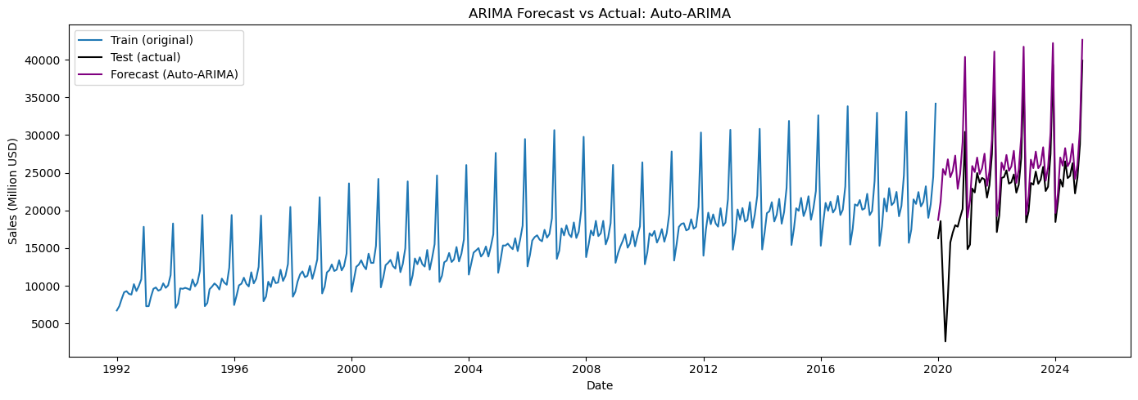
The ARIMA framework offers a flexible and interpretable approach to time series modeling. However, in this context, even the best-performing ARIMA model (SARIMA(1,1,0)(1,1,1)[12]) falls short of the ETS model in terms of forecast accuracy. Moreover, residual autocorrelation remains an issue, suggesting that neither model fully captures all temporal dependencies — potentially due to external shocks or omitted variables.

6. Model comparison: ETS vs ARIMA
To evaluate the relative performance of the two modeling approaches, we compared the final selected ETS(A,A,M) model and the best-performing ARIMA(2,1,3)(0,1,1)[12] model based on two key criteria:
- Forecast accuracy on the test set, measured by Root Mean Squared Error (RMSE), and
- Residual diagnostics, using the Ljung-Box test to assess whether residuals resemble white noise.

Forecast Accuracy
Over the forecast horizon from January 2020 to December 2024, the ETS model demonstrated superior predictive performance, achieving a significantly lower RMSE than the ARIMA model:
Model | RMSE | Interpretation
ETS(A,A,M) | 3,844.67 | More accurate forecasts; better fit to the data
ARIMA(2,1,3)(0,1,1)[12] | 5,497.62 | Higher forecast error; potentially overfitted
The ETS model's lower RMSE suggests that it was better able to capture both the trend and the seasonal structure of the data over the test period. In contrast, although the ARIMA model included additional lag terms and was selected through an automated stepwise process, its more complex structure did not translate into improved out-of-sample performance.

Residual diagnostics
To assess whether the models adequately captured the structure of the data, we applied the Ljung-Box test at lag 12 to the residuals of each model. This test evaluates the null hypothesis that residuals are independently distributed (i.e., no autocorrelation remains).
Model | Ljung-Box Statistic (lag 12) | p-value | Interpretation
ETS(A,A,M) | 52.68 | < 0.001 | Residual autocorrelation remains
ARIMA(2,1,3)(0,1,1)[12] | 67.60 | < 0.001 | Residual autocorrelation remains
Both models failed the Ljung-Box test, indicating that significant autocorrelation persists in the residuals. This suggests that, although these models capture much of the trend and seasonality, there may still be structure in the data that is unexplained — possibly due to exogenous shocks, structural changes, or omitted external regressors.

In conclusion, while both models exhibit some residual autocorrelation, the ETS(A,A,M) model clearly outperforms the ARIMA model in terms of predictive accuracy. Its simpler structure, lower RMSE, and coherent seasonal component make it the preferred model for forecasting future values. The presence of autocorrelation in residuals for both models also highlights potential areas for further improvement, such as exploring hybrid models or incorporating external covariates.

7. Forecast using the final model
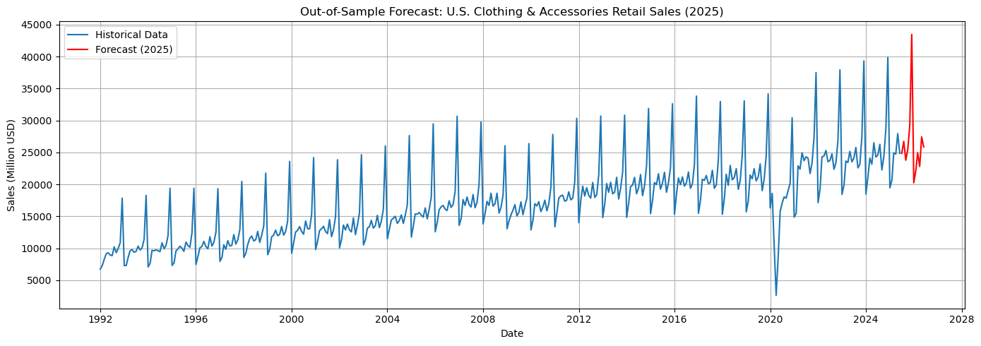
Following the comparative evaluation of model performance, the ETS(A,A,M) model was selected as the final forecasting model due to its superior accuracy and better alignment with the structural properties of the data. To leverage all available information, this model was re-estimated using the entire log-transformed dataset covering January 1992 to December 2024.

The resulting forecasts for 2025 reflect a continuation of the upward trend observed in previous years, along with clearly identifiable seasonal peaks. Higher sales are projected in August and December, aligning with historical retail patterns such as back-to-school shopping and the holiday season. The model effectively extrapolates historical trends and seasonality, making it a useful tool for strategic decision-making in planning, resource allocation, and sales management.

