DAILY WORK STATEMENT - SEPTEMBER 2026
Daloyar Hassan
Role: Program Officer | Reporting Month: September 2026 (01 Sep - 30 Sep)
Organization: Small Kindness Bangladesh (SKB) | Document Status: Official Daily Work Statement

Date | Day | Location / Activity Type | Official Tasks & Key Accomplishments
27 Aug 2026 | Wed | PCSDP Camp | Conducted English Day 7: Taught Pronouns, Determiners, Relative clauses & guided Formal/Informal letter writing.
28 Aug 2026 | Thu | PCSDP Camp | Conducted English Day 8: Led Adjectives/Adverbs lessons, Conjunctions/Prepositions exercises & Narrative story writing.
29 Aug 2026 | Fri | PCSDP Camp | Conducted English Day 9: Conducted Phrasal verbs training, Narrative revision drills & interactive group communication practice.
30 Aug 2026 | Sat | PCSDP Camp | Conducted English Day 10: Administered Final English Test, evaluated speaking/writing performance, compiled student scores & progress report.
30 Aug 2026 | Sun | PCSDP Camp | Concluded PCSDP 2026 English training operations, supported certificate distribution, archived final student records & returned from camp.
 | Mon | Central Office | Resumed at regular works at SKB office.
01 Sep 2026 | Tue | Central Office | Initiated compliance review for Karaman Income Generating Project Trabzon Fishing Boat Project (PID 22211); finalized and updated 4 Quran Distribution concept notes (5%- & 10%-Euro tiers for BD & RR); initiated parent/guardian NID verification process for under-18 beneficiaries.
02 Sep 2026 | Wed | Central Office | Reconciled beneficiary ID verification files across livelihood projects; resolved missing NID records for 4 out of 5 beneficiaries, Sewing Machine Distribution lists, and NID replacements for PID 22219.
03 Sep 2026 | Thu | Central Office | Formulated standardized field data correction protocols for beneficiary registration lists, verified financial vouchers, and compiled official dossiers for Fishing Boat Distribution Projects (5+2 Boats).
04 Sep 2026 | Fri | Central Office | Weekend
05 Sep 2026 | Sat | Central Office / Special Duty | Weekend
06 Sep 2026 | Sun | Central Office | Recalibrated itemized project budgets, unit cost structures, and distribution verification registers across active community development projects.
07 Sep 2026 | Mon | Central Office / Donor Submission | Compiled and submitted 3 official project closing packages to IHH Turkey: Patuakhali Donor Declaration (PID 22211), Satkhira Donor Declaration (PID 22579), Rohingya Sewing Machine NID Cards (PIDs 22219 & 22222).
08 Sep 2026 | Tue | Central Office | Compliance audit package; audited 38 blurry/mismatched NID entries in 2025 Zakat distribution register (PID 22023); processed Patuakhali IGP feedback (PID 20967) and archived ongoing grant files.
09 Sep 2026 | Wed |  | On Emergency Leave for Aunt’s Health Issues
10 Sep 2026 | Thu | Central Office | Compiling donor feedback logs, auditing field beneficiary lists, and preparing Form-7 documentation packages for donor reporting.
11 Sep 2026 | Fri | Central Office / Special Duty | Drafted 6 documentation for Saudi National Day 96 Event (WAMY) and conducted specialized Friday technical review for coming IHH delegates resolving projects compliance queries across Fishing Boat guardian NIDs verification.
12 Sep 2026 | Sat | Central Office / Special Duty | Drafted formal legal guardian explanation letters for minor beneficiary signatures (PIDs 17962, 18918, 22579); finalized those 6 documentations for Saudi National Day 96 Event (WAMY).
13 Sep 2026 | Sun | Central Office | Prepared NID Verification Report and guardian clarification letters for PID 20967; organized master deliverable archives for Rohingya WFS Sewing Machines (PID 22219) and incoming proposal files.
14 Sep 2026 | Mon | Central Office | Processed final compliance files for PID 22222 (Sewing Machine NIDs, Cow/Goat lists & NIDs, Donor Clarification Letter), AC Declaration, and Patuakhali IGP Master Distribution Registers (PID 20967); audited NID verification records for PID 20788.
15 Sep 2026 | Tue | Central Office | Processed donor feedback for Patuakhali Fishing Boat Distribution (PID 22211) and Solar Panel 170-Package Distribution (PID 22786); drafted official SKB Declaration Letters for Patuakhali fishing boat distribution.
16 Sep 2026 | Wed | Central Office | Executed final verification of distribution lists, official invoices, and financial vouchers for Patuakhali IGP (PID 20967) and Rohingya Skills Sewing Machines (PID 22222); updated replacement NID highlighting and donor compliance letters.
17 Sep 2026 | Thu | Central Office | Completed end-of-stage upload of bank fund receival certificates, payment vouchers, and finalized project closing documentation packages to donor.
18 Sep 2026 | Fri | Central Office | Weekend
19 Sep 2026 | Sat | Central Office | Weekend
20 Sep 2026 | Sun | Central Office | Compiled master Form-7 compliance dossiers for Income Generating Program 2024 (PID 20967 - 5 Cows, 100 Goats, 3 Boats), Patuakhali Boats (PID 22211), and Satkhira Livelihood (PID 22579).
21 Sep 2026 | Mon | Central Office | Finalized Project 20967 audit corrections; updated Satkhira Declaration (PID 22579) and Zakat Fitra (PID 23801) archives; corrected Cow Distribution Beneficiary SL 5 (added legal guardian father's NID & signature for Kobaib).
22 Sep 2026 | Tue | Central Office | Formulated and compiled the comprehensive Nippon Foundation Strategic Proposal Suite (Concept Notes, Winning Proposals, Coastal Fishermen Master Budget, NGOAB FD7 Budget & BOQ in English & Bangla); reviewed donor audit feedback on Solar Panel (PID 22786/20736), Poor & Injured Support (PID 20634), and Trabzon Boats (PID 22211).
23 Sep 2026 | Wed | Central Office | Finalized Nippon Foundation Micro-Segmented Budget & Proposal packages; submitted iHH Feedback Report; updated Fire Victims Form-7 (PID 21484 - 3,308 beneficiaries); issued official Clarification Letter for Solar PID 22786 (SL 129 & 130 household split); scanned and re-uploaded clean non-edited forms.
24 Sep 2026 | Thu | Central Office | Resolved Monira Begum duplicate entry for PID 20788; translated cost line items for PID 17962; aligned invoice and Form-7 dates for PID 20787; engineered Master Architecture & Technical Specifications for SKB Works Portal.
25 Sep 2026 | Fri | Central Office / Special Duty | Conducted half-day Friday project closing session with IHH Donor Delegates (Caner Abi, Munawwar); finalized PID 20788 Goat Distribution NID merge & official project sign-off.
26 Sep 2026 | Sat | Central Office / Special Duty | Worked on Saturday executing field compliance audit of Project ID 22567 sewing machine distribution roster; identified 1 minor recipient (SL 28 Rupa, age 16) and 23 household cards with minor dependents; authored official MS Word Clarification & Legal Guardian Verification Letter with signature blocks for IHH.

Summary of Working Days (September 2026):
Total Days | Office, Field & Special Duty | On Leave | Weekend Off Days
30 Days | 25 Days | 1 Day | 4 Days

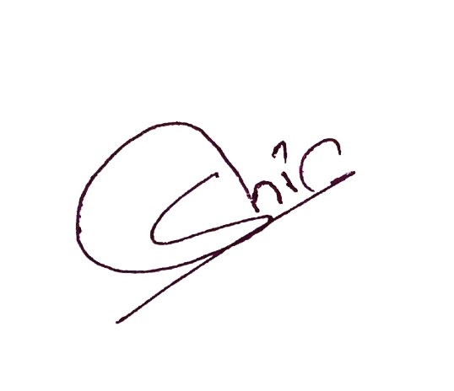  Daloyar Hassan | Md Abu Huraira | Ashraful Alam
_________________________  Prepared By (Employee) | _________________________  Verified By (Executive Director) | _________________________  Approved By Accountant Officer

