Harrison Willis
Operating Plan
Three businesses. One agent stack. A budget that holds.
Whitepaper · v0.1
22 April 2026

Contents

1. Executive summary
This paper describes the operating plan that pulls together four threads I have been developing in parallel: an autonomous trading business, a household-operations business with two product shapes, a personal assistant modelled on Perplexity Computer but running on my own stack, and a Business Manager agent that sits above all of it and owns cost.
The thesis is simple. Each business is a coordination problem over a specific domain. The same agent stack can run all three if the state lives in one place (Obsidian markdown), the agent host is shared (OpenClaw + Claude Code), and a dedicated overseer keeps model calls cheap. Premium models are the exception, not the default.
Token cost is a first-class product constraint. A Business Manager agent routes calls, caches aggressively, and reports monthly — otherwise the stack eats the business.

At a glance
Project | Status | Next concrete action | Why it matters
Personal Assistant (Perplexity Computer replica) | Design complete; not installed | Week 1: install OpenClaw, vault-scoped, Claude-only, no external writes | The force multiplier that makes the other two projects run themselves
Home Manager | Customer Zero underway; whitepaper drafted | Close safety item (water-heater vent); point the assistant at the 9-item backlog | The first real workload for the assistant; proof the stack generalises off trading
Tempo Trading | V15 portfolio validated; not yet live | Paper-trade IFVG + Lumi for 4 weeks; then small live size | The only project currently capable of generating capital to fund the others
Business Manager agent | Not yet built | Week 1, day 2: stand up ledger + monthly budget + routing rules | Without it, AI spend silently eats every other business's margin

2. Operating principles

One vault. One host. One overseer.
All three businesses are coordination problems. All three have state, events, and decisions. The rational move is to share the substrate:
- State lives in ~/HW (the Obsidian vault). Markdown is free, legible, and diff-able.
- Agent host is shared: OpenClaw + Claude Code running on a Mac or a $6/month VPS. One install, not three.
- A Business Manager agent sits above the host, watches spend, routes calls to the cheapest model that can do the job, and writes a monthly ledger.

Token frugality as a product constraint
Running three businesses through frontier models by default is the fastest way to burn a budget with nothing to show. The plan assumes premium reasoning is scarce and expensive, and designs around it. Concretely:
- Haiku or GPT-4o-mini for 80% of calls (classification, extraction, routine summaries).
- Sonnet / 4o for middling work (drafting, multi-step reasoning within one domain).
- Opus / GPT-5 / Grok only when cheaper models have failed or the stakes warrant it.
- Prompt caching on everything repeated: system prompts, vault context, skill definitions.
- Local models (DeepSeek-R1-Distill-Qwen-14B already on the trading box) for work that does not need frontier quality — specifically the Nova/Sable research personas.
- Obsidian itself is the cheapest memory: a summary cached in the vault costs $0 to re-read.

Approval queue, not autonomy
Every action with real-world consequence (sending email, paying a vendor, placing a trade, filling a form) goes through an approval queue in the vault at inbox/approval/. The agent drafts; a human approves. This is how the same host can safely run a trading business, a services business, and a personal assistant — the blast radius is bounded by the approval step.

3. The operating stack
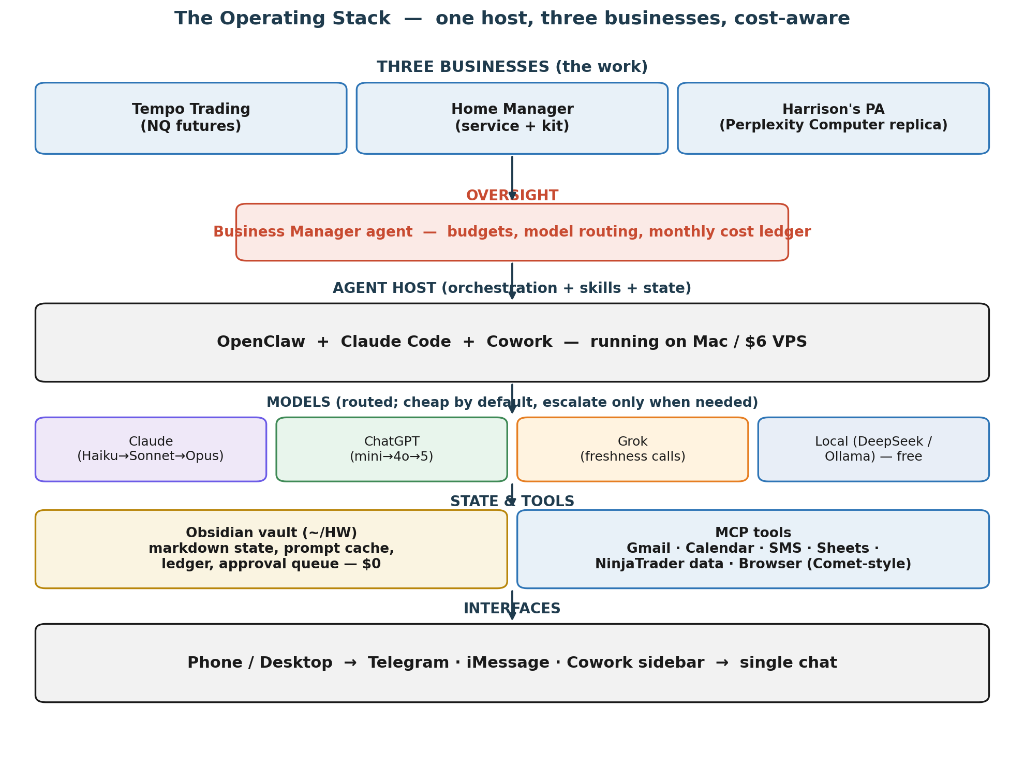
Read top to bottom: three businesses sit on top, a Business Manager watches spend above the host, the host runs OpenClaw + Claude Code + Cowork, models are routed (cheap by default), and state plus tools plug in below. Interfaces at the bottom — phone and desktop — feed a single chat line.

Why these pieces
- OpenClaw — open source, local, brings-your-own-LLM. Gives up the polish of Perplexity Computer in exchange for full control and no $200/month seat. The build plan in the AI Automation Build-Out doc walks the install, week by week.
- Claude Code — the reasoning primary; also the pre-commit lint hook on the vault. Uses Claude API (Haiku → Sonnet → Opus) with routing.
- Cowork — the sidebar that hosts the live dashboards, TodoList, approvals and artifacts; the desktop surface for the whole system.
- Obsidian (~/HW) — the persistent state layer. Already set up (283 files, zero orphans). Same vault serves all three businesses; costs nothing per call.
- MCP tools — Gmail, Calendar, SMS/Telegram, Google Sheets (already wired), NinjaTrader data, and a Comet-style browser skill gated behind a domain allowlist.

4. Personal Assistant — the Perplexity Computer replica

What it is
An always-on agent that reads my email, maintains my calendar, does research, drafts documents, files them in the vault, and chases the long tail of to-dos that I forget. The design target is what Perplexity Computer ships: a multi-model orchestrator that can run a workflow for hours or days unattended. The difference is that mine runs on my machine, uses my keys, routes through the Business Manager for cost, and answers to a single approval queue.

Why not just buy Perplexity Computer
Two reasons. First, $200/month for a single-vendor agent is the wrong shape for a stack that already runs Claude, Grok via API, and ChatGPT on a Plus seat — I would be paying for orchestration I can do myself. Second, Perplexity Computer is closed. I cannot point it at my Obsidian vault, my trading box, my home-manager skills, or my own tools. OpenClaw plus Claude gives me the same capability on my terms.

Capability parity checklist
Perplexity Computer capability | Our equivalent | Status
19-model orchestration | Router inside Business Manager picks among Claude tiers, GPT tiers, Grok, and local DeepSeek | Design complete
Long-running workflows | OpenClaw scheduled tasks (already have 4 running for the vault) | Partial — extend to PA domain
Custom Skills (teach once, reuse) | OpenClaw skills directory + Obsidian markdown templates | Shape exists; needs PA skills written
Browser use (Comet) | Claude-in-Chrome + browser.interact with domain allowlist | Available, not yet scoped for PA
Always-on local (Mac mini) | $6 VPS or the Mac I already own | Not yet deployed
Voice | Optional — only if it earns its keep | Out of scope v1

Four-week build plan
- Week 1 — crawl. Install OpenClaw scoped to the vault only. Claude as the sole reasoner. No external writes. Prove the loop.
- Week 2 — walk. Wire Gmail ingest. Stand up inbox/approval/ with a frontmatter schema. Agent drafts replies; I approve.
- Week 3 — run. Add Grok for web freshness, ChatGPT for structured extraction. Turn on scheduled tasks. Agent drafts my morning brief.
- Week 4 — refine. Browser skill (allowlisted domains), custom skills for recurring workflows, circuit breakers, kill switches. Deploy to Mac mini as an always-on.
Full week-by-week in AI_Automation_BuildOut_Plan.docx (in the original session outputs; to be copied into ~/HW/personal/projects/ai-assistant/).

5. Home Manager — services business + DIY kit

What it is
A household concierge sold two ways. The service tier is done-for-you: Lite $750/mo, Standard $1,800/mo, Premium $3,500/mo, covering the thirteen service lines in the existing services catalog. The kit is a $299 one-time package with ~$40–$90/month in operating cost, letting a technical homeowner run the same playbook themselves using Claude Code + Obsidian + MCP. Same playbook, two audiences.

Customer Zero
My own house. Backlog has nine open repair items (tracked in home-repair-backlog.md). The safety-critical item (water-heater vent) should close first. The Home Manager project is the first domain the Personal Assistant gets pointed at, which is the reason the PA gets built before the Home Manager product ships.

Economics
Tier | Price | What's included | Target customer
DIY Kit | $299 one-time + $40–90/mo operating | Scaffold repo, skill library, whitepaper, starter prompts | Technical homeowners who want automation
Lite (service) | $750 / month | Intake, vendor coordination, monthly report, 2 service lines | First Customer One customers — friends and family
Standard | $1,800 / month | All 13 service lines, bi-weekly report, priority response | Mid-market — households spending >$3k/mo on household services already
Premium | $3,500 / month | Weekly report, calendar integration, on-site audits, vendor negotiation | Busy families or second-home owners

90-day plan
- Weeks 1–4: Customer Zero workload runs on the PA. Write SOPs as the work happens.
- Weeks 5–8: Recruit 2–3 friends-and-family at the Lite tier. Price below cost is fine; the point is feedback.
- Weeks 9–12: Ship the DIY kit publicly. Product Hunt / HN launch. Kit revenue subsidises the services build.

6. Tempo Trading — autonomous NQ futures

What is validated
- IFVG + Lumi (V15 rewrite to spec): +19.8 pts/day combined on tick-level backtest, Calmar 23.1. Paper-trade next.
- SF Portfolio: tick-level validated, NinjaTrader bar-gating fix applied. In development.
- Wick Fade: backtest only. 68% of edge from a debunked flip leg. Unproven — do not trade.
- BOS FVG: dead. Killed by the bar-sim trailing bug. See the saga MOC.

Next 12 weeks
- Weeks 1–4: paper-trade IFVG + Lumi live-sim.
- Weeks 5–8: if paper results hold within 20% of backtest, deploy small live size (<$10k).
- Weeks 9–12: scale by Calmar, not by confidence. Pre-approve all risk-limit changes in the approval queue.

How the assistant helps
The PA does not place trades. It runs the /trade-review daily habit (already in the vault as a slash command), reads the logs, drafts the weekly rollup, flags invalidations against the invalidation-rules ledger, and prepares the Sunday-evening deck for the following week. It frees the hour-a-day that currently goes to journaling.

7. The Business Manager agent — cost overseer
This is the new piece. The Business Manager is an agent persona — the same pattern as Nova and Sable on the trading side — but its domain is cost, not alpha. It owns the AI and tooling budget across all three businesses. It sees every call and routes it; it sees every invoice and logs it; it writes the monthly ledger and the alert when any line is trending hot.
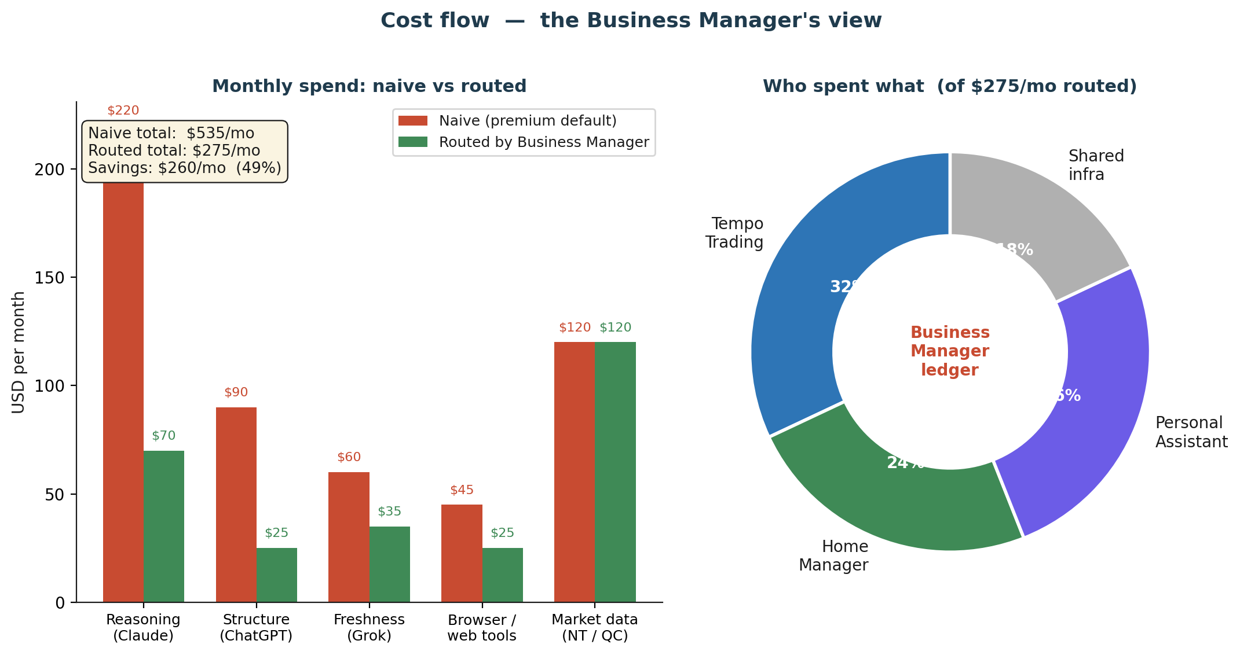

Responsibilities
- Set and enforce a monthly budget per business (Tempo, Home Manager, PA, shared).
- Route every model call to the cheapest tier that can do the job. Escalate only on failure or explicit override.
- Maintain a ledger at ~/HW/business/ledger.md — one line per API call, aggregated nightly into monthly rollups.
- Issue a daily digest when any line is projected to exceed budget by month end.
- Run the monthly close: actual spend vs. budget, cost per project, model mix, cache hit rate, recommended adjustments.
- Kill-switch the stack if a runaway (cost spike > 3x daily median) is detected before approval.

Routing rules (v0)
Workload class | Default model | Escalation | Approx $ / 1k calls
Classification / extraction | Haiku or GPT-4o-mini | Sonnet on disagreement | $0.20 – $0.80
Drafting (email, notes, briefs) | Sonnet / GPT-4o | Opus for 1-shot high-stakes | $2 – $8
Research with live web | Grok 2 (freshness-optimised) | Opus + Grok combo on hard Qs | $3 – $10
Heavy reasoning / one-shot | Opus or GPT-5 | n/a | $15 – $50
Personas (Nova/Sable) | Local DeepSeek-R1-Distill-Qwen-14B | Claude only if local fails twice | $0 (local)

Monthly budget (starting values)
- Tempo Trading: $80/mo — mostly data, modest reasoning; personas run local.
- Home Manager: $60/mo — chase/intake/report skills are mostly Haiku-class.
- Personal Assistant: $65/mo — the heaviest user; prompt caching is critical here.
- Shared infra (Obsidian, OpenClaw, Claude Max): $45/mo.
- Total cap: $250/mo. Naïve baseline (premium-by-default) would run ~$535/mo — the BM is the difference.

Cost-reduction tactics the BM enforces
- Prompt caching on all system prompts and vault context (Anthropic caching saves ~90% on repeated input tokens).
- Response length caps on low-stakes calls (no 2,000-token answers to yes/no questions).
- Summarise-then-reason: the PA reads summaries from the vault first; full sources only on miss.
- Batch similar requests (end-of-day rollup instead of a call every time a new email arrives).
- Dedupe: if the same research request came in this week, return the cached synthesis.
- Cold pass on local models: triage happens locally, frontier tokens only on the shortlist.

8. Token reduction strategy (deep dive)
The Business Manager enforces rules; this section is the why behind each one.

8.1 Cache everything repeated
System prompts, skill definitions, and the subset of the vault the agent reads on every run do not change between calls. Anthropic's prompt caching drops repeat-input cost by ~90%. The PA's morning brief (~40k tokens of context) should cost me hundreds a month if I pay full price; with caching it costs tens.

8.2 Route, don't default
Most tasks do not need Opus. Classification (is this email urgent?), extraction (what's the vendor name?), and summarisation (one paragraph per note) work on Haiku or GPT-4o-mini. The BM's router is a simple table lookup — the escalation path exists, but only fires on failure.

8.3 Summarise then reason
Every time a source is read, a summary gets written back into wiki/summaries/. Next time the agent needs that source, it reads the summary first (cheap, already paid for). Only on a miss does it re-read the original. This is the Karpathy LLM Wiki pattern; the vault was designed for it.

8.4 Batch and schedule
A model call in response to every Gmail notification is a way to burn money while looking productive. Instead, the PA batches: one inbox pass per hour, one rollup per day, one weekly review. Scheduled tasks run these at off-peak (where providers offer cheaper off-peak, use it).

8.5 Local first for the personas
Nova and Sable — the trading research personas — do not need frontier reasoning for their day-to-day. DeepSeek-R1-Distill-Qwen-14B already runs on the trading box. The BM only escalates to Claude when the local model returns low confidence or gets flagged by a downstream check.

8.6 Kill the verbose defaults
A 1,500-word answer to a routine question is a tax. Every skill in the system has an output length cap set in its SKILL.md. If the user asks for more, they ask explicitly.

9. Master execution timeline
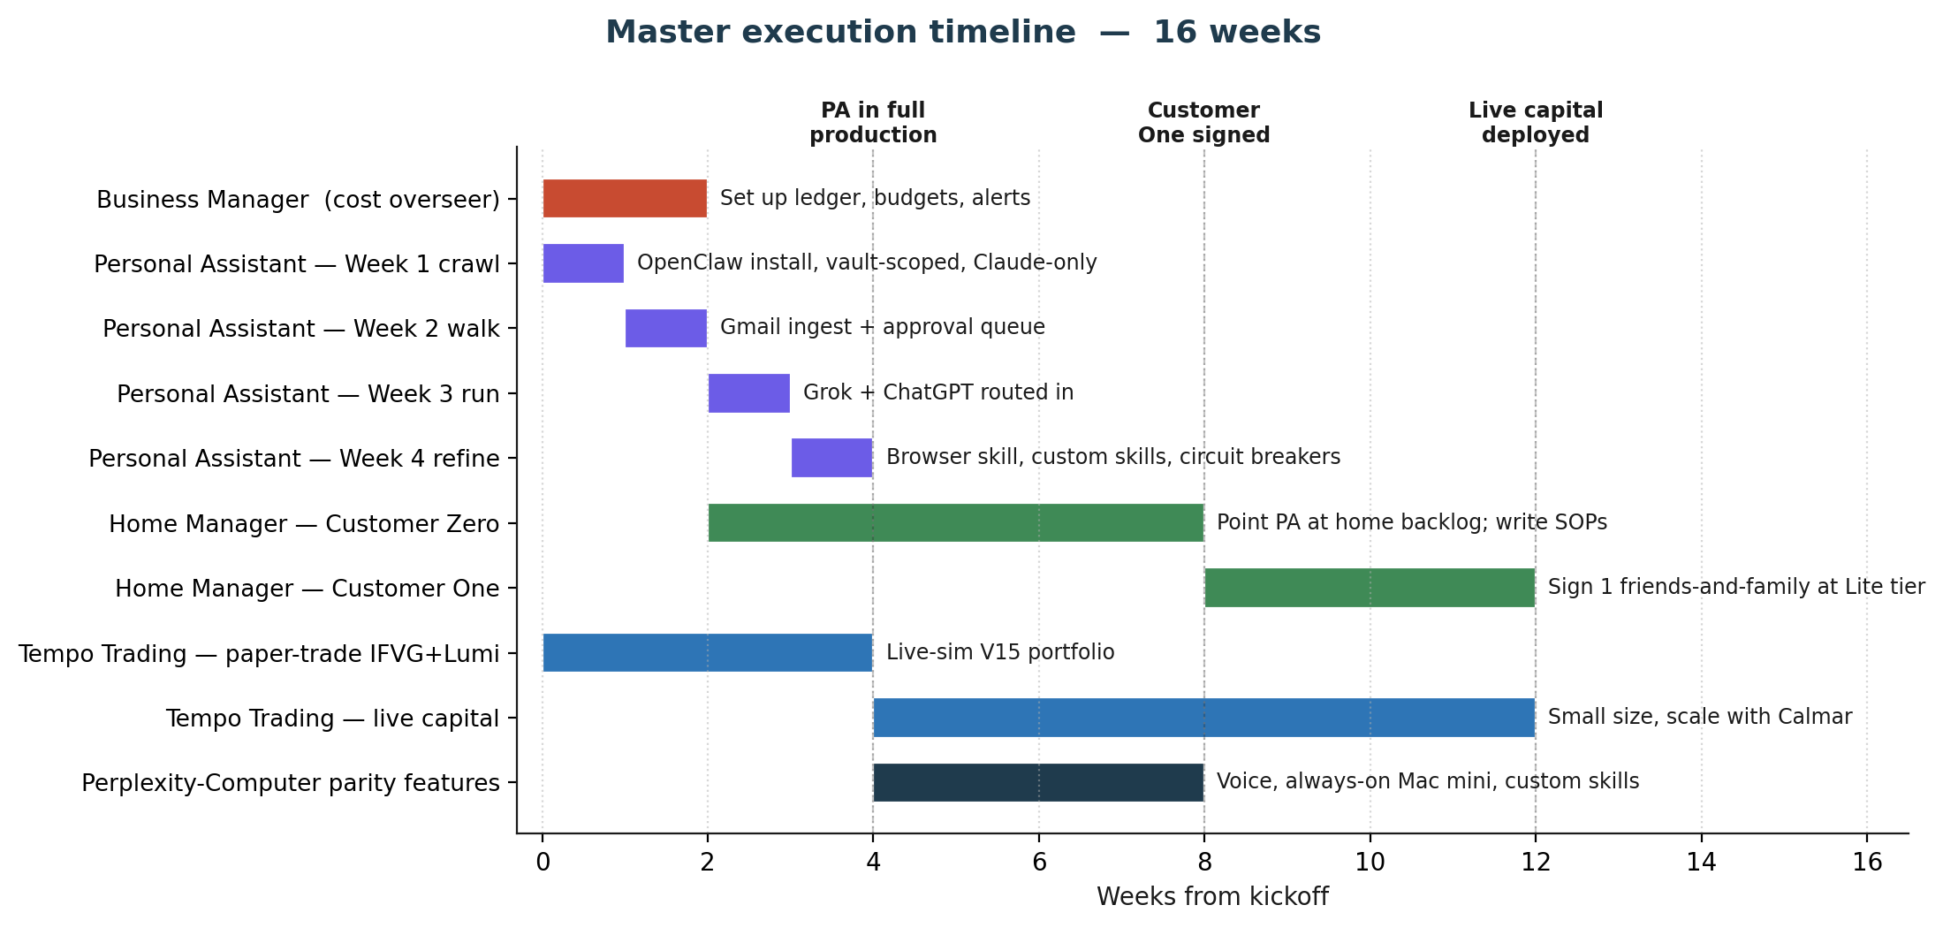
Sixteen weeks from kickoff. The critical-path call: build the Personal Assistant first (Weeks 1–4), because everything else gets leveraged by it. Home Manager Customer Zero starts in parallel on Week 3 once the PA can actually hold context about the house. Tempo paper-trades on its existing rails while the PA comes online. Live capital does not deploy until Week 5 at earliest, conditional on paper results matching backtest within 20%.

Week-by-week highlights
- Weeks 1–2: Business Manager ledger live, PA in crawl mode, routing rules enforced from day one.
- Weeks 3–4: PA handles Gmail + approvals + drafts; first Home Manager SOPs written as Customer Zero runs.
- Weeks 5–8: Tempo goes live small. Home Manager signs Customer One. PA gains browser skill, voice deferred.
- Weeks 9–12: DIY kit launches publicly. Tempo scales by Calmar. PA adds always-on Mac mini deployment.
- Weeks 13–16: Perplexity-Computer parity features (custom skills library, multi-model orchestration UI). Monthly close discipline established.

10. Risks and open questions

Risks
- Agent stack fragility. OpenClaw is powerful but its maintainer has explicitly warned it is dangerous without command-line comfort. Vault scoping and circuit breakers are mandatory.
- Cost drift. The BM has to catch spend spikes inside 24 hours; a two-week miss could blow the monthly cap. Daily digest is not optional.
- Context-sharing privacy. Same vault holds trading logs, client notes, and household repair data. Access patterns need to stay segmented at the tool layer.
- Trading drawdown. Paper-trade-to-live has historically under-delivered 30–50% of backtest edge. Size accordingly.
- Customer One acquisition. Home Manager services tier is priced for UHNW-adjacent — that market is small locally. DIY Kit hedges this.

Open questions for next session
- Where does the Business Manager live in the vault? Proposed: ~/HW/business/. Confirm.
- Is the Mac mini purchase worth $599 for always-on, or is the $6 VPS enough for v1?
- Do I want to keep the ChatGPT seat ($20/mo), or route everything through the API? API is cheaper per call but loses the UI.
- Who's Customer One for Home Manager? Candidate list needs three names before Week 5.

11. Appendix — vault index

Existing vault files this plan depends on
- ~/HW/CLAUDE.md — operating manual for the vault
- ~/HW/personal/projects/home-manager/whitepaper-claude-code-kit.md
- ~/HW/personal/projects/home-manager/services-catalog.md
- ~/HW/personal/projects/home-manager/home-repair-backlog.md
- ~/HW/work/projects/tempo-trading/index.md
- ~/HW/wiki/entities/nova-sable-brains.md
- ~/HW/wiki/summaries/openclaw-install-audit-20260420.md

Files this plan adds
- ~/HW/personal/projects/ai-assistant/index.md — PA project page (to create)
- ~/HW/personal/projects/ai-assistant/AI_Automation_System_Design.docx (copy from prior session)
- ~/HW/personal/projects/ai-assistant/AI_Automation_BuildOut_Plan.docx (copy from prior session)
- ~/HW/business/ledger.md — Business Manager cost ledger (to create)
- ~/HW/business/budgets.md — monthly caps per project
- ~/HW/business/routing-rules.md — model routing table
- ~/HW/master-plan.md — one-page pointer to this whitepaper

End of document.

