Dylan Hudson

EIC230-101

11/18/20

Lab Report: PLC Level Control Lab

In this lab we explored using a PLC to drive a pump to control the water level in a cylindrical tank. We did this by reading the data from an ultra-sonic sensor and feeding that data into a PID control program running on a UniLogics PLC.

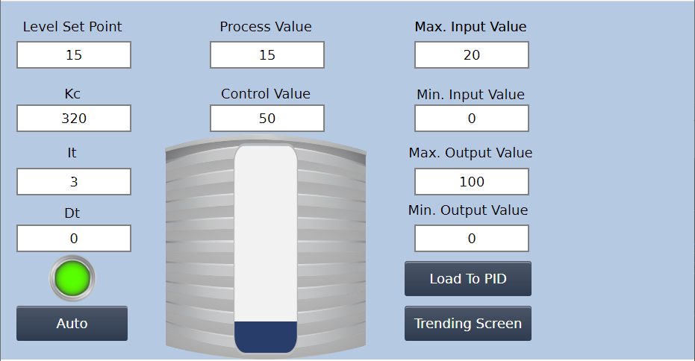

Figure

Figure 1 shows my HMI and the values I used in order to have the most stable level control. The Set Point was on a scale from 0 to 20. I used 320 for the Proportional (Kc), 3 for the Integral (It), and 0 for the Derivative (Dt). I did not need to use the derivative to make this system functional.

Initially the values were set to 120Kc and 3600 It. This just did not work that well and there was a good deal of oscillation. I ended up setting 6It and 240Kc. This was still not enough. I moved the Kc up to 360 and it was a little too much, so I brought it down to 320. When I brought it down to 320Kc It was a very smooth transition when going from a Set Point of 5 to a Set Point of 15. I decided though to half the integral. With the 320Kc and the 3It I found my setpoint and my proportional to make the tank stay at a steady level. See Figure 2.

Figure Red represents the setpoint, the Blue represents the water level.

Figure The HMI Interface

In Figure 3, all the values on the left side are for user inputs and linked to the Setting 1 PID Parameters (Figure 4).

Figure 4

The program then loads this data and stores it into the PID 1 configuration file (Figure 5) where it is used to drive the pump.

This is the program used to run everything in the system. It takes the users input and when Load is pressed the values are put into the PID. The Water level sensor (ultrasonic) is connected to the PLC and that data is put into the PID Process Value. The Control Value is then put into the Pump 1 to drive the pump.

