|  |  |  |
| --- | --- | --- |
| **Phase 1:** | **Project Charter** |  |

With your team, you will work together to develop a project charter “Project Proposal”. The best charters will clearly describe the required elements, so reduce the “filler information” and go only into enough detail to be understood. You have to use a project charter template illustrated below that includes the following elements:

1. Problem Statement.
2. Project Description.
3. Project Objectives.
4. Project Scope, Constraints, Assumptions.
5. Project Estimated Budget.
6. Project Estimated Time.
7. Major Project Milestones.

|  |  |  |  |  |  |  |  |  |  |  |  |
| --- | --- | --- | --- | --- | --- | --- | --- | --- | --- | --- | --- |
| |  |  |  |  |  |  |  |  |  |  |  | | --- | --- | --- | --- | --- | --- | --- | --- | --- | --- | --- | | **Project Charter:**   |  | | --- | | Project title: Workspace web project | | Project Start Date: 20/5/2024 Project Finish Date: 20/6/2024 | | Problem Statement: In Riyadh , a rapidly  growing city with diverse industries and businesses , individuals often struggle to quickly locate specific workplaces or understand the range of employment opportunities available . This highlights the need for a comprehensive workplace directory that provides accessible and organized information about all workplaces in Riyadh . | | **Description:**  Our project aims to develop a digital workplace dictionary focused on Riyadh . This dictionary will serve as a centralized platform offering detailed information about various workplaces across different sectors in the city . The purpose of this project is to facilitate easy access to workplace details for residents , job seekers , and professionals alike . | | Objectives:  Create a directory that includes a wide range of creative workspaces for students , freelancers , Small Companies (Start-ups), business owner. | | Project Scope, Constraints, Assumptions:  -Distribution of responsibilities among the work team  -design site map and wireframes for the website  -developing websites using (HTML,CSS,JavaScript)  -connect a website with database using php  -test website and make sure there are no errors  Only have to moth to finish, The topic was determined by the teacher “city directory website “ | | Project Estimated Budget:  15,000 | | Project Estimated Time:  23 days | | Major project milestones: | | -Project topic  -Name of project  -Deploy the website after closing  -Signature and approval by stakeholders | | |

|  |  |  |
| --- | --- | --- |
| **Phase 2:** | **Project Activity Planning** |  |

Depending on the Phase 1, develop a partial plan that is including:

1. Create the task list as Work breakdown structure (WBS) in MS. Project.

WBS:

|  |  |
| --- | --- |
| WBS | Name |
| **1** | **Workspace web project** |
| **1.1** | **Initiating** |
| 1.1.1 | Identify the stakeholders |
| 1.1.2 | determine the project cost |
| 1.1.3 | determine Poject topic |
| **1.2** | **Planning for the website project** |
| **1.2.1** | **Define and collect the base information** |
| 1.2.1.1 | Name of project |
| 1.2.1.2 | Define Goal |
| **1.3** | **Analysis the website function** |
| 1.3.1 | Functional requirements: |
| 1.3.2 | Non-functional requirements: |
| **1.4** | **design the Website** |
| 1.4.1 | user interface design |
| 1.4.2 | content layout and organzation |
| **1.5** | **Implementation and execute** |
| **1.5.1** | **Create Web Pages** |
| 1.5.1.1 | Home page |
| 1.5.1.2 | Items page |
| 1.5.1.3 | Company page |
| 1.5.1.4 | About us page |
| **1.5.2** | **Create database** |
| 1.5.2.1 | Fill database with data |
| **1.6** | **Testing and mainten the website** |
| 1.6.1 | Upload the website in local server |
| 1.6.2 | Testing the website |
| **1.7** | **Closing the website project** |
| 1.7.1 | Prepare final project presentation |
| 1.7.2 | Signature and approval by stakeholders |
| 1.7.3 | Deploy the website |

* Review the project charter to develop a consistent **WBS** of your project.
* Use one of the approaches to develop the WBS and explain.

Approaches:

I use top-down approach to create a Work Breakdown Structure (WBS).

, the top-down approach in creating a WBS ensures that the project is well-structured, organized, and aligned with its main objectives. It facilitates better planning, communication, and control, ultimately contributing to the project's success.

In example, I start from analysis the website function and Ibreak down this main object into three smaller work packages: functional requirements, non-functional requirements, create set map.

* Draw the **chart** form of the WBS.
* For **only two WBS items**, write the description as in the **WBS Dictionary**. All WBS dictionary items should be correct, clear and well written.

**WBS Dictionary:**

|  |
| --- |
| WBS Dictionary |
| **Project Title:** Workspace web project |
| **WBS Item Number**: 1.5.2 |
| **WBS Item Name:** Create Database |
| **Description**: The task involves creating a comprehensive database for managing hardware and software inventory within the corporate IT infrastructure. This database will be accessible through the corporate intranet and will serve as a central repository for tracking all hardware and software assets utilized by employees. The database will facilitate the identification of current hardware and software resources, including details such as make, model, serial numbers, and location. It will also support the documentation of employee information, including departmental affiliations and physical locations. Additionally, the database will enable the production of reports listing each department's employees and their associated hardware and software. Regular updates to the database will be conducted following physical inventory checks and inputs from department managers. The successful completion of this task is vital for ensuring accurate inventory management and facilitating future hardware and software upgrade. |

|  |
| --- |
| WBS Dictionary |
| **Project Title:** Workspace web project |
| **WBS Item Number:** 1.5.1 |
| **WBS Item Name:** Create Web pages |
| **Description:** Creating web pages involves designing and developing digital interfaces accessible through web browsers. These pages serve as the presentation layer of a website or application, providing users with the visual and interactive elements they interact with. The process includes structuring content using HTML for markup, styling elements using CSS for visual presentation, and adding interactivity and functionality using JavaScript. Additionally, considerations for responsiveness, accessibility, and cross-browser compatibility are crucial to ensure a seamless user experience across various devices and platforms. Throughout the development process, testing and refinement are conducted to address any issues and optimize performance. Regular updates and maintenance are also necessary to keep the web pages current and aligned with evolving user needs and technological standards. |

1. Use Requirement Traceability Matrix (RTM) to specify the project Requirement and their status.

Requirement Traceability Matrix (RTM):

|  |  |  |  |
| --- | --- | --- | --- |
| **Requirement No.** | **Name** | **Category** | **status** |
| R1 | Computers | Hardware | completed |

|  |  |  |  |
| --- | --- | --- | --- |
| **Requirement No.** | **Name** | **Category** | **status** |
| R2 | Project team | Human | Completed |

|  |  |  |  |
| --- | --- | --- | --- |
| **Requirement No.** | **Name** | **Category** | **status** |
| R3 | Software tools | Software | In progress |

|  |  |  |  |
| --- | --- | --- | --- |
| **Requirement No.** | **Name** | **Category** | **status** |
| R4 | Web /SQL server | Server | In progress |

|  |  |  |  |
| --- | --- | --- | --- |
| **Requirement No.** | **Name** | **Category** | **status** |
| R5 | Data Warehouse | Software | In progress |

|  |  |  |
| --- | --- | --- |
| **Phase 3:** | **Project Activity Scheduling** |  |

Base on your WBS; Draw a Gantt chart with resource spread sheet by using MS ROJECT and include the following requirements: [ Insert print screen for all requirements ]

1. Define the milestones (follow the guidelines for defining the milestones).

• Insert print screen that shows milestones on time line into your project document.

Answer:

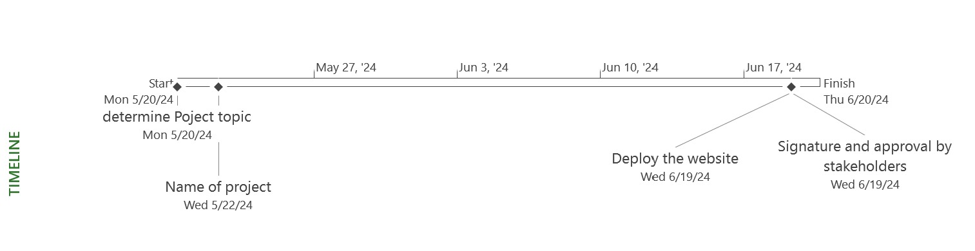

Define expected duration and start/stop dates of each task.

Answer:

|  |  |  |  |
| --- | --- | --- | --- |
| Name | Duration | Start | Finish |
| **Workspace web project** | **23 days** | **Mon 5/20/24** | **Thu 6/20/24** |
| **Initiating** | **2 days** | **Mon 5/20/24** | **Tue 5/21/24** |
| Identify the stakeholders | 2 days | Mon 5/20/24 | Tue 5/21/24 |
| determine the project cost | 0 days | Tue 5/21/24 | Tue 5/21/24 |
| determine Poject topic | 0 days | Tue 5/21/24 | Tue 5/21/24 |
| **Planning for the website project** | **1 day** | **Wed 5/22/24** | **Wed 5/22/24** |
| **Define and collect the base information** | **1 day** | **Wed 5/22/24** | **Wed 5/22/24** |
| Name of project | 0 days | Wed 5/22/24 | Wed 5/22/24 |
| Define Goal | 1 day | Wed 5/22/24 | Wed 5/22/24 |
| **Analysis the website function** | **3 days** | **Thu 5/23/24** | **Mon 5/27/24** |
| Functional requirements: | 2 days | Thu 5/23/24 | Fri 5/24/24 |
| Non-functional requirements: | 1 day | Mon 5/27/24 | Mon 5/27/24 |
| **design the Website** | **3 days** | **Tue 5/28/24** | **Fri 5/31/24** |
| user interface design | 3 days | Tue 5/28/24 | Fri 5/31/24 |
| content layout and organzation | 3 days | Tue 5/28/24 | Fri 5/31/24 |
| **Implementation and execute** | **7 days** | **Wed 6/5/24** | **Thu 6/13/24** |
| **Create Web Pages** | **5 days** | **Wed 6/5/24** | **Tue 6/11/24** |
| Home page | 1 day | Wed 6/5/24 | Wed 6/5/24 |
| Items page | 1 day | Thu 6/6/24 | Thu 6/6/24 |
| Company page | 1 day | Fri 6/7/24 | Fri 6/7/24 |
| About us page | 1 day | Mon 6/10/24 | Mon 6/10/24 |
| **Create database** | **3 days** | **Tue 6/11/24** | **Thu 6/13/24** |
| Fill database with data | 3 days | Tue 6/11/24 | Thu 6/13/24 |
| **Testing and mainten the website** | **3 days** | **Fri 6/14/24** | **Tue 6/18/24** |
| Upload the website in local server | 3 days | Fri 6/14/24 | Tue 6/18/24 |
| Testing the website | 0 days | Tue 6/18/24 | Tue 6/18/24 |
| **Closing the website project** | **1 day** | **Wed 6/19/24** | **Wed 6/19/24** |
| Prepare final project presentation | 1 day | Wed 6/19/24 | Wed 6/19/24 |
| Signature and approval by stakeholders | 0 days | Wed 6/19/24 | Wed 6/19/24 |
| Deploy the website | 0 days | Wed 6/19/24 | Wed 6/19/24 |

1. Create a working time exception in the project calendar.

Answer:

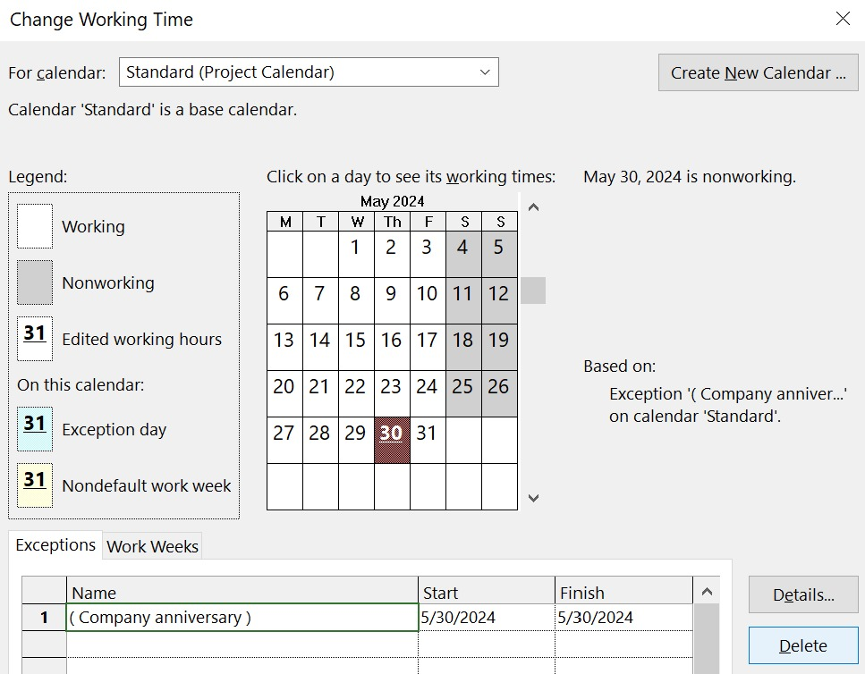

1. Create task dependencies by linking the tasks.

• Insert print screen that shows Gantt chart view after linking the tasks.

Example of the way linking the tasks:

Gantt chart:

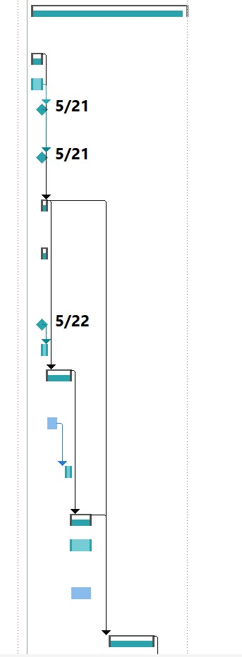

1. fine the needed resources in the resource sheet and make sure that you define the related information (type, cost …etc.).

• Insert print screen\copy that shows the resource sheet into your project document.

Answer:

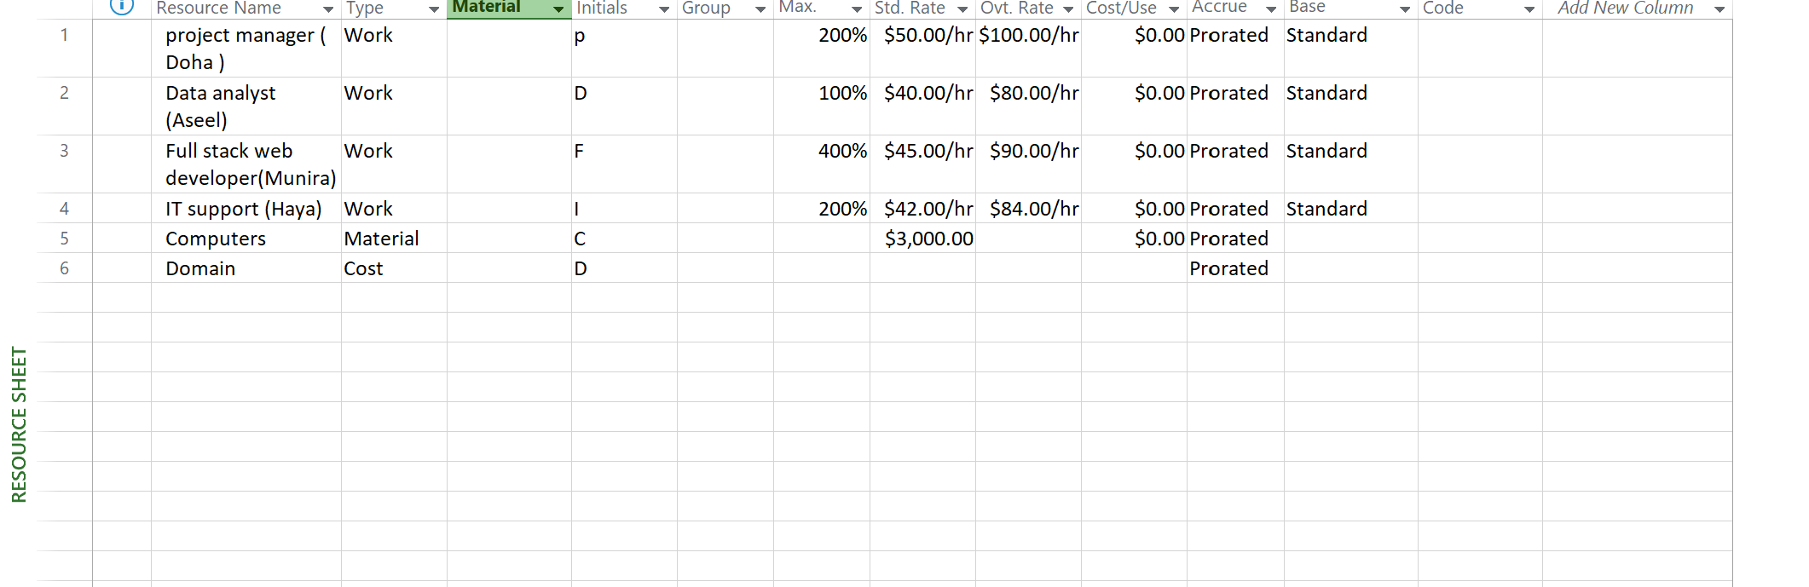

1. Assign resources to tasks.

Answer:

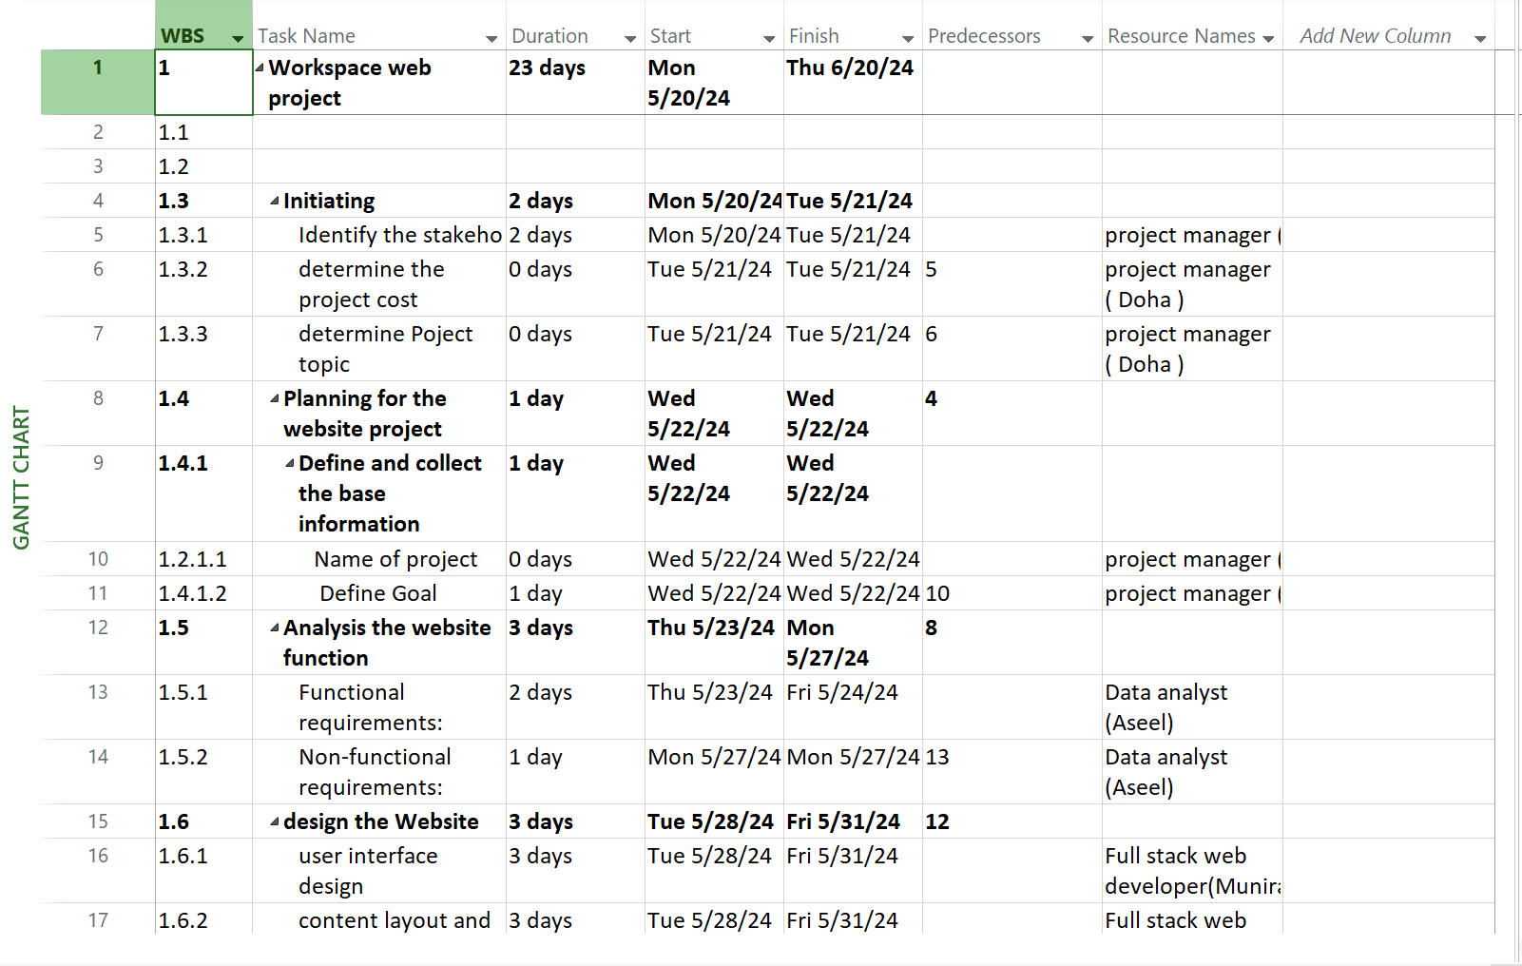

1. Suppose that there are overallocation, solve it and show the leveling Gantt view.

Before solve overallocation:

1. Insert print screen for Resource Graph before and after overallocation.

After solve overallocation:

Leveling Gantt:

