**Deploy Spring Boot Web Application**

**from OpenShift Web Console**

This document shows the basic steps to deploy a Spring Boot web application to OpenShift using OpenShift Web Console.

To make the document simple and clean, I just list each button/link/menu item that is clicked or selected, without wording like “click Create button” or “click Actions dropdown and then click menu item Edit Route”. So you will simply see:

*Create*

*Actions – Edit Route*

For the mandatory input filed, the label and the value typed are listed. For instance:

*Name: dannyproject*

The screenshots are captured before and after a button click.

Let’s get started.

Login to OpenShift 4.4

Administrator Perspective

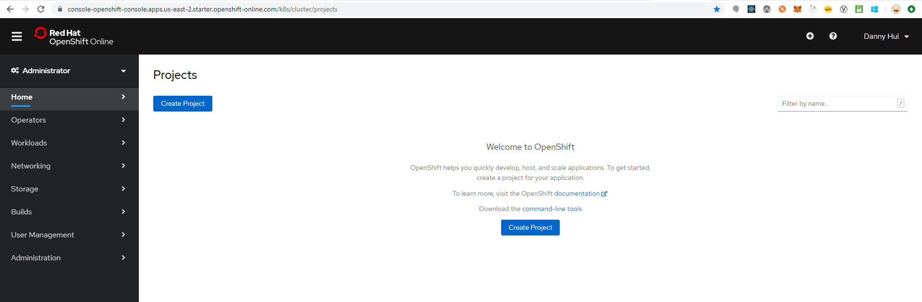

Create Project

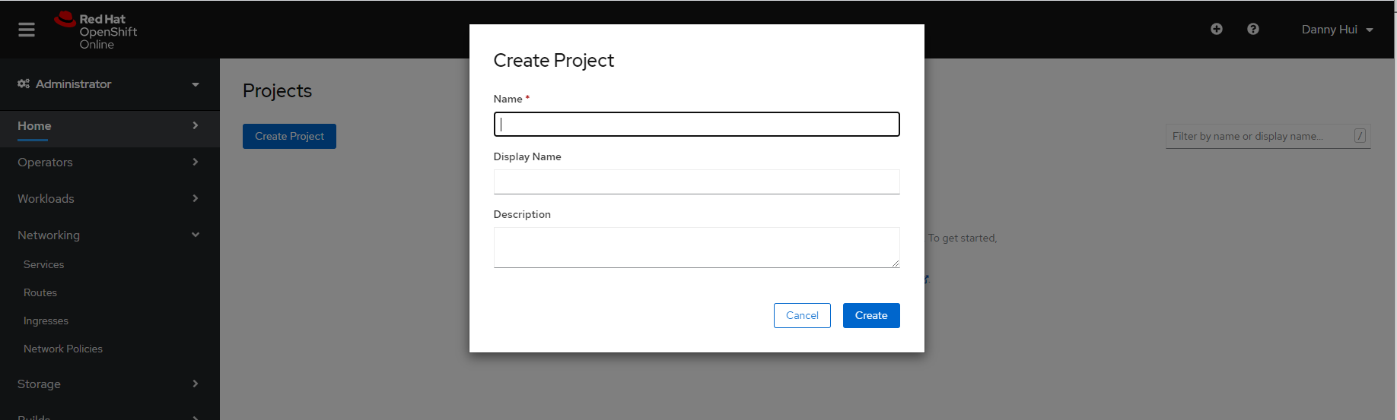

Name: dannyproject

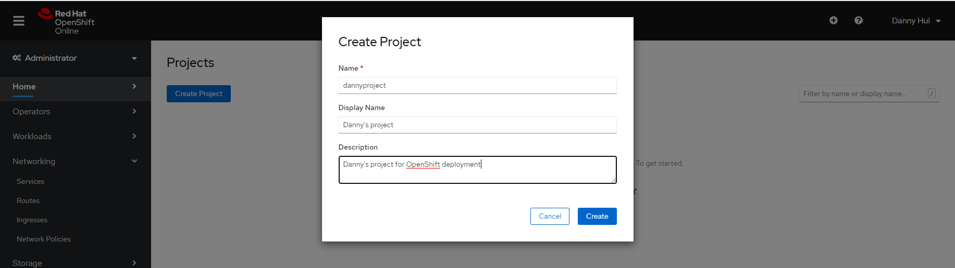

Create

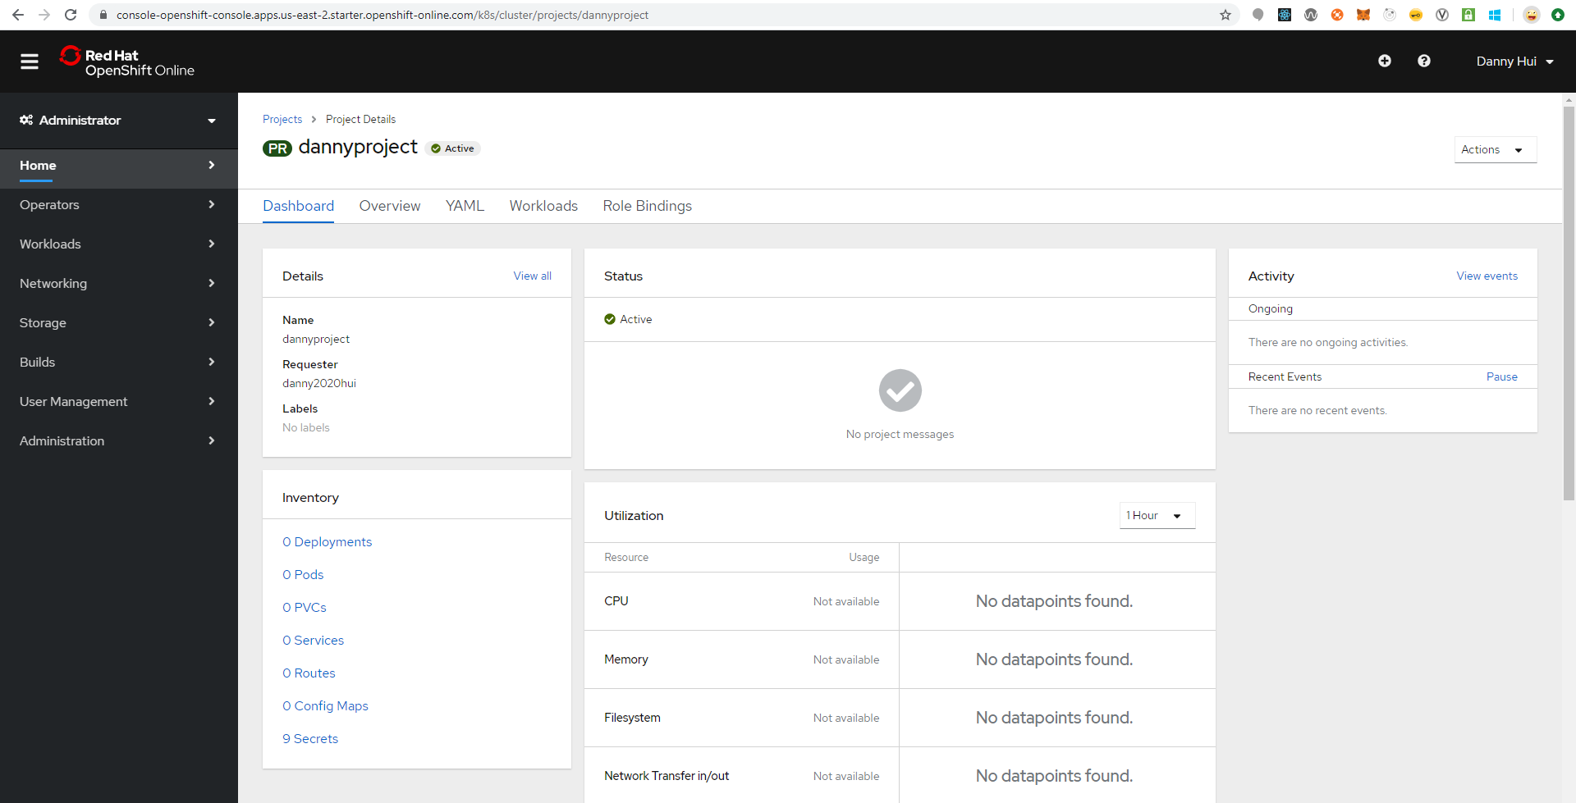

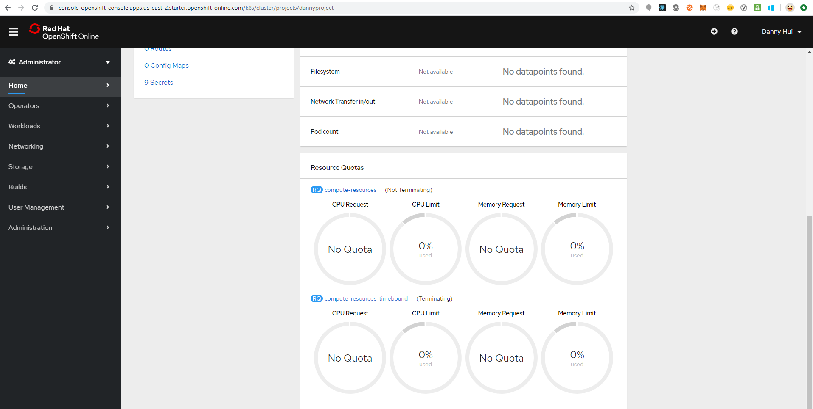

Developer Perspective

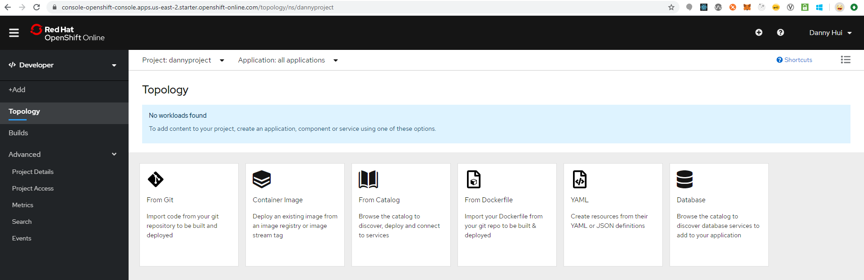

Deploy Spring Boot Web Application

Source:

<https://github.com/dhui808/springbootstarter>

+Add

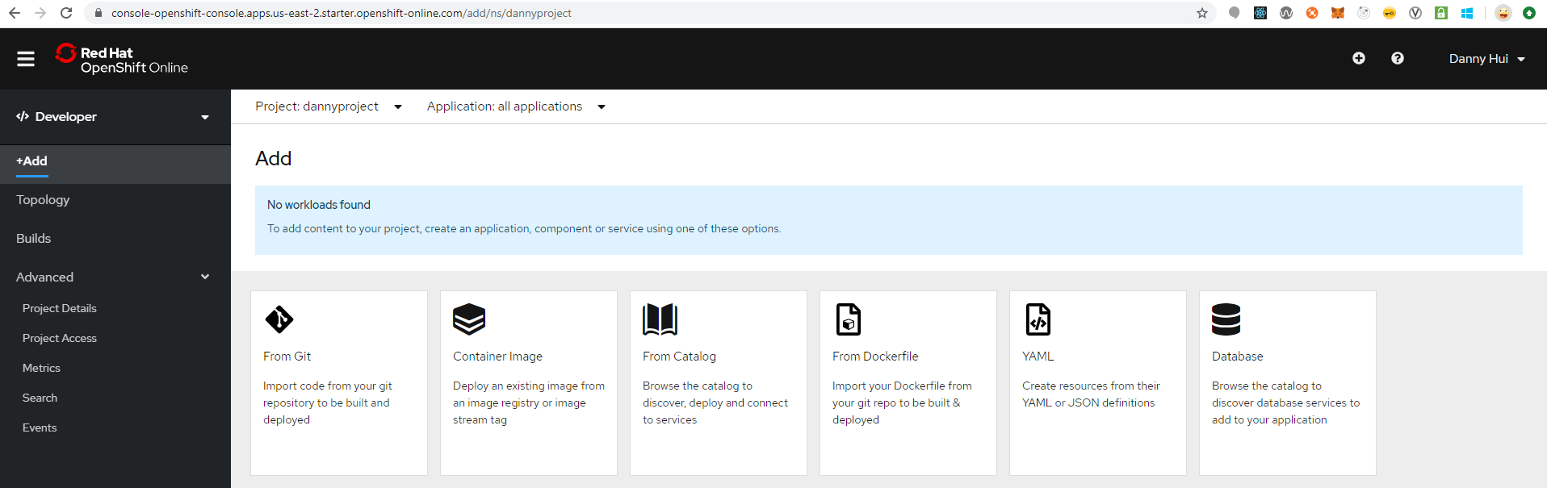

From Git

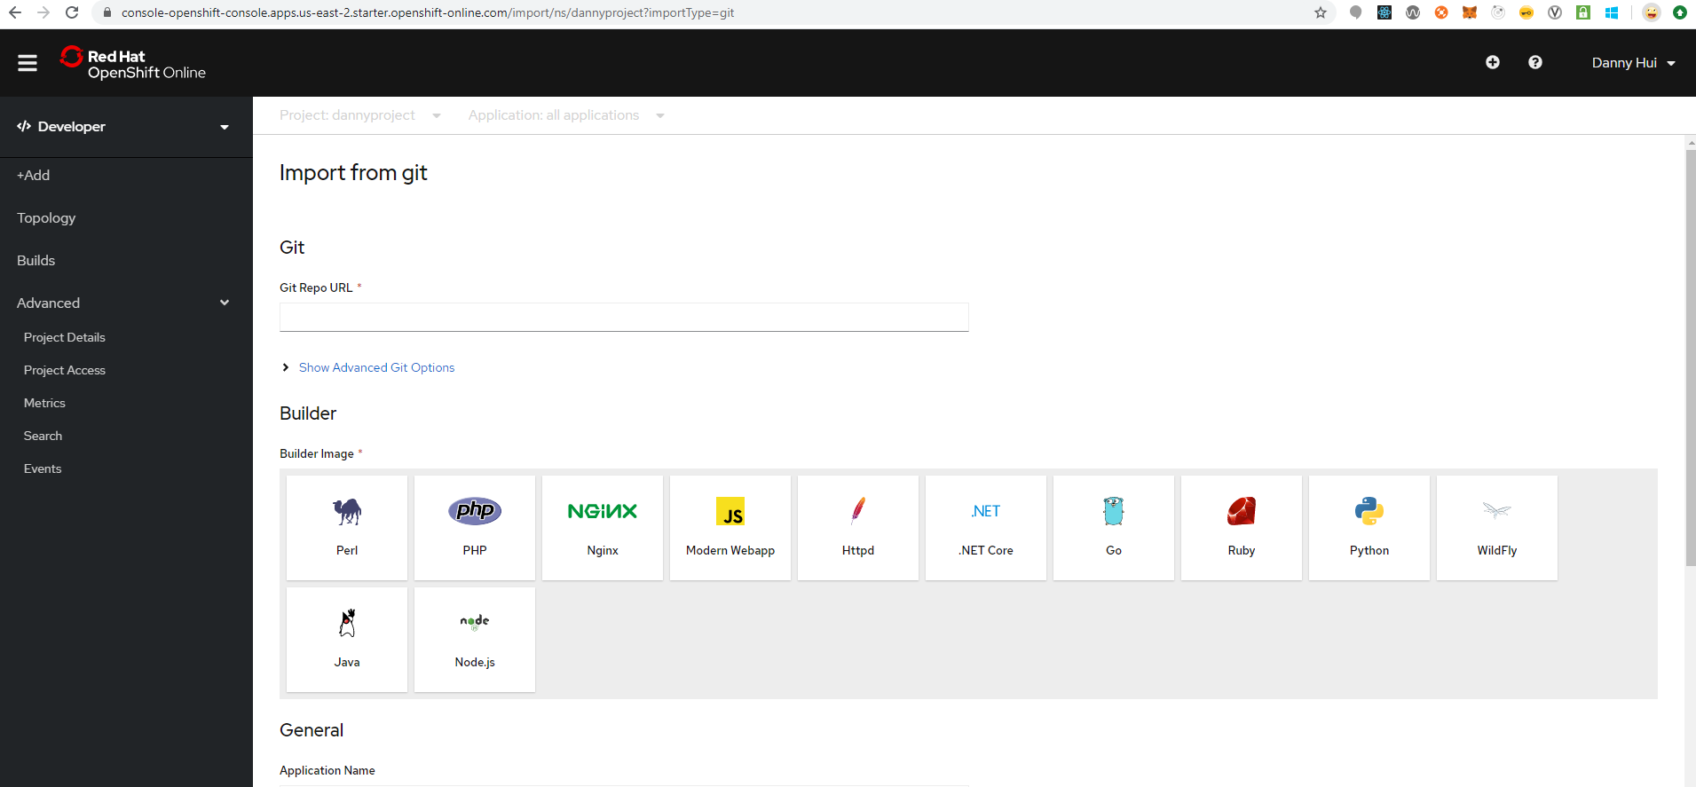

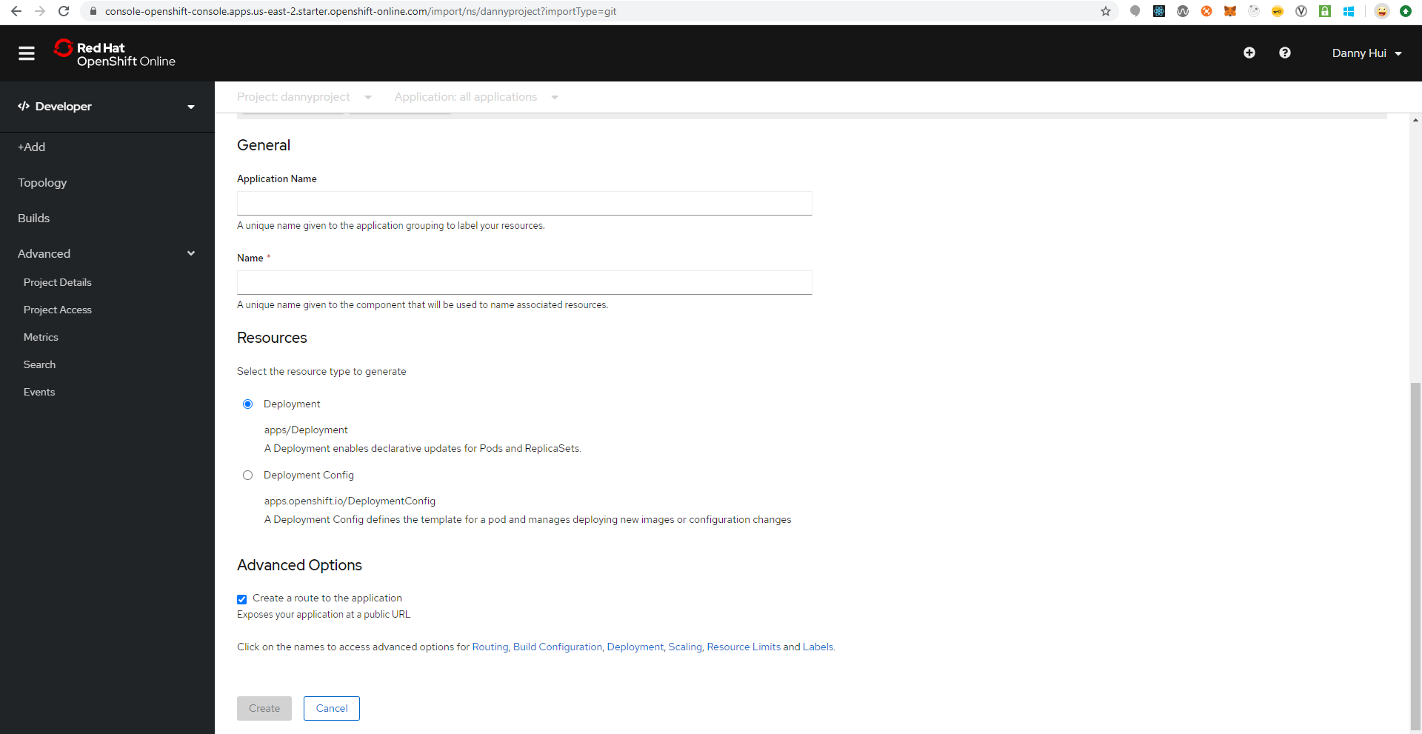

Git Repo URL

<https://github.com/dhui808/springbootstarter>

Build Image

Java

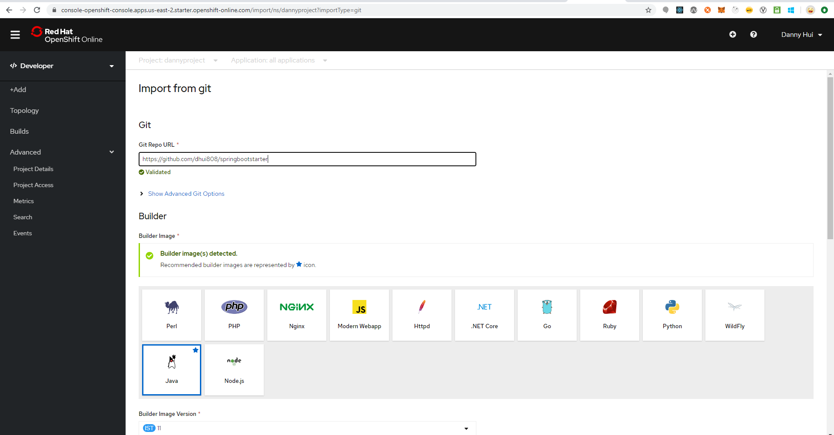

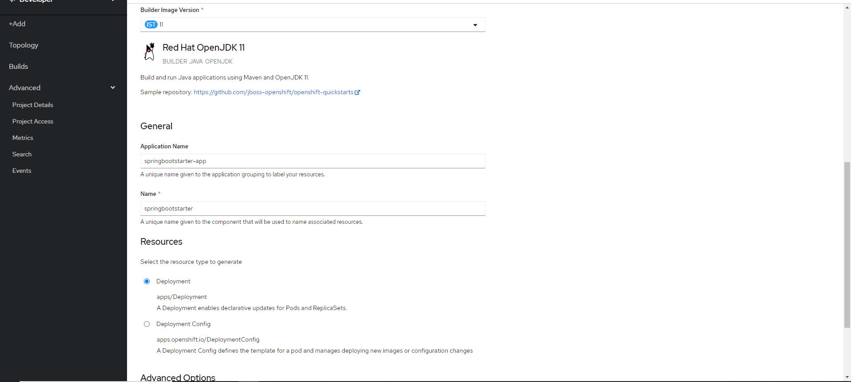



Deployment (default selected)

Create

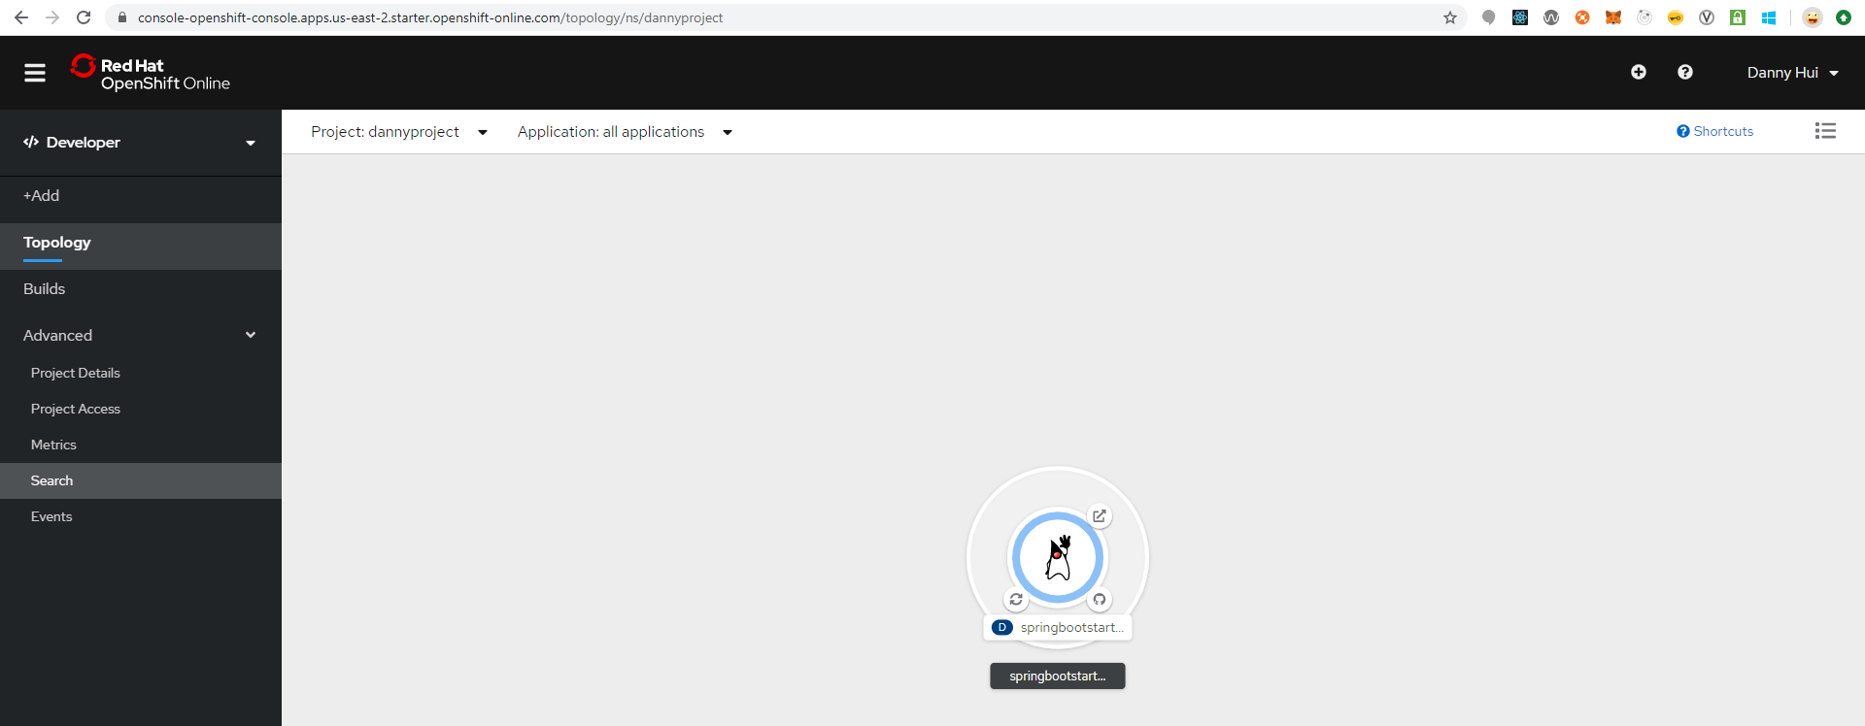

Java Duke icon

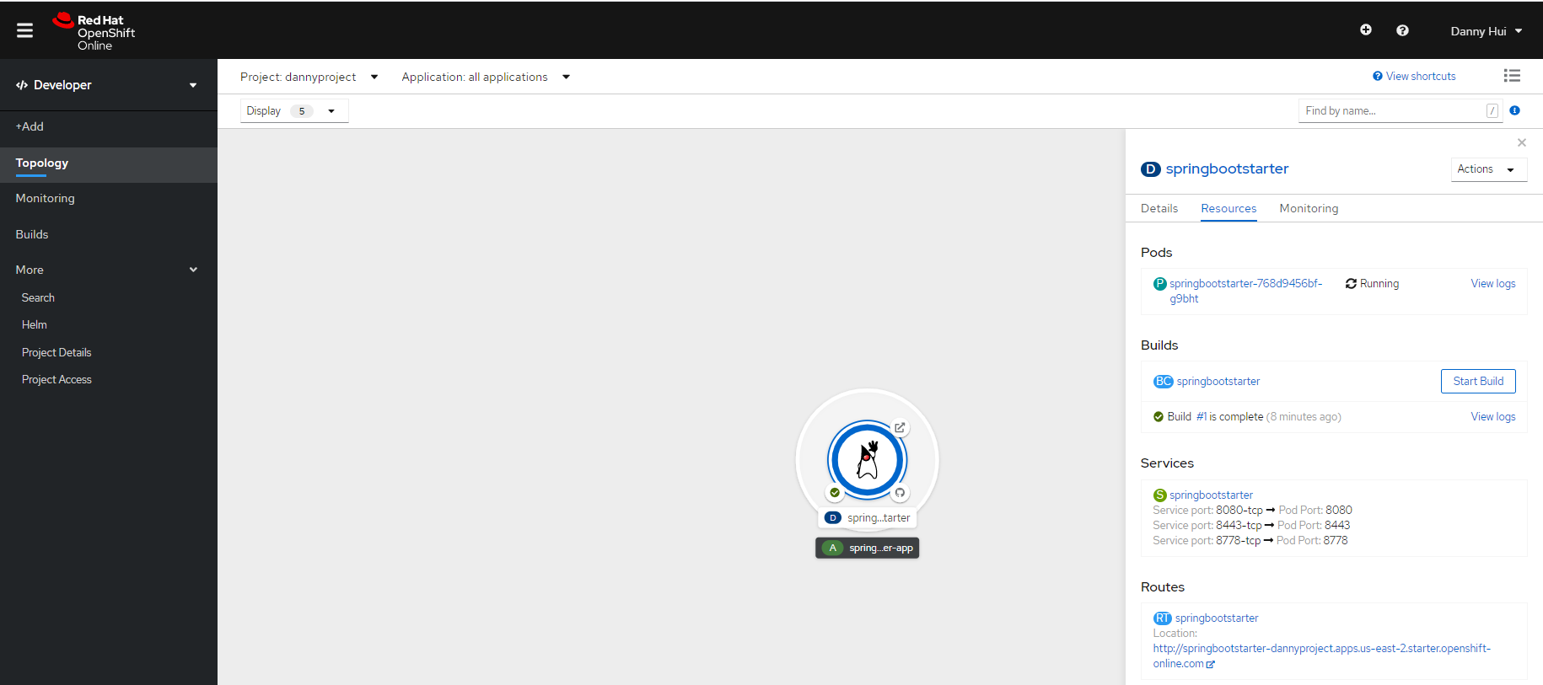

This is application URL

From browser:

<http://springbootstarter-dannyproject.apps.us-east-2.starter.openshift-online.com/springbootstarter/hello>



Voila!